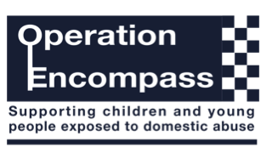

26.02.21

Dear Parents/Carers,

Rockbourne Park has been given the opportunity to take part in a project that will run jointly between schools and the Metropolitan Police.

Operation Encompass is the reporting to schools, prior to the start of the next school day, when a child or young person has been exposed to, or involved in, any domestic incident.

Operation Encompass will ensure that a member of the school staff, known as a Dedicated Safeguarding Lead, is trained to allow them to liaise with the police and to use the information that has been shared, in confidence, while ensuring that the school is able to make provision for possible difficulties experienced by children, or their families, who have been involved in, or exposed to, a domestic abuse incident.
We are keen to offer the best support possible to all our pupils and we believe this will be extremely beneficial for all those involved.

Yours Faithfully,

Stephen Orton

Assistant Headteacher

