

**TEST AND TRACE**

**If any staff, pupils or family members develop COVID19 symptoms or test positive at the start of the Easter holidays (before 08.04.21) –** **please contact the HT on** 07854 265 287 or via email asturman@kenningtonpark.org.uk

This will allow us to contact NHS Test and Trace and inform any other members of our school community should it be necessary.

**FREE SCHOOL MEALS OVER THE EASTER BREAK**

Schools are no longer responsible for organising Free School Meals Vouchers. The government provides support with food and other essentials through the COVID Winter Grant Scheme. This scheme, run by local authorities, has operated successfully since November including over the Christmas and February half term holidays. The scheme ensures that individuals, families and children who require it, including those eligible for free school meals, can receive the support they need. Further information on the provision of free school meals and the COVID Winter Grant Scheme can be found in the DfE guidance on [providing school meals during the coronavirus (COVID-19) outbreak](https://www.gov.uk/government/publications/covid-19-free-school-meals-guidance/covid-19-free-school-meals-guidance-for-schools?utm_source=26%20March%202021%20C19&utm_medium=Daily%20Email%20C19&utm_campaign=DfE%20C19).

**As we get to the end of term 4, I wanted to thank all of the staff, pupils and families for all the hard work that has gone into making this year a very successful one for us so far at KPA and Oak Park. 70% of our pupils returned before the full re-opening of schools on 8th March and this has helped to reduce the disruption to their learning and overall development which was at risk during the second national Lockdown. The staff have worked incredibly hard to ensure that pupils have been able to continue their education –both on and offsite -and we are all really happy that everyone is now back. We are looking forward to some return to normality in the coming months. This newsletter has some important information on COVID-19 as well as some highlights from the term. I would like to wish everyone a lovely Easter Holiday and hope that lots of chocolate is on the menu.**

**Kind regards, Miss Sturman**



EGGSITING TIMES

**We really enjoyed looking after our chick eggs in the incubator. 6 very healthy and friendly chicks are now running free on a farm.**

**CHANGES TO TEST AND TRACE SUPPORT PAYMENTS TO PARENTS/CARERS**

Parents and carers of children who have been advised to self-isolate by their education setting or by NHS Test and Trace are now able to apply for a [Test and Trace Support Payment](https://www.gov.uk/government/publications/test-and-trace-support-payment-scheme-claiming-financial-support/claiming-financial-support-under-the-test-and-trace-support-payment-scheme?utm_source=22%20March%202021%20C19&utm_medium=Daily%20Email%20C19&utm_campaign=DfE%20C19) or discretionary payment of £500, if they meet the eligibility criteria. Parents and carers should apply to their local authority to receive a payment. Applications for the Test and Trace Support Payment scheme are made via the local authority in which the parent or carer resides, not the local authority where the setting is situated, if these are different.

**To be eligible applicants must meet all of the criteria that:**

1. They are the parent/guardian of a child or young person in the same household and need to take time off work to care for them whilst they self-isolate. This is limited to one parent/carer per household.
2. They are employed or self employed
3. They cannot work from home while undertaking caring responsibilities and will lose income as a result.
4. They meet all the other means tested eligibility criteria for a Test and Trace Support Payment or locally determined criteria for a discretionary payment.

**That their child or young person:**

* Is aged 15 or under (or under 25 with an EHC Plan) and normally attends an education or child care setting.
* Has been told to self-isolate by NHS Test and Trace or by their child’s educational; setting because they have been identified as being as a close contact of someone who has tested positive for Coronavirus (COVID-19)

|  |
| --- |
|  |

|  |
| --- |
|  |

T

**END OF TERM: THURSDAY 1ST APRIL – 3PM**

**START OF TERM 5: MONDAY 19TH APRIL – ALL PUPILS EXPECTED BACK ON THIS DAY.**

On 4th March, we chose **Where’s Wally as our theme for WORLD BOOK DAY**. Miss Emma and Miss Janice set up a real life Where’s Wally hunt for us all and pupils and staff had a great day.

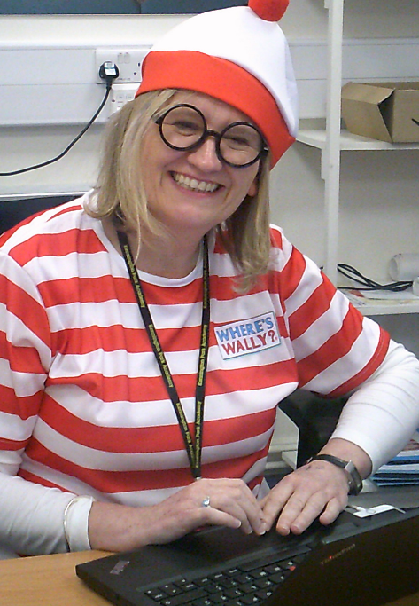

**END OF TERM : THURSDAY 1ST APRIL – 3PM**

**START OF TERM 5 : MONDAY 19TH APRIL – ALL PUPILS EXPECTED BACK ON THIS DAY.**