I have produced a parent-friendly version of our school’s calculation policy so that can parents can assist with homework at home in the same way as the children would be taught in school. I understand that we were often taught in different ways during our own time at school and some misunderstandings may occur if parent and child are being taught how to solve problems in different ways.
Most children will begin at the Concrete stage with a new skill and slowly move through towards Abstract. This is not a race and if a child is not ready for the next stage, they should not be moved on to it until they are.
Some of the skills below may not be relevant to your child yet, for example if they are in Year 3; however they will be able to explain the method that they are currently using in class.
I hope that this helps to assist your child as they make their way through Kennington Primary School and develop a positive relationship with Maths.
Thank you for your continued support,
Mr Goulds
Maths Leader

Addition
Objective and Strategies | Concrete | Pictorial | Abstract
Combining two parts to make a whole number. | Use cubes to add two numbers together as a group or in a bar. Use base 10 equipment to add two groups together. | 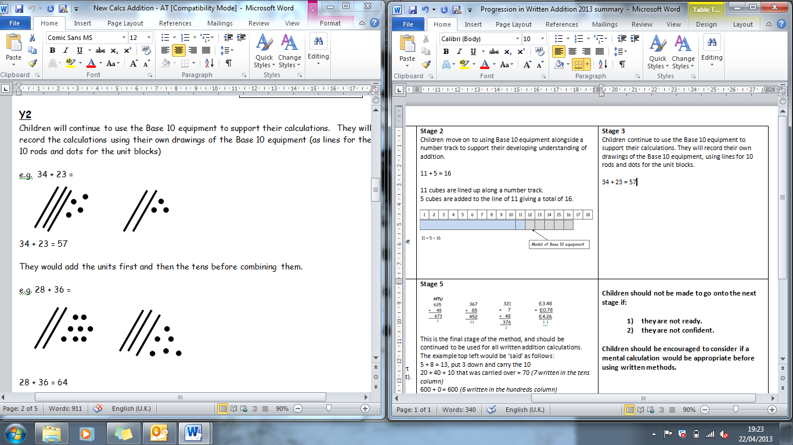  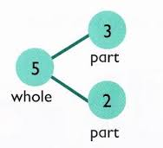  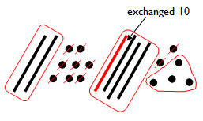  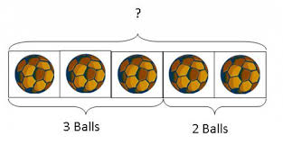  Using sticks and dots and exchanging when crossing a ten.  8  1  Use pictures to add two numbers together as a group or in a bar. | 4 + 3 = 7  10= 6 + 4  5  3  Use the part-part whole diagram as shown above to move into the abstract.
Column method- no regrouping | 24 + 15=  Add together the ones first then add the tens. Use the Base 10 blocks first before moving onto place value counters.  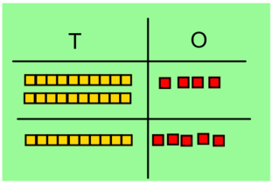  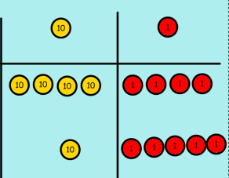 | Draw the counters as shown below or draw sticks and dots to show the numbers being added together.  T O | 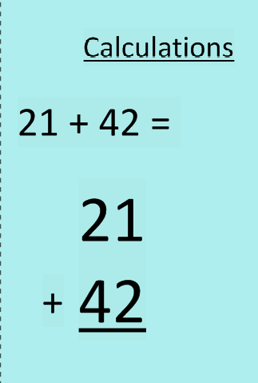
Column method- regrouping | 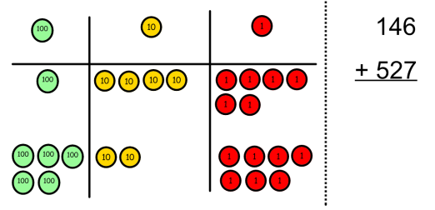  Make both numbers on a place value grid.  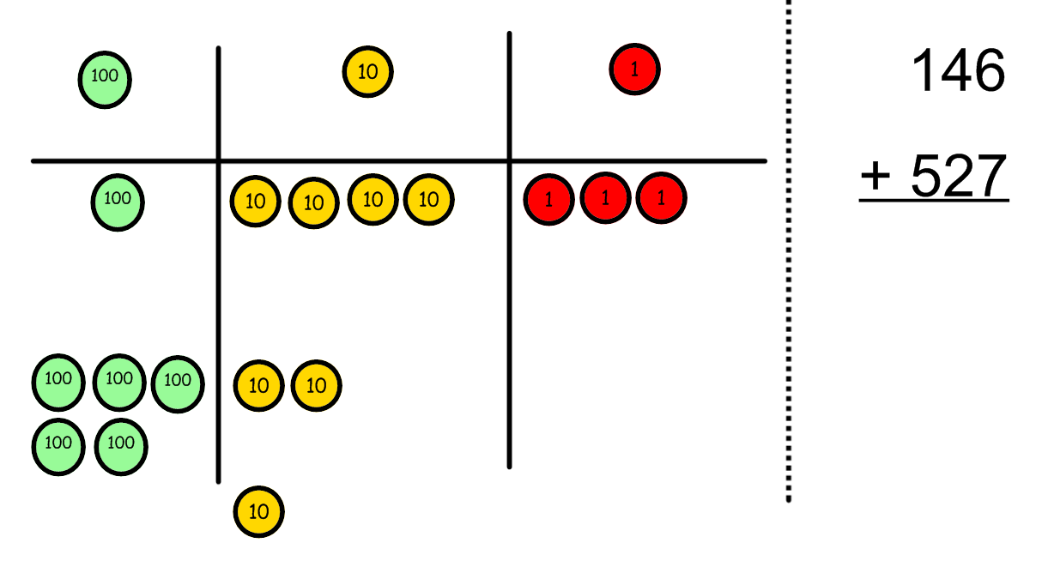  Add up the units and exchange 10 ones for one 10.  Add up the rest of the columns, exchanging the 10 counters from one column for the next place value column until every column has been added. | 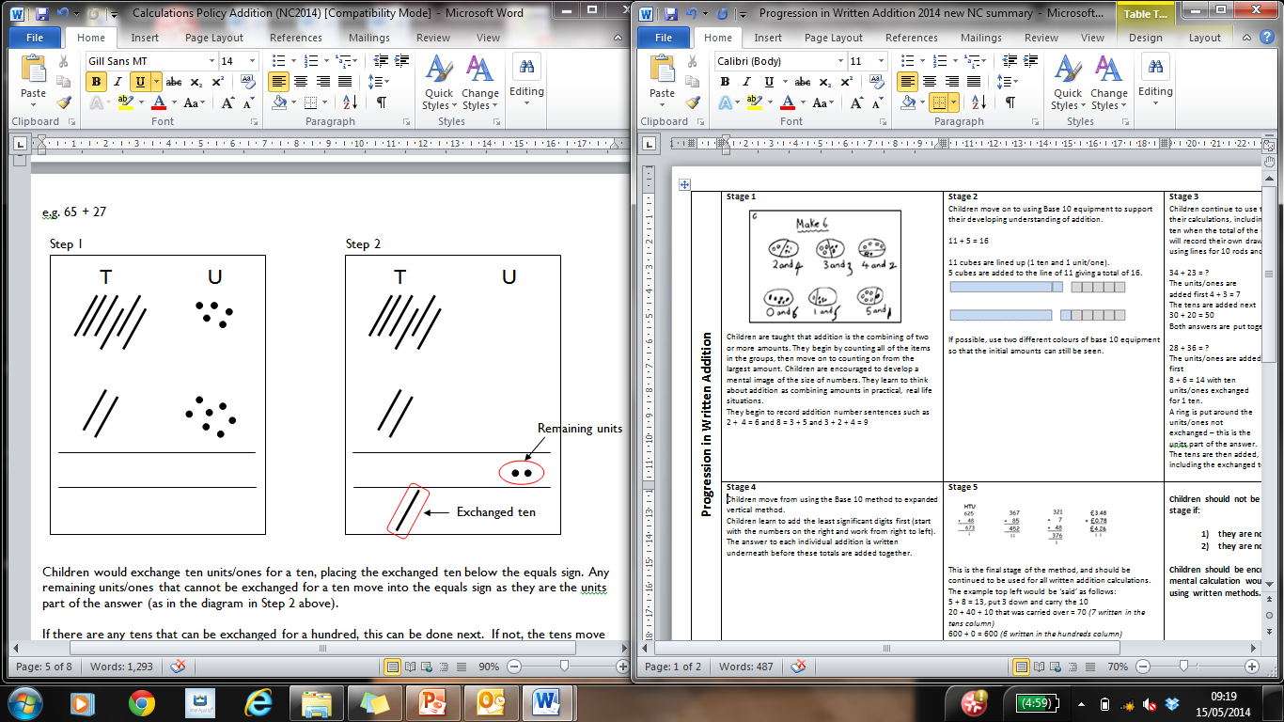  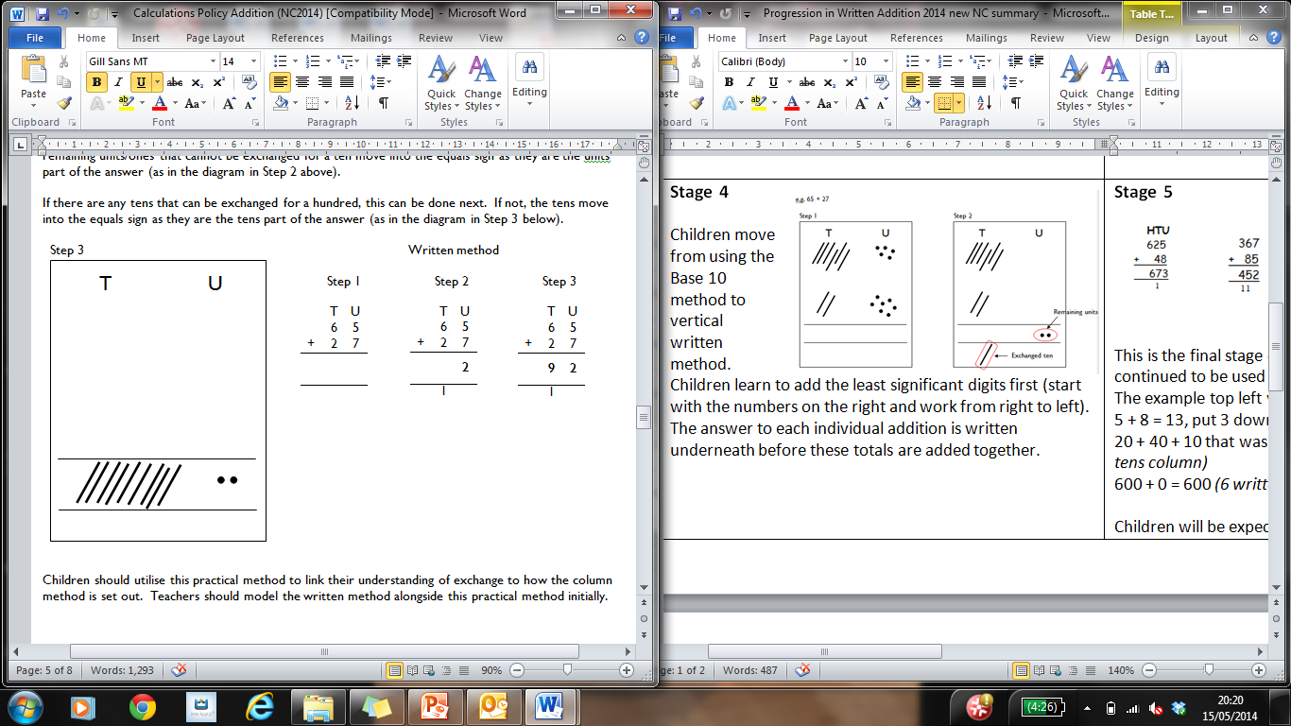  Children can draw a pictoral representation of the columns and place value counters to further support their learning and understanding. | Start by partitioning the numbers before moving on to clearly show the exchange below the addition.  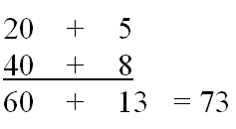  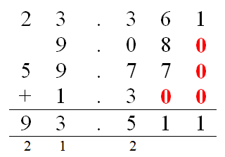  As the children move on, introduce decimals with the same number of decimal places and different. Money can be used here.

Subtraction
Objective and Strategies | Concrete | Pictorial | Abstract
Find the difference | Compare amounts and objects to find the difference.  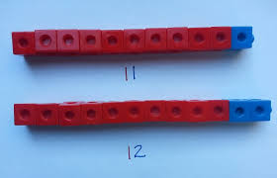  Use cubes to build towers or make bars to find the difference  Use basic bar models with items to find the difference | Count on to find the difference.  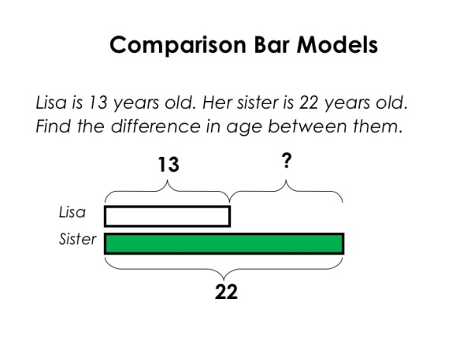  Draw bars to find  the difference between 2 numbers. | Hannah has 23 sandwiches, Helen has 15 sandwiches. Find the difference between the number of sandwiches.
Part Part Whole Model | Link to addition- use the part whole model to help explain the inverse between addition and subtraction.  If 10 is the whole and 6 is one of the parts. What is the other part?  10 - 6 = |     Use a pictorial representation of objects to show the part part whole model. | 10  5  Move to using numbers within the part whole model.
Column method without regrouping | Use Base 10 to make the bigger number then take the smaller number away.  Show how you partition numbers to subtract. Again make the larger number first. | 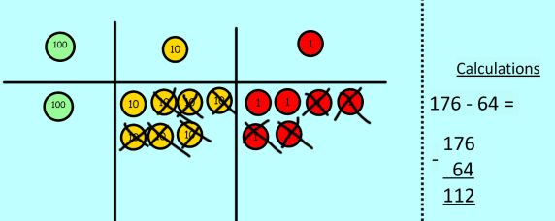  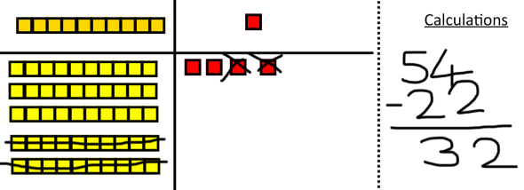  Draw the Base 10 or place value counters alongside the written calculation to help to show working. | 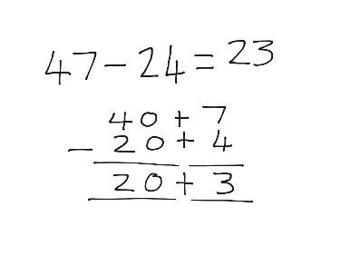  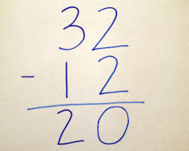  This will lead to a clear written column subtraction.
Column method with regrouping | Make the larger number with sticks and dots or counters.  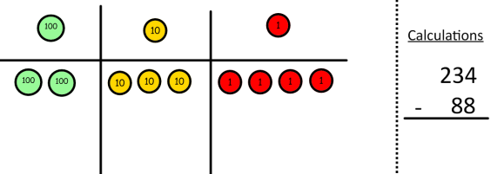  Start with the ones, can I take away 8 from 4 easily? I need to exchange one of my tens for ten ones.  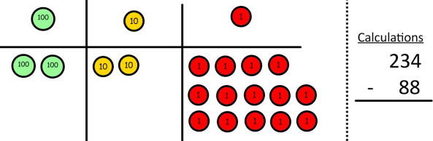  Now I can subtract my ones. | Draw the counters onto a place value grid and show what you have taken away by crossing the counters out as well as clearly showing the exchanges you make.  When confident, children can find their own way to record the exchange/regrouping.  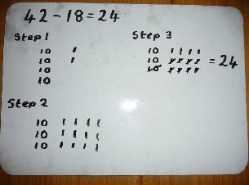  Just writing the numbers as shown here shows that the child understands the method and knows when to exchange/regroup. | Children can start their formal written method by partitioning the number into clear place value columns.

Multiplication
Objective and Strategies | Concrete | Pictorial | Abstract
Arrays- showing multiplication | 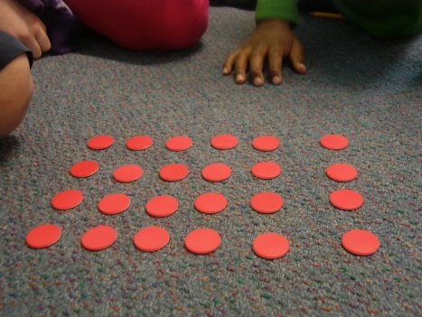  Create arrays using counters/ cubes to show multiplication sentences. | Draw arrays in different rotations to find commutative multiplication sentences and point out that commutative nature of these number sentences.  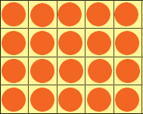  Link arrays to area of rectangles. | Use an array to write multiplication sentences.  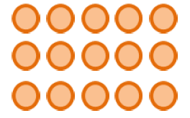
Grid Method | Show the link with arrays to first introduce the grid method.  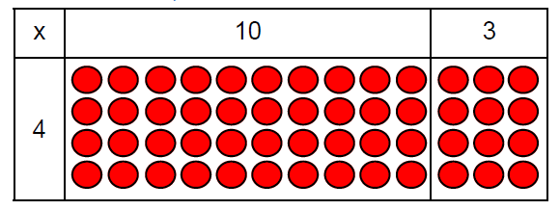  4 rows of 10  4 rows of 3  4 rows of 13  Fill each row with 126.  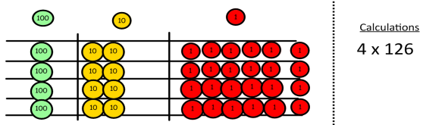  Add up each column, starting with the ones making any exchanges needed.  . | Children can represent the work they have done with place value counters in a way that they understand.  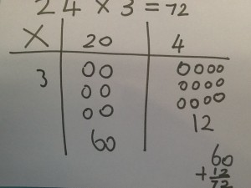  They can draw the counters, using colours to show different amounts or just use circles in the different columns to show their thinking as shown below. | 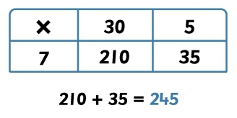  Start with multiplying by one digit numbers and showing the clear addition alongside the grid.  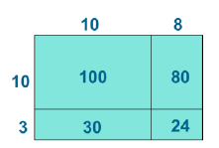  Moving forward, multiply by a 2 digit number showing the different rows within the grid method.

Division
Objective and Strategies | Concrete | Pictorial | Abstract
Sharing objects into groups | 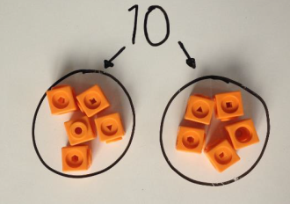  I have 10 cubes, can you share them equally in 2 groups? | Children use pictures or shapes to share quantities.    8 ÷ 2 = 4 | Share 9 buns between three people.  9 ÷ 3 = 3
Division with a remainder | 14 ÷ 3 =  Divide objects between groups and see how much is left over  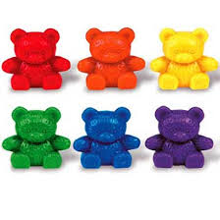 | Jump forward in equal jumps on a number line then see how many more you need to jump to find a remainder.  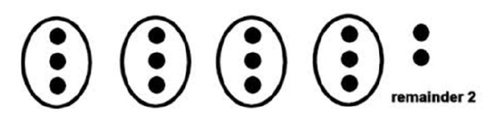  Draw dots and group them to divide an amount and clearly show a remainder. | Complete written divisions and show the remainder using r.  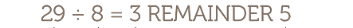
Short division | 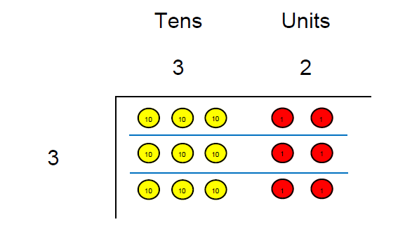  Use place value counters to divide using the bus stop method alongside. | 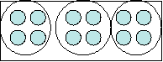  Students can continue to use drawn diagrams with dots or circles to help them divide numbers into equal groups.  Encourage them to move towards counting in multiples to divide more efficiently. | Begin with divisions that divide equally with no remainder.  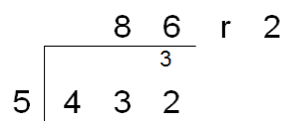  Move onto divisions with a remainder.

