I have produced a parent-friendly version of our school’s calculation policy so that can parents can assist with homework at home in the same way as the children would be taught in school. I understand that we were often taught in different ways during our own time at school and some misunderstandings may occur if parent and child are being taught how to solve problems in different ways.
Most children will begin at the Concrete stage and slowly move through towards Abstract. This is not a race and if a child is not ready for the next stage, they should not be moved on to it until they are.
I hope that this helps to assist your child as they make their way through Kennington Primary School and develop a positive relationship with Maths.
Thank you for your continued support,
Mr Goulds
Maths Leader

EYFS/Key Stage 1- Addition
Objective and Strategies | Concrete | Pictorial | Abstract
Adding two numbers together to make a whole. | Use cubes, counters or any objects to add two numbers together as a group or in a bar. | 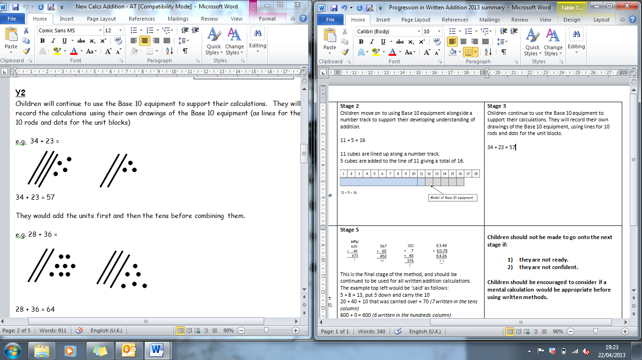  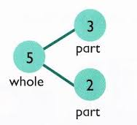  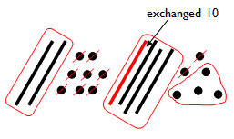  Using sticks and dots and exchanging when crossing a ten.  8  1  Use pictures to add two numbers together as a group or in a bar. | 4 + 3 = 7  __ = 5 + 3  5  3  Use the part-part whole diagram as shown above to move into the abstract.
Starting at the larger number and counting on | Start with the larger number on the bead string/ cube tower/Base 10 equipment and then count on to the smaller number 1 by 1 to find the answer. | 12 + 5 = 17  Start at the larger number on the number line and count on in ones or in one jump to find the answer. | 5 + 12 = 17  Place the larger number in your head and count on the smaller number to find your answer.

Subtraction
Objective and Strategies | Concrete | Pictorial | Abstract
Taking away ones | Use physical objects, counters, cubes etc to show how objects can be taken away.      6 – 2 = 4 | Cross out drawn objects/ sticks and tens to show what has been taken away.  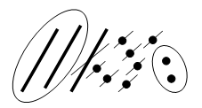  39 – 17 = 22 | 18 - 3= 15  8 – 2 = 6
Counting back | Use counters/cubes and move them away from the group as you take them away counting backwards as you go. write the number sentence down.  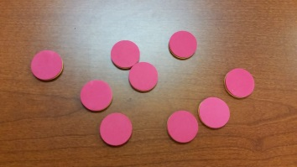 | Count back on a number line or 100 square.  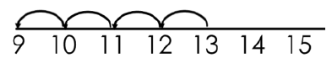  Start at the larger number and count back the smaller number showing the jumps on the number line. | Put 13 in your head, count back 4. What number are you at?
Find the difference | Compare amounts to find the difference.  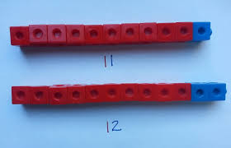  Use cubes to build towers to find the difference  Use basic bar models with items to find the difference | 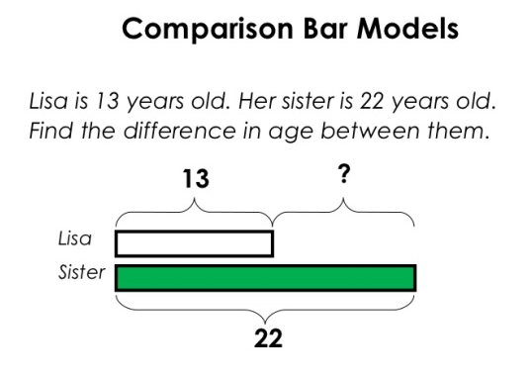  Draw bars to find  the difference between 2 numbers. | Hannah has 23 sandwiches, Helen has 15 sandwiches. Find the difference between the number of sandwiches.

Multiplication
Objective and Strategies | Concrete | Pictorial | Abstract
Counting in multiples | 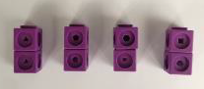  Count in multiples supported by objects in equal groups. | Use a number line or pictures to continue support in counting in multiples. | Count in multiples of a number aloud.  Write sequences with multiples of numbers.  2, 4, 6, 8, 10  5, 10, 15, 20, 25 , 30
Repeated addition |   Use different objects to add equal groups. |  | Write addition sentences to describe objects and pictures.
Arrays- showing commutative multiplication | 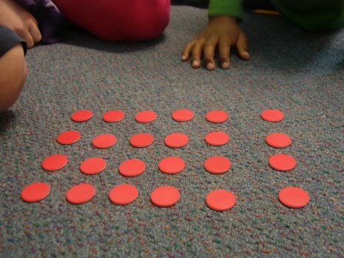  Create arrays using counters/ cubes to show multiplication sentences. | Draw arrays in different ways such as 4 rows of 5 and 5 rows of 4 so children understand that they lead to the same answer.  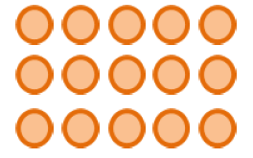 | 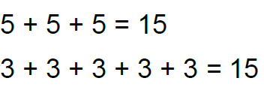  Write multiplication sentences and reinforce repeated addition.

Division
Objective and Strategies | Concrete | Pictorial | Abstract
Sharing objects into groups | 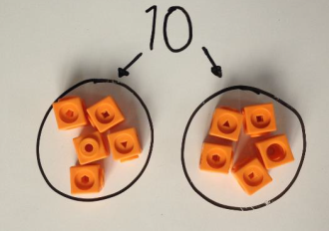  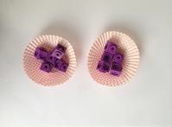  I have 10 cubes, can you share them equally in 2 groups? | Children use pictures or shapes to share quantities.    8 ÷ 2 = 4 | Share 9 buns between three people.  9 ÷ 3 = 3
Division as grouping | Divide quantities into equal groups.  Use cubes, counters, objects or place value counters to aid understanding. | 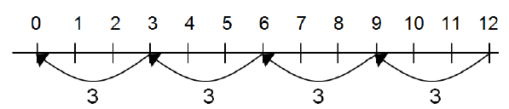  Use a number line to show jumps in groups. The number of jumps equals the number of groups.  Think of the bar as a whole. Split it into the number of groups you are dividing by and work out how many would be within each group. | 28 ÷ 7 = 4  Divide 28 into 7 groups. How many are in each group?
Division within arrays (Year 2) | 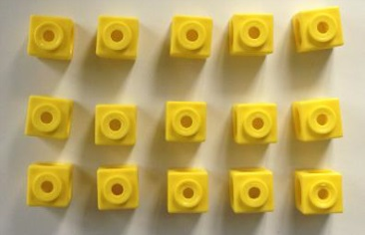  Use cubes to make an array – what groups of numbers can children see? | 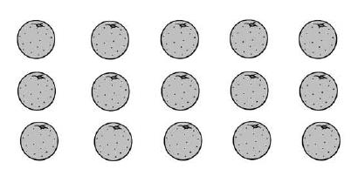  Draw an array (can be objects as above or simply dots) and use lines to split the array into groups to make division sentences. | Find the inverse of multiplication and division sentences by creating four linking number sentences.  7 x 4 = 28  4 x 7 = 28  28 ÷ 7 = 4  28 ÷ 4 = 7

