Welcome to
Kennington Primary School

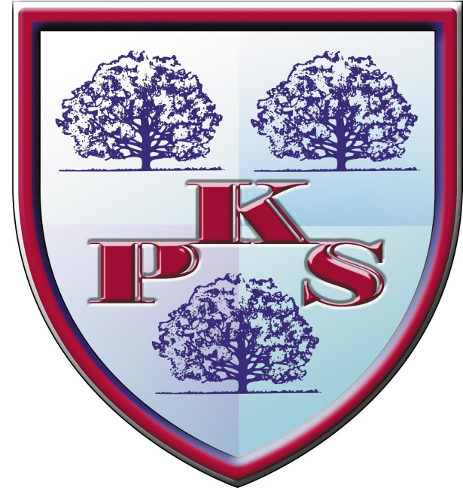
01772 774044
office@kennington.lancs.sch.uk
www.kennington.lancs.sch.uk
@kenningtonCPS

‘Learn…enjoy…succeed’

On behalf of the governors and myself welcome to Kennington Primary School!
Whether you’re a prospective parent or a long standing family member of one of our pupils, I hope you find our website interesting and informative.
Our children come from wonderfully diverse backgrounds and cultures, which helps prepare them for life in 21st century multicultural Preston and indeed Great Britain. Our staff are both experienced and enthusiastic and go the extra mile to ensure the children in their care receive the best education possible.
Myself and my team strive to both engage and inspire all of our pupils so that they become fully rounded young people who, when they leave us at the end of Year 6, are more than ready to confidently take the next steps in their educational adventure.
Our provision not only aims to deliver an exciting curriculum, tailored to the needs of every child in school but also provide our children with opportunities and experiences beyond that of the normal timetable. We feel we have woven in to our provision essential learning experiences which go beyond the constraints of the normal curriculum. ‘Forest Fridays’ in Reception Class, den building and fire making in Year 4 and water sport activities at Plas Menai when they reach Year 6 all add up to something more than just the 3 Rs for our children.
Being head teacher of Kennington Primary School is a fantastic job and I’m proud to serve such a wonderful and supportive school community.
If you would like to visit our school or would like more information about us please don't hesitate to call the school office where Mrs Molloy, our school business manager, would be delighted to arrange an appointment for you.
Mr Simon Pritchard
Head Teacher
Kennington Primary School

Daily timetable

Morning session
Foundation/Key Stage 1 8:45am to 11:45am
Key Stage 2 8:45am to 12:15pm

Afternoon session
Foundation/Key Stage 1 12:45pm to 3:00pm
Key Stage 2 1:15pm to 3:00pm

Morning playtime 10:15am to 10:30am
Afternoon playtime

Children can enter School from 8:35am until 8:45am through the Infant or Junior playground. Entry after 8:45 is through the School Reception where children should be signed in as Late.

Holidays
Parents intending to take holidays during term time should apply to the Headteacher using a ‘Leave of Absence’ form which can either be collected from the school office or completed on ParentApps.
Parents are asked to plan holidays around school holiday closures in order to minimise disruption to their child’s education.
Holidays in term time can only be granted in ‘exceptional circumstances.’

Absence
Parents should always let school know why their children are absent so that their child’s absence is not registered as unauthorised.

Please help us account for all absences; if your child is ill please telephone or send a message through the ParentApp before 9:30am.

If your child needs time off school e.g. for a Hospital appointment, please let us know in advance.

Wherever possible try to make appointments out of school time.

Uniform
Boys  Burgundy sweatshirt with School Logo  School tie  White shirt (Winter) / White polo shirt (Summer)  Grey trousers (Winter) / Shorts (Summer)  Grey socks  Black sensible shoes (no trainers or trainer style shoes) | Girls  Burgundy sweatshirt/cardigan with School Logo  School tie  White shirt (short or long sleeved)  Grey pinafore/skirt/trousers  Blue & white Summer dress (Summer only)  White socks or plain black/grey tights  Black sensible shoes (flat heels only, no boots)

PE KIT  Dark blue shorts/PE skirt  White t-shirt  Black slip on pumps  PE bag for the kit | Games kit (Juniors only)  Outdoor trainers  A tracksuit can be worn in winter if it’s very cold

Jewellery
- No jewellery, such as rings, earrings, bracelets or necklaces are allowed to be worn in school.
- Children may wear a wrist watch as this encourages them to tell the time.
- Nail varnish should not be worn.
Health
If your child suffers from any medical conditions please inform us of the details e.g. asthma, allergies. If special or emergency medication is necessary please inform school so that a care plan can be completed concerning procedures e.g. use of inhalers.

We do discourage medicines in school, however we appreciate that from time to time it is necessary to administer prescribed medicine. We do not administer un-prescribed medicine. Please bring the medication with prescription label attached to the office to complete a medication form. You are welcome to come to school to administer medication; please inform the school office if this is your intention.

Please inform us if your child has head lice so that other parent scan be informed we have them in school.

Inclusion (SEND)
We always try to work closely with parents of children who are experiencing problems. You will be informed if your child is on the SEN record. Parents who are concerned about their child’s progress should speak to the class teacher or head teacher.
Our local offer is available on request

Out of school care
Breakfast Club
Breakfast Club is run onsite by Mrs Nuttall & Mrs Bentley from 7:45-8:45 each day.

OAKS Afterschool Club
OAKS Afterschool Club is run by Little Acorns Pre-School; children are collected from Kennington Primary School and escorted to the Little Acorns building.

Please see attached leaflets for more information

Learning mentor
Mrs Nuttall is our Learning Mentor is and there to support children and families who are experiencing difficulties. She is always available for support & guidance; please contact the school office if you would like to meet with Mrs Nuttall.

Food & Drink
Lunchtime
We are fortunate to have our own kitchen; our catering staff prepare hot and cold meals with a three weekly menu cycle. Meal choices can be made by parents using ParentPay up to 11:59pm the night before or on the whiteboard each morning. Children can also choose to have a packed lunch.
Please inform the school office if your child is entitled to Free School Meals.

Milk in KS1
Children will receive milk free of charge until the term after they turn five years old. School will send out information at the start of each term. Parents who wish for their child to receive milk are asked to pay on a termly/annual basis using ParentPay.

DON’T FORGET TO DOWNLOAD PARENTAPPS & PARENTPAY TO KEEP UP TO DATE WITH CURRENT NEWS & PAY FOR MEALS/TRIPS
Learning mentor

