Kennington Primary School
Covid-19 Procedures
We have put these procedures in place to ensure the safety of all the pupils and staff in school. Please read this information carefully and follow the instructions given.
Many thanks from the Kennington staff

Before School:
- Check your child is well and not showing symptoms (see important information section).
- Clean uniform should be worn.
- Children may bring into school:
- a packed lunch including drink,
- fruit snack for playtime,
- a named water bottle with water for use during day
- a school reading book bag
- only necessary books e.g. reading book/diary
- PE kit
- Coat
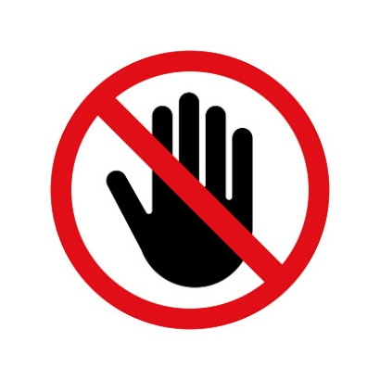
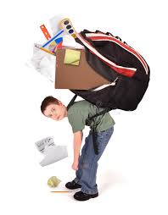
Only essentials should be brought into school and no unnecessary belongings e.g. pencil cases, toys etc.

Travelling to school:
- Parents and pupils are encouraged to walk to school where possible;
- Where this is not possible, use of private transport is recommended;
- If public transport has to be used parents and pupils are advised to follow social distancing rules and to wear a face covering when on public transport;
- Families who use public transport please read the following guidance:
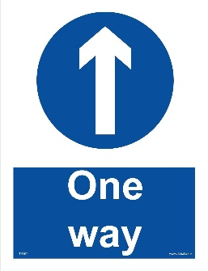
https://www.gov.uk/guidance/coronavirus-covid-19-safer-travel-guidance-for-passengers

Arrival at school:
WE HAVE A ONE-WAY SYSTEM IN PLACE. PLEASE FOLLOW THE SIGNS AND OBSERVE THE ONE-WAY SYSTEM
- One parent only to drop off/collect
- We have implemented new start/finish times (see important information section)
- Only arrive at your child’s allotted time. If you do arrive earlier, please do not congregate around the school gates/perimeter. Remain in your car if using private transport.
- KS1 children to enter playground through Beechway gate.
- KS1 Parents can escort child to designated drop off in the playground observing 2m social distancing.
- KS1 Parents to leave playground via the driveway gate.
- KS2 children and parents to enter playground through Holmefield Rd gate. They must follow the one-way system and walk past Little Acorns and also exit via the driveway gate on Beechway.
- The KS2 gate will be entry only and must not be used as an exit.
- The path between Little Acorns Nursery and the school hall/kitchen will be one-way. You can only walk from KS2 playground into KS1 playground- and not the other way. If you need to access KS2 playground from the KS1 playground you must walk around the perimeter of the school along Kennington Rd.
- The office will be closed to face to face contact. All messages should be passed on via telephone or email. Parents will not be allowed into the building.
- Please do not congregate around the school premises.
Collection from school:
Please observe social distancing whilst collecting your child.
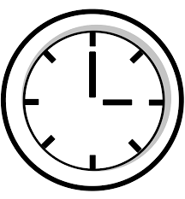

- Only arrive at the allotted pick up time. You must be on time (see important information section).

- KS1 Parents to enter the KS1 playground through Beechway gate and exit through the driveway gate.
- KS2 Parents should enter the KS2 playground via the Holmefield Rd gate. They must follow the one-way system and walk past Little Acorns and exit via the driveway gate on Beechway.
- The KS2 gate will be entry only and must not be used as an exit.
- Do not enter the playground before your allotted time.
- Please observe social distancing whilst collecting your child.
- Follow the one-way system and exit through the driveway gates.
- Due to the one-way system, all children will leave school via driveway gate on Beechway. We must avoid congestion at this exit point so please do not all try to park on Beechway. Park your car elsewhere around school and walk.
- Children in Reception and Years 1, 2, 3 and 4 must be collected within the school premises by an adult/responsible person. Children in Years 5 and 6 may walk to meet their parents outside the premises at a safe, pre-arranged place or walk home by themselves.

Arrival at home
- Children should wash their hands when they arrive at home.
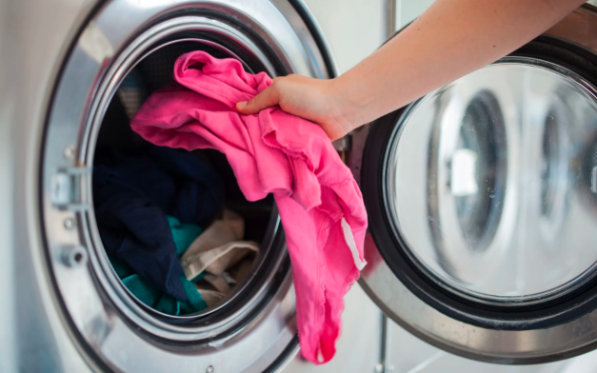
- It is recommended that the children get changed and the clothes are put in the wash.

* * IMPORTANT INFORMATION* *

Symptoms of Coronavirus
The main symptoms of coronavirus are:
- high temperature – this means you feel hot to touch on your chest or back (you do not need to measure your temperature)
- new, continuous cough – this means coughing a lot for more than an hour, or 3 or more coughing episodes in 24 hours (if you usually have a cough, it may be worse than usual)
- loss or change to your sense of smell or taste – this means you’ve noticed you cannot smell or taste anything, or things smell or taste different to normal

Coronavirus Testing

To arrange a test for your child, yourself or a family member, please use this link:
https://www.gov.uk/get-coronavirus-test
If you have problems using the online service, call 119 (Lines are open 7am to 11pm)
If the test result is positive, you must inform school immediately, and must isolate for at least 10 days from the onset of their symptoms (which could mean the self-isolation ends before or after the original 14-day isolation period). You are advised that your household should self-isolate for at least 14 days from when the symptomatic person first had symptoms.
If someone tests negative, if they feel well and no longer have any symptoms similar to those identified for coronavirus (COVID-19), they can stop self-isolating. They may still have another virus, such as a cold or flu, therefore it is still advisable to avoid contact with others until they recover. However other members of their household can stop self-isolating.

Face coverings
Government guidance states that children will not have to wear face coverings in school. This guidance is ‘led by science’ as within a school the children not with people that they don’t meet normally. They will see the same limited number of children and staff every day.
If children wear a face covering whilst travelling to school they must follow the these procedures upon entering school:
- Those removing face coverings are required to wash or sanitise their hands immediately when removing them on arrival at school;
- Reusable face coverings must be placed in a plastic bag that the wearer has brought with them and stowed in a safe place such as a school bag to be taken home;
- Children should be instructed not to touch the front of their face covering

COVID-19 - STAGGERED START/FINISH TIMES
Oak Class:
(These timings will commence at the end of the Induction period)
Start: 8.45- 8.55 - Oak classroom door
Finish: 3.00 - Oak classroom door
Cherry Class:
Start: 8.35- 8.45 – Small gate
Finish: 2.50 – Small gate
Willow Class:
Start: 8.35- 8.45 – KS1 door
Finish: 2.50 – KS1 door
Beech Class:
Start: 8.45- 8.55 – KS1 door
Finish: 3.00 – KS1 door
Year 3:
Start: 8.35- 8.45 - own classroom external door
Finish: 2.50 - own classroom external door
Year 4:
Start: 8.35- 8.45 - Main KS2 door
Finish: 2.50 - Main KS2 door
Year 5:
Start: 8.45- 8.55 – Small KS2 door (next Y3 classroom)
Finish: 3.00 - Small KS2 door (next Y3 classroom)
Year 6:
Start: 8.45- 8.55 - Main KS2 door
Finish: 3.00 - Main KS2 door

COVID-19
HOME SCHOOL AGREEMENT

The school will do its best to:

- Provide an environment which has been risk assessed in response to the COVID-19 infection.

- Adhere, where possible, to the social distancing rules as set out by the government as much as we reasonably can.

- Contact parents/carers if your child displays symptoms of COVID-19;

- Inform you if staff or children in your child’s ‘bubble’ test positive for COVID-19

- Continue our clear and consistent approach to rewards and sanctions for children as set out in the Behaviour Policy as well the expectations outlines in this agreement.

- Communicate between home and school through notices, newsletters, text and the school website.

To help my child at school, I know and understand that:
- If my child, or anyone in my household, shows symptoms of COVID-19, I will not send them to school, we will self-isolate for 14 days as a family.
- If my child shows symptoms of COVID-19 at school, I will collect my child from school immediately. I will get them tested and I will let the school know as soon as possible.
- When dropping my child off and picking them up, I will adhere to the 2 metre social distancing rules.
- When dropping off and picking up, I will strictly stick to the school timings for my child. NO CHILDREN WILL BE ALLOWED ON SITE UNTIL DOORS OPEN
- My child will not bring any unnecessary items into school with them or take items home from school.
- I will not be allowed into the school and will contact school via telephone or email.
- I need to support all staff in their efforts to create an ‘as safe as possible’ environment during this time.
- I will read all letters/messages/ emails that are sent home.
- I will inform the school of any changes to parents/carer and emergency contacts details.
- I will follow social distancing rules at all times.
- I will encourage my child to behave in a safe way.
- I UNDERSTAND THAT WITH CHILDREN, SOCIAL DISTANCING CAN NOT BE GUARANTEED

