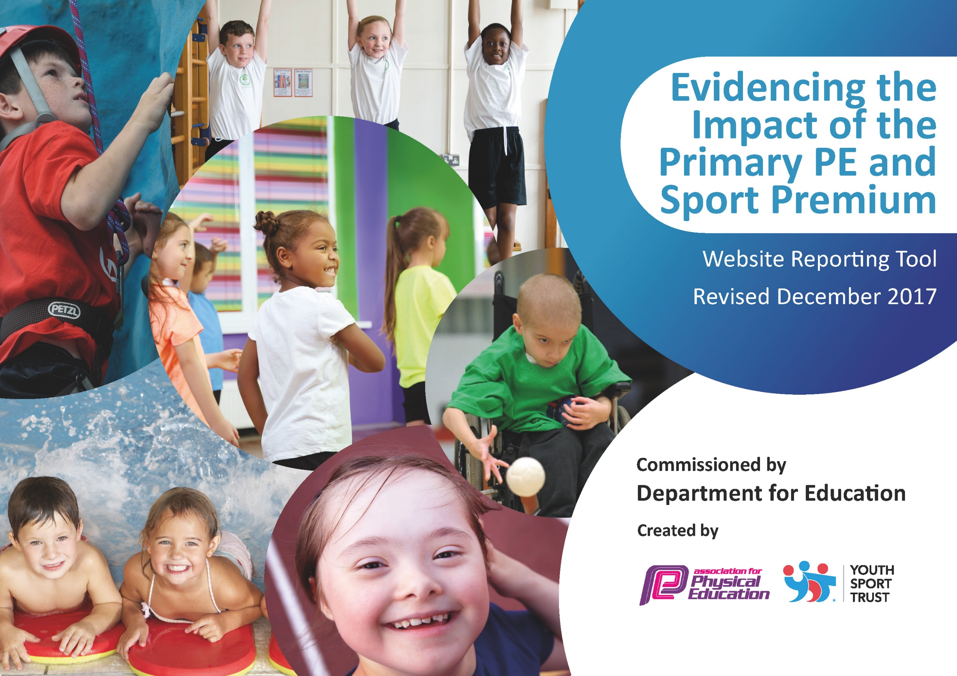

Meeting national curriculum requirements for swimming and water safety | Please complete all of the below*:
What percentage of your current Year 6 cohort swim competently, confidently and proficiently over a distance of at least 25 metres? | 68%
What percentage of your current Year 6 cohort use a range of strokes effectively [for example, front crawl, backstroke and breaststroke]? | 68%
What percentage of your current Year 6 cohort perform safe self-rescue in different water-based situations? | 68%
Schools can choose to use the Primary PE and Sport Premium to provide additional provision for swimming but this must be for activity over and above the national curriculum requirements. Have you used it in this way? | No

Academic Year: 2018/19 | Total fund allocated: £16,569.66 | Date Updated: 14.11.19
Key indicator 1: The engagement of all pupils in regular physical activity – Chief Medical Officer guidelines recommend that primary school children undertake at least 30 minutes of physical activity a day in school |  |  |  | Percentage of total allocation:
 |  |  |  | 28%
School focus with clarity on intended impact on pupils: | Actions to achieve: | Funding allocated: | Evidence and impact: | Sustainability and suggested next steps:
Introduce ways of improving physical activity in School  Increase participation in physical activity during playtimes and lunchtimes | JS to complete Wake-up, Shake-up training course in order to train staff as to how to deliver sessions each day in class.  New playground markings will be installed in both KS1 and KS2 playgrounds.  Support staff to be trained how to use the playground markings outside  Y5 play leaders to continue on the infant playground to increase participation in regular physical activity and games. | £0  £4575  £149 | All staff agreed to use SuperMovers at least once a day to engage children in physical activity.  Children have responded really well to the videos; almost all children are engaged.  Children are using the playground markings, which is having a positive impact on their physical activity.  Support staff have encouraged children to engage in games using the new playground markings each breaktime.  Training was given to the Year 5 children in order for them to be play leaders for KS1 children, using the new playground markings on the KS1 playground. | Children will gain an understanding of the importance of physical activity each day. More teaching is needed to embed the importance of regular physical activity.  Lots of physical activity should be going during breaktimes.
Key indicator 2: The profile of PE and sport being raised across the school as a tool for whole school improvement |  |  |  | Percentage of total allocation:
 |  |  |  | 0%
School focus with clarity on intended impact on pupils: | Actions to achieve: | Funding allocated: | Evidence and impact: | Sustainability and suggested next steps:
All sporting achievements to be celebrated each week in whole school assembly. Children will be proud of their achievements and strive to enter competitions to earn medals and certificates.  Sporting events and successes to be published on social media and in school to raise profile of PE and Sport for visitors, parents and pupils.  Local sporting personalities to be invited into school to engage children’s interest in sport. Each personality to act as role models for children to aspire to. | Children to be praised and celebrated for their successes and participation in school and out of school sport.  Notice board to be sourced and put up on junior corridor in school.  Twitter and the school website to be regularly updated with school sporting success and results.  PNE player(s) to be invited to school to talk to children. | £0  £0  £0  No additional cost | Celebration assemblies are devoted to praising childrens’ successes. Children enjoy being honoured for their participations and achievements.  Notice board has been fixed to the KS2 corridor permanently. Notice board was used to show individual and team achievements, notices and events.  Parents and children are becoming well informed about our sporting successes and results. This has risen the profile of school sport and highlighted the opportunities on offer for children.  One PNE footballer came into school to visit one of the classes. The children got a lot out of the day; really enjoyed meeting the player and interviewing him. The children came away feeling inspired to work hard in order to achieve their dream. | Celebration assemblies to continue each week in school, celebrating sporting achievement.  Children, parents and staff will have a good understanding of what clubs, competitions and sporting events are being.  All staff to continue to upload photos and results of sporting events.  PNE links to be maintained throughout next year.

Key indicator 3: Increased confidence, knowledge and skills of all staff in teaching PE and sport |  |  |  | Percentage of total allocation:
 |  |  |  | 59%
School focus with clarity on intended  impact on pupils: | Actions to achieve: | Funding  allocated: | Evidence and impact: | Sustainability and suggested  next steps:
Children to receive high quality PE lessons delivered with confidence and enthusiasm by staff members.  Assessment of Childrens’ progress in PE and Sport to be improved. | PNE will be employed to train teaching staff on areas of weakness. Teachers to be trained as to how to deliver high quality teaching and learning of PE.  JS to attend course on delivering badminton coaching in PE lessons. JS to run a badminton staff meeting.  Assessment of PE to be reviewed by JS. Teaching, learning and assessment of PE tool to be bought to improve quality of assessment whilst reducing workload on teachers. | £9200  £40  £539 | Staff are confident at teaching games in the PE curriculum. High quality PE lessons have ensured the enjoyment and the participation of all children in school.  Staff meeting was held; giving staff a greater understanding of badminton as a sport and how it can be used to teach the skills needed in net and wall activities.  Staff are beginning to upload evidence of children in their PE lessons. | Staff will continue to liaise with PNE staff to ensure all parts of the Curriculum is taught well.  All KS2 staff will teach badminton as part of their Net and Wall skills and learning in PE.  The PE App will allow staff to monitor progress of children according to skills taught in PE lessons. A summative Assessment will be carried out at the end of each half term to assess a child’s progress.
Key indicator 4: Broader experience of a range of sports and activities offered to all pupils |  |  |  | Percentage of total allocation:
 |  |  |  | 9%
School focus with clarity on intended  impact on pupils: | Actions to achieve: | Funding  allocated: | Evidence and impact: | Sustainability and suggested  next steps:
Children to be given the opportunity to try new sports delivered by outside agencies.  Children to try out a new sport or activity | Judo club to be offered to children of all ages.  JS to run a School Games Day in which children can be given the opportunity to try a new sport. New equipment to be purchased.  JS to attend badminton teaching course in order to start a new badminton club.  New badminton equipment to be purchased in order to start club in September.  Miltarycation Ltd to teach children basic survival skills and bushcraft. | £0  £100  £30  £200  £1200 | 18 children attended Judo club in school. Almost all children were playing the sport for the first time.  School games day was completed.  The club was a great success. Less active children signed up to the club and attended for 8 weeks. Children enjoyed learning the new sport and were able to compete in a badminton festival with another local school.  KS2 Classes have used the badminton equipment in Net and Wall games in the hall.  All of Year 5 participated in the activities. Life lessons were learnt and children gained new experiences. | Judo club to continue offering the club to pupils each year.  Children will continue to focus on the core values of the School Games throughout all sport in school.  Skills should be clearly improved across KS2.  New opportunites will be looked at to give more children new experiences.
Key indicator 5: Increased participation in competitive sport |  |  |  | Percentage of total allocation:
 |  |  |  | 4%
School focus with clarity on intended  impact on pupils: | Actions to achieve: | Funding  allocated: | Evidence and impact: | Sustainability and suggested  next steps:
Children to be given opportunities to represent school in competition. | Calendar to be shared with staff at the beginning of each term. All staff to take at least one team per term.  Clubs to be put on in the lead up to tournaments. | £565  £0 | All staff have shared the workload of taking teams to competitions. Lots of children across school have represented school in sport. SEN and less active children were entered into inclusive events.  A wide range of sports clubs have been on offer to children in KS1 and KS2. | This will be maintained next year to allow more children to participate and compete for school.

