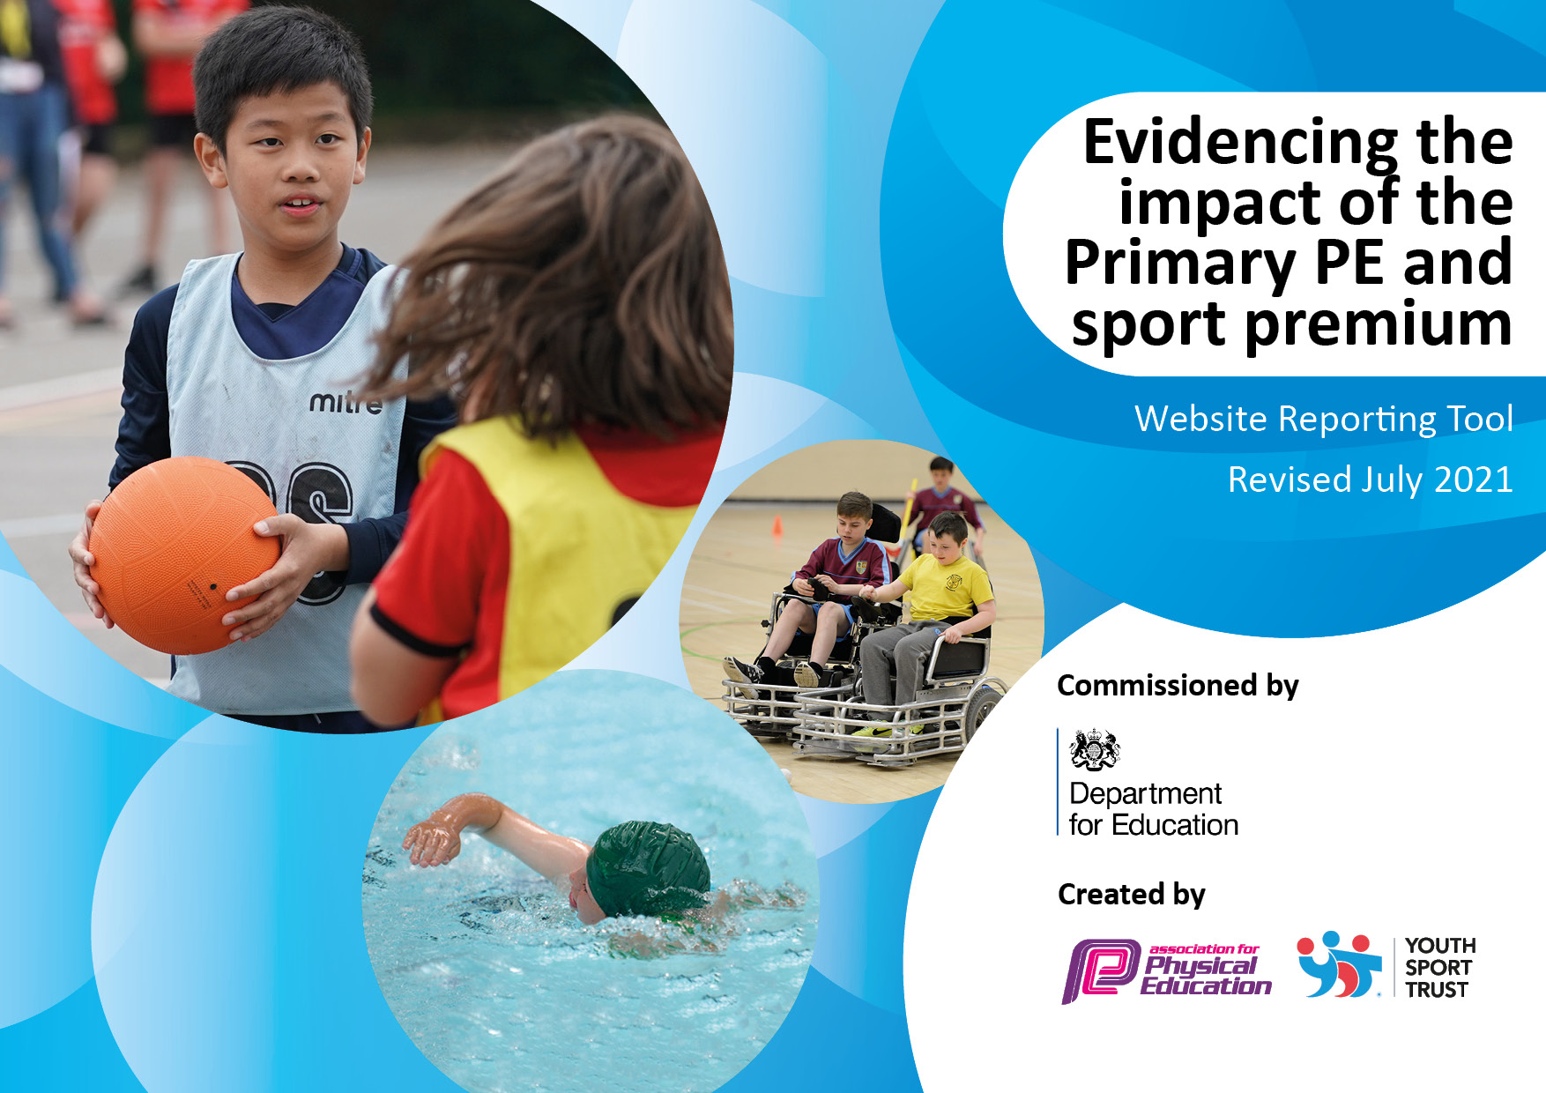
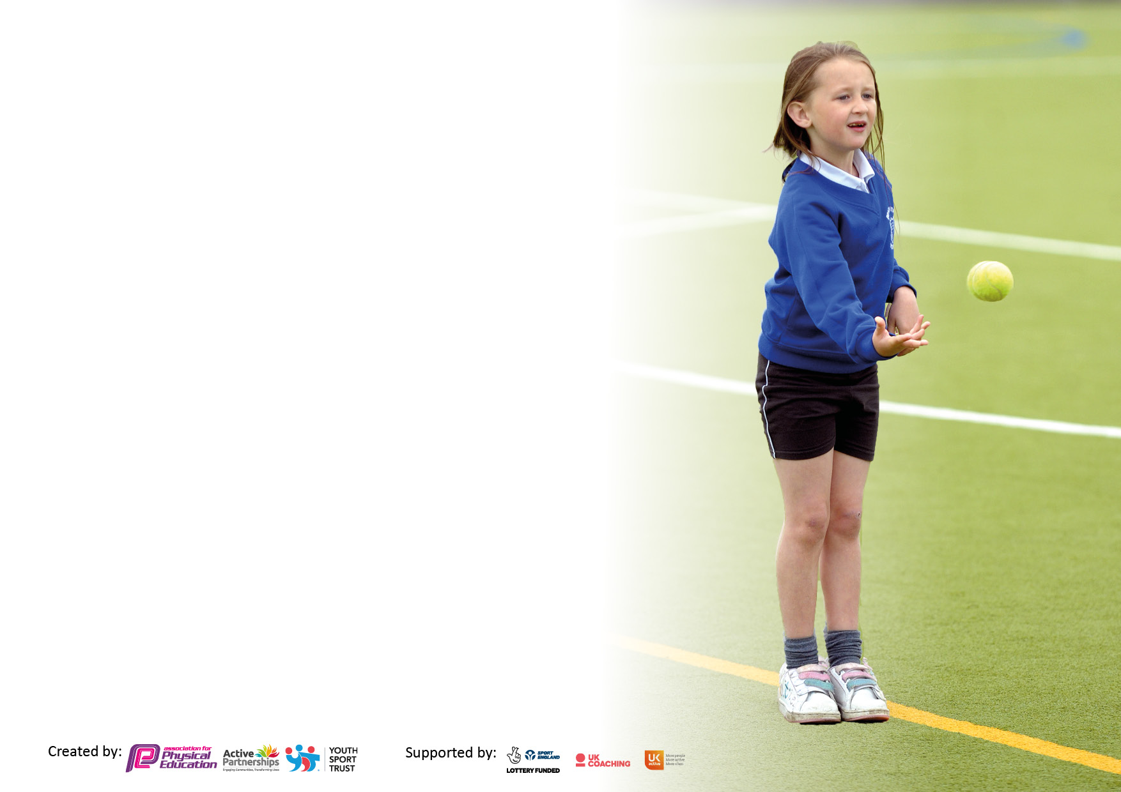

It is important that your grant is used effectively and based on school need. The Education Inspection Framework makes clear there will be a focus on ‘whether leaders and those responsible for governors all understand their respective roles and perform these in a way that enhances the effectiveness of the school’.

Under the Quality of Education Ofsted inspectors consider:
Intent - Curriculum design, coverage and appropriateness
Implementation - Curriculum delivery, Teaching (pedagogy) and Assessment
Impact - Attainment and progress

To assist schools with common transferable language this template has been developed to utilise the same three headings which should make your plans easily transferable between working documents.

Schools must use the funding to make additional and sustainable improvements to the quality of Physical Education, School Sport and Physical Activity (PESSPA) they offer. This means that you should use the Primary PE and sport premium to:

- Develop or add to the PESSPA activities that your school already offer
- Build capacity and capability within the school to ensure that improvements made now will benefit pupils joining the school in future years
- The Primary PE and sport premium should not be used to fund capital spend projects; the school’s budget should fund these.

Pleasevisitgov.ukfortherevisedDfEguidanceincludingthe5keyindicatorsacrosswhichschoolsshoulddemonstrate animprovement.Thisdocumentwillhelpyoutoreviewyourprovisionandtoreportyourspend.DfEencouragesschools to use this template as an effective way of meeting the reporting requirements of the Primary PE and sport premium.

We recommend you start by reflecting on the impact of current provision and reviewing the previous spend.

Schools are required to publish details of how they spend this funding, including any under-spend from 2020/2021, as well as on the impact it has on pupils’ PE and sport participation and attainment. All funding must be spent by 31st July 2022.

We recommend regularly updating the table and publishing it on your website throughout the year. This evidences your ongoing self-evaluation of how you are using the funding to secure maximum, sustainable impact. Final copy must be posted on your website by the end of the academic year and no later than the 31st July 2022. To see an example of how to complete the table please click HERE.
Created by: Supported by:

Details with regard to funding
Please complete the table below.

Total amount carried over from 2021-2022 | £10,314
Total amount allocated for 2022/2023 | £18,100
How much (if any) do you intend to carry over from this total fund into 2023/24? | £16,689
Total amount allocated for 2023/24 | £18,100
Total amount of funding for 2023/24. To be spent and reported on by 31st July 2024. | £34,789
Swimming Data
Please report on your Swimming Data below.

Meeting national curriculum requirements for swimming and water safety.

N.B. Complete this section to your best ability. For example you might have practised safe self-rescue techniques on dry land which you can then transfer to the pool when school swimming restarts.
Due to exceptional circumstances priority should be given to ensuring that pupils can perform safe self rescue even if they do not fully meet the first two requirements of the NC programme of study
What percentage of your current Year 6 cohort swim competently, confidently and proficiently over a distance of at least 25 metres?  N.B. Even though your pupils may swim in another year please report on their attainment on leaving primary school at the end of the summer term 2022.  Please see note above | 24% (8 out of 34)
What percentage of your current Year 6 cohort use a range of strokes effectively [for example, front crawl, backstroke and breaststroke]?  Please see note above | 24% (8 out of 34)
What percentage of your current Year 6 cohort perform safe self-rescue in different water-based situations? | 24% (8 out of 34)
Schools can choose to use the Primary PE and sport premium to provide additional provision for swimming but this must be for activity over and above the national curriculum requirements. Have you used it in this way? | No

Action Plan and Budget Tracking
Capture your intended annual spend against the 5 key indicators. Clarify the success criteria and evidence of impact that you intend to measure to evaluate for pupils today and for the future.

Academic Year: 2022/23 | Total fund allocated: | Date Updated: July 2023
Key indicator 1: The engagement of all pupils in regular physical activity – Chief Medical Officers guidelines recommend that primary school pupils undertake at least 30 minutes of physical activity a day in school |  |  |  | Percentage of total allocation:
 |  |  |  | %
Intent | Implementation |  | Impact
Your school focus should be clear what you want the pupils to know and be able to do and about  what they need to learn and to  consolidate through practice: | Make sure your actions to achieve are linked to your intentions: | Funding allocated: | Evidence of impact: what do pupils now know and what can they now do? What has changed?: | Sustainability and suggested next steps:
To provide children with further opportunities to engage in regular physical activities, resulting in increased fitness and enjoyment levels amongst children.  To increase the physical activity, stamina and confidence of SEN children in school. To develop resilience amongst our SEN children. | -Purchase new playtime equipment to engage children with physical activities during playtimes.  -Marker flags to be purchased to mark of areas on the field for children to play in  -Maple group (SEN class) to receive expert coaching in swimming throughout the year.  -Cycling and scootering to school will be encouraged to increase physical activity and new bike racks will be purchased and installed to encourage children to be active.  -Play leaders in Y5 to be chosen and trained, in order to engage KS1 children in physical activity. | £721.71  £72.79  £600  £0 | -EYFS, KS1 and KS2 equipment is being used on a daily basis. The new equipment is engaging and exciting for children to use, therefore many children are active during the day.  -Maple group have attended swimming lessons for a full term. The children have grown in confidence and their swimming capabilities and independence has greatly improved.  -Many children are coming to school on bikes and scooters and using the bike racks available.  -A small group of Y5 children were selected to engage KS1 children with football skills, increasing their physical activity during playtimes. Most children in KS1 accessed this opportunity. | -Mr Sudell and school leaders will continue to look for ways to provide opportunities for children to engage in physical activity.  -Maple group will continue to go swimming in the next Autumn term, to give more children opportunities to partake in the activity and to build upon previous successes.  -Cycling and scootering to school will continue to be encouraged in the future.  -Mr Sudell and school leaders will continue to look for ways to provide opportunities for play leaders to be developed further.
Key indicator 2: The profile of PESSPA being raised across the school |  |  |  | Percentage of total allocation:
 |  |  |  | %
Intent | Implementation |  | Impact
Your school focus should be clear what you want the pupils to know and be able to do and about  what they need to learn and to  consolidate through practice: | Make sure your actions to achieve are linked to your intentions: | Funding allocated: | Evidence of impact: what do pupils now know and what can they now do? What has changed?: | Sustainability and suggested next steps:
Achievements in PE to be recognised and celebrated.  Introduce new team competitions where children get to represent their team in a given sport  To ensure children are given the opportunity to develop their own character during a PE lesson. The intent is for all children to achieve a sense of success during every PE lesson, regardless of their sporting or physical ability. | -Children who represent school in competition will be acknowledged in assemblies by giving out trophies, medals or certificates to participants  -Children who represent school in sport will be recognised by naming participants in the school newsletter to celebrate any outstanding performances or just general participation  -Mr Pritchard to set up team competitions with the support of team captains. Children to compete in kurling, dodgeball and tri-golf.  -Teachers to identify children in their classes to target during their lessons  -Teachers to emphasise the character value, highlighted in their lesson plan on the PE Passport app.  -Identify resources suitable to support character development in PE. | £0 | -Children are aware of the opportunities available in school and value participating in school sport competitions  -Children have been enthusiastic about representing their teams. Lots of character values have been on display and team captains have stepped up to leading their teams. Nearly all children in school from Year 1 and above have had the opportunity to compete in at least 1 sport.  -Lots of evidence to suggest children have has opportunities to develop their character, but it is difficult to quantify, until child voice is taken into account. | The sports display board will be refreshed, placing a bigger emphasis on the character values needed to participate in sports, as well as communicating school sports events, teams and successes.  -The success of intra-sports competitions will continue next year, and winning teams will continue to receive a badge on the team competition board in school.  -The idea of character in the PE curriculum will be developed next year and written into the school’s development plan.

Key indicator 3: Increased confidence, knowledge and skills of all staff in teaching PE and sport |  |  |  | Percentage of total allocation:
 |  |  |  | %
Intent | Implementation |  | Impact
Your school focus should be clear | Make sure your actions to | Funding | Evidence of impact: what do | Sustainability and suggested
what you want the pupils to know | achieve are linked to your | allocated: | pupils now know and what | next steps:
and be able to do and about | intentions: |  | can they now do? What has
what they need to learn and to |  |  | changed?:
consolidate through practice:
-Give staff the tools they need to assess PE lessons well. This will allow teachers to identify gaps, which will inform their planning and intervention, resulting in children making better progress and being more knowledgeable of the subject.  To increase the knowledge and confidence of staff when teaching PE, particularly in Dance and Gymnastics. The intent is to give children opportunity to access high quality lessons in which they can increase in the knowledge and attainment of dance and gymnastics.  To increase the knowledge and confidence of staff in early years and Year 4, resulting in children accessing higher quality PE lessons.  Children to be given access to audio and videos required for high quality PE lessons. | -The focus of a staff meeting will be assessing children in PE. An assessment structure will be agreed with staff and implemented  -Provide staff with ongoing support and exposure to high quality Gymnastics lessons, delivered by PNE coaches  -Identify more CPD opportunities for staff  -Ensure teaching staff are aware of the curriculum outcomes for their year group  -Mrs Harris to attend a full day course with Jess Squires, leading expert in PE education.  -Miss O’Brien to attend tennis CPD, to support her with the net and wall unit of the curriculum  -Purchase a new projector and PA system so staff and children can have access high quality visual and audio resources available, leading to higher quality PE lessons.  -Purchase a portable music player, for use in PE lessons outdoors and on the field. | £699  £6500  £189  £0  £3419 | -Mr Sudell delivered a staff meeting on how to use the Primary PE Passport app appropriately and talked staff through assessment practice in PE. Staff feedback suggested that it had a positive impact on their confidence of teaching and assessing children in PE. This should have a great impact on identifying children with gaps in their knowledge, leading to immediate intervention and support given for selected children.  -Staff and children have given positive feedback about Dance lessons and all children have engaged well in all lessons delivered by PNE staff and Kennington staff.  Feedback from staff highlighted the huge impact these courses have had on their teaching and understanding of PE in their respective year groups. Mrs Harris is using a wider range of resources to get the most out of her lessons and she has shared her best practise with other staff.  -All staff use the projector and PA system regularly in PE lessons, which has greatly improved the quality of teaching and learning, particularly in dance lessons, where music is an essential tool to influence movement.  A portable music player and new sound system has been purchased to improve the quality of music used for Dance and PE in general. | -The PE Passport app will continue to be used to make recordings of lessons and will be used to identify gaps and support needed for future planning within the subject.  -PNE dance and gymnastics coaches will continue to be employed for next year to continue developing Kennington staff’s confidence in teaching dance and gymnastics, resulting in greater knowledge and attainment in those curriculum areas.  -Mr Sudell will look into booking other staff on Lancashire’s courses to support with the delivery of the PE curriculum.  The new equipment should last a long time in school, and will continue to be used to improve the quality of teaching and learning.
Key indicator 4: Broader experience of a range of sports and activities offered to all pupils |  |  |  | Percentage of total allocation:
 |  |  |  | %
Intent | Implementation |  | Impact
Your school focus should be clear | Make sure your actions to | Funding | Evidence of impact: what do | Sustainability and suggested
what you want the pupils to know | achieve are linked to your | allocated: | pupils now know and what | next steps:
and be able to do and about | intentions: |  | can they now do? What has
what they need to learn and to |  |  | changed?:
consolidate through practice:
To give children across both Key Stages an opportunity to engage in new sports, either in school or after school. Children will be fully engaged and active during PE lessons and after school sports clubs, demonstrating an enjoyment and confidence. | -After school club calendar is up to date and maintained  -The curriculum overview will need to be updated to reflect a broad range of sports exposure across all Key Stages  -Pupil Voice meetings will need to take place to gauge what sports children are unfamiliar with.  -Skilled coaches will be bought in to offer new experiences for all children. | £0 | -A range of sports have been selected for Kennington’s curriculum overview, to reflect the lack of opportunities given to Kennington children outside of school.  - Kennington entered many tournaments on offer to give the children a chance to compete with other schools in sport. This was highly successful with the support of our committed staff team. | Exposure to a range of sports will be continued into the next action plan for 2023-2024  Child voice needs to be made a priority for children to express which sports they would like to experience for next year.

Key indicator 5: Increased participation in competitive sport |  |  |  | Percentage of total allocation:
 |  |  |  | %
Intent | Implementation |  | Impact
Your school focus should be clear | Make sure your actions to | Funding | Evidence of impact: what do | Sustainability and suggested
what you want the pupils to know | achieve are linked to your | allocated: | pupils now know and what | next steps:
and be able to do and about | intentions: |  | can they now do? What has
what they need to learn and to |  |  | changed?:
consolidate through practice:
-To give every child in school the opportunities to participate in competitive sport. | -The school will enter all competitions available from DB Sports and PPPSC.  -A record of children who represent school will be kept, to monitor which children have represented school.  -A range of sports clubs will be available to children so they can participate in competitions outside of school time. | £140 | -Children from every year group represented school in competition. Children were proud to be selected to represent school. | -Continue to record which children have represented school using the Lancashire PE Passport app, to ensure different groups of children are given the opportunity to participate in competitive sport.

Signed off by
Head Teacher:
Date:
Subject Leader: | J.Sudell
Date: | 31.7.23
Governor:
Date:

