Kennington’s Y3/4 Book List –

Read as many books as you can to earn yourself bronze, silver and gold rewards!

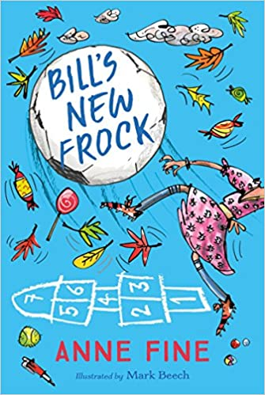  Bill’s New Frock – Anne Fine (4.3)  Date Finished: | 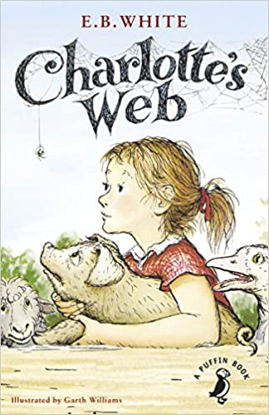  Charlotte’s Web – E.B. White (4.4)  Date Finished: | 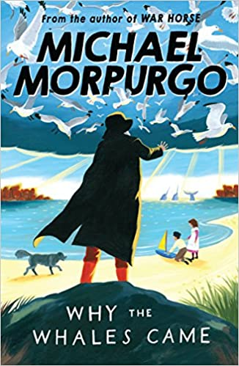  Why the Whales Came – Michael Morpurgo (5.2)  Date Finished: | 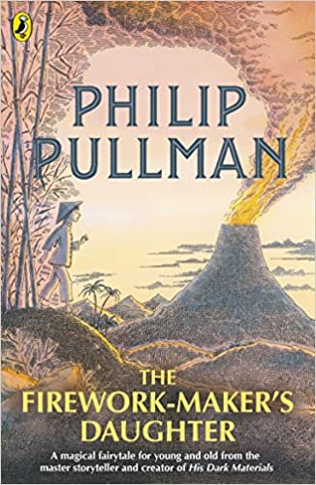  The Firework-Maker’s Daughter – Philip Pullman (5.3)  Date Finished:
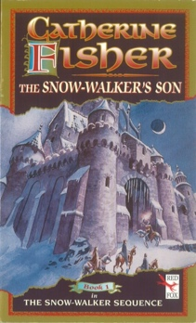  The Snow-Walker’s Son – Catherine Fisher (4.4)  Date Finished: | 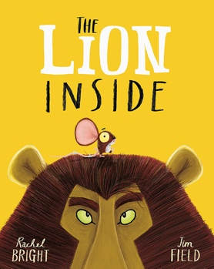  The Lion Inside – Rachel Bright (3.1)  Date Finished: | 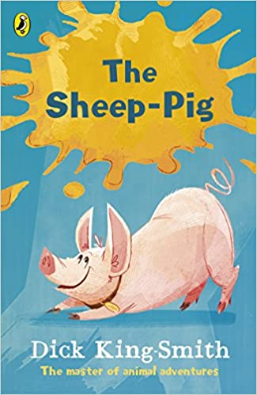  The Sheep – Pig – Dick King Smith (5.6)  Date Finished: | 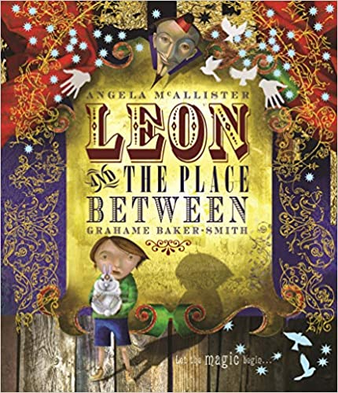  Leon and the Place Between - Angela McAllister (3.0)  Date Finished:
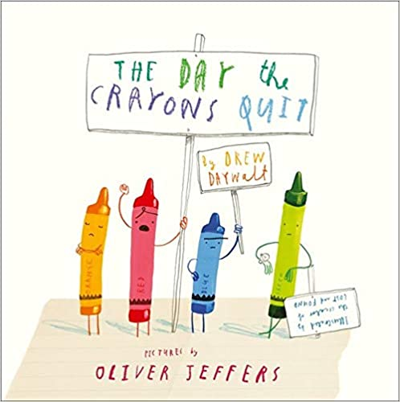  The Day the Crayons Quit - Drew Daywalt (3.8)  Date Finished: | 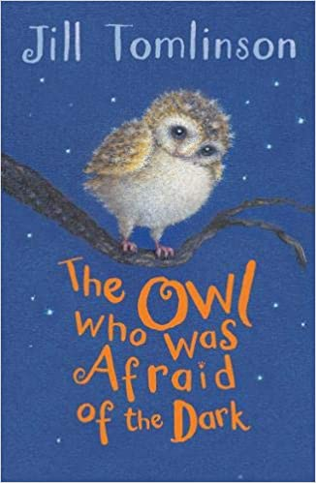  The Owl Who Was Afraid of the Dark – Jill Tomlinson (3.6)  Date Finished: | 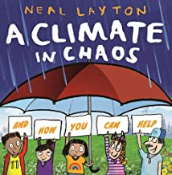  A Climate in Chaos – Neal Layton  Date Finished: | 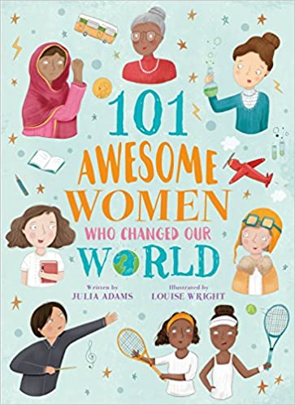  101 Awesome Women Who Changed Our World  Date Finished:

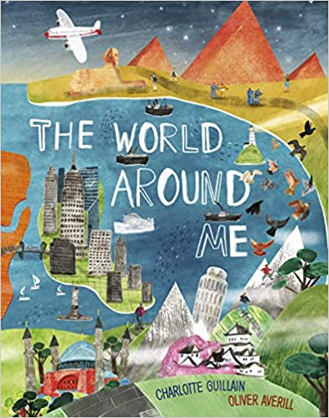  The World Around Me – Charlotte Guilian  Date Finished: | 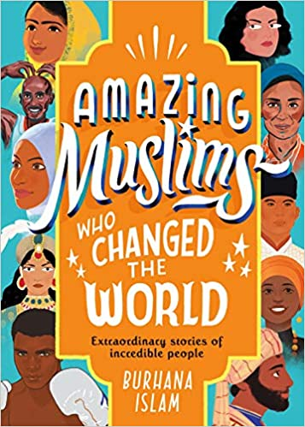  Amazing Muslims Who Changed the World – Burhana Islam  Date Finished: | 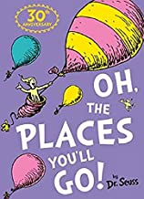  Oh, The Places You'll Go! - Dr Seus (3.3)  Date Finished: | 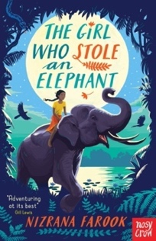  The Girl Who Stole an Elephant - Nizrana Farook (4.3)  Date Finished:
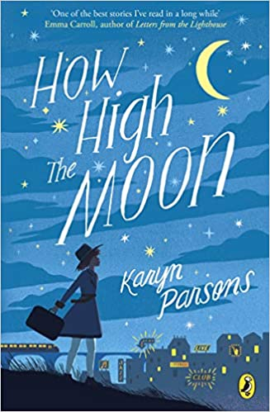  How High the Moon – Karyn Parsons (4.5)  Date Finished: | 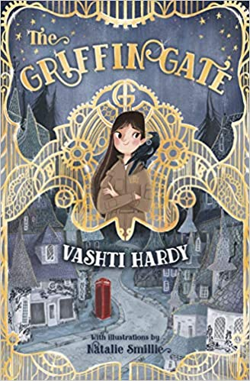  The Griffin Gate – Vashti Hardy (4.5)  Date Finished: | 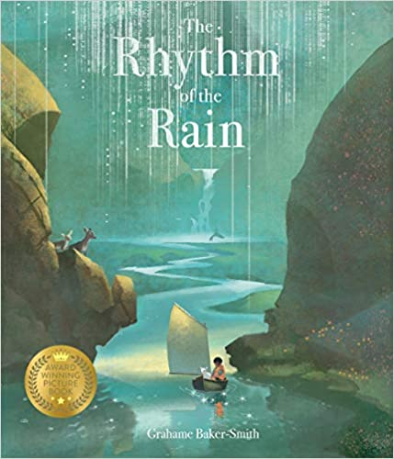  The Rhythm of the Rain – Grahame Baker Smith  Date Finished: | 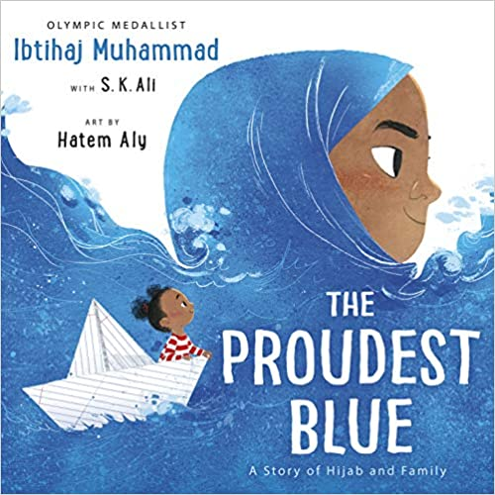  The Proudest Blue – Ibtihaj Muhammad (2.3)  Date Finished:
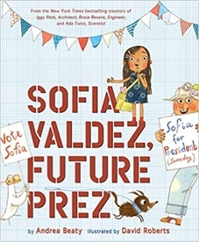  Sofia Valdez, Future Prez – Andrea Beaty (3.7)  Date Finished: | 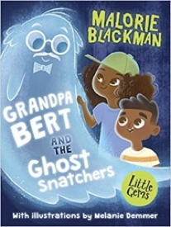  Grandpa Bert and the Ghost Snatchers – Malorie Blackman (3.2)  Date Finished: | 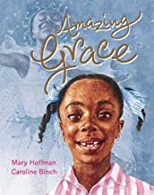  Amazing Grace – Mary Hoffman (3.5)  Date Finished: | 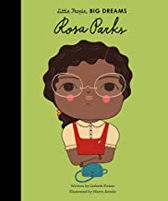  Rosa Parks – Lisbeth Kaiser (4.6)  Date Finished:
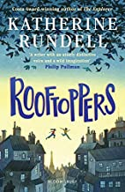  Rooftoppers – Katherine Rundell (3.5)  Date Finished: | 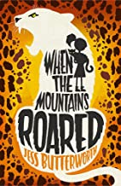  When the Mountains Roared – Jess Butterworth (4.2)  Date Finished: | 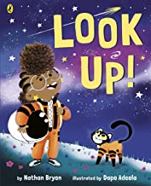  Look Up! – Nathan Byron (3.5)  Date Finished: | 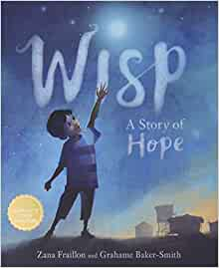  Wisp: A Story of Hope – Zana Fraillon (3.5)  Date Finished:
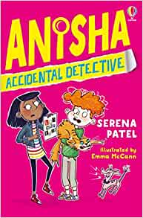  Anisha: Accidental Detective – Serena Patel (4.8)  Date Finished: | 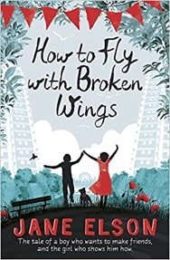  How to Fly with Broken Wings – Jane Elson (4.7)  Date Finished: | 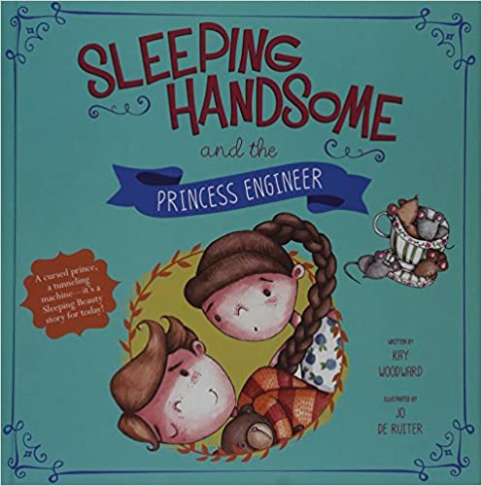  Sleeping Handsome and the Princess Engineer – Kay Woodward (3.0)  Date Finished: | 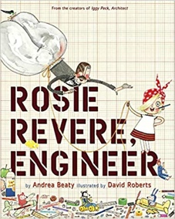  Rosie Revere, Engineer – Andrea Beaty (4.2)  Date Finished:
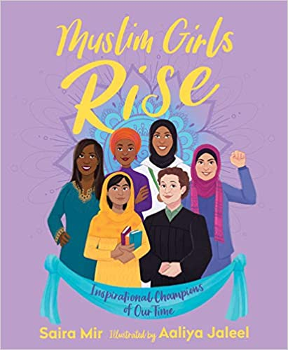  Muslim Girls Rise: Inspirational Champions of Our Time – Saira Mir  Date Finished: | 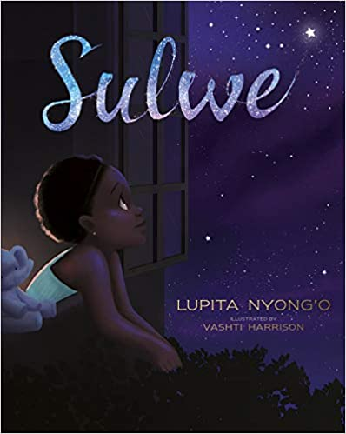  Sulwe – Lupita Nyong (3.4)  Date Finished: | 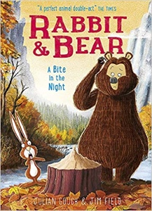  A Bite in the Night – Julian Gough (4.6)  Date Finished: | 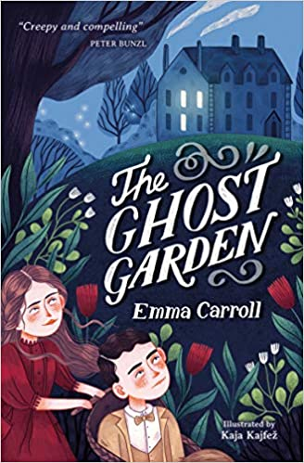  The Ghost Garden – Emma Carroll (4.6)  Date Finished:
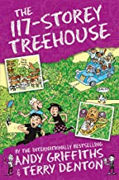  The 117-Storey House Treehouse – Andy Griffiths (3.4)  Date Finished: | 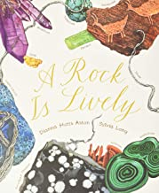  A Rock is Lively – Dianna Hutts Aston  Date Finished: | 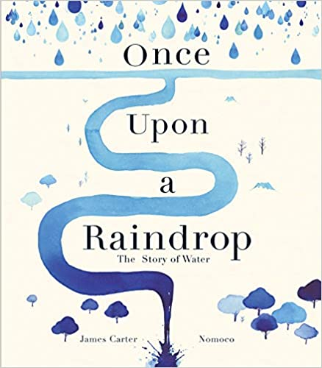  Once Upon a Raindrop: The Story of Water – James Carter  Date Finished: | 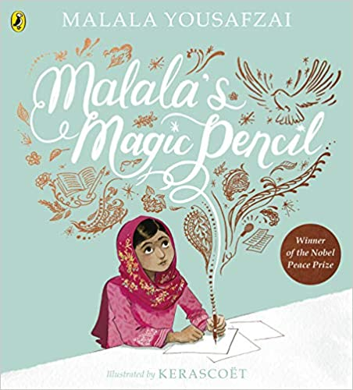  Malala’s Magic Pencil – Malala Yousafzai (3.6)  Date Finished:
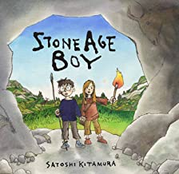  Stone Age Boy – Satoshi Kitamura (3.5)  Date Finished: | 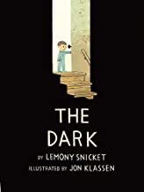  The Dark – Lemony Snicket (3.1)  Date Finished: | 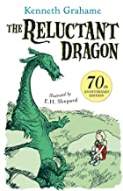  The Reluctant Dragon – Kenneth Grahame (2.6)  Date Finished: | 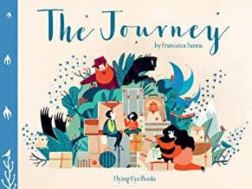  The Journey – Francesca Sanna (3.2)  Date Finished:
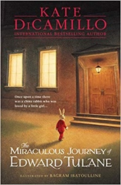  The Miraculous Journey of Edward Tulane – Kate DiCamillo (4.4)  Date Finished: | 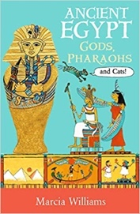  Ancient Egypt Gods, Pharaohs and Cats – Marcia Williams (4.5)  Date Finished: | 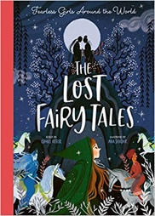  The Lost Fairytales: Fearless Girls Around the World – Isabel Otter  Date Finished: | 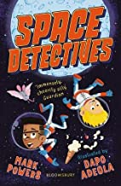  Space Detectives – Mark Powers (4.9)  Date Finished:
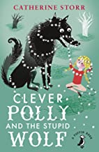  Clever Polly and the Stupid Wolf – Catherine Storr (4.5)  Date Finished: | 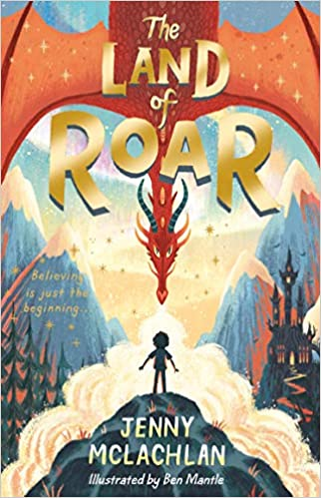  The Land of Roar – Jenny McLachlan (4.8)  Date Finished: | 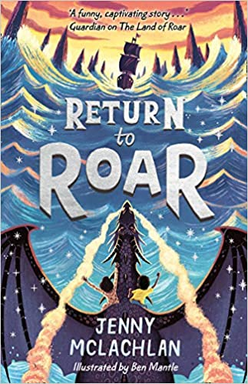  Return to Roar – Jenny McLachlan (4.7)  Date Finished: | 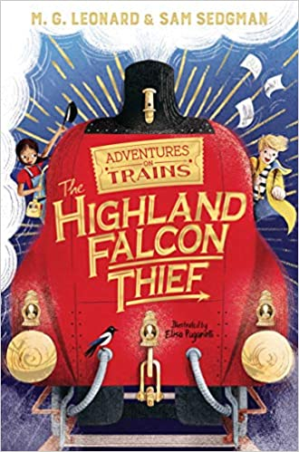  The Highland Falcon Thief – M.G. Leonard (4.7)  Date Finished:
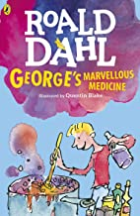  George’s Marvellous Medicine (4.0) – Roald Dahl  Date Finished: | 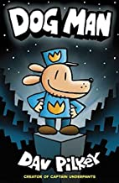  Dog Man – Dav Pilkey (2.6)  Date Finished: | 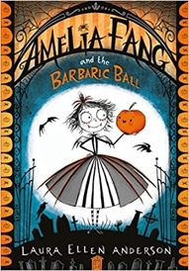  Amelia Fang and the Barbaric Ball – Laura Ellen Anderson (4.4)  Date Finished: | 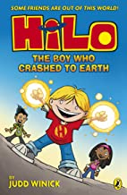  HiLo: The Boy Who Crashed to Earth – Judd Winick (2.3)  Date Finished:
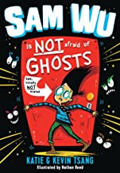  Sam Wu is NOT Afraid of Ghosts – Katie Tsang (3.7)  Date Finished: | 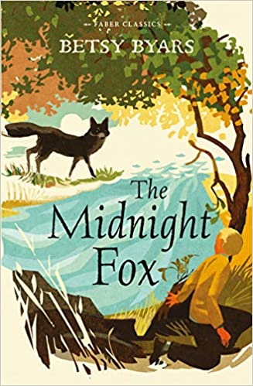  The Midnight Fox – Betsy Byars (4.9)  Date Finished: | 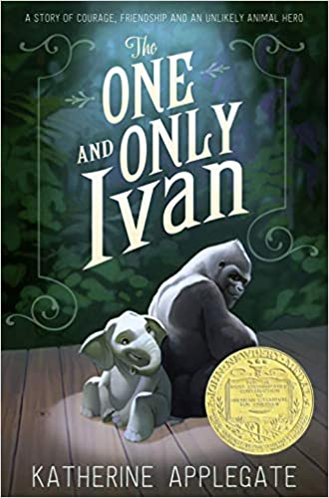  The One and Only Ivan – Katherine Applegate (3.6)  Date Finished: | 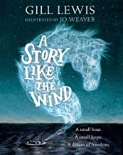  A Story Like The Wind – Gill Lewis (4.6)  Date Finished:
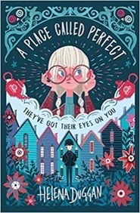  A Place Called Perfect – Helena Duggan (5.0)  Date Finished: | 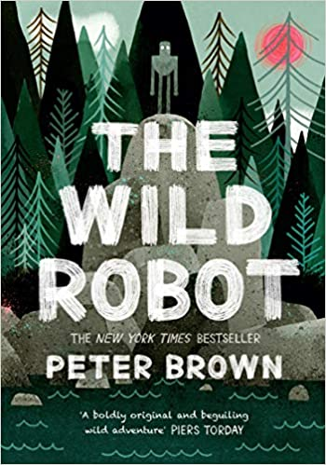  The Wild Robot – Peter Brown (5.1)  Date Finished: | 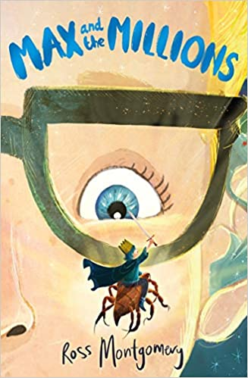  Max and the Millions – Ross Montgomery (4.4)  Date Finished: | 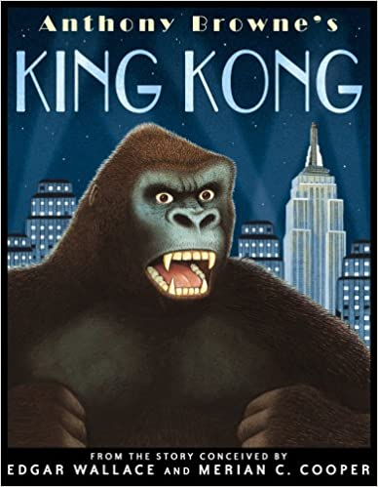  King Kong – Anthony Browne (4.4)  Date Finished:
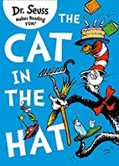  The Cat in the Hat – Dr Seuss (2.1)  Date Finished: | 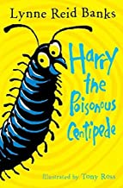  Harry and the Poisonous Centipede – Lynne Reid Banks (3.7)  Date Finished: | 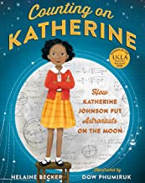  Counting on Katherine – Helaine Becker  Date Finished: | 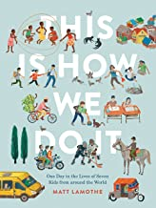  This Is How We Do It – Matt Lamothe  Date Finished:
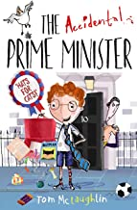  The Accidental Prime Minister – Tom McLaughlin (4.6)  Date Finished: | 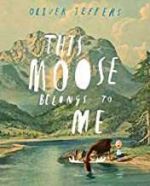  This Moose Belongs to Me – Oliver Jeffers (3.1)  Date Finished: | 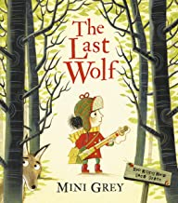  The Last Wolf – Mini Grey (3.7)  Date Finished: | 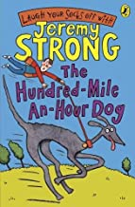  The Hundred-Mile-An-Hour Dog – Jeremy Strong (4.8)  Date Finished:
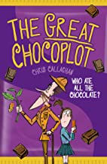  The Great Chocoplot – Chris Callaghan (5.5)  Date Finished: | 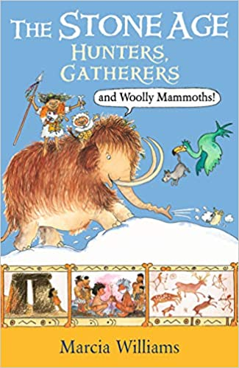  The Stone Age Hunters, Gatherers and Woolly Mammoths – Marcia Williams  Date Finished: | 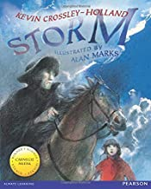  Storm – Kevin Crossley-Holland (4.1)  Date Finished: | 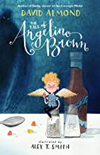  The Tale of Angelino Brown – David Almond (3.8)  Date Finished:
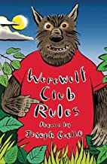  Werewolf Club Rules! – Joseph Coelho  Date Finished: | 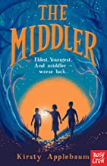  The Middler – Kirsty Applebaum (3.3)  Date Finished: | 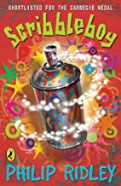  Scribbleboy – Philip Ridley (3.4)  Date Finished: | 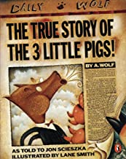  The True Story of the Three Little Pigs – Jon Scieszka (3.0)  Date Finished:
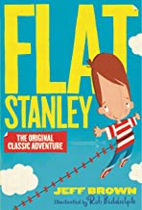  Flat Stanley – Jeff Brown (4.2)  Date Finished: | 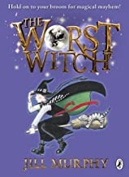  The Worst Witch – Jill Murphy (5.4)  Date Finished: | After the War: From Auschwitz to Ambleside – Tom Palmer (4.8)  Date Finished: | 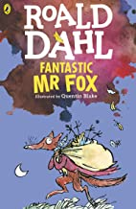  Fantastic Mr Fox – Roald Dahl (4.1)  Date Finished:
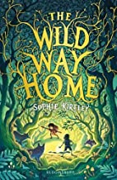  The Wild Way Home – Sophie Kirtley (4.2)  Date Finished: | 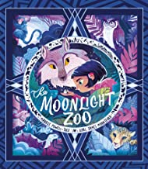  The Moonlight Zoo – Maudie Powell-Tuck (3.0)  Date Finished: | 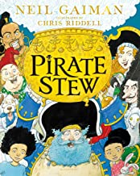  Pirate Stew – Neil Gaiman (3.4)  Date Finished: | 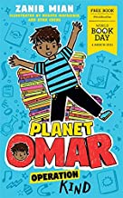  Planet Omar: Operation Kind – Zanib Mian (4.5)  Date Finished:
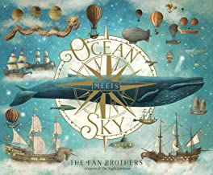  Ocean Meets the Sky – Terry Fan (2.3)  Date Finished: | 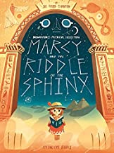  Marcy and the Riddle of the Sphinx – Joe Todd Stanton  Date Finished: | 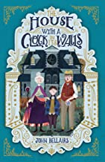  The House with a Clock in its Walls – John Bellairs (5.0)  Date Finished: | 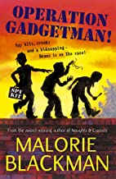  Operation Gadgetman – Malorie Blackman (4.1)  Date Finished:
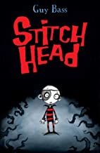  Stitch Head – Guy Bass (4.6)  Date Finished: | 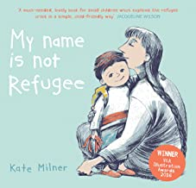  My Name is Not Refugee – Kate Milner  Date Finished: | 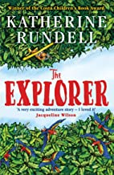  The Explorer – Katherine Rundell (4.5)  Date Finished: | 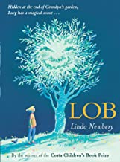  LOB – Linda Newberry (4.2)  Date Finished:
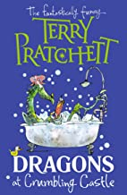  Dragons at Crumbling Castle – Terry Pratchett (5.5)  Date Finished: | 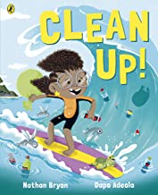  Clean Up! – Nathan Byron  Date Finished: | 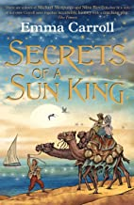  Secrets of a Sun King – Emma Carroll (5.0)  Date Finished: | 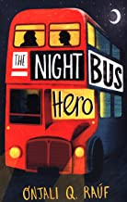  The Night Bus Hero – Onjali Q. Rauf (5.3)  Date Finished:
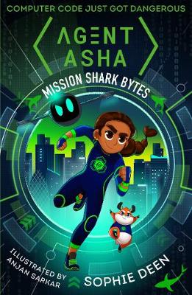  Agent Asha: Mission Shark Bytes – Sophie Deen (5.4)  Date Finished: | 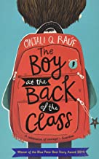  The Boy at the Back of the Class – Onjali Q Rauf (5.4)  Date Finished:

