Kennington’s Y5/6 Book List –

Read as many books as you can to earn yourself bronze, silver and gold rewards!

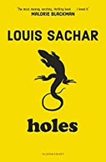  Holes – Louis Sachar (4.6)  Date Finished: | 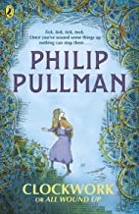  Clockwork or All Wound Up – Philip Pullman (5.7)  Date Finished: | 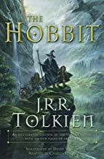  The Hobbit – J.R.R. Tolkein (6.6)  Date Finished: | 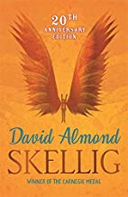  Skellig – David Almond (3.5)  Date Finished:
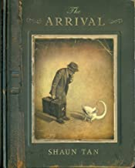  The Arrival – Shaun Tan  Date Finished: | 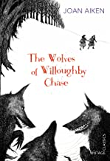  The Wolves of Willoughby Chase – Joan Aiken (6.5)  Date Finished: | 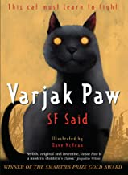  Varjak Paw – S.F. Said (3.8)  Date Finished: | 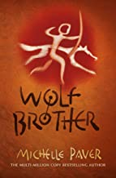  Wolf Brother – Michelle Paver (4.5)  Date Finished:
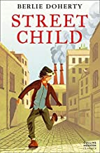  Street Child – Berlie Doherty (5.1)  Date Finished: | 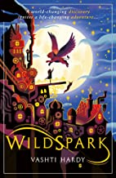  Wildspark – Vashti Hardy (5.6)  Date Finished: | 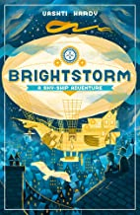  Brightstorm – Vashti Hardy (5.5)  Date Finished: | 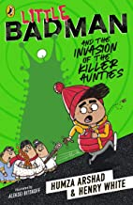  Little Badman and the Invasion of the Killer Aunties – Humza Arshad and Henry White (4.3+)  Date Finished:

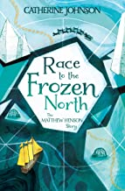  Race to the Frozen North – Catherine Johnson (4.6)  Date Finished: | 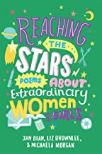  Reaching the Stars: Poems about Extraordinary Women and Girls – Jan Dean  Date Finished: | 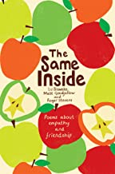  The Same Inside – Liz Brownlee  Date Finished: | 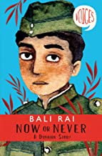  Now or Never: A Dunkirk Story – Bali Rai (5.0+)  Date Finished:
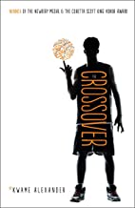  The Crossover – Kwae Alexander (4.3)  Date Finished: | 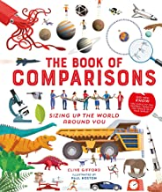  The Book of Comparisons – Clive Gifford  Date Finished: | 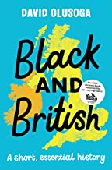  Black and British: A short, essential history – David Olusoga (8.2)  Date Finished: | 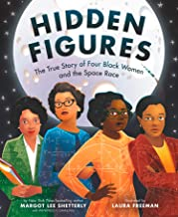  Hidden Figures: The True Story of Four Black Women and the Space Race – Margot Lee Shetterly (5.8)  Date Finished:
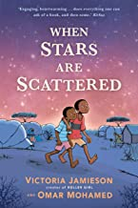  When Stars are Scattered – Victoria Jamieson (3.7)  Date Finished: | 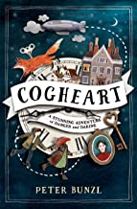  Cogheart – Peter Bunzl (5.7)  Date Finished: | 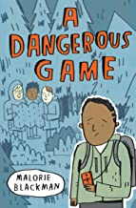  A Dangerous Game – Malorie Blackman (3.7)  Date Finished: | 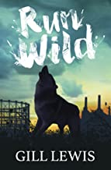  Run Wild – Gill Lewis (3.5)  Date Finished:
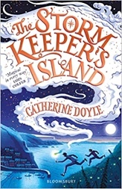  The Storm Keeper’s Island – Catherine Doyle (5.5)  Date Finished: | 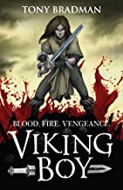  Viking Boy – Tony Bradman (5.2)  Date Finished: | 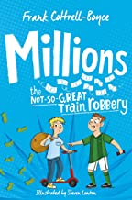  Millions – Frank Cotrell Boyce (4.0)  Date Finished: | 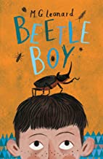  Beetle Boy – M.G. Leonard (4.9)  Date Finished:
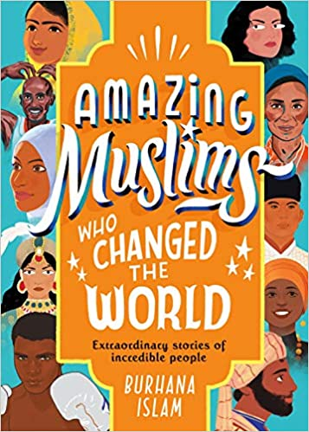  Amazing Muslims Who Changed the World – Burhana Islam  Date Finished: | 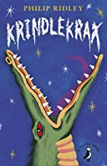  Krindlekrax – Philip Ridley (4.0)  Date Finished: | 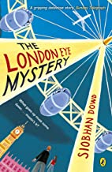  The London Eye Mystery – Siobhan Dowd (4.1)  Date Finished: | 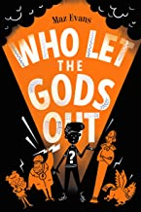  Who Let the Gods Out – Maz Evans (5.8)  Date Finished:
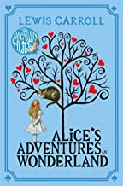  Alice’s Adventures in Wonderland – Lewis Caroll (7.4)  Date Finished: | 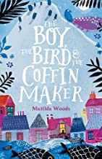  The Boy, the Bird and the Coffin Maker (4.7)  Date Finished: | 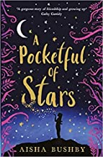  A Pocketful of Stars – Aisha Bushby (4.7)  Date Finished: | 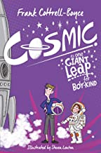  Cosmic – Frank Cottrell-Boyce (4.5)  Date Finished:
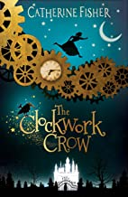  The Clockwork Crow – Catherine Fisher (4.1)  Date Finished: | 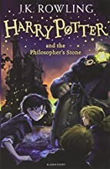  Harry Potter and the Philosopher’s Stone – J.K. Rowling (6.0)  Date Finished: | 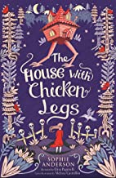  The House with Chicken Legs – Sophie Anderson (5.0)  Date Finished: | 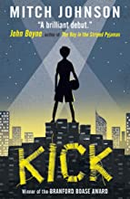  Kick – Mitch Johnson (5.0)  Date Finished:
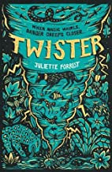  Twister – Juliette Forrest (4.4)  Date Finished: | 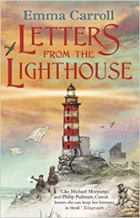  Letters from the Lighthouse – Emma Carroll (4.9)  Date Finished: | 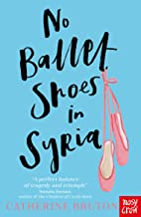  No Ballet Shoes in Syria – Catherine Bruton (5.5)  Date Finished: | 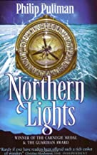  Northern Lights – Philip Pullman (6.2)  Date Finished:
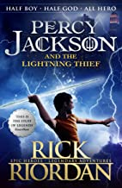  Percy Jackson and the Lightning Thief – Rick Riordan (4.5)  Date Finished: | 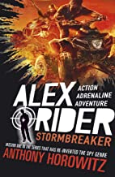  Alex Rider: Stormbreaker – Anthony Horowitz (5.1)  Date Finished: | 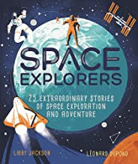  Space Explorers: 25 Extraordinary Stories of Space Exploration and Adventure – Libby Jackson  Date Finished: | 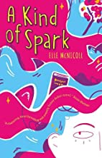  A Kind of Spark – Elle McNicoll (4.3)  Date Finished:
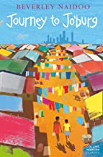  Journey to Jo’burg – Beverley Naidoo (4.6)  Date Finished: | 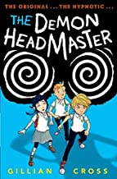  The Demon Headmaster – Gillian Cross (4.6)  Date Finished: | 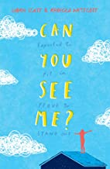  Can You See Me? – Libby Scott (5.6)  Date Finished: | 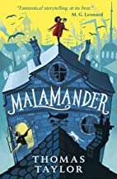  Malamander – Thomas Taylor (4.8)  Date Finished:
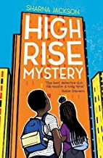  High Rise Mystery – Sharna Jackson (3.5)  Date Finished: | 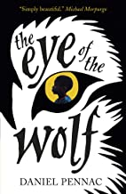  The Eye of the Wolf – Daniel Pennac (4.3)  Date Finished: | 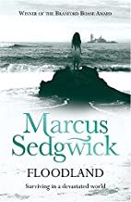  Floodland – Marcus Sedgwick (3.7)  Date Finished: | 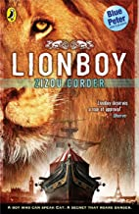  Lionboy – Zizou Corder (5.7)  Date Finished:
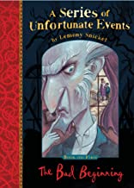  A Series of Unfortunate Events: The Bad Beginning – Lemony Snicket (6.4)  Date Finished: | 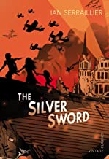  The Silver Sword – Ian Serrailier (5.5)  Date Finished: | 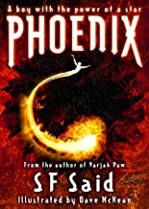  Phoenix – S F Said (4.9)  Date Finished: | 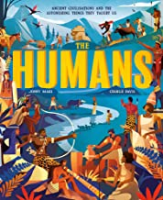  The Humans: Ancient Civilisations and Astonishing Things They Taught Us – Jonny Marx  Date Finished:
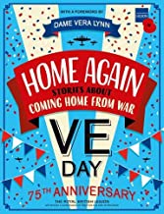  Home Again: Stories about Coming Home from War – Tony Bradman  Date Finished: | 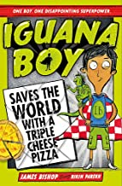  Iguana Boy Saves the World with a Triple Cheese Pizza – James Bishop (5.5)  Date Finished: | 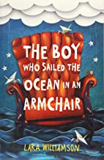  The Boy who Sailed the Ocean in an Armchair – Lara Williamson (5.4)  Date Finished: | 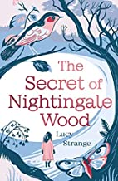  The Secret of Nightingale Wood – Lucy Strange (5.1)  Date Finished:
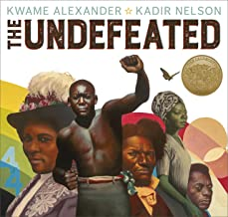  The Undefeated – Kwame Alexander  Date Finished: | 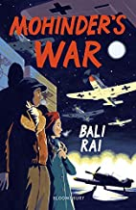  Mohinder’s War – Bali Rai (4.2)  Date Finished: | 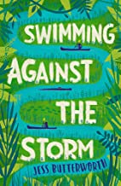  Swimming Against the Storm – Jess Butterworth (4.4)  Date Finished: | 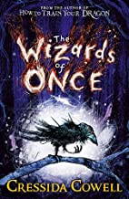  The Wizards of Once – Cressida Cowell (6.5)  Date Finished:
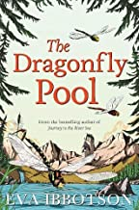  The Dragonfly Pool – Eva Ibbotson (6.5)  Date Finished: | 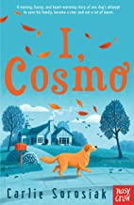  I, Cosmo – Carlie Sorosiak (4.9)  Date Finished: | 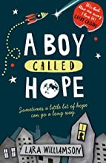  A Boy called Hope – Lara Williamson (5.4)  Date Finished: | 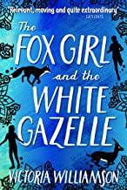  The Fox Girl and the White Gazelle – Victoria Williamson (5.3)  Date Finished:
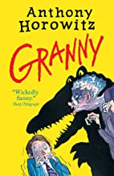  Granny – Anthony Horowitz (4.9)  Date Finished: | 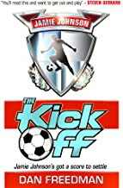  The Kick Off – Dan Freedman (4.9)  Date Finished: | 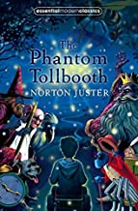  The Phantom Tollbooth – Norton Juster (6.7)  Date Finished: | 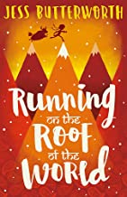  Running on the Roof of the World – Jess Butterworth (4.1)  Date Finished:
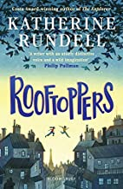  Rooftoppers – Katherine Rundell (3.5)  Date Finished: | 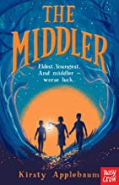  The Middler – Kirsty Applebaum (3.3)  Date Finished: | 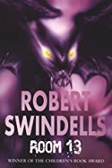  Room 13 – Robert Swindells (4.3)  Date Finished: | 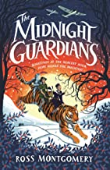  The Midnight Guardians – Ross Montgomery (4.6)  Date Finished:
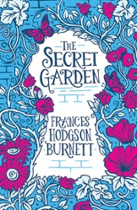  The Secret Garden – Frances Hodgson Burnett (6.3)  Date Finished: | 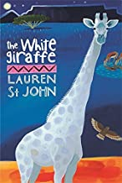  The White Giraffe – Lauren St John (6.2)  Date Finished: | 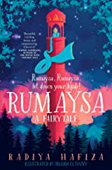  Rumaysa: A Fairytale – Radiya Hafiza  Date Finished: | 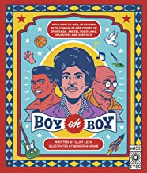  Boy Oh Boy – Cliff Leek (6.9)  Date Finished:
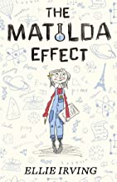  The Matilda Effect – Ellie Irving (5.3)  Date Finished: | 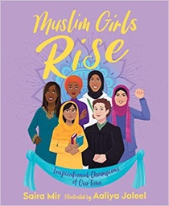  Muslim Girls Rise: Inspirational Champions of Our Time – Saira Mir  Date Finished: | 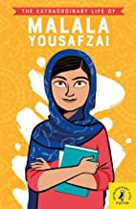  The Extraordinary Life of Malala Yousafzai – Hiba Noor Khan (6.7)  Date Finished: | 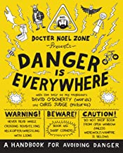  Danger is Everywhere – David O’Doherty (5.1)  Date Finished:
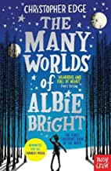  The Many Worlds of Albie Bright – Christopher Edge (6.2)  Date Finished: | 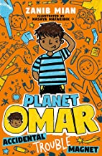  Planet Omar: Accidental Trouble Magnet – Zanib Mian (5.2)  Date Finished: | 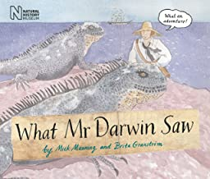  What Mr Darwin Saw – Mick Manning (5.4)  Date Finished: | 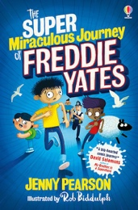  The Super Miraculous Journey of Freddie Yates – Jenny Pearson (4.9)  Date Finished:
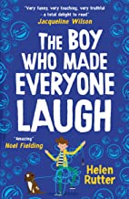  The Boy Who Made Everyone Laugh – Helen Rutter  Date Finished: | 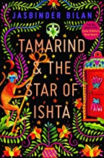  Tamarind and the Star of Ishta – Jasbinder Bilan (5.1)  Date Finished: | 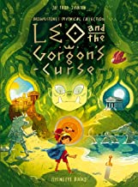  Leo and the Gorgon’s Curse – Joe Todd Stanton  Date Finished: | 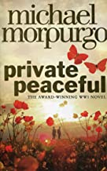  Private Peaceful – Michael Morpurgo (5.2)  Date Finished:
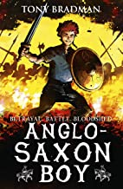  Anglo Saxon Boy – Tony Bradman (6.3)  Date Finished: | 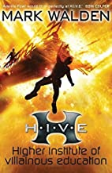  The H.I.V.E Series: Earthfall – Mark Walden (7.1)  Date Finished: | 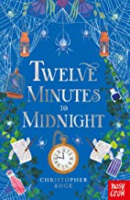  Twelve Minutes to Midnight – Christopher Edge (7.5)  Date Finished: | 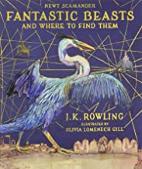  Fantastic Beasts and Where to Find Them – J.K. Rowling (8.8)  Date Finished:

