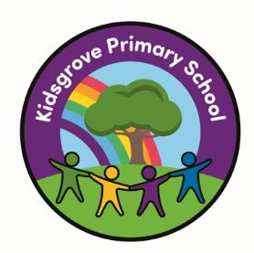

Kidsgrove Primary School
Long-Term Art and Design and Design Technology
Overviews
Art and Design and Design and Technology Overview

KS1
Cycle A | Structures: Constructing a windmill | Drawing: Making your mark | Textiles: Puppets | Sculpture and 3D: Paper Play | Cooking and Nutrition: Smoothies | Sculpture and 3D: Clay Houses
Cycle B | Structures: Baby bear’s chair | Craft and Design: Map it out | Mechanisms: Fairground wheel | Painting and mixed media: Colour Splash | Mechanisms: Making a moving monster | Painting and Mixed Media: Life in Colour

Lower KS2
Cycle A | Digital world:  Wearable  technology | Sculpture and 3D:  Abstract shape and  space | Cooking and  nutrition: Eating  seasonally | Drawing: Growing  artists | Structures:  Constructing a  castle | Drawing: Power  prints
Cycle B | Structure:  Pavilions | Painting and mixed  media: Light and  dark | Mechanical  systems: Making a  slingshot car | Craft and design:  Ancient Egyptian  scrolls | Electrical systems:  Torches | Craft and design:  Fabric of nature

Upper KS2
Cycle A | Electrical systems:  Doodlers | Drawing: I need  space | Mechanical  systems: Making a  pop-up book | Painting and mixed  media: Portraits | cooking and  nutrition:  Developing a  Recipe | Drawing: Make my  voice heard.
Cycle B | Textiles:  Waistcoats | Sculpture and 3D:  Interactive  installation | Structure:  Playgrounds | Craft and design:  Photo opportunity | digital world:  Navigating the  world | Sculpture and 3D:  Making memories -

