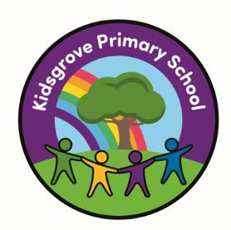

Kidsgrove Primary School
Long-Term History
Overviews
History Overview
EYFS
Strand | Understanding the World
Nursery | All about me | Celebrations – Bonfire night | Celebrations – Chinese New Year | Significant events throughout history | History through Nursery rhymes | Punch and Judy
Reception | Me and my world. | Celebrations – Bonfire night | Celebrations – Chinese New Year | Significant figures throughout history | History through texts | Holidays in the past.

KS1
Cycle A | The past: Local Area | The Past: Local People | Queen Elizabeth II | Stories about the past | Stories of rulers | Ships and Seafarers
Cycle B | London | The great change Makers | Queen Victoria | Victorian Lives | Neolithic Revolution | Stone Age

Lower KS2
Cycle A | Ancient Egypt | Cradles of Civilisation | The Indus Valley | Persia and Greece | Ancient Greece | Alexander the Great
Cycle B | Roman Republic | Roman Empire | Roman Britain | Christianity in 3 empires | Arabia and early Islam | Cordoba – The city of light

Upper KS2
Cycle A | Islamic civilisations | Anglo-Saxon Britain | Vikings in Britain (1) Lady of the Mercians | Norse culture | Vikings in Britain (2) Changing Rulers, Changing Worlds | Local history study – school planned unit
Cycle B | The Maya | Life in two kingdoms in the African continent | A theme through time - Part 1 | A theme through time - Part 2 | Britain in the era of the Second World War | Local history study – school planned unit

