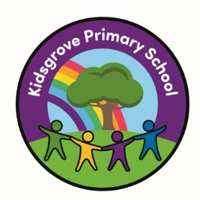

Kidsgrove Primary School
Long-Term Music
Overviews
Music Overview
KS1
 | Autumn 1 | Autumn 2 | Spring 1 | Spring 2 | Summer 1 | Summer 2
Cycle A | Keeping the pulse (my favourite things) | Tempo (snail and mouse) | Pitch (superheroes) | Instruments (musical Storytime) | . Singing (On this island) | Picth (Musical me)
Cycle B | Dynamics (seaside) | Sound patterns (fairy Tales) | Call and response (Animals) | Musical symbols (under the sea) | Contrasting dynamics (space) | Structure (Myths and legends)

 | Autumn 1 | Autumn 2 | Spring 1 | Spring 2 | Summer 1 | Summer 2
Cycle A | Instrumental lessons unit: South America | Developing singing technique (Vikings) | Instrumental lessons unit: Caribbean | Body and turned percussion (rainforest) | Jazz | Adapting transposing motifs (Romans)
Cycle B | Creating a composition in response to an animation (theme mountains) | Rock and roll | Ballads | Haiku, music and performance (Hanami festival) | Changes in pitch, tempo and dynamics (river) | Samaba and carnival sounds and instruments (South America)

Lower KS2
Upper KS2

 | Autumn 1 | Autumn 2 | Spring 1 | Spring 2 | Summer 1 | Summer 2
Cycle A | Film music | Composition notion (Ancient Egypt) | Musical Theatre | Theme and variations (pop art) | Songs of world war 2 | Composing and performing a leavers song
Cycle B | Looping and remixing | Blues | Dynamics, pitch and texture (coast by fingels cave) | Composition to represent the festival of colour (Holi festival) | Southwest Africa | Composing and performing a leavers song
Cycle A and B | Ukulele musical instrument lessons taught by peripatetic teachers

