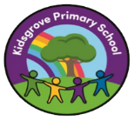
The principles of ELS foundation Stage 1 are based upon:
- Delivery of high-quality
- Interactions and teaching
- Development of Vocabulary and language
- Modelling of effective communication
- Building awareness of the sounds within our language
- Repetition and enforcement of learning

The primary activities, outside of the phonics groups, that take place every day are:
• reading high-quality stories
• rhymes and songs being shared and learned (one per week)
• modelling ‘how to’ and ensuring children are listening attentively
• interacting with and encouraging conversations with children and adults
• reproducing audibly the sounds that they hear when orally segmenting or blending
• explicitly teaching vocabulary.

