EYFS | Writing objectives are divided into ongoing objectives (objectives which will be taught throughout Year 1), and mastery objectives (objectives which will be specifically taught and mastered in one half term, then applied in subsequent writing units)
EYFS Mastery Writing Objectives
School Term | Autumn 1 | Autumn 2 | Spring 1 |  | Spring 2 | Summer 1 | Summer 2
Pathways English Text | 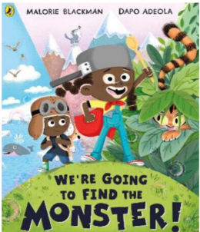  We’re Going to Find the Monster by Malorie Blackman  Black Lives Themed | 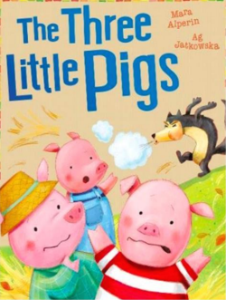  The Three Little Pigs by Mara Alperin | 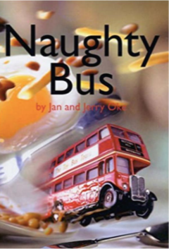  Naughty Bus by Jan Oke |  | 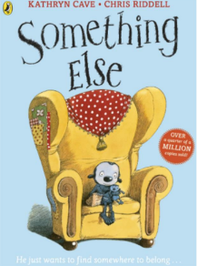  Something Else by Kathryn Cave  SMSC Themed | 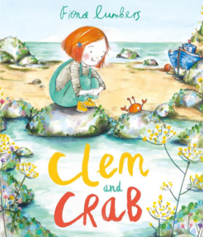  Clem and Crab by Fiona Lumbers  Environment Themed | 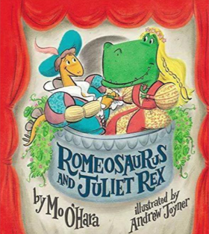  Romeosaurus & Juliet Rex by Mo O’Hara  Shakespeare Themed
Outcomes & Genre | Outcome: Fiction – Retell and Labels | Outcome: Traditional Tale with Character Focus | Outcome: Recount |  | Outcome: Fiction – Narrative Story Telling | Outcome: Fiction – Retell Story | Outcome: Fiction – Rewrite the Story
Mastery Key Progression - Nursery | Use some of their print and letter knowledge in their early writing | Use some of their print and letter knowledge in their early writing | Use some of their print and letter knowledge in their early writing. Write some or all of their name |  | Use some of their print and letter knowledge in their early writing  Write some or all of their name | Use some of their print and letter knowledge in their early writing  Write some or all of their name  Write some letters accurately | Use some of their print and letter knowledge in their early writing Write some letters accurately
Mastery Key Progression – Reception | Spell words by identifying the sounds and then writing the sound with letter/s Form lower-case letters correctly | Spell words by identifying the sounds and then writing the sound with letter/s Form lower-case letters correctly | Form lower-case letters correctly  Write short sentences with words with known sound-letter correspondences  Spell words by identifying the sounds and then writing the sound with letter/s  Re-read what they have written to check that it makes sense |  | Form lower case letters and some capital letters correctly  Write short sentences with words with known sound-letter correspondences  Re-read what they have written to check that it makes sense | Form lower case and capital letters correctly  Write short sentences with words with known sound-letter correspondences using a capital letter and full stop Re-read what they have written to check that it makes sense | Form lower-case and capital letters correctly Spell words by identifying the sounds and then writing the sound with letters •  Write short sentences with words with known sound-letter correspondences using a capital letter and full stop  Re-read what they have written to check that it makes sense
Nursery Group Progression of Skills |  |  |  | Reception Group Progression of Skills
Writing | Use some of their print and letter knowledge in their early writing |  |  | Spell words by identifying the sounds and then writing the sound with letters
Communication and Language |  |  |  | Use new vocabulary in different contexts (communication and language)  Describe events in some detail (communication and language)
Writing  Communication and Language | Write some or all of their name |  |  | Connect one idea or action to another using a range of connectives (Communication and language)
Communication and Language | Develop their communication of irregular tenses and plurals (communication and language)
Writing | Write some letters accurately Use some of their print and letter knowledge in their early writing  Know many rhymes, be able to talk about familiar books, and be able to tell a long story  Understand ‘why’ questions (communication and language) |  |  | Write short sentences with words with known sound-letter correspondences using a capital letter and full stop  Re-read what they have written to check that it makes sense  Form lower-case and capital letters correctly  Retell the story, once they have developed a deep familiarity with the text; some as exact repetition and some in their own words (communication and language)  Articulate their ideas and thoughts in well-formed sentences (communication and language)

