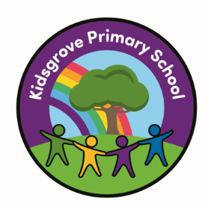

Kidsgrove Primary School
Long-Term Writing Overviews

Year Group | Autumn 1 | Autumn 2 | Spring 1 | Spring 2 | Summer 1 | Summer 2
EYFS | 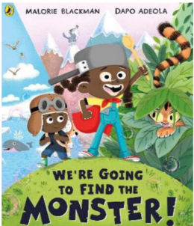  We’re Going to Find the Monster by Malorie Blackman  Black Lives Themed  Outcome: Fiction – Retell and Labels | 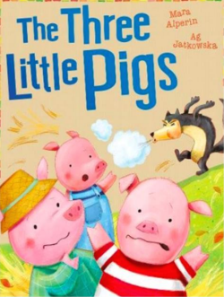  The Three Little Pigs by Mara Alperin  Outcome: Traditional Tale with Character Focus | 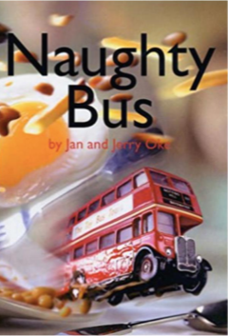  Naughty Bus by Jan Oke  Outcome: Recount | 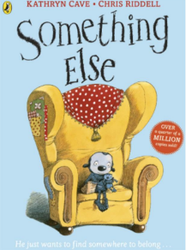  Something Else by Kathryn Cave  SMSC Themed  Outcome: Fiction – Narrative Story Telling | 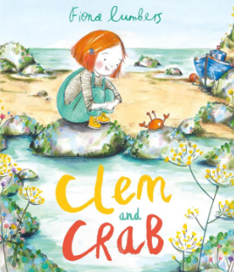  Clem and Crab by Fiona Lumbers  Environment Themed  Outcome: Fiction – Retell Story | 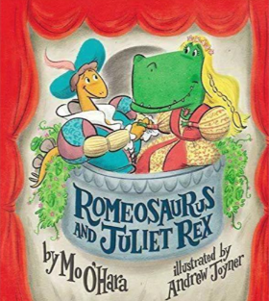  Romeosaurus & Juliet Rex by Mo O’Hara  Shakespeare Themed  Outcome: Fiction – Rewrite the Story
Year ½  Cycle A | 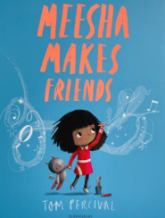  Meesha Makes Friends by Tom Percival  Black Lives Themed  Outcome: Recount – Diary Entry | 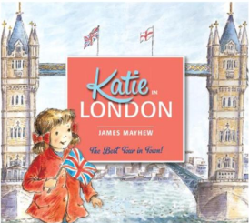  Katie in London by James Mayhew  Geography curriculum link – London  Outcome: Information – Non-Chronological Report about London | 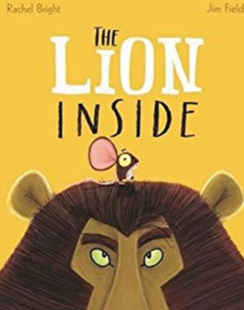  The Lion Inside by Rachel Bright  Geography curriculum link – London  Outcome: Fiction – Journey Story | 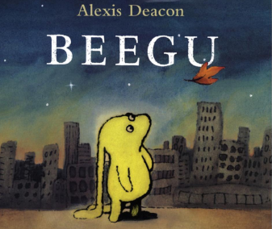  Beegu by Alexis Deacon  SMSC Themed  Outcome: Fiction Writing | 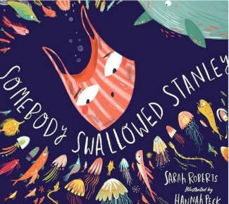  Somebody Swallowed Stanley  Environment Themed  Outcome: Non-Fiction – Fact Files about Sea Animals. | 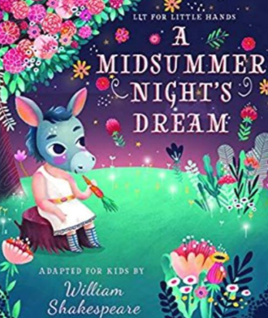  A Midsummer Night’s Dream by Lit for Little Hands  Shakespeare Themed  Outcome: Fiction – Character Description
Year ½  Cycle B | 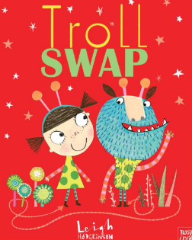  Troll Swap by Leigh Hodgkinson  Science Curriculum link – Animals including humans – offspring  Outcome: Fiction – Story with Character Focus | 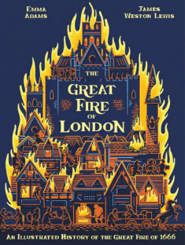  The Great Fire of London by Emma Adams  History Curriculum Link – Significant events beyond living memory  Outcome: Information Report | 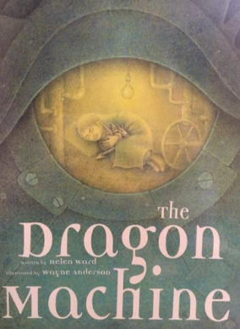  The Dragon Machine by Helen Ward  Outcome: Fiction – Story with Adventure Focus | 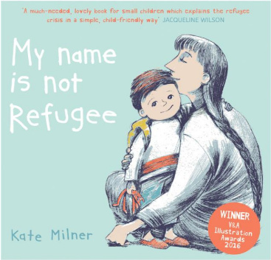  My Name is Not Refugee by Kate Milner  SMSC Themed  Outcome: Recount – Diary Entry | 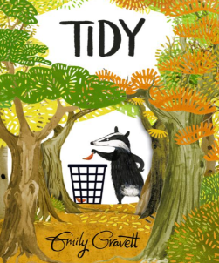  Tidy by Emily Gravett  Environment Themed  Outcome: Letter | 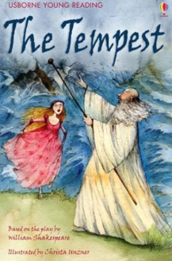  Usborne Illustrated Stories from Shakespeare (The Tempest)  Shakespeare Themed  Outcome: Fiction Retell – Shakespeare
Year ¾  Cycle A | 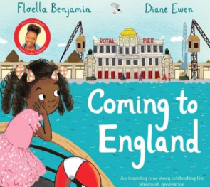  Coming to England by Floella Benjamin  Black Lives Themed  Outcome: Recount – Letter Writing | 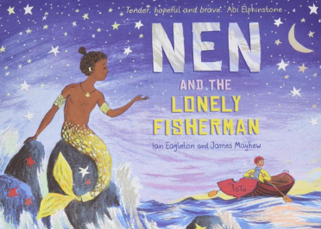  Nen and the Lonely Fisherman  By Ian Eagleton  PHSE curriulcum link – family diversity / LGBTQ Outcome: Narrative – Fantasy Story | 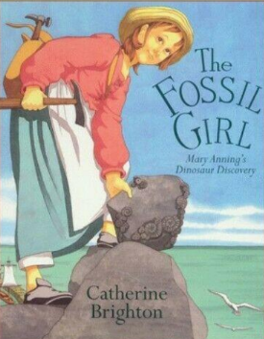  The Fossil Girl by Catherine Brighton  Outcome: Recount – A Journal | 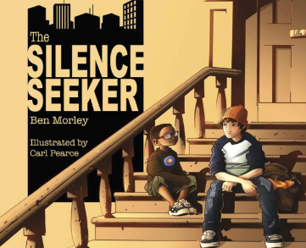  The Silence Seeker by Ben Morley  SMSC Themed  Outcome: Fiction – Rewrite | 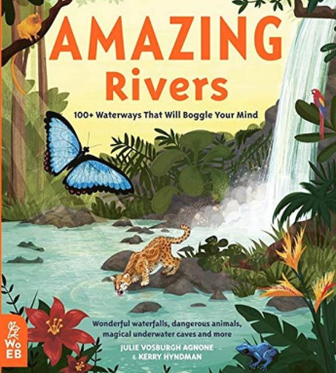  Amazing Rivers by Julie Vosburgh  Environment Themed  Outcome: Information/ Persuasion – Information Board | 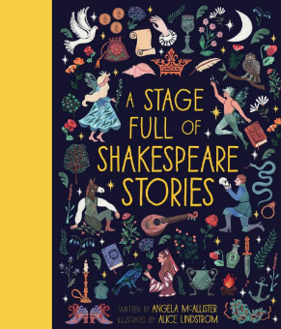  A Stage Full of Shakespeare Stories  (The merchant in Venice)  Shakespeare Themed  Outcome: Non- Fiction Information Text
Year ¾  Cycle B | 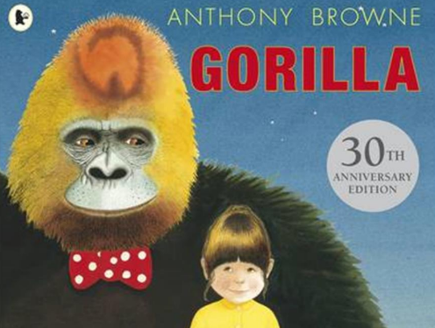  Gorilla by Antony Brown  Science Curriculum link – Animals  Geography Curriculum link – natural environment of gorillas / topographical features  Outcome: Recount Writing | 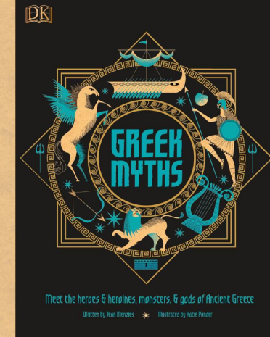  Greek Myths  History curriculum link – Ancient Greeks  Outcome: Narrative – Myth | 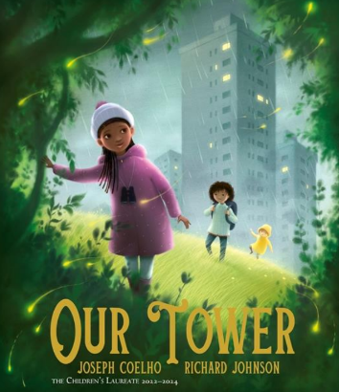  Our Tower by Joseph Coelho  British values – Representations (living in urban areas)  Outcome: Recount – Nature Journal | 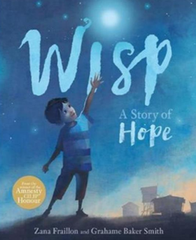  Wisp by Zana Fraillon  SMSC themed  Outcome: Fiction – First Person Recount | 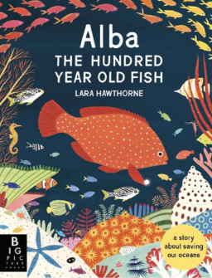  Alba the Hundred-Year-Old Fish by Lara Hawthorne  Environment Themed  Outcome: Non-Chronological Report in the form of an information board. | 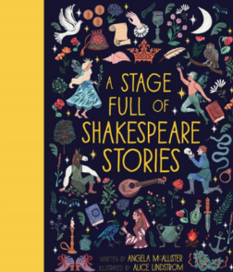  A Stage Full of Shakespeare Stories by Angela McAllister (Julius Cesear)  Shakespeare Themed  Outcome: Fiction – Playscript
Year 5/6  Cycle A | 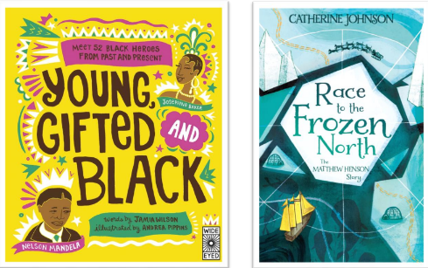  Race to the Frozen North by Catherine Johnson/ Young, Gifted and Black by Jamia Wilson.  Black Lives Themed  Outcome: Recount – Diary | 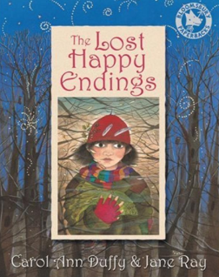  The Lost Happy Endings by Carol Ann Duffy  History curriculum link – Anglo-Saxons  Geography curriculum link – towns and settlements  Outcome: Fiction – Traditional Tale | 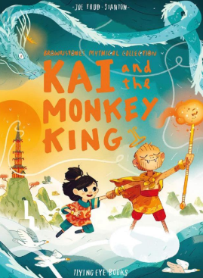  Kai and the Monkey King by Joe Todd-Stanton  History curriculum link – Early civilisations (Shang Dynasty)  Outcome: Fiction – Adventure | 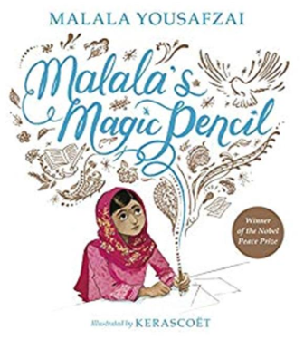  Malala’s Magic Pencil by Malala Yousafzai  SMSC themed  Outcome: Recount Writing – Autobiography | 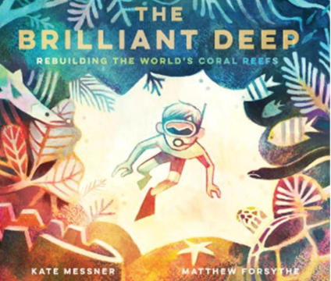  The Brilliant Deep by Kate Messner  Environment Themed  Outcome: Hybrid text – Information and Persuasion | 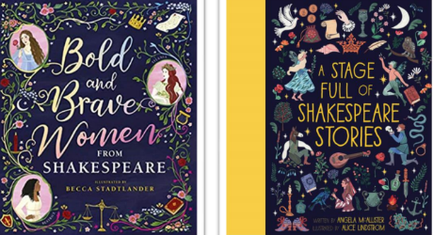  Bold and Brave Women from Shakespeare by Shakespeare Birthplace Trust  Shakespeare themed  Outcome: Recount – Monologue
Year 5/6  Cycle B | 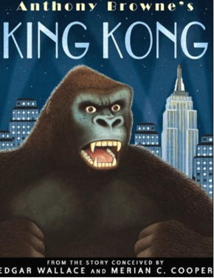  King Kong by Anthony Browne  Geography Curriculum link – North America  Science Curriculum link – Evolution and Inheritance  Outcome: Fiction – Adventure Narrative | 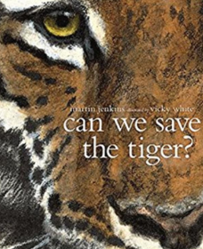  Can We Save The Tiger? By Martin Jenkins  Geography Curriculum link – Animal species/ climate zones  Science Curriculum link – Living things / classification  Outcome: Report Writing | 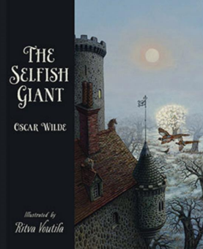  The Selfish Giant by Oscar Wilde and Ritva Voutila  Science Curriculum link – Digestive system  Outcome: Fiction – Classic Narrative | 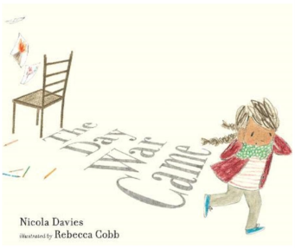  The Day the War Came by Nicola Davies, Leaf by Sandra Dieckmann  SMSC Themed  Outcome: Recount – Persuasive Letter | 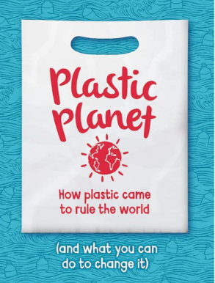  Plastic Planet: How Plastic Came to Rule the World by Georgia Amson-Bradshaw  Environment Themed  Outcome: Hybrid Text – Information and Persuasion | 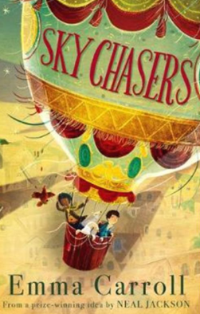  Sky Chasers by Emma Carroll  Outcome: Fiction - Adventure Story, including narrative from different viewpoints.

