Year 1 | Writing objectives are divided into ongoing objectives (objectives which will be taught throughout Year 1), and mastery objectives (objectives which will be specifically taught and mastered in one half term, then applied in subsequent writing units)
Year 1 Mastery Writing Objectives – Cycle A
School Term | Autumn 1 | Autumn 2 | Spring 1 | Spring 2 | Summer 1 | Summer 2
Pathways English Text | 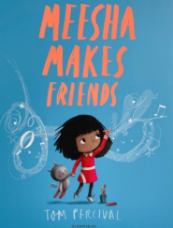  Meesha Makes Friends by Tom Percival  Black Lives Themed | 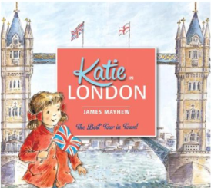  Katie in London by James Mayhew | 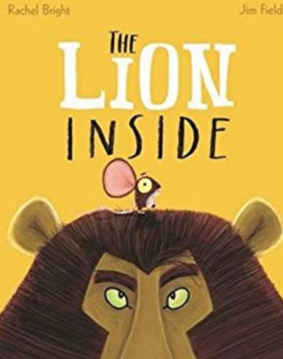  The Lion Inside by Rachel Bright | 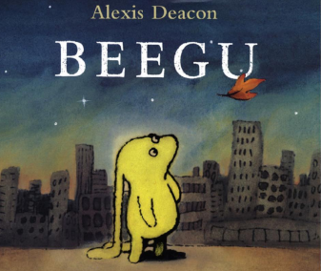  Beegu by Alexis Deacon  SMSC Themed | 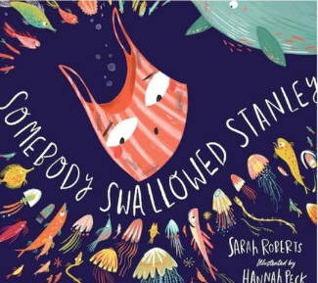  Somebody Swallowed Stanley  Environment Themed | 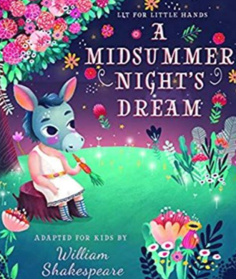  A Midsummer Night’s Dream by Lit for Little Hands  Shakespeare Themed
Outcomes & Genre | Outcome: Recount  Diary Entry | Outcome: Non Fiction  Information – Non-Chronological Report about London | Outcome: Fiction Journey Story | Outcome: Fiction  Write own version of the story.. | Outcome: Non-Fiction  Fact Files about Sea Animals. | Outcome: Fiction Character Description
Mastery Key Progression | Combine words to make sentences  Leave spaces between words  Begin to use capital letters and  full stops  Use capital letters for names  of people and the personal  pronoun ‘I’ | Join words using ‘and’  Use plural noun suffixes -s and -es  Sequence sentences to form short narratives (link ideas or  events by pronoun)  Punctuate sentences using a capital letter and full stop  Use capital letters for names of people and places | Punctuate sentences using a capital letter and a full stop, some question marks  and exclamation marks  Join words and clauses  using and  Some accurate use of the prefix un-  Add suffixes where no  change is needed to the root of the word e.g. -ed, -ing, -er, -est | Join words and clauses using and  Punctuate sentences using a  capital letter and a full stop, question mark or exclamation mark  Add suffixes where no change is needed to the root word e.g. -ed,  -ing, -er, -est | Join words and clauses using and  Add suffixes where no change is needed to the root word e.g. -ed, -ing, -er, -est  Change the meaning of verbs  and adjectives by adding the prefix un-  Punctuate sentences using a  capital letter and a full stop, question mark or exclamation mark | Join words and clauses  using and  Use simple description  Sequence sentences to  form short narratives (link ideas or events by  pronouns)  Use capital letters for  names of people and  places  Punctuate sentences  using a capital letter, full  stop, question mark or  exclamation mark.
Year Group Progression of Skills
Grammar (word) | Use plural noun suffixes -s and -es  Add suffixes to verbs where no change is needed to the root  Change the meaning of verbs and adjectives by adding prefix un
Grammar (sentence) | Combine words to make sentences  Leave spaces between words  Join words and clauses using and  Sequence sentences to form short narratives
Grammar (punctuation) | Use a capital letter for names of people, places, the days of the week, and the personal pronoun ‘I’  Punctuate sentences using a capital letter and a full stop, question mark or exclamation mark
Composition | Write sentences:  Say out loud what is going to be written about  Compose a sentence orally before writing it  Sequence sentences to form short narratives  Re-read and check sense  Discuss what has been written with the teacher or other pupils  Read writing aloud clearly enough to be heard by peers and the teacher
Transcription / Handwriting | Sit correctly at a table, holding a pencil comfortably and correctly  Begin to form lower-case letters in the correct direction, starting and finishing in the  right place  Form capital letters  Form digits 0-9  Understand which letters belong to which handwriting ‘families’ (i.e. letters that are  formed in similar ways) and to practise these.
Year 1 Key Word Lists
Common Expectation Words | the, a, do, to, today, of, said, says, are, were, was, is, his, has, I, you, your, they, be, he, me, she, we, no, go, so, by, my, here, there, where, love, come, some, one, once, ask, friend, school, put, push, pull, full,  house, our.
High Frequency Words | The, that, not, look, put, and, with, then, don’t, could, a, all, were, come, house, to, we, go, will, old, said, can, little, into, too, in, are, as, back, by, he, up, no, from, day, I, had, mum, children, made, of, my, one,  him, time, it, her, them, Mr, I’m, was, what, do, get, if, you, there, me, just, help, they, out, down, now, Mrs, on, this, dad, came, called, she, have, big, oh, here, is, went, when, about, off, for, be, it’s, got, asked,  at, like, see, their, saw, his, some, looked, people, make, but, so, very, your, an
Year 1 | Writing objectives are divided into ongoing objectives (objectives which will be taught throughout Year 1), and mastery objectives (objectives which will be specifically taught and mastered in one half term, then applied in subsequent writing units)
Year 1 Mastery Writing Objectives – Cycle B
School Term | Autumn 1 | Autumn 2 | Spring 1 | Spring 2 | Summer 1 | Summer 2
Pathways English Text | 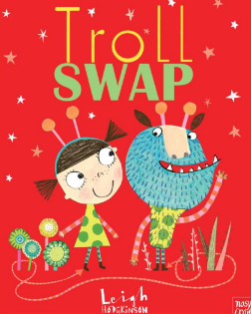  Troll Swap by Leigh Hodgkinson | 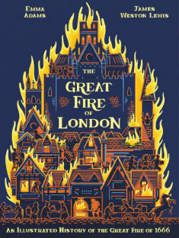  The Great Fire of London by Emma Adams | 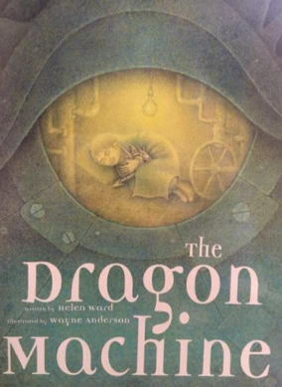  The Dragon Machine by Helen Ward |   My Name is Not Refugee by Kate Milner  SMSC Themed | 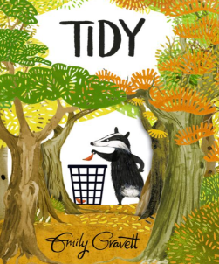  Tidy by Emily Gravett  Environment Themed | 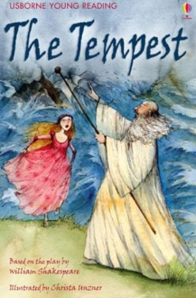  Usborne Illustrated Stories from Shakespeare (The Tempest)  Shakespeare Themed
Outcomes & Genre | Outcome: Fiction  Story with Character Focus | Outcome: Information Report | Outcome: Fiction Story with Adventure Focus | Outcome: Recount Diary Entry | Outcome: Letter | Outcome: Fiction Retell
Mastery Key Progression | Combine words to make  sentences  Begin to join words using  and  Punctuate sentences using a capital letter and a full stop  Use a capital letter for  names of people and the  personal pronoun ‘I’ | Join words using and  Punctuate sentences using a capital letter and a full stop  Use plural noun suffixes -s and -es | Join words and clauses  using and  Add suffixes where no  change is needed to the  root of the word e.g. ed,  -ing, -er, -est  Punctuate sentences using a capital letter and a full stop, question mark or exclamation mark | Join words and clauses using and  Add suffixes where no  change is needed to the root of the word e.g. -ing, -ed, -er, -est  Punctuate sentences using a capital letter and a full stop, question mark or  exclamation mark | Join words and clauses using and  Add suffixes where no change is needed to the root word e.g. -ed, -ing, -er, -est  Change the meaning of verbs and adjectives by adding the prefix un-  Punctuate sentences using a capital letter and a full stop, question mark or exclamation  mark | Join words and clauses  using and  Punctuate sentences using a capital letter and a full stop, question mark or exclamation mark  Use simple description  Use a capital letter for  names of people and  places
Year Group Progression of Skills
Grammar (word) | Use plural noun suffixes -s and -es  Add suffixes to verbs where no change is needed to the root  Change the meaning of verbs and adjectives by adding prefix un
Grammar (sentence) | Combine words to make sentences  Leave spaces between words  Join words and clauses using and  Sequence sentences to form short narratives
Grammar (punctuation) | Use a capital letter for names of people, places, the days of the week, and the personal pronoun ‘I’  Punctuate sentences using a capital letter and a full stop, question mark or exclamation mark
Composition | Write sentences:  Say out loud what is going to be written about  Compose a sentence orally before writing it  Sequence sentences to form short narratives  Re-read and check sense  Discuss what has been written with the teacher or other pupils  Read writing aloud clearly enough to be heard by peers and the teacher
Transcription / Handwriting | Sit correctly at a table, holding a pencil comfortably and correctly  Begin to form lower-case letters in the correct direction, starting and finishing in the  right place  Form capital letters  Form digits 0-9  Understand which letters belong to which handwriting ‘families’ (i.e. letters that are  formed in similar ways) and to practise these.
Year 1 Key Word Lists
Common Expectation Words | the, a, do, to, today, of, said, says, are, were, was, is, his, has, I, you, your, they, be, he, me, she, we, no, go, so, by, my, here, there, where, love, come, some, one, once, ask, friend, school, put, push, pull, full,  house, our.
High Frequency Words | The, that, not, look, put, and, with, then, don’t, could, a, all, were, come, house, to, we, go, will, old, said, can, little, into, too, in, are, as, back, by, he, up, no, from, day, I, had, mum, children, made, of, my, one,  him, time, it, her, them, Mr, I’m, was, what, do, get, if, you, there, me, just, help, they, out, down, now, Mrs, on, this, dad, came, called, she, have, big, oh, here, is, went, when, about, off, for, be, it’s, got, asked,  at, like, see, their, saw, his, some, looked, people, make, but, so, very, your, an

