Year 2 | Writing objectives are divided into ongoing objectives (objectives which will be taught throughout Year 1), and mastery objectives (objectives which will be specifically taught and mastered in one half term, then applied in subsequent writing units)
Year 2 Mastery Writing Objectives – Cycle A
School Term | Autumn 1 | Autumn 2 | Spring 1 | Spring 2 | Summer 1 | Summer 2
Pathways English Text | 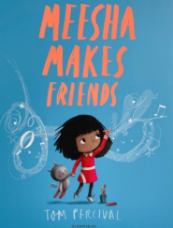  Meesha Makes Friends by Tom Percival  Black Lives Themed | 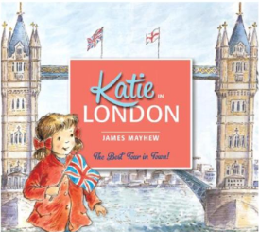  Katie in London by James Mayhew | 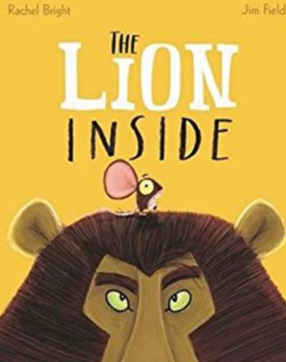  The Lion Inside by Rachel Bright | 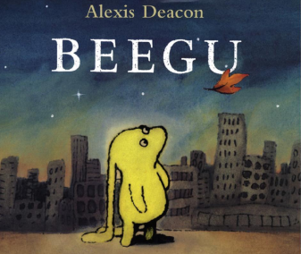  Beegu by Alexis Deacon  SMSC Themed | 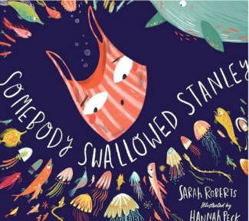  Somebody Swallowed Stanley  Environment Themed | 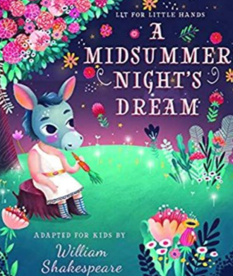  A Midsummer Night’s Dream by Lit for Little Hands  Shakespeare Themed
Outcomes & Genre | Outcome: Recount  Diary Entry | Outcome: Non Fiction  Information – Non-Chronological Report about London | Outcome: Fiction Journey Story | Outcome: Fiction  Write own version of the story.. | Outcome: Non-Fiction  Fact Files about Sea Animals. | Outcome: Fiction Character Description
Mastery Key Progression | Use subordination (because) and co-ordination (and)  Use expanded noun phrases to describe and specify  Use punctuation correctly –full stops, capital letters | Use co-ordination (but,or)  Add-ly to turn adjectives into adverbs  Use commas to separate items in a list | Write sentences with  different forms: statement, question,  exclamation, command  Use subordination (apply  because, introduce when)  Use present and past  tenses correctly and  consistently (some  progressive)  Use punctuation correctly - exclamation marks, question marks | Use subordination (apply because, when; introduce that)  Use present and past tenses correctly and consistently  Use the progressive form of verbs in the present and past tense  Use punctuation correctly -apostrophes for the possessive (singular) | Use subordination (if, that)  Add -er and -est to adjectives  Use homophones and near homophones  Write down ideas, key words, new vocabulary  Use punctuation correctly –apostrophes for contracted forms | Use subordination (using  when, if, that, or because)  and co-ordination (using  or, and, or but)  Use expanded noun  phrases to describe and  specify  Use present and past  tenses correctly and  consistently including the progressive form  Add suffixes to spell  longer words
Year Group Progression of Skills
Grammar (word) | Form nouns using suffixes such as –ness, –er and by compounding [for example, whiteboard, superman]  Form adjectives using suffixes such as –ful, –less (A fuller list of suffixes can be found on page 46 in the year 2 spelling section in English Appendix 1)  Use the suffixes –er, –est in adjectives and use –ly in Standard English to turn adjectives into adverbs
Grammar (sentence) | Write expanded noun phrases for description and specification [for example, the blue butterfly, plain flour, the man in the moon]  Use subordination (using when, if, that, because) and co-ordination (using or, and, but)  Write sentences with different forms: Statement, question, exclamation or command
Grammar (cohesion – tenses) | Use present and past tenses correctly and consistently  Use the progressive form of verbs in the present and past tense to mark actions in progress [for example, she is drumming, he was shouting]
Grammar (punctuation) | Use capital letters, full stops, question marks and exclamation marks to demarcate sentences  Use commas to separate items in a list  Use apostrophes to mark where letters are missing in spelling and to mark singular possession in nouns [for example, the girl’s name
Composition | Develop positive attitudes towards and stamina for writing:  Write narratives about personal experiences and those of others (real and fictional)  Write about real events  Write poetry  Write for different purposes  Plan or say out loud what is going to be written about  Write down ideas, key words, new vocabulary  Encapsulate what is to be written, sentence by sentence  Make simple additions, revisions and corrections:  Evaluate writing with the teacher and other pupils  Re-read to check sense P  roof-read to check for errors in spelling, grammar and punctuation  Read aloud with intonation
Year 2 Key Word Lists
Common Expectation Words | door, floor, poor, because, find, kind, mind, behind, child, children*, wild, climb, most, only, both, old, cold, gold, hold, told, every, everybody, even, great, break, steak, pretty, beautiful, after, fast, last, past, father, class, grass, pass, plant, path, bath, hour, move, prove, improve, sure, sugar, eye, could, should, would, who, whole, any, many, clothes, busy, people, water, again, half, money, Mr, Mrs, parents, Christmas.
High Frequency Words | water, bear, find, these, live, away, can’t, more, began, say, good, again, I’ll, boy, soon, want, cat, round, animals, night, over, long, tree, never, narrator, how, things, magic, next, small, did, new, shouted, first, car, man, after, us, work, couldn’t, going, wanted, other, lots, three, where, eat, food, need, head, would, everyone, fox, that’s, king, or, our, though, baby, town, took, two, way, fish, I’ve, school, has, been, gave, around, think, yes, stop, mouse, every, home, play, most, something, garden, who, take, red, bed, fast, didn’t, thought, door, may, only, ran, dog, right, still, many, know, well, sea, found, laughed

Year 2 | Writing objectives are divided into ongoing objectives (objectives which will be taught throughout Year 1), and mastery objectives (objectives which will be specifically taught and mastered in one half term, then applied in subsequent writing units)
Year 2 Mastery Writing Objectives – Cycle B
School Term | Autumn 1 | Autumn 2 | Spring 1 | Spring 2 | Q | 11
Pathways English Text | 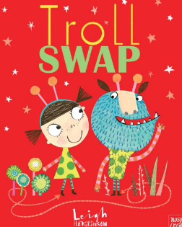  Troll Swap by Leigh Hodgkinson | 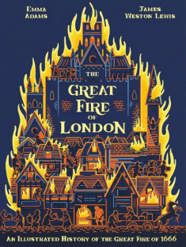  The Great Fire of London by Emma Adams | 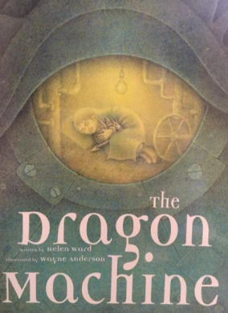  The Dragon Machine by Helen Ward | 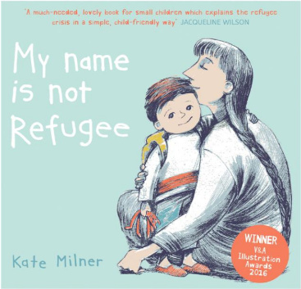  My Name is Not Refugee by Kate Milner  SMSC Themed | 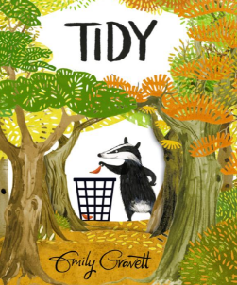  Tidy by Emily Gravett  Environment Themed | 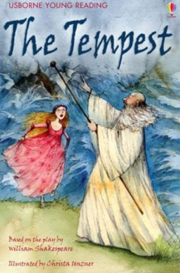  Usborne Illustrated Stories from Shakespeare (The Tempest)  Shakespeare Themed
Outcomes & Genre | Outcome: Fiction  Story with Character Focus | Outcome: Information Report | Outcome: Fiction Story with Adventure Focus | Outcome: Recount Diary Entry | Outcome: Letter | Outcome: Fiction Retell
Mastery Key Progression | Use punctuation correctly – full stops, capital letters  Use expanded noun phrases to describe and specify  Use subordination (because) and coordination (and) | Use co-ordination (but, or)  Add -ly to turn adjectives into adverbs Use commas to separate items in a list | Write sentences with different forms: statement, question, exclamation, command  Use subordination (apply because, introduce when)  Use present and past tenses correctly and consistently (some progressive)  Use punctuation correctly - exclamation marks, question marks | Use the progressive form of verbs in the present and past tense  Use subordination (apply because, when; introduce (so) that)  Use present and past tenses correctly and consistently  Use punctuation correctly – apostrophes for the possessive (singular) | Use subordination (if, that)  Add -er and -est to adjectives  Use homophones and near homophones  Write down ideas, key words, new vocabulary  Use punctuation correctly – apostrophes for contracted forms | Use present and past tenses correctly and consistently including the progressive form  Use subordination (using when, if, that, or because) and co-ordination (using or, and, or but)  Use expanded noun phrases to describe and specify  Add suffixes to spell longer words e.g. -ment, -ful  Make simple additions, revisions and corrections
Year Group Progression of Skills
Grammar (word) | Form nouns using suffixes such as –ness, –er and by compounding [for example, whiteboard, superman]  Form adjectives using suffixes such as –ful, –less (A fuller list of suffixes can be found on page 46 in the year 2 spelling section in English Appendix 1)  Use the suffixes –er, –est in adjectives and use –ly in Standard English to turn adjectives into adverbs
Grammar (sentence) | Write expanded noun phrases for description and specification [for example, the blue butterfly, plain flour, the man in the moon]  Use subordination (using when, if, that, because) and co-ordination (using or, and, but)  Write sentences with different forms: Statement, question, exclamation or command
Grammar (cohesion – tenses) | Use present and past tenses correctly and consistently  Use the progressive form of verbs in the present and past tense to mark actions in progress [for example, she is drumming, he was shouting]
Grammar (punctuation) | Use capital letters, full stops, question marks and exclamation marks to demarcate sentences  Use commas to separate items in a list  Use apostrophes to mark where letters are missing in spelling and to mark singular possession in nouns [for example, the girl’s name
Composition | Develop positive attitudes towards and stamina for writing:  Write narratives about personal experiences and those of others (real and fictional)  Write about real events  Write poetry  Write for different purposes  Plan or say out loud what is going to be written about  Write down ideas, key words, new vocabulary  Encapsulate what is to be written, sentence by sentence  Make simple additions, revisions and corrections:  Evaluate writing with the teacher and other pupils  Re-read to check sense P  roof-read to check for errors in spelling, grammar and punctuation  Read aloud with intonation
Year 2 Key Word Lists
Common Expectation Words | door, floor, poor, because, find, kind, mind, behind, child, children*, wild, climb, most, only, both, old, cold, gold, hold, told, every, everybody, even, great, break, steak, pretty, beautiful, after, fast, last, past, father, class, grass, pass, plant, path, bath, hour, move, prove, improve, sure, sugar, eye, could, should, would, who, whole, any, many, clothes, busy, people, water, again, half, money, Mr, Mrs, parents, Christmas.
High Frequency Words | water, bear, find, these, live, away, can’t, more, began, say, good, again, I’ll, boy, soon, want, cat, round, animals, night, over, long, tree, never, narrator, how, things, magic, next, small, did, new, shouted, first, car, man, after, us, work, couldn’t, going, wanted, other, lots, three, where, eat, food, need, head, would, everyone, fox, that’s, king, or, our, though, baby, town, took, two, way, fish, I’ve, school, has, been, gave, around, think, yes, stop, mouse, every, home, play, most, something, garden, who, take, red, bed, fast, didn’t, thought, door, may, only, ran, dog, right, still, many, know, well, sea, found, laughed

