Year 3 | Writing objectives are divided into ongoing objectives (objectives which will be taught throughout Year 1), and mastery objectives (objectives which will be specifically taught and mastered in one half term, then applied in subsequent writing units)
Year 3 Mastery Writing Objectives – Cycle A
School Term | Autumn 1 | Autumn 2 | Spring 1 | Spring 2 | Summer 1 | Summer 2
Pathways English Text | 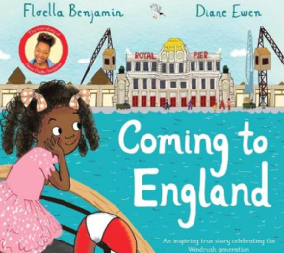  Coming to England by Floella Benjamin  Black Lives Themed | 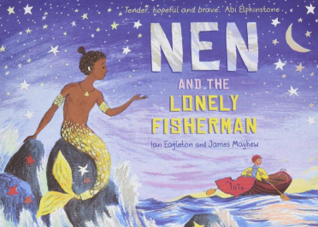  Nen and the Lonely Fisherman  By Ian Eagleton | 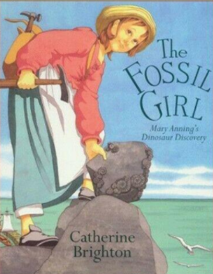  The Fossil Girl by Catherine Brighton | 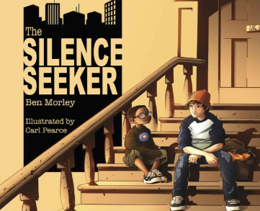  The Silence Seeker by Ben Morley  SMSC Themed | 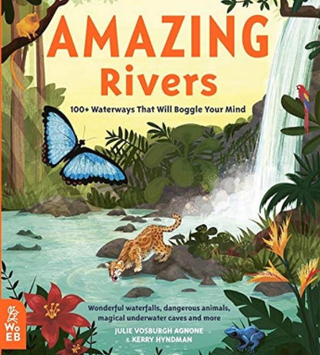  Amazing Rivers by Julie Vosburgh  Environment Themed | 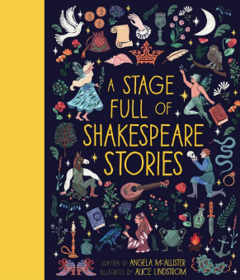  A Stage Full of Shakespeare Stories  (The Merchant in Venice)  Shakespeare Themed
Outcomes & Genre | Outcome: Recount Letter Writing | Outcome: Narrative Fantasy Story | Outcome: Recount  A Journal | Outcome: Fiction  Rewrite | Outcome: Information/ Persuasion Information Board | Outcome: Non- Fiction Information Text
Mastery Key Progression | Grammar  Group related ideas into paragraphs  Use prepositions to express time, place and cause Inverted commas to punctuate direct speech (one session)  Vocabulary  Build a varied and rich vocabulary | Grammar  Use conjunctions to express time, place and cause  Use adverbs to express time  Use a or an according to whether the next word begins with a vowel or consonant  Composition  In narratives, create characters, settings and plot  Use inverted commas to punctuate direct speech | Grammar  Build an increasing range of sentence structures  Use adverbs to express time, place and cause  Use headings and sub-headings to aid presentation  Composition  Assess the effectiveness of own and others’ writing | Grammar  Form nouns with a range of prefixes Use present and past tenses correctly and consistently including the progressive and present perfect forms  Use inverted commas to punctuate direct speech (using dialogue to show relationship between characters)  Vocabulary  Build a varied and rich vocabulary | Grammar  Use a or an according to whether the next word begins with a vowel or consonant Use prepositions, conjunctions and adverbs to express time, place and cause  Group related ideas into paragraphs  Use the present perfect form of verbs in contrast to the past tense | Grammar  Build an increasing range of sentence structures  In non-narrative material, use simple organisational devices including headings and subheadings to aid presentation  Use present and past tenses correctly and consistently including the progressive and present perfect forms
Year Group Progression of Skills
Grammar (word) | Form nouns with a range of prefixes [for example super–, anti–, auto–]  Use a or an according to whether the next word begins with a vowel or consonant
Grammar (sentence) | Express time, place and cause using conjunctions [for example, when, before, after, while, so, because], adverbs [for example, then, next, soon, therefore], or prepositions [for example, before, after,
Grammar (paragraph) | Group related ideas into paragraphs  Use headings and sub-headings to aid presentation  Expressing time, place and cause using conjunctions, adverbs and prepositions  Expressing time, place and cause using conjunctions, adverbs and prepositions
Grammar (cohesion) | Use the present perfect form of verbs instead of the simple past [for example, He has gone out to play contrasted with He went out to play]
Grammar (punctuation) | Use inverted commas to punctuate direct speech
Composition | Plan writing:  Plan writing by discussing the structure, vocab and grammar of similar writing  Discuss and record ideas  Draft and write:  Compose and rehearse sentences orally  Build a varied and rich vocabulary  Build an increasing range of sentence structures  In narratives, create settings, characters and plot  In non-narrative use simple organisational devices such as heading, sub-headings  Evaluate and edit:  Assess the effectiveness of own and others’ writing  Propose changes to grammar and vocabulary to improve consistency  Proof-read for spelling and punctuation errors  Read aloud own writing using appropriate intonation and controlling the tone and volume so that the meaning is clear
Year 3 Key Word Lists
Common Expectation Words | Door, floor, poor, because, find, kind, mind, behind, child, children*, wild, climb, most, only, both, old, cold, gold, hold, told, every, everybody, even, great, break, steak, pretty, beautiful, after, fast, last, past, father, class, grass, pass, plant, path, bath, hour, move, prove, improve, sure, sugar, eye, could, should, would, who, whole, any, many, clothes, busy, people, water, again, half, money, Mr, Mrs, parents, Christmas – and/or others according to programme used.
High Frequency Words | Water, bear, find, these, live, away, can’t, more, began, say, good, again, I’ll, boy, soon, want, cat, round, animals, night, over, long, tree, never, narrator, how, things, magic, next, small, did, new, shouted, first, car, man, after, us, work, couldn’t, going, wanted, other, lots, three, where, eat, food, need, head, would, everyone, fox, that’s, king, or, our, though, baby, town, took, two, way, fish, I’ve, school, has, been, gave, around, think, yes, stop, mouse, every, home, play, most, something, garden, who, take, red, bed, fast, didn’t, thought, door, may, only, ran, dog, right, still, many, know, well, sea, found, laughed
Year 3 / 4 Word List | accident(ally) actual(ly) address answer appear arrive believe bicycle breath breathe build busy/business calendar caught centre century certain circle complete consider continue decide describe different difficult disappear early earth eight/eighth enough exercise experience experiment extreme famous favourite February forward(s) fruit grammar group guard guide heard heart height history imagine increase important interest island knowledge learn length library material medicine mention minute natural naughty notice occasion(ally) often opposite ordinary particular peculiar perhaps popular position possess(ion) possible potatoes pressure probably promise purpose quarter question recent regular reign remember sentence separate special straight strange strength suppose surprise therefore though/although thought through various weight woman/women

Year 3 | Writing objectives are divided into ongoing objectives (objectives which will be taught throughout Year 1), and mastery objectives (objectives which will be specifically taught and mastered in one half term, then applied in subsequent writing units)
Year 3 Mastery Writing Objectives – Cycle B
School Term | Autumn 1 | Autumn 2 | Spring 1 | Spring 2 | Q | 11
Pathways English Text | 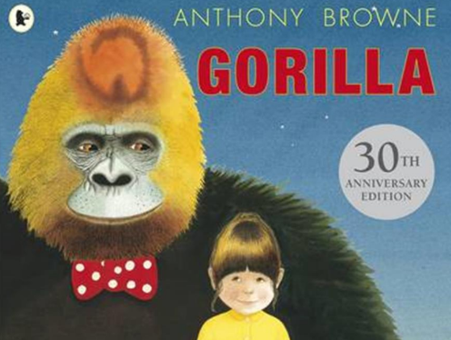  Gorilla by Antony Brown | 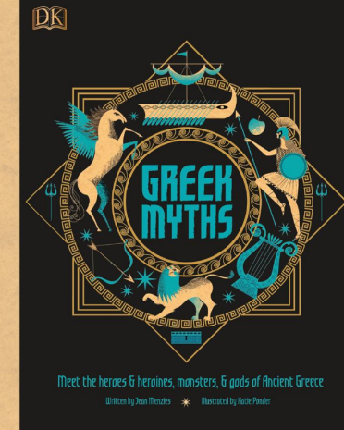  Greek Myths | 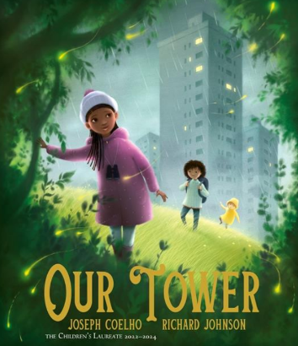  Our Tower by Joseph Coelho | 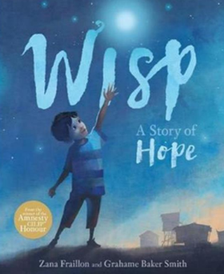  Wisp by Zana Fraillon  SMSC themed | 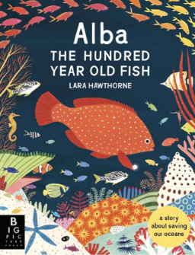  Alba the Hundred-Year-Old Fish by Lara Hawthorne  Environment Themed | 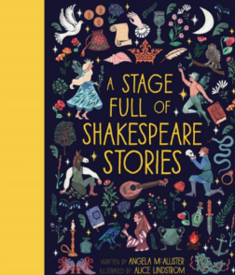  A Stage Full of Shakespeare Stories by Angela McAllister (Julius Cesear)  Shakespeare Themed
Outcomes & Genre | Outcome: Recount  To write a narrative based on the story of ‘Gorilla’ | Outcome: Narrative Myth | Outcome: Recount Nature Journal | Outcome: Fiction First Person Recount | Outcome: Non-Chronological Report in the form of an information board. | Outcome: Fiction Playscript
Mastery Key Progression | Grammar  Write expanded noun  phrases for description and specification (Y2)  Use prepositions to express time, place and cause  Group related ideas into  paragraphs  Use inverted commas to  punctuate direct speech | Grammar  Use conjunctions to express time, place and cause  Use punctuation correctly apostrophes for the possessive (singular)  Vocabulary  Build a rich and varied vocabulary  Composition  In narratives, create characters, settings and plot | Grammar  Use present and past tenses correctly and consistently including the progressive form and the present perfect form  Group related ideas into paragraphs  Use inverted commas to punctuate direct speech (using dialogue to show relationship between characters) | Grammar  Build an increasing range of sentence structures  Use adverbs to express time, place and cause  Choose nouns or pronouns appropriately for clarity and cohesion and to avoid repetition  Use inverted commas to punctuate direct speech | Grammar  Use a or an according to whether the next word begins with a vowel or a consonant  Group related ideas into paragraphs  In non-narrative material, use simple organisational devices including headings and subheadings to aid presentation  Use punctuation correctly, including apostrophes for the possessive (singular)  Vocabulary  Build a rich and varied vocabulary | Grammar  Extend the range of sentences with more than one clause by using a wider range of conjunctions (including: when, if because, although) Group related ideas into paragraphs  Use present and past tenses correctly and consistently, including the progressive form and the present perfect form (Consolidate punctuation covered so far)
Year Group Progression of Skills
Grammar (word) | Form nouns with a range of prefixes [for example super–, anti–, auto–]  Use a or an according to whether the next word begins with a vowel or consonant
Grammar (sentence) | Express time, place and cause using conjunctions [for example, when, before, after, while, so, because], adverbs [for example, then, next, soon, therefore], or prepositions [for example, before, after,
Grammar (paragraph) | Group related ideas into paragraphs  Use headings and sub-headings to aid presentation  Expressing time, place and cause using conjunctions, adverbs and prepositions  Expressing time, place and cause using conjunctions, adverbs and prepositions
Grammar (cohesion) | Use the present perfect form of verbs instead of the simple past [for example, He has gone out to play contrasted with He went out to play]
Grammar (punctuation) | Use inverted commas to punctuate direct speech
Composition | Plan writing:  Plan writing by discussing the structure, vocab and grammar of similar writing  Discuss and record ideas  Draft and write:  Compose and rehearse sentences orally  Build a varied and rich vocabulary  Build an increasing range of sentence structures  In narratives, create settings, characters and plot  In non-narrative use simple organisational devices such as heading, sub-headings  Evaluate and edit:  Assess the effectiveness of own and others’ writing  Propose changes to grammar and vocabulary to improve consistency  Proof-read for spelling and punctuation errors  Read aloud own writing using appropriate intonation and controlling the tone and volume so that the meaning is clear
Year 3 Key Word Lists
Common Expectation Words | Door, floor, poor, because, find, kind, mind, behind, child, children*, wild, climb, most, only, both, old, cold, gold, hold, told, every, everybody, even, great, break, steak, pretty, beautiful, after, fast, last, past, father, class, grass, pass, plant, path, bath, hour, move, prove, improve, sure, sugar, eye, could, should, would, who, whole, any, many, clothes, busy, people, water, again, half, money, Mr, Mrs, parents, Christmas – and/or others according to programme used.
High Frequency Words | Water, bear, find, these, live, away, can’t, more, began, say, good, again, I’ll, boy, soon, want, cat, round, animals, night, over, long, tree, never, narrator, how, things, magic, next, small, did, new, shouted, first, car, man, after, us, work, couldn’t, going, wanted, other, lots, three, where, eat, food, need, head, would, everyone, fox, that’s, king, or, our, though, baby, town, took, two, way, fish, I’ve, school, has, been, gave, around, think, yes, stop, mouse, every, home, play, most, something, garden, who, take, red, bed, fast, didn’t, thought, door, may, only, ran, dog, right, still, many, know, well, sea, found, laughed
Year 3 / 4 Word List | accident(ally) actual(ly) address answer appear arrive believe bicycle breath breathe build busy/business calendar caught centre century certain circle complete consider continue decide describe different difficult disappear early earth eight/eighth enough exercise experience experiment extreme famous favourite February forward(s) fruit grammar group guard guide heard heart height history imagine increase important interest island knowledge learn length library material medicine mention minute natural naughty notice occasion(ally) often opposite ordinary particular peculiar perhaps popular position possess(ion) possible potatoes pressure probably promise purpose quarter question recent regular reign remember sentence separate special straight strange strength suppose surprise therefore though/although thought through various weight woman/women

