Year 4 | Writing objectives are divided into ongoing objectives (objectives which will be taught throughout Year 1), and mastery objectives (objectives which will be specifically taught and mastered in one half term, then applied in subsequent writing units)
Year 4 Mastery Writing Objectives – Cycle A
School Term | Autumn 1 | Autumn 2 | Spring 1 | Spring 2 | Summer 1 | Summer 2
Pathways English Text | 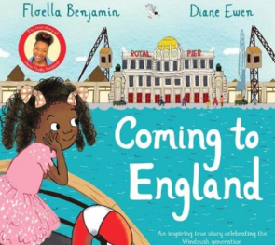  Coming to England by Floella Benjamin  Black Lives Themed | 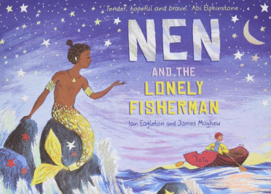  Nen and the Lonely Fisherman  By Ian Eagleton | 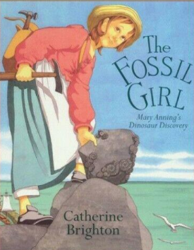  The Fossil Girl by Catherine Brighton | 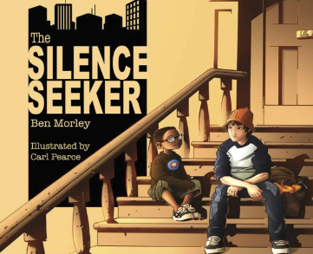  The Silence Seeker by Ben Morley  SMSC Themed | 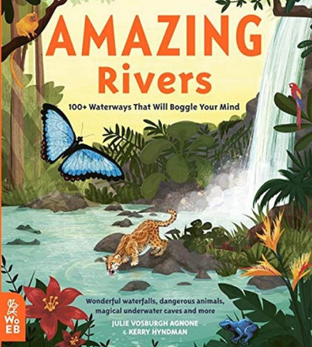  Amazing Rivers by Julie Vosburgh  Environment Themed | 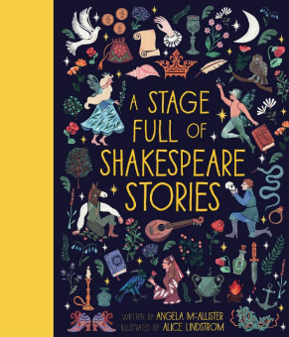  A Stage Full of Shakespeare Stories  (The Merchant in Venice)  Shakespeare Themed
Outcomes & Genre | Outcome: Recount Letter Writing | Outcome: Narrative Fantasy Story | Outcome: Recount  A Journal | Outcome: Fiction  Rewrite | Outcome: Information/ Persuasion Information Board | Outcome: Non- Fiction Information Text
Mastery Key Progression | Grammar  Expand noun phrases by the addition of modifying adjectives, nouns and prepositional phrases Use fronted adverbials Use commas after fronted adverbials Organise paragraphs around a theme (using fronted adverbials to introduce or connect paragraphs) | Grammar  Extend the range of sentences with more than one clause by using a wider range of conjunctions including when, if, because, although  Use Standard English for verb inflections  Use and punctuate direct speech  Vocabulary  Build a varied and rich vocabulary | Grammar  Expand noun phrases by the addition of modifying adjectives, nouns and prepositional phrases  Build an increasing range of sentence structures  Choose nouns or pronouns appropriately for clarity and cohesion and to avoid repetition Indicate possession by using the possessive apostrophe with plural nouns  The grammatical difference between plural and possessive ‘s | Grammar  Use Standard English for verb inflections  Organise paragraphs around a theme (using fronted adverbials to introduce or connect paragraphs)  Use present and past tenses correctly and consistently including the progressive form and the present perfect form  Use and punctuate direct speech (using dialogue to show relationship between two characters) | Grammar  Use present and past tenses correctly and consistently including the progressive form and the present perfect form  Indicate possession by using the possessive apostrophe with plural nouns.  Vocabulary  Build a varied and rich vocabulary | Grammar  Build a varied and rich vocabulary and an increasing range of sentence structures  Use paragraphs to organise information and ideas around a theme  Variety of verb forms used correctly and consistently  The grammatical difference between plural and possessive ‘s’
Year Group Progression of Skills
Grammar (word) | Recognise the grammatical difference between plural and possessive –s  Use standard English forms for verb inflections instead of local spoken forms [for example, we were instead of we was, or I did instead of I done]
Grammar (sentence) | Extend the range of sentences with more than one clause by using a wider range of conjunctions, including when, if, because, although  Expand noun phrases by the addition of modifying adjectives, nouns and preposition phrases (e.g. the teacher expanded to: the strict maths teacher with curly hair
Grammar (paragraph) | Use paragraphs to organise ideas around a theme  Use Fronted adverbials [for example, later that day, I heard the bad news.]  Choose appropriate pronouns or nouns within and across sentences to aid cohesion and avoid repetition
Grammar (punctuation) | Use commas after fronted adverbials  Indicate apostrophes to mark plural possession [for example, the girl’s name, the girls’ names]  Use inverted commas and other punctuation to indicate direct speech [for example, a comma after the reporting clause; end punctuation within inverted commas: The conductor shouted, “Sit down!”]
Composition | Plan writing:  Plan writing by discussing the structure, vocab and grammar of similar writing  Discuss and record ideas  Draft and write:  Compose and rehearse sentences orally  Build a varied and rich vocabulary  Build an increasing range of sentence structures  In narratives, create settings, characters and plot  In non-narrative use simple organisational devices such as heading, sub-headings  Evaluate and edit:  Assess the effectiveness of own and others’ writing  Propose changes to grammar and vocabulary to improve consistency  Proof-read for spelling and punctuation errors  Read aloud own writing using appropriate intonation and controlling the tone and volume so that the meaning is clear
Year 4 Key Word Lists
Common Expectation Words | door, floor, poor, because, find, kind, mind, behind, child, children*, wild, climb, most, only, both, old, cold, gold, hold, told, every, everybody, even, great, break, steak, pretty, beautiful, after, fast, last, past, father, class, grass, pass, plant, path, bath, hour, move, prove, improve, sure, sugar, eye, could, should, would, who, whole, any, many, clothes, busy, people, water, again, half, money, Mr, Mrs, parents, Christmas – and/or others according to programme used.
High Frequency Words | Water, bear, find, these, live, away, can’t, more, began, say, good, again, I’ll, boy, soon, want, cat, round, animals, night, over, long, tree, never, narrator, how, things, magic, next, small, did, new, shouted, first, car, man, after, us, work, couldn’t, going, wanted, other, lots, three, where, eat, food, need, head, would, everyone, fox, that’s, king, or, our, though, baby, town, took, two, way, fish, I’ve, school, has, been, gave, around, think, yes, stop, mouse, every, home, play, most, something, garden, who, take, red, bed, fast, didn’t, thought, door, may, only, ran, dog, right, still, many, know, well, sea, found, laughed
Year 3 / 4 Word List | accident(ally) actual(ly) address answer appear arrive believe bicycle breath breathe build busy/business calendar caught centre century certain circle complete consider continue decide describe different difficult disappear early earth eight/eighth enough exercise experience experiment extreme famous favourite February forward(s) fruit grammar group guard guide heard heart height history imagine increase important interest island knowledge learn length library material medicine mention minute natural naughty notice occasion(ally) often opposite ordinary particular peculiar perhaps popular position possess(ion) possible potatoes pressure probably promise purpose quarter question recent regular reign remember sentence separate special straight strange strength suppose surprise therefore though/although thought through various weight woman/women

Year 4 | Writing objectives are divided into ongoing objectives (objectives which will be taught throughout Year 1), and mastery objectives (objectives which will be specifically taught and mastered in one half term, then applied in subsequent writing units)
Year 4 Mastery Writing Objectives – Cycle B
School Term | Autumn 1 | Autumn 2 | Spring 1 | Spring 2 | Q | 11
Pathways English Text | 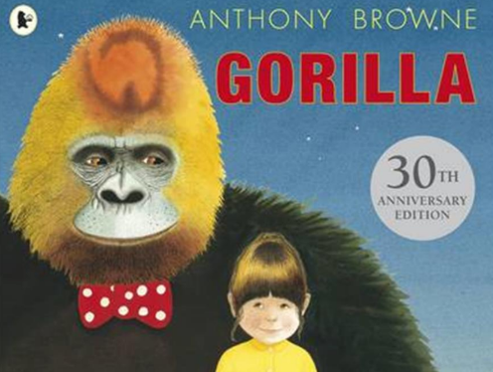  Gorilla by Antony Brown | 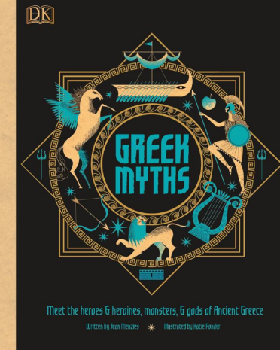  Greek Myths | 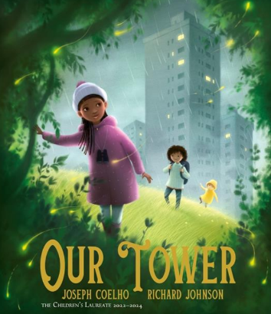  Our Tower by Joseph Coelho | 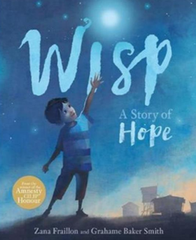  Wisp by Zana Fraillon  SMSC themed | 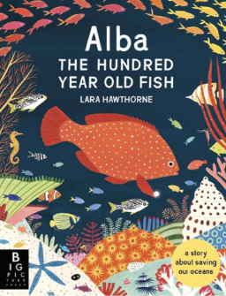  Alba the Hundred-Year-Old Fish by Lara Hawthorne  Environment Themed | 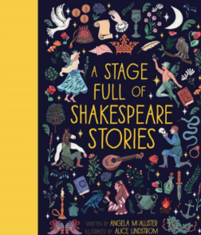  A Stage Full of Shakespeare Stories by Angela McAllister (Julius Cesear)  Shakespeare Themed
Outcomes & Genre | Outcome: Recount  To write a narrative based on the story of ‘Gorilla’ | Outcome: Narrative Myth | Outcome: Recount Nature Journal | Outcome: Fiction First Person Recount | Outcome: Non-Chronological Report in the form of an information board. | Outcome: Fiction Playscript
Mastery Key Progression | Grammar  Expand noun phrases by the addition of modifying adjectives, nouns and prepositional phrases Choose nouns or pronouns appropriately for clarity and cohesion and to avoid repetition Use fronted adverbials Organise paragraphs around a theme (Use paragraphs to organise and sequence more extended narrative structures)  Use commas after fronted adverbials | Grammar  Extend the range of sentences with more than one clause by using a wider range of conjunctions including when, if, because, although  Use Standard English for verb inflections  Recognise the grammatical difference between plural and possessive ‘s’  Indicate possession by using the possessive apostrophe with plural nouns  Vocabulary  Build a rich and varied vocabulary | Grammar  Variety of verb forms used correctly and consistently including the progressive and the present perfect forms  Use Standard English for verb inflections  Organise paragraphs around a theme (using fronted adverbial to introduce or connect paragraphs)  Use and punctuate direct speech (using dialogue to show the relationship between characters) | Grammar  Expand noun phrases by the addition of modifying adjectives, nouns and prepositional phrases  Choose nouns or pronouns appropriately for clarity and cohesion and to avoid repetition  Use and punctuate direct speech  Use commas after fronted adverbials | Grammar  Propose changes to grammar and vocabulary to improve consistency, including the accurate use of pronouns in sentences  Organise paragraphs around a theme (to organise and sequence more extended narrative structures)  Indicate possession by using the possessive apostrophe with plural nouns  Recognise the grammatical difference between plural and possessive ‘s’  Vocabulary  Build a rich and varied vocabulary | Grammar  Extend the range of sentences with more than one clause by using a wider range of conjunctions (including: when, if, because, although  Organise paragraphs around a theme  Variety of verb forms used correctly and consistently including the progressive and the present perfect forms  Vocabulary  Build a rich and varied vocabulary
Year Group Progression of Skills
Grammar (word) | Recognise the grammatical difference between plural and possessive –s  Use standard English forms for verb inflections instead of local spoken forms [for example, we were instead of we was, or I did instead of I done]
Grammar (sentence) | Extend the range of sentences with more than one clause by using a wider range of conjunctions, including when, if, because, although  Expand noun phrases by the addition of modifying adjectives, nouns and preposition phrases (e.g. the teacher expanded to: the strict maths teacher with curly hair
Grammar (paragraph) | Use paragraphs to organise ideas around a theme  Use Fronted adverbials [for example, later that day, I heard the bad news.]  Choose appropriate pronouns or nouns within and across sentences to aid cohesion and avoid repetition
Grammar (punctuation) | Use commas after fronted adverbials  Indicate apostrophes to mark plural possession [for example, the girl’s name, the girls’ names]  Use inverted commas and other punctuation to indicate direct speech [for example, a comma after the reporting clause; end punctuation within inverted commas: The conductor shouted, “Sit down!”]
Composition | Plan writing:  Plan writing by discussing the structure, vocab and grammar of similar writing  Discuss and record ideas  Draft and write:  Compose and rehearse sentences orally  Build a varied and rich vocabulary  Build an increasing range of sentence structures  In narratives, create settings, characters and plot  In non-narrative use simple organisational devices such as heading, sub-headings  Evaluate and edit:  Assess the effectiveness of own and others’ writing  Propose changes to grammar and vocabulary to improve consistency  Proof-read for spelling and punctuation errors  Read aloud own writing using appropriate intonation and controlling the tone and volume so that the meaning is clear
Year 4 Key Word Lists
Common Expectation Words | door, floor, poor, because, find, kind, mind, behind, child, children*, wild, climb, most, only, both, old, cold, gold, hold, told, every, everybody, even, great, break, steak, pretty, beautiful, after, fast, last, past, father, class, grass, pass, plant, path, bath, hour, move, prove, improve, sure, sugar, eye, could, should, would, who, whole, any, many, clothes, busy, people, water, again, half, money, Mr, Mrs, parents, Christmas – and/or others according to programme used.
High Frequency Words | Water, bear, find, these, live, away, can’t, more, began, say, good, again, I’ll, boy, soon, want, cat, round, animals, night, over, long, tree, never, narrator, how, things, magic, next, small, did, new, shouted, first, car, man, after, us, work, couldn’t, going, wanted, other, lots, three, where, eat, food, need, head, would, everyone, fox, that’s, king, or, our, though, baby, town, took, two, way, fish, I’ve, school, has, been, gave, around, think, yes, stop, mouse, every, home, play, most, something, garden, who, take, red, bed, fast, didn’t, thought, door, may, only, ran, dog, right, still, many, know, well, sea, found, laughed
Year 3 / 4 Word List | accident(ally) actual(ly) address answer appear arrive believe bicycle breath breathe build busy/business calendar caught centre century certain circle complete consider continue decide describe different difficult disappear early earth eight/eighth enough exercise experience experiment extreme famous favourite February forward(s) fruit grammar group guard guide heard heart height history imagine increase important interest island knowledge learn length library material medicine mention minute natural naughty notice occasion(ally) often opposite ordinary particular peculiar perhaps popular position possess(ion) possible potatoes pressure probably promise purpose quarter question recent regular reign remember sentence separate special straight strange strength suppose surprise therefore though/although thought through various weight woman/women

