Year 5 | Writing objectives are divided into ongoing objectives (objectives which will be taught throughout Year 1), and mastery objectives (objectives which will be specifically taught and mastered in one half term, then applied in subsequent writing units)
Year 5 Mastery Writing Objectives – Cycle A
School Term | Autumn 1 | Autumn 2 | Spring 1 | Spring 2 | Summer 1 | Summer 2
Pathways English Text | 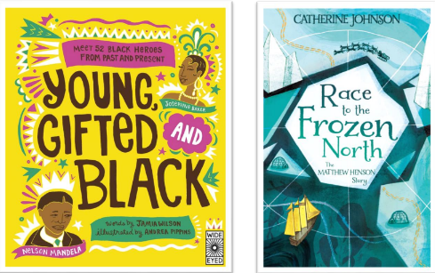  Race to the Frozen North by Catherine Johnson/ Young, Gifted and Black by Jamia Wilson.  Black Lives Themed | 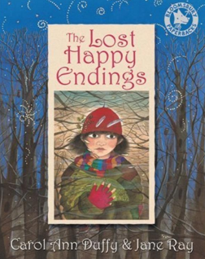  The Lost Happy Endings by Carol Ann Duffy | 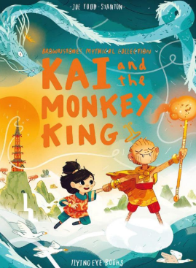  Kai and the Monkey King by Joe Todd-Stanton | 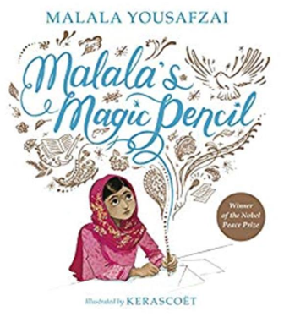  Malala’s Magic Pencil by Malala Yousafzai  SMSC themed | 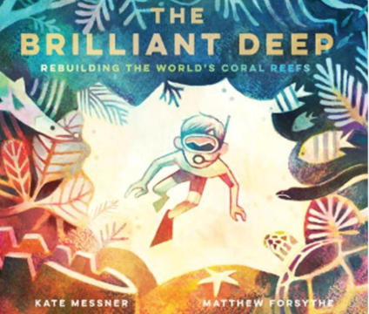  The Brilliant Deep by Kate Messner  Environment Themed | 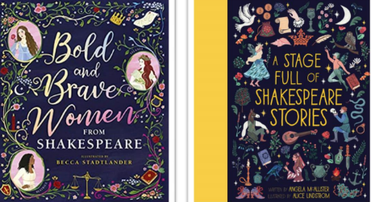  Bold and Brave Women from Shakespeare by Shakespeare Birthplace Trust  Shakespeare themed
Outcomes & Genre | Outcome: Recount  Diary | Outcome: Fiction Traditional Tale | Outcome: Fiction Adventure | Outcome: Recount Writing Autobiography | Outcome: Hybrid text  Information and Persuasion | Outcome: Recount Monologue
Mastery Key Progression | Grammar  Organise paragraphs around a theme with a focus on more complex narrative structures  Use commas after fronted adverbials (Y4 recap)  Use commas to clarify meaning or avoid ambiguity in writing  Composition  Plan writing by identifying audience and purpose | Grammar  Use expanded noun phrases to convey complicated information concisely  Use of inverted commas and other punctuation  Punctuate direct speech  Composition  Describe settings, characters and atmosphere  Integrate dialogue to convey character and advance the action | Grammar  Use expanded noun phrases to convey complicated information concisely Use relative clauses beginning with who, which, where, when, whose, that or an omitted relative pronoun  Link ideas across paragraphs using adverbials  Use commas to clarify meaning and avoid ambiguity in writing | Grammar  Variety of verb forms used correctly and consistently  Use commas to clarify meaning or avoid ambiguity in writing  Link ideas across paragraphs using adverbials of time, place and number  Use brackets, dashes or commas to indicate parenthesis  Extend the range of sentences with more than one clause by using a wider range of conjunctions (Y4) | Grammar  Use modal verbs to indicate degrees of possibility  Use devices to build cohesion within a paragraph Choose the appropriate register  Use brackets, dashes or commas to indicate parenthesis (recap)  Composition  Enhance meaning through selecting appropriate grammar and vocabulary | Grammar  Use relative clauses beginning with who, which, where, when, whose, that or an omitted relative pronoun  Use adverbs to indicate degrees of possibility  Link ideas using tense choices  Composition  Use a wider range of devices to build cohesion across paragraphs
Year Group Progression of Skills
Grammar (word) | Convert nouns or adjectives into verbs using suffixes [for example, –ate; –ise; –ify]  Use verb prefixes [for example, dis–, de–, mis–, over– and re–]
Grammar (sentence) | Use relative clauses beginning with who, which, where, when, whose, that, or an omitted relative pronoun  Use relative clauses beginning with who, which, where, when, whose, that, or an omitted relative pronoun
Grammar (paragraph) | Organise paragraphs around a theme with a focus on more complex narrative structures  Use devices to build cohesion within a paragraph [for example, then, after that, this, firstly]  Link ideas across paragraphs using adverbials of time [for example, later], place [for example, nearby] and number [for example, secondly] or tense choices [for example, he had seen her before]
Grammar (cohesion) | Link ideas using tense choices  Use modal verbs [for example, might, should, will, must] or adverbs [for example, perhaps, surely] to indicate degrees of possibility
Grammar (punctuation) | Use commas to clarify meaning or avoid ambiguity  Use brackets, dashes or commas to indicate parenthesis
Composition | Plan writing:  Identify the audience for and purpose of writing  Note and develop initial ideas, drawing on reading and research  Draft and write:  Enhance meaning through selecting appropriate grammar and vocabulary  Describe settings, characters and atmosphere  Integrate dialogue to convey character and advance the action  Précis longer passages  Use a wide range of devices to build cohesion  Use organisational and presentational devices  Evaluate and edit:  Propose changes to vocabulary, grammar and punctuation to enhance effects and clarify meaning  Use consistent and correct tense  Subject and verb agreement when using singular and plurals  Distinguish between the language of speech and writing  Choose the appropriate register  Proof-read for spelling and punctuation error
Year 5 Key Word Lists
Year 5/6 Word List | accommodate accompany according achieve aggressive amateur ancient apparent appreciate attached available average awkward bargain bruise category cemetery committee communicate community competition conscience* conscious* controversy convenience correspond criticise (critic + ise) curiosity definite desperate determined develop dictionary disastrous embarrass environment equip (–ped, –ment) especially exaggerate excellent existence explanation familiar foreign forty frequently government guarantee harass hindrance identity immediate(ly) individual interfere interrupt language leisure lightning marvellous mischievous muscle necessary neighbour nuisance occupy occur opportunity parliament persuade physical prejudice privilege profession programme pronunciation queue recognise recommend relevant restaurant rhyme rhythm sacrifice secretary shoulder signature sincere(ly) soldier stomach sufficient suggest symbol system temperature thorough twelfth variety vegetable vehicle yacht

Year 5 | Writing objectives are divided into ongoing objectives (objectives which will be taught throughout Year 1), and mastery objectives (objectives which will be specifically taught and mastered in one half term, then applied in subsequent writing units)
Year 5 Mastery Writing Objectives – Cycle B
School Term | Autumn 1 | Autumn 2 | Spring 1 | Spring 2 | Q | 11
Pathways English Text | 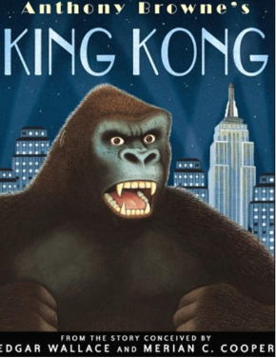  King Kong by Anthony Browne | 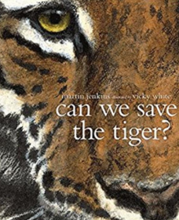  Can We Save The Tiger? By Martin Jenkins | 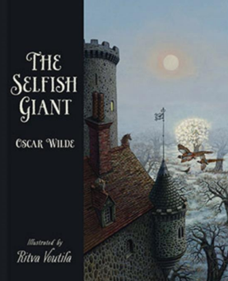  The Selfish Giant by Oscar Wilde and Ritva Voutila | 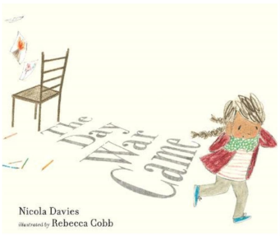  The Day the War Came by Nicola Davies, Leaf by Sandra Dieckmann  SMSC Themed |   Plastic Planet: How Plastic Came to Rule the World by Georgia Amson-Bradshaw  Environment Themed | 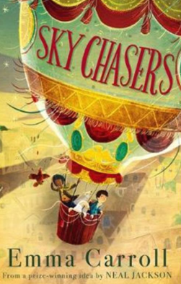  Sky Chasers by Emma Carroll
Outcomes & Genre | Outcome: Fiction Adventure Narrative | Outcome: Report Writing | Outcome: Fiction Classic Narrative | Outcome: Recount Persuasive Letter | Outcome: Hybrid Text  Information and Persuasion | Outcome: Fiction Adventure Story, including narrative from different viewpoints.
Mastery Key Progression | Grammar  Link ideas across paragraphs using adverbials  Use expanded noun phrases to convey complicated information concisely  Commas after fronted adverbials (Y4)  Use fronted adverbials (Y4)  Composition  Integrate dialogue to convey character and advance the action | Grammar  Use expanded noun phrases  to convey complicated  information concisely  Use modal verbs or adverbs to indicate degrees of possibility  Use brackets, dashes or commas to indicate  parenthesis  Composition  Plan writing by identifying  audience and purpose | Grammar  Use relative clauses  beginning with who, which, where, when, whose, that or an omitted relative pronoun  Choose the appropriate register  Use commas to clarify  meaning or avoid ambiguity  in writing  Composition  Integrate dialogue to convey character and advance the action | Grammar  Link ideas across paragraphs using adverbials and tense choices Variety of verb forms used correctly and consistently including modal verbs and the present perfect form  Use brackets, dashes or commas to indicate parenthesis | Grammar  Use relative clauses beginning with who, which, where, when, whose, that or an omitted relative pronoun  Use brackets, dashes or commas to indicate parenthesis  Use of the hyphen (to join a prefix to a root word)  Composition  Use devices to build cohesion within a paragraph | Grammar  Use adverbs to indicate degrees of possibility  Describe characters, settings and atmosphere  Use commas to clarify meaning or avoid ambiguity in writing  Composition  Enhance meaning through selecting appropriate grammar and vocabulary
Year Group Progression of Skills
Grammar (word) | Convert nouns or adjectives into verbs using suffixes [for example, –ate; –ise; –ify]  Use verb prefixes [for example, dis–, de–, mis–, over– and re–]
Grammar (sentence) | Use relative clauses beginning with who, which, where, when, whose, that, or an omitted relative pronoun  Use relative clauses beginning with who, which, where, when, whose, that, or an omitted relative pronoun
Grammar (paragraph) | Organise paragraphs around a theme with a focus on more complex narrative structures  Use devices to build cohesion within a paragraph [for example, then, after that, this, firstly]  Link ideas across paragraphs using adverbials of time [for example, later], place [for example, nearby] and number [for example, secondly] or tense choices [for example, he had seen her before]
Grammar (cohesion) | Link ideas using tense choices  Use modal verbs [for example, might, should, will, must] or adverbs [for example, perhaps, surely] to indicate degrees of possibility
Grammar (punctuation) | Use commas to clarify meaning or avoid ambiguity  Use brackets, dashes or commas to indicate parenthesis
Composition | Plan writing:  Identify the audience for and purpose of writing  Note and develop initial ideas, drawing on reading and research  Draft and write:  Enhance meaning through selecting appropriate grammar and vocabulary  Describe settings, characters and atmosphere  Integrate dialogue to convey character and advance the action  Précis longer passages  Use a wide range of devices to build cohesion  Use organisational and presentational devices  Evaluate and edit:  Propose changes to vocabulary, grammar and punctuation to enhance effects and clarify meaning  Use consistent and correct tense  Subject and verb agreement when using singular and plurals  Distinguish between the language of speech and writing  Choose the appropriate register  Proof-read for spelling and punctuation error
Year 5 Key Word Lists
Year 5/6 Word List | accommodate accompany according achieve aggressive amateur ancient apparent appreciate attached available average awkward bargain bruise category cemetery committee communicate community competition conscience* conscious* controversy convenience correspond criticise (critic + ise) curiosity definite desperate determined develop dictionary disastrous embarrass environment equip (–ped, –ment) especially exaggerate excellent existence explanation familiar foreign forty frequently government guarantee harass hindrance identity immediate(ly) individual interfere interrupt language leisure lightning marvellous mischievous muscle necessary neighbour nuisance occupy occur opportunity parliament persuade physical prejudice privilege profession programme pronunciation queue recognise recommend relevant restaurant rhyme rhythm sacrifice secretary shoulder signature sincere(ly) soldier stomach sufficient suggest symbol system temperature thorough twelfth variety vegetable vehicle yacht

