Year 6 | Writing objectives are divided into ongoing objectives (objectives which will be taught throughout Year 1), and mastery objectives (objectives which will be specifically taught and mastered in one half term, then applied in subsequent writing units)
Year 6 Mastery Writing Objectives – Cycle A
School Term | Autumn 1 | Autumn 2 | Spring 1 | Spring 2 | Summer 1 | Summer 2
Pathways English Text | 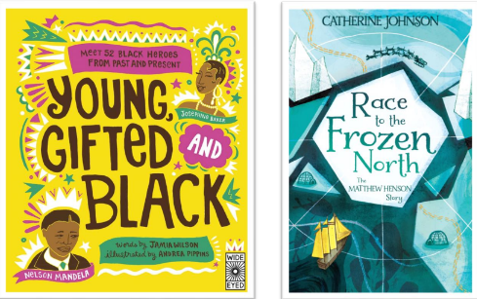  Race to the Frozen North by Catherine Johnson/ Young, Gifted and Black by Jamia Wilson.  Black Lives Themed | 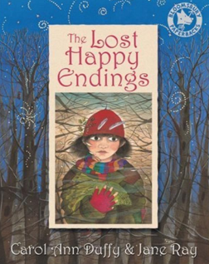  The Lost Happy Endings by Carol Ann Duffy | 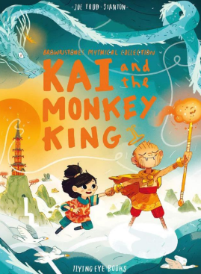  Kai and the Monkey King by Joe Todd-Stanton | 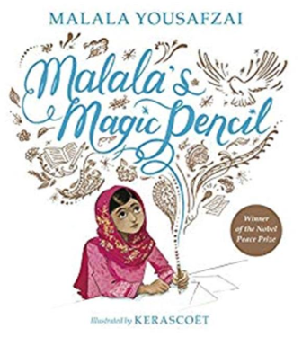  Malala’s Magic Pencil by Malala Yousafzai  SMSC themed | 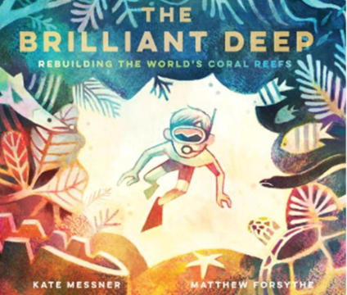  The Brilliant Deep by Kate Messner  Environment Themed | 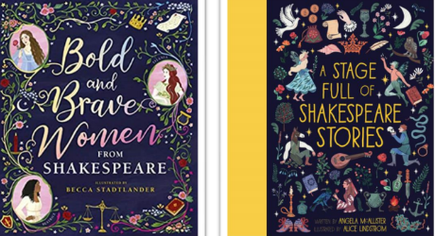  Bold and Brave Women from Shakespeare by Shakespeare Birthplace Trust  Shakespeare themed
Outcomes & Genre | Outcome: Recount  Diary | Outcome: Fiction Traditional Tale | Outcome: Fiction Adventure | Outcome: Recount Writing Autobiography | Outcome: Hybrid text  Information and Persuasion | Outcome: Recount Monologue
Mastery Key Progression | Grammar  Use passive verbs  Use commas to clarify meaning or avoid ambiguity in writing (Y5 recap)  Use hyphens to avoid ambiguity  Composition  Plan writing by identifying audience and purpose  Link ideas across paragraphs using a wider range of cohesive devices (Y5 recap) | Grammar  Use expanded noun phrases to convey complicated information concisely (Y5 recap) Use brackets, dashes or commas to indicate parenthesis  Composition  Describe settings, characters and atmosphere  Integrate dialogue to convey character and advance the action | Grammar  Use passive verbs Use a wider range of devices to build cohesion (adverbials and conjunctions) Use semi-colons, colons or dashes to mark boundaries between independent clauses  Composition  Enhance meaning through selecting appropriate grammar and vocabulary | Grammar  Recognise vocabulary and structures for formal speech and writing, including subjunctive forms Use a wider range of devices to build cohesion (synonyms)  Variety of verb forms used correctly and consistently including the present perfect form  Use colons or dashes to mark boundaries between independent clauses | Grammar  Recognise vocabulary and structures for formal speech and writing, including subjunctive forms Use a colon to introduce a list and use semi-colons within lists Punctuate bullet points consistently  Composition  Use a wider range of devices to build cohesion across paragraphs | Grammar  Propose changes to vocabulary, grammar and punctuation to enhance effects and clarify meaning  Choose the appropriate register  Use semi-colons, colons or dashes to mark boundaries between independent clauses
Year Group Progression of Skills
Grammar (word) | Recognise vocabulary and structures for formal speech and writing, including subjunctive forms
Grammar (sentence)
Grammar (paragraph) | Use layout devices  Link ideas across paragraphs using a wider range of cohesive devices [for example, repetition, adverbials, ellipsis
Grammar (Cohesion) | choices Use modal verbs [for example, might, should, will, must] or adverbs [for example, perhaps, surely] to indicate degrees of possibility Use the passive to affect the presentation of information in a sentence [for example, I broke the window in the greenhouse versus The window in the greenhouse was broken (by me)].  Use subjunctive forms such as If I were or Were they to come in some very formal writing and speech
Grammar (punctuation) | Use the semi-colon, colon and dash to mark the boundary between independent clauses [for example, it’s raining; I’m fed up]  Use the colon to introduce a list and use semi-colons within lists  Punctuate bullet points consistently  Use hyphens to avoid ambiguity [for example, man eating shark versus man-eating shark, or recover versus re-cover
Composition | Plan writing:  Identify the audience for and purpose of writing  Note and develop initial ideas, drawing on reading and research  Draft and write:  Enhance meaning through selecting appropriate grammar and vocabulary  Describe settings, characters and atmosphere  Integrate dialogue to convey character and advance the action  Précis longer passages  Use a wide range of devices to build cohesion  Use organisational and presentational devices  Evaluate and edit:  Propose changes to vocabulary, grammar and punctuation to enhance effects and clarify meaning  Use consistent and correct tense  Subject and verb agreement when using singular and plurals  Distinguish between the language of speech and writing  Choose the appropriate register  Proof-read for spelling and punctuation error
Year 6 Key Word Lists
Year 5/6 Word List | accommodate accompany according achieve aggressive amateur ancient apparent appreciate attached available average awkward bargain bruise category cemetery committee communicate community competition conscience* conscious* controversy convenience correspond criticise (critic + ise) curiosity definite desperate determined develop dictionary disastrous embarrass environment equip (–ped, –ment) especially exaggerate excellent existence explanation familiar foreign forty frequently government guarantee harass hindrance identity immediate(ly) individual interfere interrupt language leisure lightning marvellous mischievous muscle necessary neighbour nuisance occupy occur opportunity parliament persuade physical prejudice privilege profession programme pronunciation queue recognise recommend relevant restaurant rhyme rhythm sacrifice secretary shoulder signature sincere(ly) soldier stomach sufficient suggest symbol system temperature thorough twelfth variety vegetable vehicle yacht

Year 6 | Writing objectives are divided into ongoing objectives (objectives which will be taught throughout Year 1), and mastery objectives (objectives which will be specifically taught and mastered in one half term, then applied in subsequent writing units)
Year 6 Mastery Writing Objectives – Cycle B
School Term | Autumn 1 | Autumn 2 | Spring 1 | Spring 2 | Q | 11
Pathways English Text | 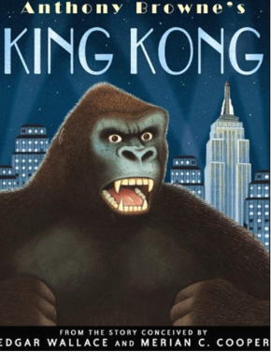  King Kong by Anthony Browne | 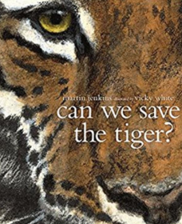  Can We Save The Tiger? By Martin Jenkins | 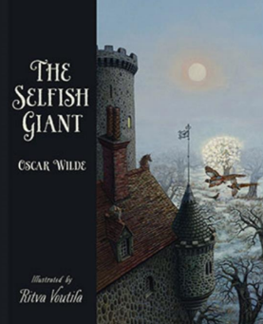  The Selfish Giant by Oscar Wilde and Ritva Voutila | 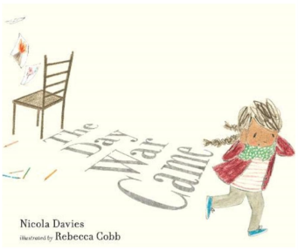  The Day the War Came by Nicola Davies, Leaf by Sandra Dieckmann  SMSC Themed |   Plastic Planet: How Plastic Came to Rule the World by Georgia Amson-Bradshaw  Environment Themed | 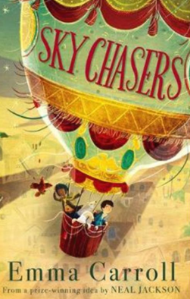  Sky Chasers by Emma Carroll
Outcomes & Genre | Outcome: Fiction Adventure Narrative | Outcome: Report Writing | Outcome: Fiction Classic Narrative | Outcome: Recount Persuasive Letter | Outcome: Hybrid Text  Information and Persuasion | Outcome: Fiction Adventure Story, including narrative from different viewpoints.
Mastery Key Progression | Grammar  Use expanded noun phrases to convey complicated information concisely Use passive verbs  Composition  Integrate dialogue to convey character and advance the action  Link ideas across paragraphs using a wider range of cohesive devices (Y5 recap) | Grammar  Use expanded noun phrases to convey complicated information concisely Use modal verbs and adverbs to indicate degrees of possibility Use brackets, dashes or commas to indicate parenthesis  Composition  Enhance meaning through selecting appropriate grammar and vocabulary | Grammar  Distinguish between the language of speech and writing Recognise vocabulary and structures for formal speech and writing, including subjunctive forms  Use passive verbs  Use semi-colons to mark boundaries between independent clauses | Grammar  Use passive verbs Variety of verb forms used correctly and consistently including the progressive and the present perfect forms  Use colons to mark boundaries between independent clauses  Composition  Use a wider range of devices to build cohesion  Use organisational and presentational devices to structure text | Grammar  Use relative clauses beginning with who, which, where, when, whose, that or an omitted relative pronoun (Y5)  Use a wider range of devices to build cohesion e.g. conjunctions, synonyms, adverbials, punctuation  Use a colon to introduce a list and use semi-colons within lists  Use hyphens to avoid ambiguity | Grammar  Recognise vocabulary and structures for formal speech and writing, including subjunctive forms Choose the appropriate register Use semi-colons, colons or dashes to mark boundaries between independent clauses  Composition  Identify the audience and purpose for writing
Year Group Progression of Skills
Grammar (word) | Recognise vocabulary and structures for formal speech and writing, including subjunctive forms
Grammar (sentence)
Grammar (paragraph) | Use layout devices  Link ideas across paragraphs using a wider range of cohesive devices [for example, repetition, adverbials, ellipsis
Grammar (Cohesion) | choices Use modal verbs [for example, might, should, will, must] or adverbs [for example, perhaps, surely] to indicate degrees of possibility Use the passive to affect the presentation of information in a sentence [for example, I broke the window in the greenhouse versus The window in the greenhouse was broken (by me)].  Use subjunctive forms such as If I were or Were they to come in some very formal writing and speech
Grammar (punctuation) | Use the semi-colon, colon and dash to mark the boundary between independent clauses [for example, it’s raining; I’m fed up]  Use the colon to introduce a list and use semi-colons within lists  Punctuate bullet points consistently  Use hyphens to avoid ambiguity [for example, man eating shark versus man-eating shark, or recover versus re-cover
Composition | Plan writing:  Identify the audience for and purpose of writing  Note and develop initial ideas, drawing on reading and research  Draft and write:  Enhance meaning through selecting appropriate grammar and vocabulary  Describe settings, characters and atmosphere  Integrate dialogue to convey character and advance the action  Précis longer passages  Use a wide range of devices to build cohesion  Use organisational and presentational devices  Evaluate and edit:  Propose changes to vocabulary, grammar and punctuation to enhance effects and clarify meaning  Use consistent and correct tense  Subject and verb agreement when using singular and plurals  Distinguish between the language of speech and writing  Choose the appropriate register  Proof-read for spelling and punctuation error
Year 5 Key Word Lists
Year 5/6 Word List | accommodate accompany according achieve aggressive amateur ancient apparent appreciate attached available average awkward bargain bruise category cemetery committee communicate community competition conscience* conscious* controversy convenience correspond criticise (critic + ise) curiosity definite desperate determined develop dictionary disastrous embarrass environment equip (–ped, –ment) especially exaggerate excellent existence explanation familiar foreign forty frequently government guarantee harass hindrance identity immediate(ly) individual interfere interrupt language leisure lightning marvellous mischievous muscle necessary neighbour nuisance occupy occur opportunity parliament persuade physical prejudice privilege profession programme pronunciation queue recognise recommend relevant restaurant rhyme rhythm sacrifice secretary shoulder signature sincere(ly) soldier stomach sufficient suggest symbol system temperature thorough twelfth variety vegetable vehicle yacht

