N

**Curriculum Overview**

**EYFS 2024-2025**

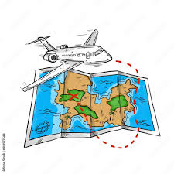

**My world. What makes it special?**

**This is me! What makes me special?**

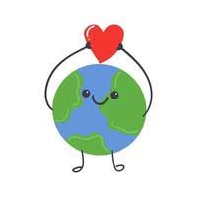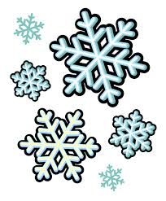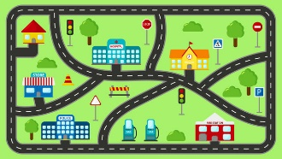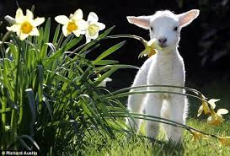

**N**

**Lets change the world!**

**Lets travel!**

**Amazing Animals**

**Brr…Its chilly!**

**Who am I?**

**Where I live**

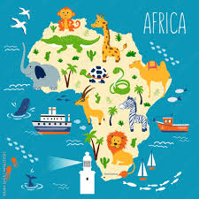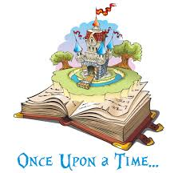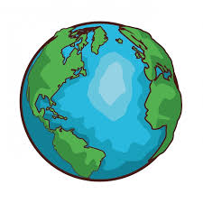

**R**

**Tale as old as time…**

**Helping hands**

**Poles apart!**

**Lets go on**

**an adventure!**

**What makes me special?**

**Growing**

**and**

**changing**