Student Uniform Policy
2023-2024

Drafted By E Postlethwaite
Date of Approval September 2023
Approved By IEB
Review Date September 2024

Abstract
Kidsgrove Secondary School has an official school uniform which all students are expected to wear. We are conscious of cost and have kept the dress as simple as possible. Most items can be purchased quite easily from a wide variety of shops. Blazers, Ties and PE Kit are available from our uniform supplier, Smart uniform.

Introduction
Our school uniform policy requires the support of parents and carers. We want our students to be smartly and sensibly dressed, and despite fashion trends, we aim to have a uniform which is practical, comfortable, and fit for purpose, but also reflects the ethos and values of the school.
A uniform also helps prepare our students for the world of work, ‘dressed for business’: the business being that of learning.
The policy is an agreement between the school and parents/carers that clarifies for parents/carers the required uniform as set out below. All students are required to wear PE uniform as stated below for PE and sports events.
Students are expected to wear their uniform with pride. Uniforms are to:
- show that they are part of Kidsgrove Secondary School. Wearing the uniform says we’re all in this together
- support students in being respectful
- give a sense of belonging for students
- give an identity to the community
- stop/ reduce peer pressure when it comes to clothes
- give a sense of order and purpose
- reduces bullying when everyone is dressed the same
Uniform appearance should be neat and tidy, with shirts tucked in, with top buttons fastened. Students are to travel to and from school in the correct uniform and to wear it appropriately during the school day and at all school functions unless stated otherwise.

Uniform

Blazer* | School Blazer (Blue Trim and new school logo for all year groups).
White shirt | Plain white long or short sleeved with a stiffened collar, top button and capable of taking a tie.
V neck school jumper (optional) | Black v neck school jumper.
Tie* | Blue and black stripe tie for all year groups.
Trousers | Tailored, black with waistband and zip. The trousers must be of normal length, without decorations. Tight fitting, low cut, jeans or ‘jean style’ trousers are not acceptable.
Skirt* (optional) | Tartan skirt (on the knee or slightly below allowing for 2 cm growth) worn without belt.
Socks/ tights | Black socks or black or neutral-coloured tights. Socks are not to be worn above the knee.
Shoes | Black low heeled shoes, enclosed at the heel and toe. No boots, trainers, canvas pumps or logos.

Miscellaneous

Outdoor coat | An outdoor coat to be worn in cold, wet weather over the blazer, and removed when inside school buildings. Non-uniform cardigans/sweatshirts or hoodies are not acceptable and are not permitted to be worn on the school site.
School bag | Waterproof and of an appropriate shape and size to carry A4 books/ folders.
Religious headwear | If required for religious purposes, religious headwear must be plain black with no pattern.
Hair | Hair should be of natural colour and no lines or extreme styles are permitted. Please contact the school prior to cutting or colouring hair if you are unsure of what is acceptable for school.
Jewellery | One plain stud in each ear and one watch is permitted. Hoops, dangly earrings, tunnels, stretchers, rings, necklaces, and bracelets are not allowed to be worn. Nose studs will need to be replaced with a clear retainer. Only school issued badges are to be worn on the blazer.
Nails and makeup | Any makeup and false tan should be subtle. False eyelashes, false/ acrylic nails and coloured nail varnish is not permitted.
Mobile phones | Mobile phones are not permitted to be used on the school site. If a student’s mobile phone goes off, or they are seen using it, this will be confiscated and parents/ carers will need to collect it from reception. When a mobile phone needs to be brought in for the journey to/ from the school, it will need to be turned off and stored securely in the bag and not in the blazer. The school takes no responsibility for mobile phones brought on site.

Items marked with an asterisk (*) are available from Smart Uniform only.

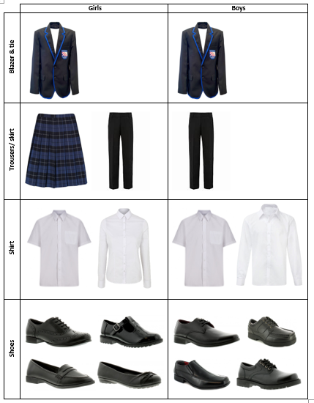

PE Kit

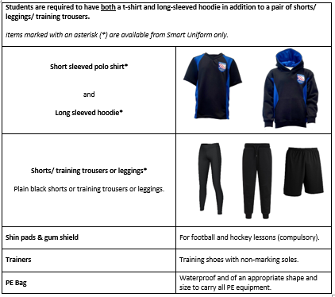
Students opting for GCSE PE also have the option of buying a GCSE PE kit package.

Students are expected to wear the correct school PE kit for every PE lesson.

We want all our students to be able to take part in PE lessons. This is our priority, and we want all students to be fully included in these lessons with appropriate PE Kit. If purchasing appropriate new PE kit is not possible due to financial hardship, then we are here to help. We will endeavour to stock a range of preloved PE kit items that will be available for students to use as needed. A voluntary and affordable contribution will be requested to be used to cover our costs of getting preloved items ready to be reused.

Funding and support of uniform
We want all our students to be able to access our school uniform. This is our priority, and we want all students to be fully included in these lessons with the correct school uniform. If purchasing appropriate new uniform is not possible due to financial hardship, then we are here to help. We will endeavour to stock a range of preloved school uniform items that will be available for students to use as needed. A voluntary and affordable contribution will be requested to be used to cover our costs of getting preloved items ready to be reused.

Mobile Phones and Electronic Devices

Whilst mobile phones have become helpful aids for parents/carers and children to communicate on the way to and from the school, their use in the school is strictly forbidden. Students may, therefore, carry phones at their own risk but any phone in use or on show during the school day will be confiscated and held in the Main Office. This includes headphones, iPods, MP3 players, cameras, or any other electronic device.

The unauthorised use of a camera (including on a phone or an iPad) constitutes an invasion of privacy, and as such is strictly forbidden. Should images of other student or staff thus obtained, or any material which brings the school’s name into disrepute, be published via the internet this may result in exclusion from the school.

Any valuable items are the responsibility of the student/parents/carers, and the school cannot take any responsibility for lost or stolen items, however we will endeavour to investigate any such problems if they arise.

Lost Property
Within a school a vast amount of lost property is generated. All items should be clearly marked with the student’s name so that they can be returned. Any property that is not claimed will be recycled after an appropriate period.

Monitoring and Evaluation
The position with relation to school dress is monitored by all staff with form tutors being the people who see students first thing in the morning. Subject staff will reinforce standards before, during and at the end of lessons. All staff will reinforce standards around school throughout the day.
Sanctions may be issued if students do not follow the uniform policy to reinforce this; examples may include uniform report, loss of social time. Serious and repeated violations of the policy may result in further sanctions.
Repeated uniform issues are also communicated with parents and discussed to resolve these.
Reminders are given to parents through the school’s regular communications.
The school has the final decision over school uniform.

