Investigating dissolving-Year 6

Name……………………………………………………………………………………………………

Hypothesis.

­­­­­As the amount of ………………………………………. increases, the time it takes to dissolve ……………………………………………………. .

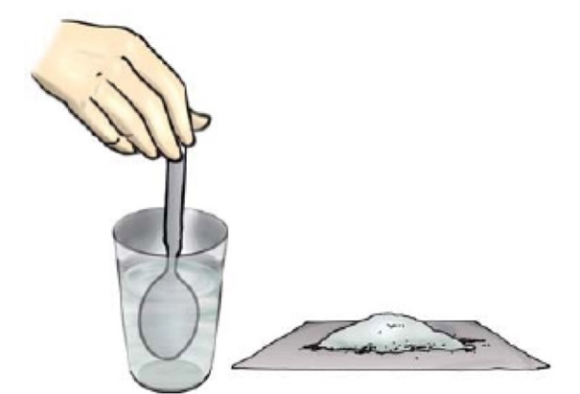Diagram.

glass

50 cm3 cold tap water water

teaspoonb

sugar

Method.

1. Add 50 cm3 cold tap ……………………………………………. into a glass.
2. Add 1 level teaspoon of ……………………………………. to the water and stir with the spoon until all of the sugar is …………………………..…………………….
3. Measure the …………………………….……………. taken to dissolve using a timer.
4. Record the time into a ………………………………….……….. table.
5. Repeat steps 1-4 for 2, 3, 4 and 5 teaspoons of ………………………………………………...

Variables.

Independent (what we change) - ………………………………………………………………………………………….

Dependent (what we measure) - ………………………………………………………………………………………….

Control (what we keep the same) - ……………………………………………………………………………………… ..........................................................................................................................................................

Results.

|  |  |
| --- | --- |
| Teaspoons of sugar/number | Time to dissolve/min |
| 1 |  |
| 2 |  |
| 3 |  |
| 4 | ` |
| 5 |  |

Graph

Time to dissolve/min

A line graph to show the ……………………………. taken for sugar to …………………………………..

|  |  |  |  |  |  |  |  |  |  |  |  |  |  |  |  |  |  |  |  |
| --- | --- | --- | --- | --- | --- | --- | --- | --- | --- | --- | --- | --- | --- | --- | --- | --- | --- | --- | --- |
|  |  |  |  |  |  |  |  |  |  |  |  |  |  |  |  |  |  |  |  |
|  |  |  |  |  |  |  |  |  |  |  |  |  |  |  |  |  |  |  |  |
|  |  |  |  |  |  |  |  |  |  |  |  |  |  |  |  |  |  |  |  |
|  |  |  |  |  |  |  |  |  |  |  |  |  |  |  |  |  |  |  |  |
|  |  |  |  |  |  |  |  |  |  |  |  |  |  |  |  |  |  |  |  |
|  |  |  |  |  |  |  |  |  |  |  |  |  |  |  |  |  |  |  |  |
|  |  |  |  |  |  |  |  |  |  |  |  |  |  |  |  |  |  |  |  |
|  |  |  |  |  |  |  |  |  |  |  |  |  |  |  |  |  |  |  |  |
|  |  |  |  |  |  |  |  |  |  |  |  |  |  |  |  |  |  |  |  |
|  |  |  |  |  |  |  |  |  |  |  |  |  |  |  |  |  |  |  |  |
|  |  |  |  |  |  |  |  |  |  |  |  |  |  |  |  |  |  |  |  |
|  |  |  |  |  |  |  |  |  |  |  |  |  |  |  |  |  |  |  |  |
|  |  |  |  |  |  |  |  |  |  |  |  |  |  |  |  |  |  |  |  |
|  |  |  |  |  |  |  |  |  |  |  |  |  |  |  |  |  |  |  |  |
|  |  |  |  |  |  |  |  |  |  |  |  |  |  |  |  |  |  |  |  |
|  |  |  |  |  |  |  |  |  |  |  |  |  |  |  |  |  |  |  |  |
|  |  |  |  |  |  |  |  |  |  |  |  |  |  |  |  |  |  |  |  |
|  |  |  |  |  |  |  |  |  |  |  |  |  |  |  |  |  |  |  |  |
|  |  |  |  |  |  |  |  |  |  |  |  |  |  |  |  |  |  |  |  |
|  |  |  |  |  |  |  |  |  |  |  |  |  |  |  |  |  |  |  |  |

Teaspoons of sugar/number

Conclusion

My results show that as ………………………………………………………. increases, time to dissolve ………………………………………...

Student follow-up

You could repeat this investigation but using warm water instead of cold water-what do you think will happen? Could you write a hypothesis that you could test?