[](https://www.google.co.uk/url?sa=i&url=https%3A%2F%2Fen.wikipedia.org%2Fwiki%2FThe_Great_Wave_off_Kanagawa&psig=AOvVaw3Dyq1uBhk2V2cLAW05ij_j&ust=1585255872039000&source=images&cd=vfe&ved=0CAIQjRxqFwoTCJiaxr3AtugCFQAAAAAdAAAAABAD)

Literacy

* Rumble in the Jungle
* <https://www.youtube.com/watch?v=fgdfofQegaM>
* Walking through the Jungle
* <https://www.youtube.com/watch?v=GDtsDL7-5AY>
* <https://www.twinkl.co.uk/go/resource/tg-ga-149-level-1-phonics-the-zoo-environmental-sounds-game>

Being Imaginative

* Pretend to move like your favourite animals.
* What are the sounds the animals make?

Physical Development

* Cutting snake to hang
* Sticky kids walking through the jungle
* https://www.youtube.com/watch?v=I1T__ThnU5E
* Threading pasta to make a snake
* Funky monkey

D.T.

* Paint or draw your favourite animal from the Jungle
* Cutting paper to make a paper chain snake
* Can you make an egg box crocodile?

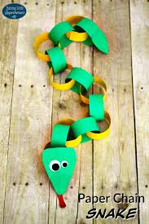

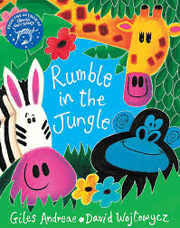

**Homework Menu**

**Preschool**



Knowledge & Understanding of the World

* Visit Chester zoo web site to find out lots about different animals.
* <https://www.chesterzoo.org/app/uploads/sites/5/2020/04/Poison-Dart-Frog-Colouring-Activity-1.pdf>
* <https://www.chesterzoo.org/schools/resources/how-to-create-a-nature-rubbing/>

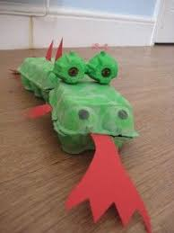

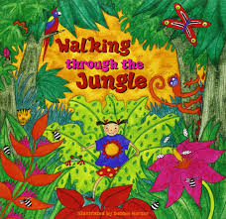

Maths

* Five Little Speckled Frogs
* Five Little Monkeys
* <https://www.twinkl.co.uk/go/resource/tg-ga-31-too-many-frogs-counting-up-to-10-game>

PHSE

* Can you remember when you last went to visit a zoo or farm with your family?
* Do you have any photos from your trip?
* Talk to your family about what you enjoyed the most.

