[](https://www.google.co.uk/url?sa=i&url=https%3A%2F%2Fen.wikipedia.org%2Fwiki%2FThe_Great_Wave_off_Kanagawa&psig=AOvVaw3Dyq1uBhk2V2cLAW05ij_j&ust=1585255872039000&source=images&cd=vfe&ved=0CAIQjRxqFwoTCJiaxr3AtugCFQAAAAAdAAAAABAD)

**Literacy**

[PhonicsPlay](https://www.phonicsplay.co.uk/) (link to website)

Username: Jan21 Password: Home

This website has interactive games for children to play. After using the log in, select the resources tab and Phase 1 and enjoy exploring the different sound games.

Share a story with someone in your family. Talk about the pictures and what you think might happen.

**Physical Development**

Ever wondered how animals move? Miss Linky will show us how we can stay active and move in different ways with our bodies. [Farm Animal Exercise | Indoor Workout for Children | No Equipment Needed PE Lesson for Kids - YouTube](https://www.youtube.com/watch?v=iHJ2fW3iJVE)

How are you getting on practising doing up your coats? For different practise, this week we can try some more getting dressed activities. Can you put your own socks on?

Communication and Language

The ladybird in our story this week talks to the animals and they make their animal sounds. Try this quiz and see which animal sounds you know. [Sounds on the Farm quiz - CBeebies - BBC](https://www.bbc.co.uk/cbeebies/puzzles/down-on-the-farm-animal-sounds-quiz)

Which ways can you communicate with other people? Try using different ways during the week.

Maybe try to learn some Makaton sign language with Mr Tumble [Something Special - CBeebies - BBC](https://www.bbc.co.uk/cbeebies/shows/something-special)

**Expressive Art and Design**

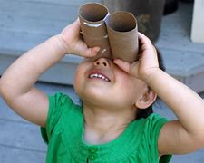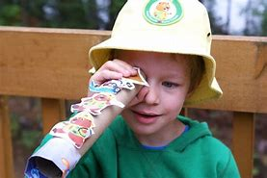Can you make some binoculars from items in your home like toilet paper rolls? Or maybe a telescope?

**Homework Menu**

**Preschool**



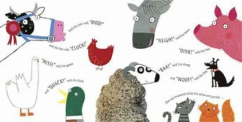

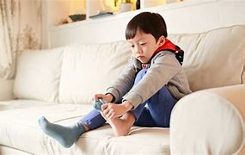

**What the ladybird heard**

[What the Ladybird Heard | What the Labybug Heard | stories read aloud - YouTube](https://www.youtube.com/watch?v=Eu9mPX7DuLA)

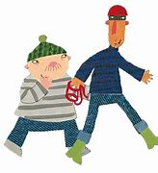

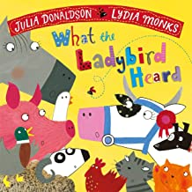

**Understanding the World**

Lanky Len and Hefty Hugh had a map of the farm in our story.

When you go out for a walk maybe you could create a map of where you are going?

If you’ve made the binoculars you could take them with you. What can you see on your walk? Did you see any animals?

Or you could create a picture of somewhere you have been or would like to go?

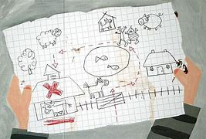

**Mathematics**

This week will be practising our number recognition from 1-5, our friendly ladybird will help us.

The link has games to play with the number of spots on the ladybird [Ladybird Spots - Counting, Matching and Ordering game (topmarks.co.uk)](https://www.topmarks.co.uk/learning-to-count/ladybird-spots#:~:text=Count%20spots%20on%20ladybirds%20up%20to%2010%20and,so%20that%20children%20can%20play%20the%20games%20repeatedly.)

Or maybe you could create your own ladybird and put your own spots onto it. How many spots does it have? Has it got the same number of spots as your age? How old are you?

**Personal, Social and Emotional**

We can practise our turn taking skills with games like “I spy”. You can try using colours or sounds. [Farm-Animals-I-Spy_Page_4.png (1700×2200) (giftofcuriosity.com)](https://www.giftofcuriosity.com/wp-content/uploads/2020/09/Farm-Animals-I-Spy_Page_4.png) (Link to I spy poster to support this if needed.)

Let’s play a hide and seek game. Can someone in the house hide a toy (no peeking) and then listening to the instructions you can go and find it? You will need to listen carefully to the clues and maybe ask for help if needed.

