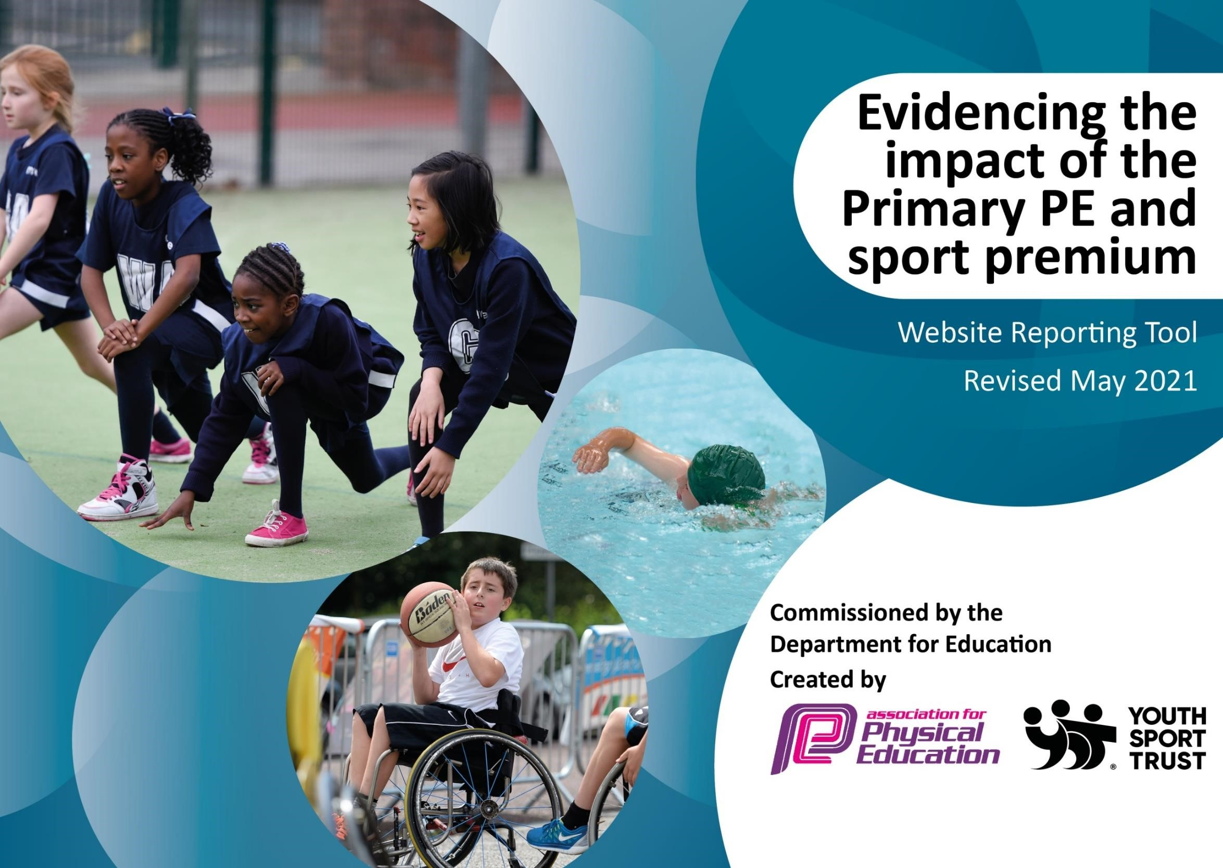

Spend and Review for 2022-23

Support for review and reflection - considering the 5 key indicators from DfE, what development needs are a priority for your setting and your pupils now and why? Use the space below to reflect on previous spend and key achievements and areas for development.

Key achievements to date until July 2023: | Areas for further improvement and baseline evidence of need:
- In the Summer Term, Sports Day took place. Key Stage 2 was adapted this year to offer more events for the children to take part in. The event is competitive, competing for points for their coloured house teams. Key Stage 1 was split into two parts, one being a round robin event working as a team and the second part being a competitive individual competition.  - Sporting Enrichment days were planned throughout the year. This promoted the introduction of alternative sports and to encourage children who may not enjoy traditional school team sports or do not have the opportunity out of school to join sporting clubs.  - We further developed our link with the Witchford School Sports Partnership (WSSP), developing enhanced sporting opportunities for children and support to the school on the teaching of PE.  - School Parliament Sports Ministers were elected to assist in developing sport across the school.  - Play Leaders were trained and throughout the year took an active part in supporting lunchtime play.  - We applied and were awarded the Silver School Games Mark.  - Made new links with the wider community and were involved with: Peterborough United Football Club, Cromwell College Sports Leaders, Pro-kick, Chatteris Dance Club, Chance to Shine Cricket; which opened opportunities and links with Chatteris Cricket Club, we were invited to the National Speed Stacking Competition.  - Encouraged children to be more physically active at play and lunchtimes by; having an outside agency playing set games, year 6 sports leaders to support play and by setting up a zoning system and purchasing new equipment to support this.  - Took part in various inter-school competitions throughout the year, offering training prior to the event to prepare the children. In these competitions we did well, always finishing in the top 3.  - Equipment purchased to support children in the SEMH provision to target and continually develop their fine and gross motor skills.  - Booster swimming sessions were planned for year 6 to support children who needed additional swimming lessons.  - An outside agency has been used to help support children in being physically active and involved in team games at lunchtimes.  - Sports Festivals that were non-competitive were planned to encourage children who want to take part in sport for fun rather than competitively in KS 1 and KS 2.  - Team teaching took place to support and train teachers with sports coaches.  - A PE equipment audit took place and additional equipment was purchased to enable us to provide high quality equipment to support and enable high quality PE sessions to take place.  - Additional training in PE was put in place to support ECT’s working in school.  - PE-coordinator attended termly network meetings to keep up-to-date with managing the subject.  - Key focus for skipping took place at the beginning of the year, with a celebration day taking place to promote the activity within school. | - Enter more sports festivals so sporting opportunities are offered to a broader range of children and year groups.  - Take part in a festival that focuses on SEND children to participate in.  - Further raise the profile of PE and sport across the school.  - Improve the general fitness and stamina of children’s fitness, by setting up a running and skipping focus.  - Continued investment in resources for the teaching of PE to maintain a good level of high quality equipment whilst broadening the resources so we can offer a wider range of sports.  - Increase opportunities for children to be more physically active throughout the day, target children with specific needs.  - Continue to develop and support the lunchtime active play.  - Continue to use Sports Premium to enhance children’s mental health and wellbeing.  - Continue to support staff training and awareness of high quality PE teaching. Research and look into the curriculum to further develop this.  - Build on links with local sports clubs and coaches to encourage uptake of out of school hours sport.  - Continue to develop the curriculum and supporting teachers in their knowledge.

Outcomes for end of the academic year of 2022-23: | Outcomes
Meeting national curriculum requirements for swimming and water safety. | 69%
What percentage of your current Year 6 cohort swim competently, confidently and proficiently over a distance of at least 25 metres? | 80%
What percentage of your current Year 6 cohort use a range of strokes effectively [for example, front crawl, backstroke and breaststroke]? | 69%
What percentage of your current Year 6 cohort perform safe self-rescue in different water-based situations? | 89%
Schools can choose to use the Primary PE and sport premium to provide additional provision for swimming but this must be for activity over and above the national curriculum requirements. Have you used it in this way? | We used some of the Sports Premium for Year 6 booster swimming sessions.

Amount Allocated for the academic year 2022-23:
Total fund allocated: £19,290

Action Plan and Budget Tracking
Capture your intended annual spend against the 5 key indicators. Clarify the success criteria and evidence of impact that you intend to measure to evaluate for pupils today and for the future.

Key indicator 1: The engagement of all pupils in regular physical activity. |  |  |  |  | Percentage of total allocation:
 |  |  |  |  | 42.72%
Intent | Implementation |  | Impact |  | Final Review
Access to high quality resources during PE lessons.  Ensure quantity of resources needed to enable access for all. | Purchase additional PE resources so that all sports and activities taught in PE sessions are fully resourced. | £2000 | The curriculum has been successfully delivered with the correct resources available to assist in this. |  | Set up an audit at the beginning of the school year to assess and plan for purchasing new equipment to meet the needs of the curriculum.
Access to increased range of high quality resources to facilitate active play at break and lunchtimes. | Purchase of additional playtime resources and replacement of lost or broken resources.  Children have access to a wider range of resources, which encourage active play both on the playground and on the school field. | £500 | Children have been introduced to and encouraged to play a range of sporting activities including: skipping, hula hooping, basketball, football, in year groups, balancing equipment. |  | Continue to develop children being physically active on focused tasks.
Purchase of resources that facilitate active play in EYFS. | Purchase a range of play equipment for the enclosed outside area that support children’s balance, strength, agility and team building skills in EYFS children. | £240 | Basic equipment has been purchased to support children in their physical activity in their continuous provision environment. |  | Audit to take place of equipment ready for next academic year when EYFS unit relocates.
Outside Agency to support children to be more physically active during lunchtimes. Children to become engaged in high quality play/regular activity throughout lunchtime break to increase: mental wellbeing, pupil aerobic activity, team building and communication; balance, co-ordination and core strength; skill and to encourage pupils to independently become more active. | Organised activities planned at lunchtimes with specific year groups to encourage children to become more physically active.  Develop a running focus within school. | £5,500 | Children engaged with team games and more physically active during lunchtimes.  Lunchtimes monitored games and number of children involved.  Focus Key Stages split throughout the week.  Focus sessions for girls and boys has also been targeted from pupil feedback. |  | Games and activities change to engage a bigger range of children and abilities.  Look into focusing on children building on stamina and fitness next academic year.
TOTAL |  | £8,240

Key indicator 2: The profile of PESSPA being raised across the school as a tool for whole school improvement. |  |  |  |  |  | Percentage of total allocation:
 |  |  |  |  | 3.11%
Intent | Implementation |  | Impact
Invest in PE equipment to specifically support the teaching in the new SEMH provision. | The SEMH provision will target specific pupils who need intervention or enrichment in their curriculum. The development of this more focused curriculum will involve the children becoming more physically active and to organise activities to improve their fine and gross motor skills. | £200 | Purchasing equipment has meant fine motor skills have been a focus in the SEMH unit, which is a focus area in the provision.  Equipment has been purchased to support gross motor development and give opportunities for children to be physically active to support them in their learning. Having the equipment has given the children greater opportunities to have active learning breaks. |  | Planned sessions organised to focus children on fine and gross motor skills.  Focused fine and gross motor sessions have been planned for in the SEMH provision due to resources being purchased, which can continue to be planed for and developed in the next academic year.
Primary Leadership Training for year 6 pupils to become Playground Leaders. | For children in Year 6 to have training and then become Playground Leaders. The Leaders will support, organise and motivate pupils at play and lunchtimes to be more physically active.  To focus the engagement of pupils in regular physical activity promoting healthy active lifestyles. | £400 | Training has been undertaken and the children over the year have been time tabled different Key Stages to support. All children have responded well to this. Impact children can confidently set up and organise games/activities for children. |  | Book in training session ready for Autumn Term for new Play Leaders to be trained.
TOTAL |  | £600

Key indicator 3: Increased confidence, knowledge and skills of all staff in teaching PE and sport. |  |  |  |  | Percentage of total allocation:
 |  |  |  |  | 13.22%
Intent | Implementation |  | Impact
Staff are given the opportunity to go on training to support their teaching. | Cambridgeshire PE training brochure is circulated termly to offer and support teaching staff training and coaching opportunities.  WSSP offers training/team teaching to support inexperienced teachers. Assess the need within school. | £1000 (£240 per teacher for team teaching from the WSSP) | Coaches came in to team teach cricket, which upskilled teachers knowledge of the subject, The impact has been teachers delivering lessons  with increased confidence and skills. Resulting in children’s learning and experiences being enhanced.  Tag rugby CPD session took place, four members of staff took part in to broaden their knowledge of the sport. Impacting their teaching of the subject and the tag rugby club which took place and successfully coming second in the local tournament.  2 x ECTs went on a CPD course specifically for ECT’s. Impacting their personal knowledge and skills of teaching PE.  1 x ECT went on a trust gymnastics course to develop her knowledge of teaching gymnastics which will make an impact in her confidence and knowledge of the subject. |  | Continue to use outside agencies to support staffs professional development.  Review staff confidence and competence in delivering high quality PE and school sport and allocate staff to upcoming CPD opportunities  Further 1:1 lesson observations to monitor staff effectiveness and confidence to enable a plan for staff development.
Witchford School Sports Partnership membership which offers:  -Transport to competitions  -Access to competitions and events  -Curriculum coaching  -Communication, support and CPD Training. | Support for the PE coordinator and through the membership allows us to be involved with competitions and festivals with other schools.  Team teaching is also set up to support and develop teacher’s skills. | £1550 | Increased participation opportunities in competitive sport.  The quality of teaching in Physical Education and Sport has improved through up-to-date support and advice given.  Staff across the school have increased confidence knowledge and skills in teaching PE and School Sport, through team teaching opportunities. |  | A focus this year was inter school competitions and sports festivals. We took part in 8 inter-school events throughout the year.  PE coordinator attended three CPD sessions for PE leaders to update knowledge.  Coaching sessions took place to support teachers and enrich children’s experiences in PE.
TOTAL |  | £2,550

Key indicator 4: Broaden experience of a range of sports and activities offered to all pupils. |  |  |  |  |  | Percentage of total allocation:
 |  |  |  |  |  | 25.4%
Intent | Implementation |  |  |  | Impact
School to hold Sport Enrichment Days throughout the year targeting different year groups.  To offer children a broad experience of sporting activities. | Focus for this year will be skipping. The aim is to make children more physically active and focused.  Book external coaches and  to lead sessions. | £2,000 | Enrichment activities were planned for to broaden children’s sporting experiences. The focus was on activities, which children would not typically experience outside of school.  Increased pupil awareness of sporting opportunities available and in the local environment, impacting on children becoming more physically active.  Through experiencing new sports children have improved physical, technical, tactical and mental understanding of sport. This has also impacted on their personal skills, which children can build on from the PE lessons, i.e. communication, teamwork, fair play and leadership.  Engaged (or re-engaged) disaffected pupils. Impacting on children becoming more physically aware or active and participating in more sporting activities. |  |  | Book coaches and sports activities well in advance, for next academic year.  Plan a rolling timetable so all year groups get to experience different sports.  Focus on specific groups of children.
Year 6 children offered Swimming Booster sessions to increase swimming and water safety confidence. | Summer 2 weekly swimming sessions booked for year 6 children to develop swimming and water safety skills. | £900 | From starting data before the booster session took place an improvement was evident of children’s confidence and awareness of water safety. |  |  | Pass this data onto secondary school to make them aware of children who still need support in this area, as funding is available to continue to develop the children into confident swimmers.  Rebook booster sessions for next academic year.
Pupils from KS1 & 2 to attend local sport festivals where they work with other local schools.  Children experience a broader range of sports in a non-competitive environment. The aim is to engage and inspire children to be more physically active. | Transport planned and paid for so no cost to pupils. | £1,500 | We took part in one, which was a great success, for year 2. Feedback from children was positive and all took an active part in the session giving them experience of taking part in a sporting event outside of school in a large setting.  Girl’s football festival took place which focused on girls that had no experience in football. This engaged a group of children who had not experienced a sporting activity outside of school before. |  |  | To enter more non-competitive festivals to encourage more children to become actively engaged with physical activity.
TOTAL |  | £4,900

Key indicator 5: Increased participation in competitive sport. |  |  |  |  |  | Percentage of total allocation:
 |  |  |  |  |  | 15.55%
Intent | Implementation |  |  |  | Impact
To attend local sports competitions to work alongside and compete against other local schools. Ensure a range of children are given the opportunity to compete and represent the school. | Transport to events planned and paid for so no cost to pupils. Take 2 teams to events if possible to ensure a range of children and abilities can be involved. | £1,500 | We entered 8 competitions over the year. Children looked forward to this and often asked about it for weeks beforehand.  The children understood the importance of taking part and the values of winning, losing and fair play.  Children took pride in representing the school and signing up to training sessions, which ran prior to the competition to prepare children.  Feedback from the children was positive and they expressed they enjoyed being part of a team and wearing the Kingsfield kit.  Through children taking part in competitions teachers have seen an Increase in confidence and standards in invasion games in PE from the children who took an active role in the competitions  Teamwork has also been a focus in PE and throughout the curriculum, building resilience in children for winning or losing.  As the year has gone on Sportsmanship and gamesmanship have improved.  Through the training and preparation for competitions Kingsfield is becoming more competitive. This year we have always finished in the top 3 teams in the tournaments we have entered. |  |  | Need to have a focus on particular groups of children (girls, SEND, etc.)  Plan ahead to ensure training sessions are in place.  Continue to celebrate success on the newsletter and in the celebration assembly.
All children encouraged to increase their fitness through internal house competitions. For some competitions have outside agencies to organise the running of the event. | Tournaments/competitions throughout the year for intra school competitions.  Whole school sports day.  Year 6 to train as leaders and organise a dodgeball intra competition for KS 2.  ‘Challenge yourself ‘personal challenge activities to improve children’s PP. | £1,500 (£200 for dodgeball training for year 6) (£800 for whole of KS 2 to take part) | The only intra competition that took place this year was Sports day which did promote and impact on children being physically active. Focus was put on developing sportsmanship and gamesmanship.  Year 6 did take part in dodgeball training which impacted on play leading and supporting in outdoor activities. |  |  | More intra-competitions need to be planned in, to continue to make an impact on children’s mindset of being physically active and competitive.
TOTAL |  | £3,000

Signed off by
Head Teacher: | Mrs. K. Coates
Date: | 18.07.23
Subject Leader: | Mrs. H. MacNeil
Date: | 18.07.23
Governor: | Mrs. L. Holzer
Date: | 18.07.23

