[](https://www.google.co.uk/url?sa=i&url=https%3A%2F%2Fen.wikipedia.org%2Fwiki%2FThe_Great_Wave_off_Kanagawa&psig=AOvVaw3Dyq1uBhk2V2cLAW05ij_j&ust=1585255872039000&source=images&cd=vfe&ved=0CAIQjRxqFwoTCJiaxr3AtugCFQAAAAAdAAAAABAD)

Being Imaginative 

Sing along to the Nursery Rhyme - I’m a little teapot.

YouTube link <https://www.youtube.com/watch?v=mdu5lLpMH_w>

Role play your very own teddy bear tea party.

Use paint or pens to create tiger footprints.

Literacy

Story - the tiger who came to tea.

YouTube Link- <https://www.youtube.com/watch?v=BXgW9UCgpc8>

Create your own shopping list for the supermarket or create your own tiger tea party menu

**Physical Development**

* Help an adult to make the lunch, spreading the butter on a sandwich or helping to cut and prepare the food. Help to pour the drink from a jug.
* Explore moving like a tiger.

Communication and Language

Let’s get chatting. When reading the story a Tiger Who Came to Tea, talk about the characters and ask questions who, what, why and when?

Positional language: can you put the Tiger under the table, on top of the table or behind the sofa.



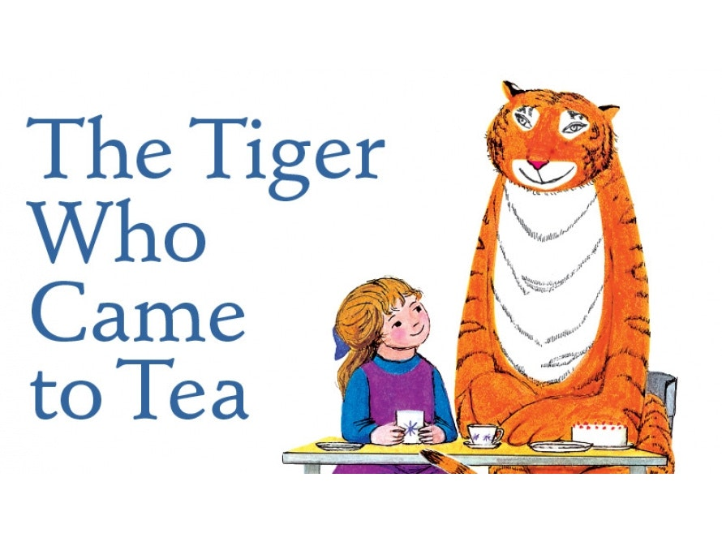

**Homework Menu**

**Pre-school**



Knowledge & Understanding of the World

Explore books or research on the computer about tigers. Where do they live? What do they like to eat?

Have a look at the tiger cam. Have a look and see what they are up to at the zoo.

Tiger Cam Link- <https://www.edinburghzoo.org.uk/webcams/tiger-cam/#tigercam>

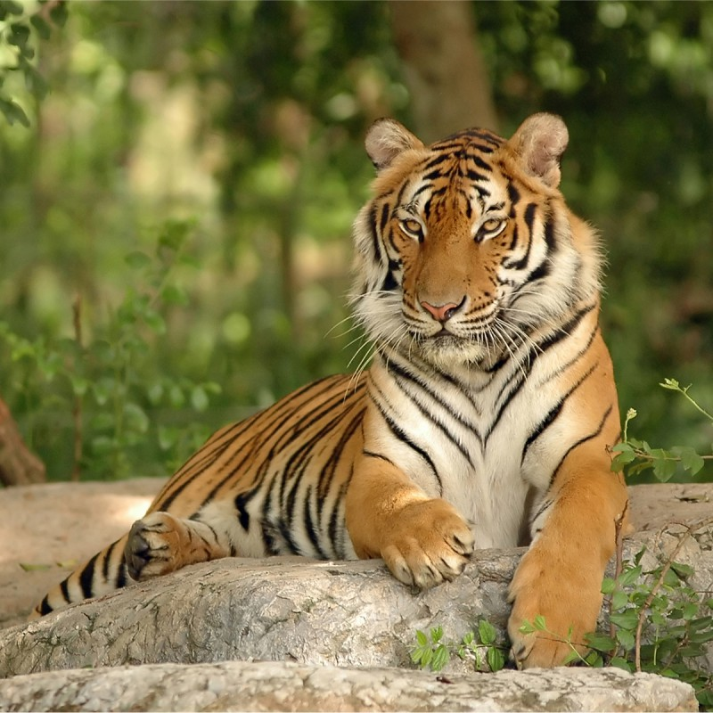

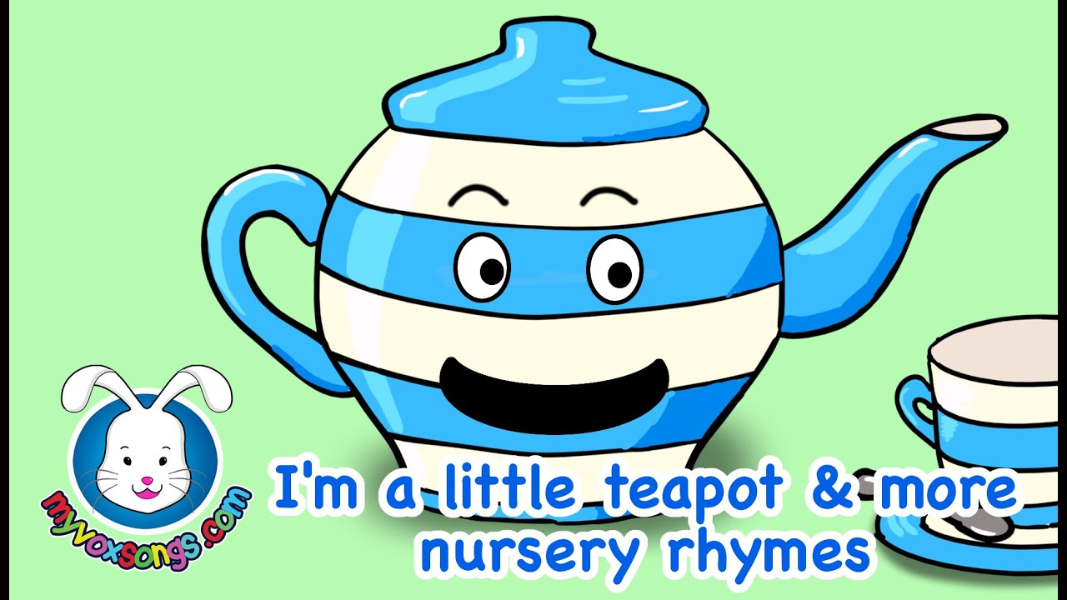

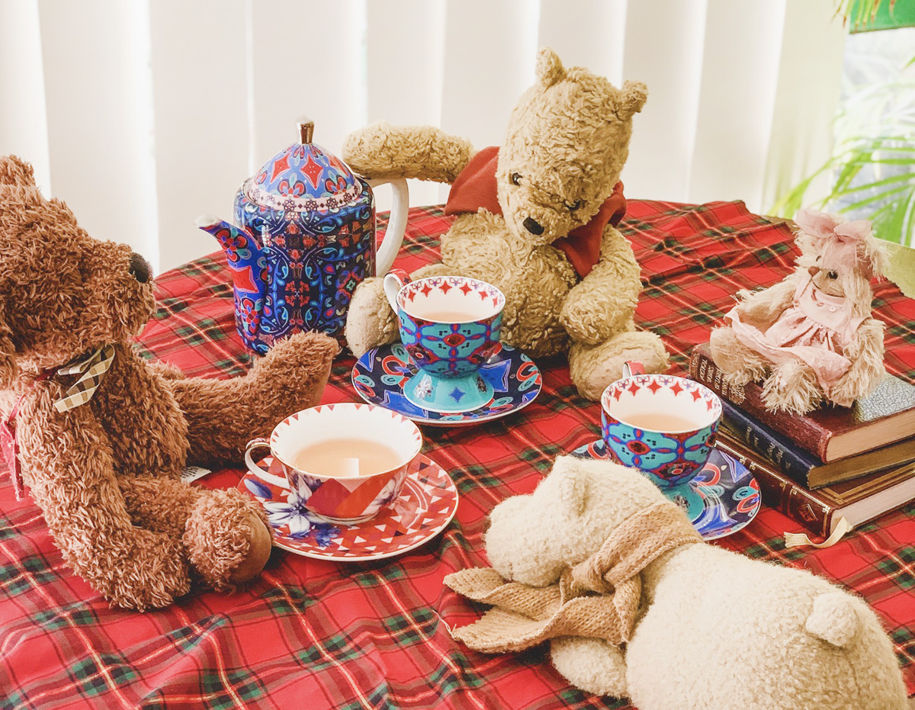

Maths

Let’s test our counting and help lay the table ready for lunch or dinner. Count out the plates and the cutlery. How many things can you count on the plate?

Count the stripes on the tiger as you draw them.

PSED

The StoryBots share their different emotions (with songs too):

["Emotions" - StoryBots Super Songs Episode 8 | Netflix Jr - YouTube](https://www.youtube.com/watch?v=akTRWJZMks0)

Talk about how you feel and what can make you feel different including your likes and dislikes.

