Year 1 Spring: Poetry: Poems about the Senses/feelings
Wednesday 13th January 2021
Read a question and write a statement in answer
Teaching
- Remind children there are five senses. Identify each one.
- Display What is … the Sun? (resources). Notice the title is a question.
- Read the poem. The poet has used his sense of sight to describe the sun. Notice how each verse answers the question. Select one verse and re-read it.
- Stress that (in this instance) the sentence begins with a capital letter and ends with a full stop.
- Read the poem again, with a suitable intonation. Invite children to join-in.
- Write the title: What is the Moon? Notice it is a question. Explain that children can use any of their five senses to write a creative description of the moon. Link back to dot day when they ‘imagined the dot as different things.
- Look at a range of images of the moon. Make a list of answers to the question with the sentence starter ‘It is…’ e.g it is a silver coin; It is Christmas bauble; It is a magical face; It is a dinner plate. It is a nightlight.
- Take an answer. How can we extend this? Model examples: It is a silver coin floating in the sky; It is Christmas bauble dropped from the tree; It is a magical face smiling down on Earth; It is a dinner plate waiting to be filled.
- Discuss their own ideas. Listen to and share suggestions.
- Select an idea and orally prepare the sentence, and model writing it.
- Use correct punctuation to write the sentence/s. Stress the sentence begins with a capital letter, includes finger spaces between words and end with a full stop.
Activity: Write a correctly punctuated, descriptive statement.

Objectives:
Composition: Say out loud what they are going to write about; Compose a sentence orally before writing it.
Grammar: Leave spaces between words; Begin to punctuate sentences using a capital letter and a full stop.
You will need: What is … the Sun? (resources); paper; writing pencils.
Children work in mixed ability groups of three
Activity
- Give each child paper.
- Have the range of images of the moon visible for reference.
- They discuss creative descriptions of the moon. Help them use their senses to prompt ideas.
- Children select their favourite idea and orally prepare and rehearse it.
- They use correct punctuation to write the sentence. Remind children to begin the sentence with a capital letter, to leave finger spaces between words and to end it with a full stop.
- Children read the sentence they have written and check it is correctly punctuated.
- Repeat for at least 3 sentences.
Outcomes:
- I know how to punctuate a question sentence.
- I know how to punctuate a statement.
- I can write a correctly punctuated statement.

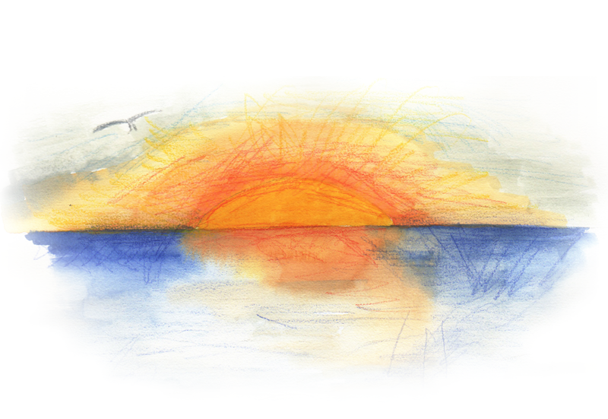
What is … the Sun?
by Wes Magee

The sun is an orange dinghy
sailing across a calm sea.

It is a gold coin
dropped down a drain in heaven.

It is a yellow beach ball
kicked high into the summer sky.

It is a read thumb print
on a sheet of pale blue paper.

It is the gold top from a milk bottle
floating on a puddle.

