Year One Homework BINGO
Choose as many activities as you would like to complete over the next 6 weeks.
PE | Art | DT | Music | PSHE
How many different ways can you travel around a room in your house? Can you walk, crawl, leap and jump? Can you go forwards and backwards?  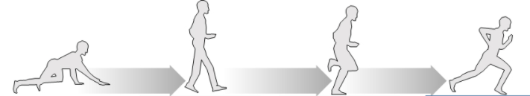 | 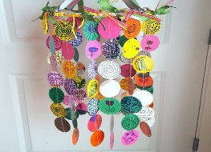  With an adult, cut paper into circles and decorate each circle. Using some string, attach each circle to the string and hang from a coat hanger to create a mobile. | Use old cardboard boxes (cereal, etc.), and create a street in London by making houses like those that would have been in the Great Fire of London.  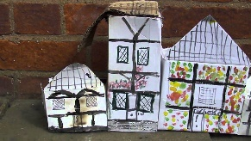 | Learn the words to the song London’s Burning.  London's Burning  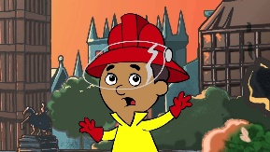 | Learn how to play a new board or card game with your family.
Ask your child to walk around a room. When you say a letter of the alphabet, ask your child to make that shape with their body. 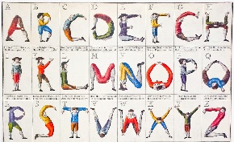 | 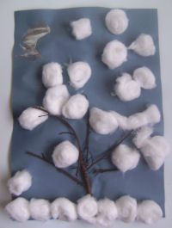  Using twigs, glue and cotton wool balls, create a winter scene including a tree. | Using things you can find in your garden (twigs, leaves, etc.) build a hotel for mini-beasts. 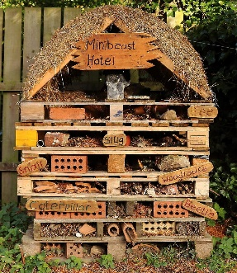 | Using ribbons or scarves as streamers, dance to a piece of music using these.  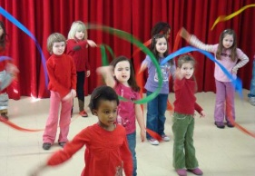 | Leave happy notes around the house for members of your family. Try to make them smile.
Using any pots you can find in your house and a rolled up sock, see if your child can throw the sock into the pot. You can make it harder or easier by using different sized pots. | Make an old fashioned toy  using your choice of  materials or draw an old fashioned toy and write the rules of how to play with it.  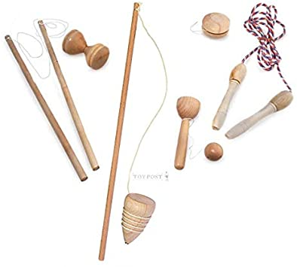 | Create a one more/one less board game! Write numbers on paper and roll a dice. What is one more and one less?  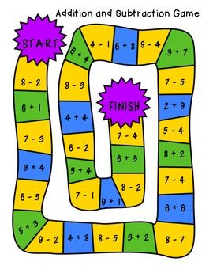 | Fill small plastic bottles with different amounts of rice or dry pasta. Can you make a tune by shaking them?  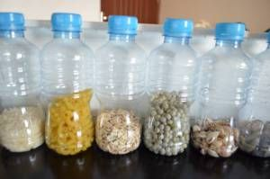 | Listen to music from around the world, explore the different rhythms and sounds, and find out about the importance of particular types of music in different cultures.
Choose a favourite nursery rhyme with your child. Can you create a dance and actions to go with it? | Draw or paint a picture of your favourite animal.  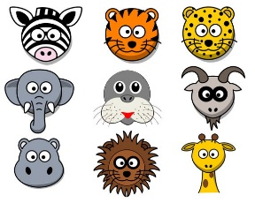 | Find a recipe for a soup or a cake, using seasonal fruits or vegetables and have a go at making it.  Take some pictures and make a poster using your photographs. | Choose your favourite song and create a dance to it. | Create a poster showing how to be healthy.
Practise your skipping, hopping or jumping in the garden or park.  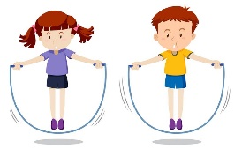 | Go on a colour hunt around your house.  Can you find 3 red, 2 yellow, 5 green, 4 blue and 1 purple object? | Use the recycling to build a home for an animal of your choice.  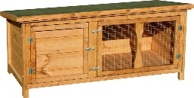 | Listen to a piece of music. Afterwards, draw a picture to show what the music reminded you of. | Write a thankyou letter to a member of your family who has done something kind for you.
Colour in the homework activities you choose. A responsible adult must sign as your witness. Return the bingo sheet when you return to school.

Name________________ Witness____________________

