Homework BINGO
Choose as many activities as you would like to complete over the next 6 weeks.
PE | Art | DT | Music | PSHE
Create a dance about the water cycle. | Sketch a member of your family or a pet. | Help cook a meal. You could plan it from a set of ingredients and with help, make lunch or tea for your family. | Write and perform a song or rap about the water cycle. | Complete a timeline to show changes in your life.
Do an online exercise class. This could be Joe Wicks, yoga or Zumba just to name a few! | Create a collage inspired by Jeannie Baker. Jeannie’s work is based on her environment so create your own collage about your environment. | Design an outfit for yourself. What materials would you use? | Keep a music diary. When you hear a piece of music during the day/week, write the title of the song and give your opinion about it. | Imagine a friend is  moving away to another part of the country. Draw a comic strip about this showing how they might feel.
Plan your own warm up routine. This should include some stretches and some cardio movements to get your heart beating faster and to warm up your muscles! | Go on a colour walk. Look for every colour of the rainbow where you live. Once home, create a poster of the things you saw or draw an illustrated map of the walk you took. | Create a thank you card for someone who you are grateful for during the pandemic. This could be a pop-up card or have a moving part. | Using junk modelling items, create your own musical instrument. | Complete a changes storyboard.
With an adult, go for a run/jog/walk. Time how long you run for. Can you beat your previous time each time you run / jog / walk? | Take photos of life in lockdown. Think about the angles that you take the photos from and give each one a title. | Make a puppet out of paper and use light and shadows to perform a show. | Research your favourite musical artist. Find out as many facts as you can. | Make a Fortune Teller.
Choose at least one PE skill to practise every weekday. It might be football skills, balancing in gymnastics or doing star jumps. | Create a rainbow picture – instructions below! | Make a model to represent what happens in the water cycle. What materials will you use? How will you join different parts? | Write and perform a song or rap about life in lockdown. | Decide on some changes that you want to make and create a plan for them.  Complete the Ladders
Colour in the homework activities you choose. A responsible adult must sign as your witness. Return the bingo sheet when you return to school.

Name________________ Witness____________________

On the outside the children record numbers, then a feeling (associated with change) on each of the flaps inside, then inside each of those a strategy that they think they themselves could use to help cope with that feeling.

Using the ‘Ladder’ resource sheet. Ask them to think about the change that they want to achieve and the different ways they could do that. They then break down their plan into small steps which they record on the ladder.

WHAT IS A RAINBOW?
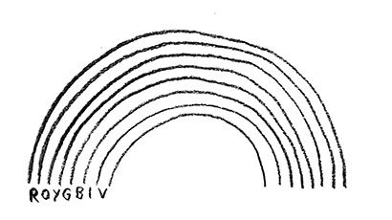
A rainbow is created when light bends and is separated into colours.

WHAT YOU NEED
- A glass of water
- White paper
- Colouring pencils
- A torch

GET SET UP
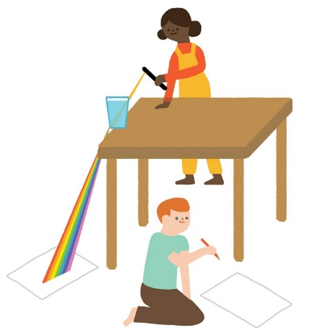
1. Place the glass of water on the edge of the table so a little bit hangs off the edge. Be very careful not to knock it over.
2. Shine the torch through the glass at the top. Adjust the angle until the light falls onto the paper below.
3. Colour over the light on the paper to create your own rainbow.
Top Tip: Turn off the lights to see the rainbow more clearly!

