Wombat Fact-File
Teacher Input for Lesson 1

What is a wombat?
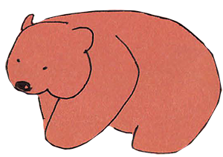
Wombats are short-legged, muscular marsupials. A marsupial is an animal that gives birth to babies, which are carried and fed in a pouch. Wombats can grow to 1 metre and can weigh up to 30kg, which is the same as 200 bananas!

Where do wombats live?
Wombats live in Australia and some small surrounding islands.

What do wombats eat?
Wombats are mainly nocturnal. They come out at night to eat grasses, herbs, bark and roots. Wombats gnaw on bark and tough vegetation to keep their teeth the right length.

Why do wombats burrow?
Wombats have wide, barrel shaped bodies and strong feet with long claws, which are good for digging. They dig out large systems of tunnels and chambers to make burrows, where they sleep, rest and raise a family.

What’s special about a wombat?
- A wombat’s pouch is unusual because it faces backwards towards the rump (the area around its bottom). This is so that the wombat won’t spray mud into the pouch when it is digging.
- Wombat poo is shaped like a cube. This is because wombats mark their territory using the scent of their poo, and cubes don’t roll away.
- Wombats have a tough bottom! When it is threatened, a wombat dives into its tunnel, blocking the entrance with its solid well-padded rump. This prevents predators from being able to remove babies or attack the wombat head on.

Truth or fib?
Day 1

- Write a sentence in the first person.
- Use past tense.
- It could be true OR it could be a fib.
- Repeat this, writing a second sentence.
- In all you will write three sentences.
- ONE will be a fib and two will be true.
- Someone else has to guess which is the fib!

HINT
Make it hard to tell whether each sentence is true or not

- Let someone else write three sentences.
- You try to guess which one is the fib.

- Repeat this several times – all sentences must be first person and past tense!

