Early Years/Reception
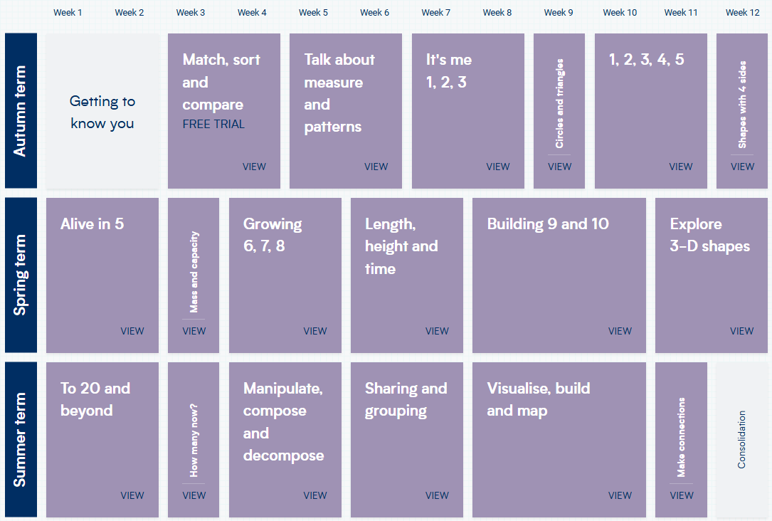
Year 1 and 2 Yearly Overview
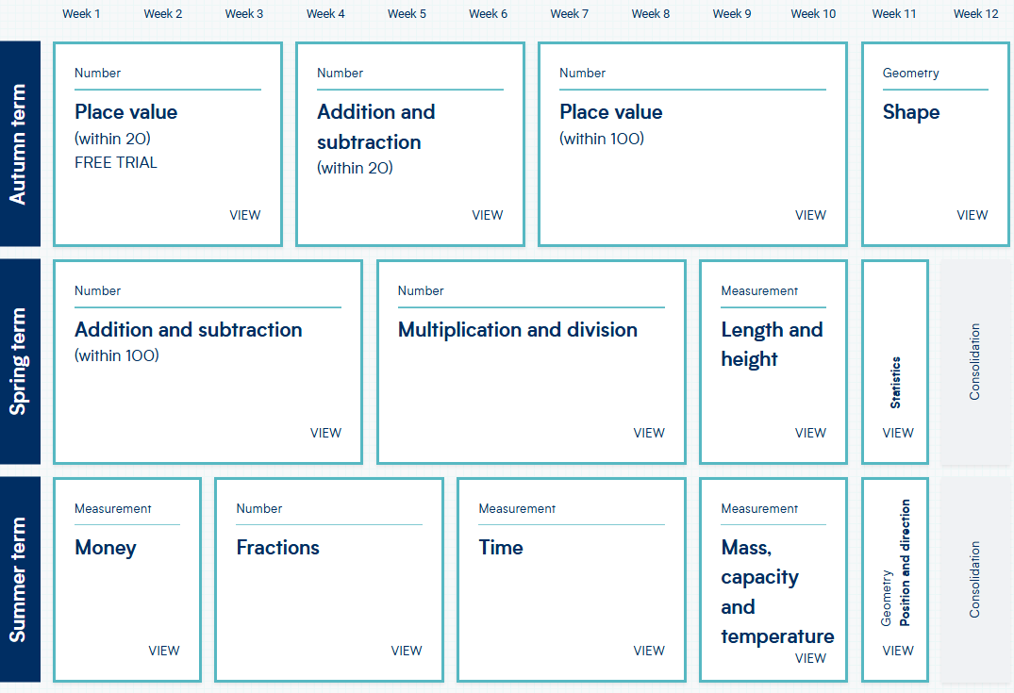
Year 3 and 4 Yearly Overview
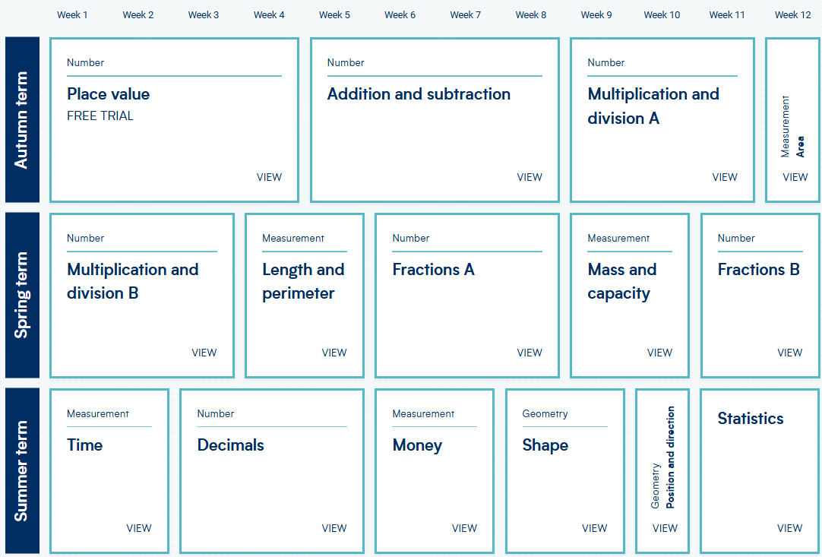
Year 5 and 6 Yearly Overview
