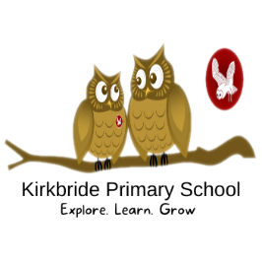

At Kirkbride Primary School, we use a scheme to help bring Art to life for our children. The scheme, by Curriculum with Unity Schools Partnership, (CUSP), is thorough, exciting and planned in detail by experts in their field.

"Every child is an artist. The problem is how to remain an artist once we grow up."
Pablo Picasso
Art and Design
At Kirkbride Primary School, we want every child to believe that they can create, to use their imagination to bring drawings, paintings, sculpture, print and collage to life. As they dive into new projects, exploring the unknown, we want them to take as much pleasure in approaching a blank canvas as they do stepping back and looking at the final product. Whilst taking pleasure in learning new skills, we hope to enable the children to feel in-tune with their own emotions and to reflect this in their work, feeling comfortable to share who they are through their creativity. Through appreciating the work of others we want children to eventually feel confident and take enjoyment in sharing their own work, evaluating it positively and with pride.

To ensure they children experience high quality of Topic lessons, we use CUSP Unity two-year rolling program of long-term planning, detailing the coverage of each subject in KS1, LKS2 and UKS2. This is also supported by the progression skills coverage, mapped out for each year group for Years 1 to 6. This ensures planning addresses the national curriculum content, but also shows progression of skills across the school.

The children are assessed on a regular basis through general lesson by lesson observation and book and art work scrutiny. This combination gives a good overall picture of how children are progressing, identifies gaps in children's knowledge and understanding and provides clear guidelines for next steps in learning. This information is regularly shared with the subject coordinator, who feeds it into their monitoring, evaluation and feedback process.

Enriching the children’s learning through creativity is our prime aim in art and design. We will make sure our children are excited by experiencing a variety of materials, tools and techniques. We will show them how art and design reflect and shape our history and contribute to culture, creativity and the wealth of our nation. We will allow them to explore the power of art through culture, religion and spirituality and learn from other great artists, designers and craftsmen.

