Art and Design Curriculum Statement

January 2023

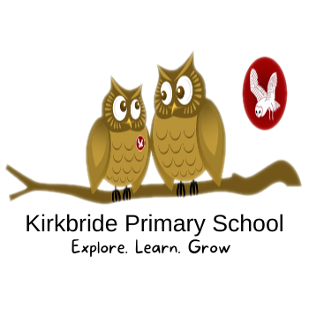

Art and Design Subject Overview
Kirkbride primary School adopted the CUSP Art curriculum starting in September, Autumn Term, 2022. We have a two-year rolling program which is organised into Cycle A and Cycle B.
This is organised into blocks with each block covering a particular set of artistic disciplines, including drawing, painting, printmaking, textiles, 3D and collage. Vertical progression in each discipline has been deliberately woven into the fabric of the curriculum so that pupils can revisit key disciplines throughout their Primary journey at increasing degrees of challenge and complexity.
In addition to the core knowledge required to be successful within each discipline, the curriculum outlines key aspects of artistic development in the Working Artistically section. Each module will focus on developing different aspects of these competencies. This will support teachers in understanding pupils’ development as artists more broadly, as well as how successfully they are acquiring the taught knowledge and skills.
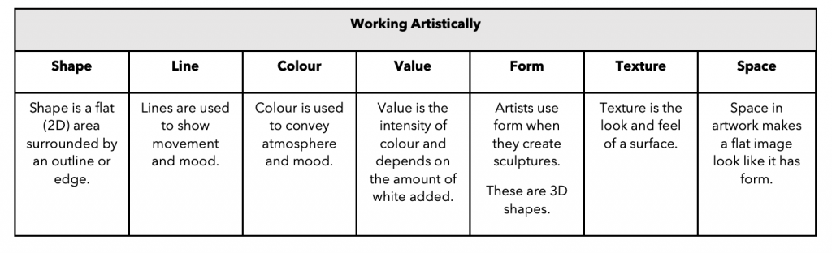© 2021 Unity Schools Partnership (Curriculum structure and principles © Greenfields Education Ltd)

INTENT
At Kirkbride Primary School, our children are ARTISTS and DESIGNERS!
We want our children to love art, craft and design! We want them to have no limits to what their ambitions are and to grow up wanting to be illustrators, graphic designers, fashion designers, curators, architects or printmakers. Our Art curriculum is designed to engage, inspire and challenge pupils, whilst equipping them with the knowledge and skills to be able to experiment, invent and create their own works of art.
As pupils progress, they should gain a deeper understanding of how art and design reflects and shapes our history, and how it contributes to the culture, creativity and wealth of our world. We want to equip our children with not only the minimum statutory requirements of the Art and Design National Curriculum. but to prepare them for the opportunities, responsibilities and experiences of later life.
We want our children to use the vibrancy of our locality near to the coast of the Solway Firth, the Lake District National Park and Fells, as an inspiration. But also, to explore artists and designers from around the World, in order to learn from other cultures and respect diversity. To that end, we have carefully selected a wide range of unique and diverse artists, craft makers and designers for children to study and have planned opportunities for children to visit Art galleries and museums locally and nationally.
IMPLEMENTATION
- At Kirkbride, Art is taught in every year group, once per term.
- Topics are blocked to allow children to focus on developing their knowledge and skills, studying each topic in depth.
- Art topics generally follow a ResearchSkills - Final Piece - Evaluate structure.
- Each child has a sketchbook. We give the child ownership of their sketchbook in order to foster their sense of creativity. Children use their sketchbooks to make initial sketches, develop skills, record ideas AND develop opinions.
- Throughout the Kirkbride journey, every child is given the opportunity to learn the skills of drawing, painting, printing, sculpture and digital art through the exploration of an initial key artist, craft maker or designer and their work
- Through in-depth discussion, the pupils explore how their art can share commonalities with famous art and use subject specific vocabulary to discuss key artworks and their own work.
- In the development of confident art critics, the pupils share their opinions and make informed observations about what will improve their own practical work.
- In KS1 and KS2, skills are planned in to be revisited, giving the children the opportunity to extend their knowledge and practice in the context of a variety of artworks from a range of eras.
- Some cross-curricular links are promoted to allow all children to deepen their understanding across the curriculum, including the use of technology, and artworks from year group specific historical, geographical and scientific contexts.
- Opportunities for children to visit local art galleries and museums are planned for, as well as visits from local artists.
- Within the CUSP units, we empower our staff to organise their own year group curriculums under the guidance of our Individual Subject Leaders. Teachers are best placed to make these judgements.
- Staff develop mixed-year group specific long-term curriculum maps which identify when the different subjects and topics will be taught across the academic year.
- Teachers follow a clear progression of skills which ensures all pupils are challenged in -line with their mixed- year group expectations and given opportunity to build on their prior knowledge.
- Opportunities to reflect and develop, including through the use of sketchbooks, and chances for self and peer- assessment are planned into each unit of study in KS1 and KS2.
- Effective CPD and standardisation opportunities are available to staff to ensure high levels of confidence and knowledge are maintained.
- Our Foundation Subject Assessment Tracker allows us to use data to inform future practice.
EYFS
Through Expressive Arts children are encouraged to explore different media, explore how media can be combined to create different effects and develop a range of skills and techniques experimenting with colour, design, texture, form and function. Children are given daily access to a range of creative opportunities and enjoy our carefully planned and well-resourced creative areas both indoors and out. Children are encouraged to create on both small and large scales and our outdoor environment supports this well. Children are encouraged to develop their communication and language skills through talking about their creations and sharing these with others to build confidence and raise self-esteem.

IMPACT
The impact of this curriculum design will lead to strong progress over time across key stages relative to a child’s individual starting point and their progression of skills. Children will therefore be expected to leave Kirkbride reaching at least age-related expectations for Art. Our Art curriculum will also lead pupils to be enthusiastic Art learners, evidenced in a range of ways, including pupil voice, their final pieces and sketchbooks.

Through the use of assessment trackers for end of block and end of term, and developing data analysis, we ensure that children who are achieving well, as well as those who need additional support are identified, and additional provision and strategies are planned in and discussed with class teachers.
The impact of our Art curriculum is to promote the opportunity for every child to be an artist. By embedding the formal elements, every child is encouraged to be creative, innovative and reflective on their own and others’ practice using the subject specific vocabulary to support their reasoning.

Through the use of sketchbooks and in-depth discussion around artists, their art and practices, pupils learn that art can be constantly reviewed and developed, further promoting the resilient, independent learners of Kirkbride. Achievements are celebrated in classrooms during walking-galleries and corridor displays, and by building increasing connections with local galleries, we aim to develop our future artists and their appreciation of the art around them.

