Design and Technology Subject Overview

January 2023
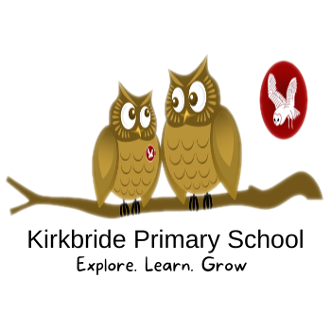

Kirkbride adopted the CUSP Design and Technology curriculum starting in September, Autumn Term 2022.
The CUSP Design and Technology curriculum is organised into blocks with each block covering a particular set of disciplines, including food and nutrition, mechanisms, structures, systems, electrical systems, understanding materials and textiles. Vertical progression in each discipline has been deliberately woven into the fabric of the curriculum so that pupils revisit key disciplines throughout their Primary journey at increasing degrees of challenge and complexity.
In addition to the core knowledge required to be successful within each discipline, the curriculum outlines key aspects of development in the Working as a Designer section. Each module will focus on promoting different aspects of these competencies. This will support teachers in understanding pupils’ progress as designers more broadly, as well as how successfully they are acquiring the taught knowledge and skills.
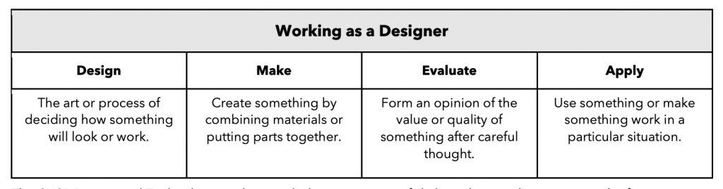

INTENT

At Kirkbride Primary School, we are DESIGNERS and TECHNOLOGISTS!

We want our children to love design technology. We want them to have no limits to what their ambitions are and grow up wanting to be architects, graphic designers, chefs or carpenters. Design and Technology is dynamic and multidimensional. It is our intention that our DT curriculum will provide opportunities to solve real and relevant problems, allowing our pupils to develop essential everyday skills and unlock their potential to be the designers and innovators of tomorrow.
The DT curriculum will encourage children to learn, to think and intervene creatively to solve problems both as an individual and as part of a team. Design and Technology will allow all Whitefield pupils to put their learning from other areas of the curriculum into practice, and will work to enhance and deepen their understanding of those areas, including maths, computing, science, and art.

Kirkbride pupils will learn about cooking, food and nutrition, ensuring that they acquire the fundamental life skills in order to be able to feed themselves healthily and independently, whilst learning about where food comes from, therefore making connections with their geographical and scientific knowledge. We want to equip them with not only the minimum statutory requirements of the design technology National Curriculum but to prepare them for the opportunities, responsibilities and experiences of later life.

IMPLEMENTATION
At Kirkbride, DT is taught in every year group, once per term. • Topics are blocked to allow children to focus on developing their knowledge and skills, studying each topic in depth.
- Many DT units are based on planning from ‘Projects on a Page’: Mechanisms (sliders and levers, wheels and axles), Free Standing Structures, Textiles, Cooking and Nutrition in KS1 Leavers and Linkages, Textiles, Frame Structures, Gears and Pulleys, Electrical systems, CAD and cooking and nutrition in KS2
- Each class has a Design Technology book. Children may use this to research products, develop design ideas and initial sketches, and showcase learned skills, technical knowledge and vocabulary, final designs, and evaluations. Each class records their work in the class book and they enjoy looking back over their projects as the year progresses.
- We use a skills-based approach to teaching and Design Technology Curriculum Statement learning using objectives taken from the National Curriculum. We teach DT skills discretely, making relevant cross-curricular links, and ensure all children access all areas of the Design Technology Curriculum.
Children will follow the 6 principles of DT:
- USER – to have a clear idea of who they are designing/making the product for.
- PURPOSE – to be able to communicate the purpose of the product they are designing/making
- FUNCTIONALITY – to design a product that works and functions effectively to fulfil the user’s needs
- DESIGN DECISIONS – to make own design opportunities, explore their own decisions and choices
- INNOVATION – opportunities to be original with their thinking, develop and explore their own ideas incorporating the essential skills involved in the process
- AUTHENTICITY – to make products that are believable, real, and meaningful to themselves and others, not just replicating ideas.
Teaching of DT will also follow the cycle of Research, Develop own ideas, Make final idea and Evaluate
- Beginning with the purpose of a product for a user, the children are encouraged to use exploration of existing products to gather first-hand experience of existing approaches. We aim to promote creative problem solvers, both as individuals and part of a team and pupils develop their understanding of the ways in which people in the past and present have used design to meet their needs.
- Children design and make quality products using a range of tools, materials, and components, make connections with their learning across the curriculum including in maths, computing, science, and art and reflect on and evaluate techniques using subject-specific vocabulary.
- Within the CUSP programs, we empower our staff to organise their own year group curriculums under the guidance of our Individual Subject Leaders. Teachers are best placed to make these judgements.
- Staff develop year group specific long-term curriculum maps which identify when the different subjects and topics will be taught across the academic year and these are reviewed regularly.
- Teachers follow a clear progression of skills which ensure all pupils are challenged in -line with their year group expectations and given opportunity to build on their prior knowledge.
- Effective CPD and standardisation opportunities are available to staff to ensure high levels of confidence and knowledge are maintained.
- Our Foundation Subject Assessment Tracker allows us to use data to inform future practice.
EYFS
Through Expressive Arts children are encouraged to construct and create purposefully selecting tools and techniques needed to shape, assemble and join materials they are using. children learn through first-hand experiences which involve putting their ideas into practise to develop an awareness and understanding of the possibilities and limitations of different materials.
Practitioners encourage children to explore, observe, solve problems, think critically, make decisions and talk about why they have made their decisions as they design and create. Children’s natural creativity is fostered and opportunities for investigation, designing and making are offered daily within our provision, which enables children to learn a great deal about their world.

IMPACT

The impact of our Design and Technology curriculum is in the development of our pupils being able to approach problems creatively and in a range of ways, applying their knowledge from across the curriculum areas independently. We know the curriculum is impacting through pupil interviews, where children talk about their love of learning and through looking at children’s books showing they take a pride in what they are learning.
By providing a range of contexts and the necessary skills, we endeavour to support pupils in their future educational journey and in understanding of the ever-developing world around them. The skills and attributes they develop will benefit them beyond school and into adulthood: the ability to use time efficiently, work with others productively, show initiative, independence, resilience and manage risks effectively will ensure well-rounded citizens who will make a difference in the wider world. Through the use of end of block, and termly assessment tracker and data analysis, we ensure that children who are achieving well, as well as those who need additional support are identified, and additional provision and strategies are planned in and discussed with class teachers. We expect the children to know more, remember more and understand more about design and technology. Most children will achieve age related expectations in this subject.

