English Curriculum
Progression Overview
January 2023
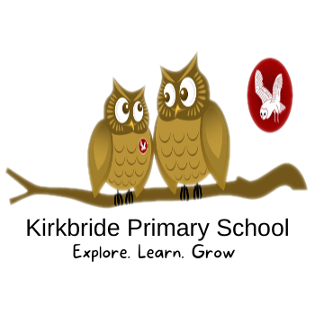

Key for reading material
Continuity of author
Heritage text
BAME author or protagonist
Strong female role model
Specific social, ethical, moral issue

Year 1/2 Ash Class
Cycle A
 | Autumn 1 | Autumn 2 | Spring 1 | Spring 2 | Summer 1 | Summer 2
Reading | 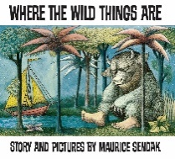  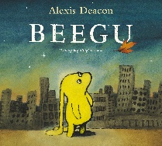  Beegu by Alexis Deacon loneliness, transition, isolation and friendships  Contemporary narrative picture book  Where the Wild things are by Maurice Sendak: Classic picture book  anger and frustration, forgiveness | 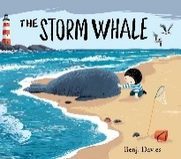  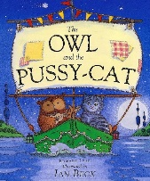  The Storm Whale by Benji Davies: loneliness, animal care, kindness, working parents Contemporary narrative picture book  The owl and the pussycat by Edward Lear: Heritage poem seminal poet  Aesop’s Fables- The boy who cried wolf: lying, trust and community | 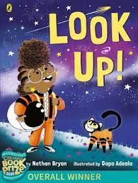  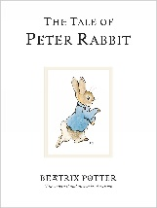  The tale of Peter Rabbit  by Beatrix Potter seminal female author  Look up! Female main character, reference to Mae Jemison By Nathan Bryon contemporary narrative picture book | 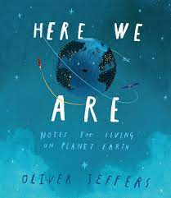  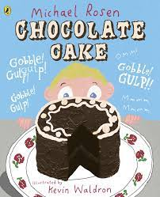  Here we are by Oliver Jeffers: contemporary narrative picture book kindness, tolerance, environmental responsibility  Chocolate cake humorous contemporary poem by Michael Rosen | 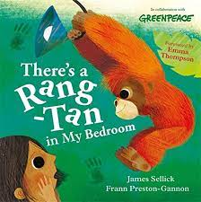  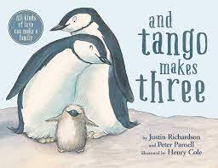  There’s a rang-tan in my bedroom by James Sellick contemporary narrative picture book and information text: female protagonist. Deforestation and endangered species  And Tango Makes three: contemporary narrative picture book and information text: same sex parents, adoption, blended families, kindness and tolerance | 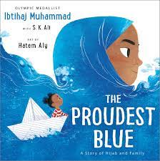  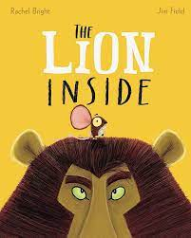  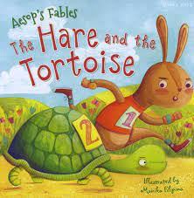  The lion inside by Rachel Bryan:contemporary rhyming narrative poem courage, self confidence and friendship  Aesop’s fables heritage text-the tortoise and the hare: pride, vanity, complacency, patience and perserverance  The proudest blue by contemporary narrative picture book Ibtihaj Muhammed: themes of difference, inlusion, courage, faith, family and resilience
Writing | Strong start with sentences  Pattern and rhyme poetry  Setting descriptions | Stories with familiar settings  Instructional writing  Shape poems and calligrams | Shape poems and calligrams  Recount from personal experience  Informal letters | Poetry on a theme (nature)  Stories with familiar settings  Recount from personal experience |  | Poetry on a theme  Instructional writing
VGPS  Introduce  Revisit  Consolidate | Capital letters and full stops  Regular plural noun suffixes -s or -es  Join words and join clauses using ‘and’  Capital letters for names and the personal pronoun ‘I’ |  | Question marks  Suffixes that can be added to verbs where no change is needed in the spelling of root words (eg helping, helped, helper)  How the prefix un– changes the meaning of verbs and adjectives  Capital letters and full stops  Capital letters for names and for the personal pronoun I  Regular plural noun suffixes –s or –es  Joining words and joining clauses using and |  | Exclamation marks  Question marks  Suffixes that can be added to verbs where no change is needed in the spelling of root words (e.g. helping, helped, helper)  How the prefix un– changes the meaning of verbs and adjectives  Capital letters and full stops  Capital letters for names and for the personal pronoun I  Regular plural noun suffixes –s or –es Using ‘and’
Spelling |  |  | Common exception words Etymology: tri/pre/anti  Adding s or es to words  Adding the endings ing ed and er to words with no change to root word |  | Adding er and est to adjectives where there’s no change to root word  Common exception words  Adding prefix un  Etymology: cent, multi, chron

Year 1/2 Ash Class
Cycle B
 | Autumn 1 | Autumn 2 | Spring 1 | Spring 2 | Summer 1 | Summer 2
Reading | 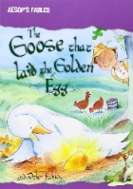  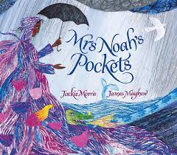  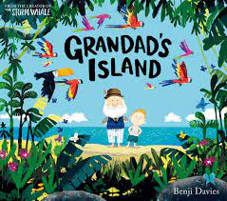  Grandad’s Island by Benji Davies contemporary narrative picture book bereavement  Aesop’s fables- The goose that laid the golden eggs: greed, patience, contentment, foolishness  Story with a moral  Mrs Noah’s pockets by Jackie Morris kindness, hope, inclusion, faith contemporary narrative picture book | 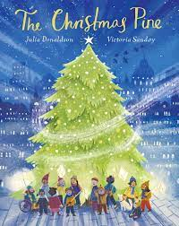  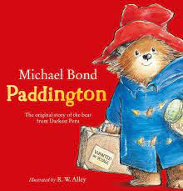  Paddington by Michael Bond themes of family, kindness and coping with change classic picture book  The Christmas Pine by Julia Donaldson Christmas traditions and values, cultural references to British landmarks contemporary narrative poem | 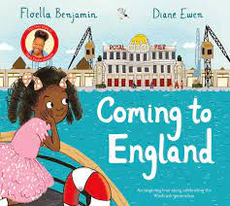  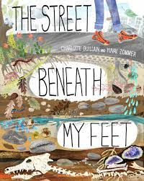  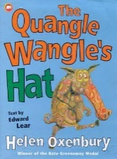  The Quangle Wangle’s hat by Edward Lear heritage poem archaic language  Coming to England by Floella Benjamin: prejudice, coping with change, belonging contemporary narrative picture book  The street beneath my feet by Charlotte Guillian: environmental responsibility  Contemporary non narrative picture book Tier 3 science vocabulary | 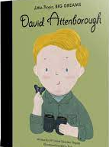  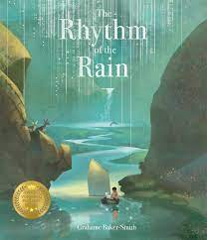  The rhythm of the rain by Graham Baker-Smith: contemporary narrative picture book environmental responsibility, belonging, world perspectives  Little people, big dream-David Attenborough:illustrated biography importance of understanding the natural world | 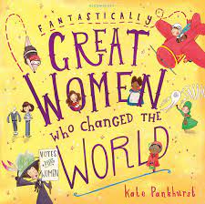  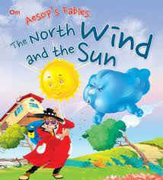  Fantastically great women who changed the world:illustrated anthology of biographies Rosa Parks, Frida Kahlo themes of bravery, tenacity, resilience and ingeunuity  Aesop’s Fables- The Sun and the Wind story with a moral | 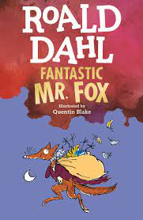  Fantastic Mr Fox by Roald Dahl: classic short novel morality, patience, family, community and tenacity
Writing | Sentence composition  Character descriptions  Poems developing vocabulary  Simple retelling of a narrative | Formal invitations  Stories from other culture | Poetry on a theme  NC Reports  Formal invitations | Stories from other cultures  Recount from personal experience |  | Recount from personal experience  Poems developing vocabulary  Character descriptions  Poetry on a theme
VGPS  Introduce  Revisit  Consolidate | Apostrophes to mark where letters are missing in spelling and to mark singular possession in nouns [for example, the girl’s name]  Past and present tense  Compounding to make new nouns  Formation of adjectives using suffixes such as –ful, –less  Expanded noun phrases  Statement, command, question, exclamation sentences  Use of capital letters, full stops, question marks and exclamation marks to demarcate sentences  Suffixes that can be added to verbs where no change is needed in the spelling of root words (e.g. helping, helped, helper) How the prefix un– changes the meaning of verbs and adjectives |  | Commas to separate items in a list  Past progressive and present progressive tense  Use of the suffixes –er, –est in adjectives  Use of –ly in Standard English to turn adjectives into adverbs  Synonyms and antonyms  Use of capital letters, full stops, question marks and exclamation marks to demarcate sentences Types of sentences  Apostrophes to mark where letters are missing in spelling and to mark singular possession in nouns [for example, the girl’s name]  Past and present tense Expanded noun phrases  Compounding to make new nouns  Formation of adjectives using suffixes such as –ful, –less |  | Commas to separate items in a list  Past progressive and present progressive tense  Use of the suffixes –er, –est in adjectives  Use of –ly in Standard English to turn adjectives into adverbs  Synonyms and antonyms  Use of capital letters, full stops, question marks and exclamation marks to demarcate sentences  Apostrophes to mark where letters are missing in spelling and to mark singular possession in nouns [for example, the girl’s name]  Past and present tense Compounding to make new nouns  Formation of adjectives using suffixes such as –ful, –less  Expanded noun phrases  Statement, command, question, exclamation sentences
Spelling | Revisit y1 common exception words and introduce y2 common exceptions  The /dʒ/ sound spelt –ge and –dge at the end of words  The /dʒ/ sound spelt g elsewhere in words before e, i and y and j before a, u and o  Etymology: bi, oct and pent | The /s/ sound spelt c before e, i and y  The /ʒ/ sound spelt s  Homophones and near-homophones  Etymology: Hex, quad, wise | Common exception words  The /l/ or /əl/ sound spelt –le at the end of words The /l/ or /əl/ sound spelt –el at the end of words  The /l/ or /əl/ sound spelt –al at the end of words Words ending –il  Etymology: quart, ward, metre | The /aɪ/ sound spelt –y at the end of words  adding –es to nouns and verbs ending in –y Adding –ed, –ing, –er and –est to a root word ending in –y with a consonant before it  Adding the endings – ing, –ed, –er, –est and –y to words ending in –e with a consonant before it Adding –ing, –ed, –er, –est and –y to words of one syllable ending in a single consonant letter after a single vowel letter  Etymology: fold, vore, semi/hemi | The /ɜ:/ sound spelt or after w The /ɔ:/ sound spelt ar after w The /ɒ/ sound spelt a after w and qu  The suffixes –ment, –ness, –ful, –less and –ly  Contractions  Etymology: trans, loc, dent | Revisit/consolidation opportunities  Application in writing  Words ending in tion  Etymology: equi

Year 3/4 Elm Class
Cycle A
 | Autumn 1 | Autumn 2 | Spring 1 | Spring 2 | Summer 1 | Summer 2
Reading | 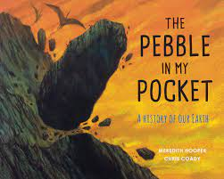  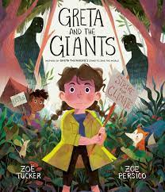  Greta and the Giants by Zoe Tucker contemporary narrative picture book with additional non narrative section themes of peaceful protest, climate change and children finding their voice  Pebble in my Pocket by Meredith Hooper contemporary non narrative picture book narrates the history of Earth, science tier 3 vocab and science curriculum link | 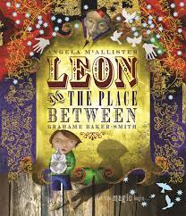  Pebble in my Pocket by Meredith Hooper  Leon and the place between contemporary narrative picture book by Graham Baker-Smith: magic, adventure, friendship and the unknown | 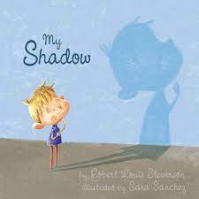  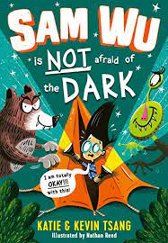  Sam Wu is not afraid of the dark by Kevin and Katie Tsang: contemporary narrative chapter book part of a series conquering fears  My Shadow poem by Robert Louis Stevenson | 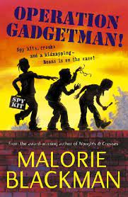  Operation Gadgetman by Malorie Blackman Themes of gentle humour, friendship, family and tenacity  Contemporary narrative chapter book crime adventure story | 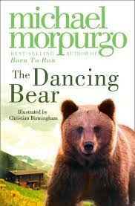  The Dancing Bear by Michael Morpurgo themes of friendship, kindness, dilemmas, bravery, loneliness, animal cruelty and community  Contemporary narrative chapter book | 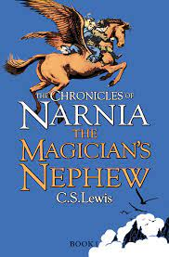  The Magician’s Nephew by CS Lewis religious references and themes of an ill parent  First book in classic Narnia series narrative chapter book
Writing | Strong start with sentences  Poetry on a theme  First person narrative description focus | NC reports  Formal letters to complain  Performance poetry | Third person narrative  NC reports | Advanced instructional writing  First person narrative descriptions  Performance poetry | Third person narrative  Formal letters to complain | Dialogue through narrative (historical stories)  Poetry on a theme (emotions)  Advanced instructional writing
VGPS  Introduce  Revisit  Consolidate | Introduction to direct speech including inverted commas  Use of a/an  Formation of nouns using prefixes  Expressing time, place and cause using conjunctions  Commas to separate items in a list  Past progressive and present progressive tense  Use of the suffixes –er, –est in adjectives  Use of –ly in Standard English to turn adjectives into adverbs  Synonyms and antonyms |  | Word families  Expressing time, place and cause using adverbs  introduction to direct speech including inverted commas  Use of a/an  Formation of nouns using prefixes  Expressing time, place and cause using conjunctions |  | Present perfect form of verbs  Expressing time, place and cause using prepositions  Word families  Expressing time, place and cause using adverbs  Introduction to direct speech including inverted commas  Use of a/an  Formation of nouns using prefixes  Expressing time, place and cause using conjunctions
Spelling | Spelling strategies  Alternate spellings for same sound  Same spelling, different sounds  Spelling polysyllabic words as accurately as possible |  | Revisit ks1 common exception words Adding –es to nouns and verbs ending in –y Adding –ed, –ing, –er and –est to a root word ending in –y with a consonant before it Y2 revisited  Adding the endings –ing, –ed, –er, –est and –y to words ending in –e with a consonant before it and to words of one syllable ending in a single consonant letter after a single vowel letter Y2 revisited  Etymology: dec, tele, photo | Homophones and near-homophones  The suffixes –ment, –ness, –ful, –less and –ly Y2 revisited  Contractions Y2 revisited  Etymology: de, uni, kilo | Rare GPCs Y2 revisited  Words ending in –tion Y2 revisited  Y3/4 statutory word list  Adding suffixes beginning with vowel letters to words of more than one syllable  Etymology: mill(e), fract, peri, graph | The /ɪ/ sound spelt y elsewhere than at the end of words  Prefixes – un– (revisited), dis–, mis–, in–, il–, im–, ir–  The suffix –ation  The suffix –ly  The /ʌ/ sound spelt ou  Etymology: scrib, aqua, mech, phono, dict

Year 3/4 Elm Class
Cycle B
 | Autumn 1 | Autumn 2 | Spring 1 | Spring 2 | Summer 1 | Summer 2
Reading | 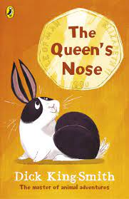  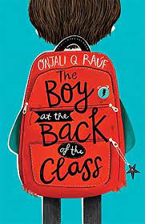  The Queen’s Nose by Dick King Smith classic short novel notable British author  The Boy at the back of the Class by Onjali Q Rauf themes of kindness, friendship, bravery, sensitivity, community and relevant social issue contemporary narrative | 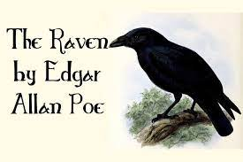  The Boy at the back of the Class by Onjali Q Rauf  The Raven by Edgar Allen Poe implicit reference to mental health heritage poem seminal poet | 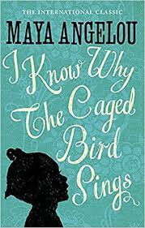  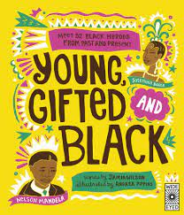  Young gifted and black by Jamia Wilson illustrated anthology achievements of black icons from history and present day  The caged bird by Maya Angelou freedom and discrimination  Poem seminal American poet | 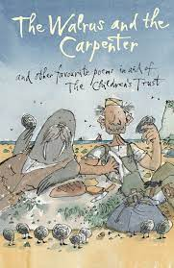  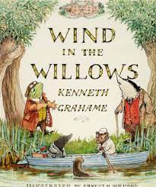  The Wind in the Willows by Kenneth Grahame heritage narrative text classic adventure story  The Walrus and the carpenter by Lewis Carroll poem | 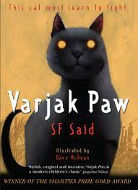  Varjak Paw b y SF Said themes of tenacity, bravery, self-belief, urban living, adventure  Contemporary narrative chapter book | 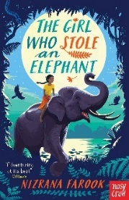  The girl who stole an elephant by Nizrana Farook set in Sri Lanka  Themes of social equality, justice, morality, friendship, political power and loyalty  Thrilling adventure story
Writing | Sentence composition  Third person adventure stories  Persuasive writing (adverts)  Poems which explore form | News reports  First person diary entries  Stories from other cultures | Poems which explore form  Poems which explore form  Critical analysis of narative poetry | Explanatory texts  Stories from other cultures | Third person adventure stories  First person diary entries | Critical analysis of narrative poetry  News reports  Explanatory Texts
VGPS  Introduce  Revisit  Consolidate | Introduce: Direct speech including inverted commas  Expanded noun phrases  Determiners  Revisit: Present perfect form of verbs  Expressing time, place and cause using prepositions  Consolidate: Verb Tenses  Word families  Expressing time, place and cause using adverbs |  | Introduce: Fronted adverbials including commas before fronted adverbials  Possessive Pronouns  Revisit: Direct speech including inverted commas  Expanded noun phrases  Determiners  Consolidate: Verb Tenses  Present perfect form of verbs  Expressing time, place and cause using prepositions |  | Introduce: Plural and possessive -s  Standard verb inflections  Revisit: Fronted adverbials including commas before fronted adverbials  Possessive Pronouns  Consolidate: Verb Tenses  Direct speech including inverted commas  Expanded noun phrases  Determiners
Spelling | Spelling strategies  Polysyllabic words  KS1 common exception words revisitied  Homophones revisited  The suffix ly revisited  Etymology: div, mono | Statutory word list  Prefixes – dis–, mis–, in–, il–, im–, ir– revisited re–, sub–, inter– , super–, anti–, auto–  : Adding suffixes revisited  Etymology: poly, pro, sign | Words with endings sounding like /ʒə/ or /tʃə/  : Words with endings sounding like /ʒən/  Homophones  Etymology: Nim, circ, arch | Words with endings sounding like /ʃən/, spelt –tion, –sion, –ssion, –cian  The suffix –ous  Statutory word list  Etymology: struct, port, vert, lat | Words with the /k/ sound spelt ch Words with the /ʃ/ sound spelt ch  Words ending with the /g/ sound spelt –gue and the /k/ sound spelt –que  Etymology: aero, hydro | Words with the /s/ sound spelt sc  Statutory word list  Words with the /eɪ/ sound spelt ei, eigh, or ey  Etymology: aud, ex

Year 5/6 Oak Class
Cycle A
 | Autumn 1 | Autumn 2 | Spring 1 | Spring 2 | Summer 1 | Summer 2
Reading | Shackleton’s Journey by William Grill  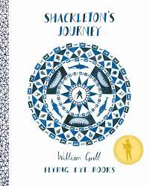  Draws on learning from across the curriculum  Contemporary non narrative picture book | 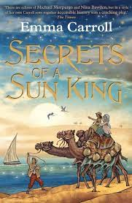  Secrets of a Sun King by Emma Carroll historical fiction themes of family, friendship, tenacity, feminism  Contemporary historical narrative  If by Rudyard Kipling heritage poem seminal British author and poet | 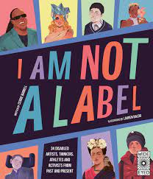  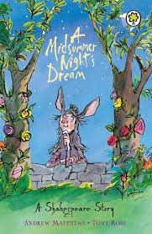  A Midsummer Night’s dream by William Shakespeare heritage classic simple retelling and plot analysis and information about Shakespeare and Globe Theatre  I am Not a label by Cerrie Burnell  Role models who have overcome disability, mental health issues or wider life challenges. Challenges stereotypes and assumptions  Illustrated anthology celebrating achievements of modern and historical role models | 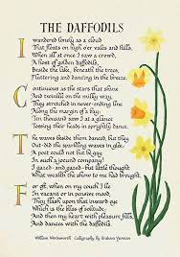  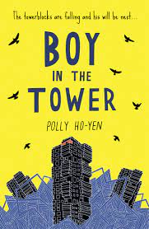  The Boy in the Tower by Polly Ho-Yen  Contemporary science-fiction narrative  Themes of mental health, young carers, friendship, trust, resilience and anxiety  Daffodils by William Wordsworth classic heritage poem British seminal poet | 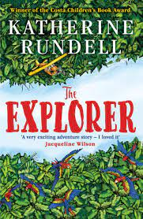  The Explorer by Katherine Rundell themes of human exploration and the morality of this, environmental responsibility, theems of friendship, adventure and the natural world  Contemporary narrative: adventure | 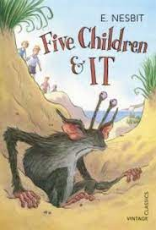  Five children and IT by E Nesbit historical references to gender, race and social discrimination to discuss  Heritage fantasy narrative
Writing | Formal letters of application  Poems that use word play | Dialogue in narrative (first person myths and legends)  Balanced argument  Poems that explore form | Third person narrative stories set in other cultures  Formal letters of application | Playscripts (Shakespeare re-telling)  Biography  Poems that use word play | Playscripts  Dialogue in narrative | Balanced argument  Biography  Poems which explore form
VGPS  Introduce  Revisit  Consolidate | Introduce: Modal verbs  Relative clauses and relative pronouns  Consolidate: Verb TensesFronted adverbials including commas after fronted adverbials  Possessive Pronouns |  | Introduce: Suffixes and prefixes  Linking ideas across paragraphs using adverbials of time, place and number  Modal verbs  Relative clauses and relative pronouns  Verb Tenses |  | Dashes, brackets or commas to indicate parenthesis  Suffixes and prefixes  Linking ideas across paragraphs using adverbials of time, place and number  Verb Tenses  Modal verbs  Relative clauses and relative pronouns
Spelling | Spelling strategies  Y3/4 statutory word list revisited  Spelling polysyllabic words |  | Prefixes, suffixes and homophones revisited  Etymology: min, sect, var | : Words with endings sounding like /ʃən/, spelt –tion, –sion, –ssion, –cian revisited  : Words with endings sounding like /ʒə/ or /tʃə/ or /ʒən/ revisited  Statutory word list  Etymology: mari, tract, micro | Words with endings sounding like /ʃəl/ spelt –cial or –tial  Endings which sound like /ʃəs/ spelt –cious or –tious  Statutory word list  Homophones  Etymology: ject, vac, ambi/amphi | Words ending in –ant, –ance /–ancy, –ent, –ence /–ency  Statutory word list  : Homophones  Words ending in –able and –ible Words ending in –ably and –ibly  Etymology: vis/vid, sol. Lun, form, term, solv/solu

Year 5/6 Oak Class
Cycle B
 | Autumn 1 | Autumn 2 | Spring 1 | Spring 2 | Summer 1 | Summer 2
Reading | 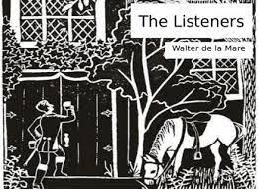  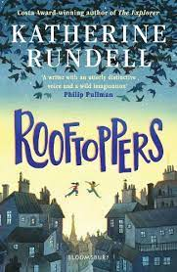  Rooftoppers by Katherine Rundell contemporary narrative set in Victorian times  Themes of friendship, determination, love, ingenuity, those living on fringes of society  The Listeners poem by Walter De la Mare themes of the supernatural, fantasy and mortality | 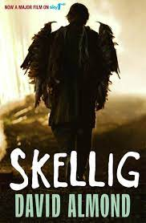  Skellig by David Almond contemporary narrative representation of an ill sibling, themes of change, friendship, family, death, fear and adventure  A carol from Flanders poem By Frederick Nivern themes of kindness, conflict and humanity | 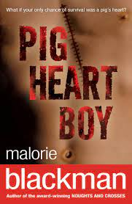  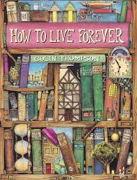  Pig heart boy contemporary narratibe by Malorie Blackman ethical issues inclues animal rights and the quest to extend life thrugh science themes of illness, friendship, loyalty, family and determination  How to live forever by Colin Thompson contemporary narrative picture book, building on study of Pigheart boy the ethics and implications of immortality | 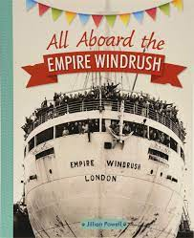  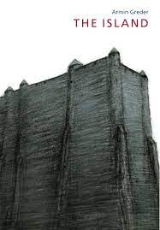  All aboard the empire windrush contemporary non-narrative history of the Windrush generation themes of change, prejudice, national identity and social history  The Island by Armin Greder contemporary narrative picture book narrative parallels themes addressed in Windrush text and history unit themes of refugees, xenophobia, social politics and human rights | 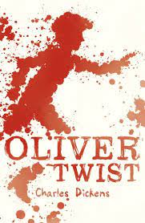  Introduction to Dickens- Oliver Twist a range of extracts from Dickens and to support learning about… archaic language, life in victorian times, social and historical contexts | 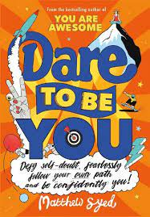  Dare to be you role models by Matthew Syed Non narrative book of empowerment celebrate difference, develop inner confidence and independence themes of difference, inspiration and kindness. Transition to secondary school
Writing | Autobiography  Discursive writing and speeches  Poems that create images and explore vocabulary | First person stories with a moral  Shakespeare’s Sonnets  Explanatory texts | Extended third person narrative (adventure stories)  Explanatory Texts | News Reports  Autobiography  First person stories with a moral | Extended third person narrative (adventure stories)  News reports | Discursive writing and speeches  Poems that create images and explore vocabulary  Shakespeare’s Sonnets
VGPS  Introduce  Revisit  Consolidate | Passive and active voice  Synonyms and antonyms  Colons, semi-colons and dashes for clauses  Hyphens  Dashes, brackets or commas to indicate parenthesis  Verb Tenses  Suffixes and prefixes  Linking ideas across paragraphs using adverbials of time, place and number |  | Formal and informal speech  Subjunctive form  Passive and active voice  Synonyms and antonyms  Colons, semi-colons and dashes for clauses  Hyphens  Verb Tenses  Dashes, brackets or commas to indicate parenthesis |  | Linking ideas across paragraphs  Formal and informal speech  Subjunctive form  Verb Tenses  Passive and active voice  Synonyms and antonyms  Colons, semi-colons and dashes for clauses  Hyphens
Spelling | Homophones revisited  Prefixes and suffixes revisited  Statutory word list  Endings which sound like /ʃəs/ spelt –cious or –tious and /ʃəl/ spelt –cial or –tial revisited  Etymology: bio, scend, quin, hept/sept | Words ending in –ant, –ance /–ancy, –ent, –ence /–ency revisited  Words ending in –able and –ible Words ending in –ably and ibly revisited  Statutory word list revisited  Etymology: cred, grad, spec, contra | Words with the /i:/ sound spelt ei after c  Homophones revisited  Adding suffixes beginning with vowel letters to words ending in –fer  Etymology: hem/haem, ann(us), iso | Words containing the letter-string ough  Words with ‘silent’ letters  Etymology: cav, dur | Consolidation of spelling curriculum  Investigative work-spelling patterns/rules/etymology

Year N/R Acorn Class
 | Autumn 1 | Autumn 2 | Spring 1 | Spring 2 | Summer 1 | Summer 2
Reading | 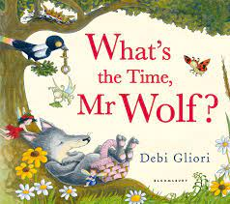  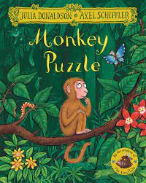  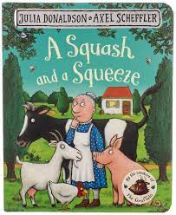  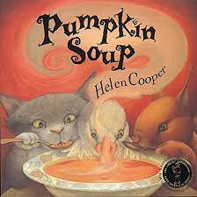  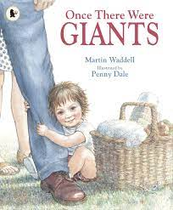  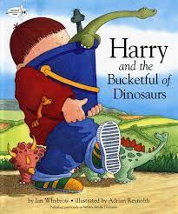  Julia Donaldson  Pat Hutchins  Eric Carle  Oliver Jeffers | 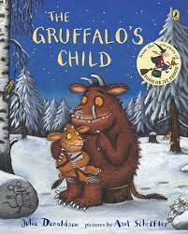  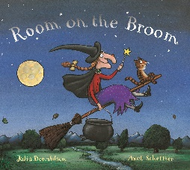  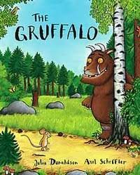  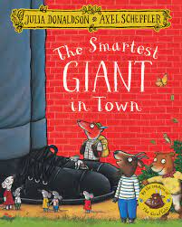  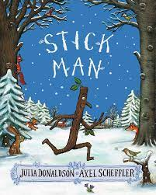 | 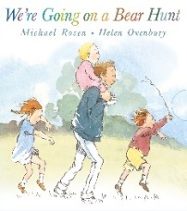  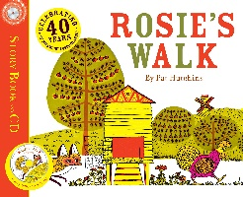  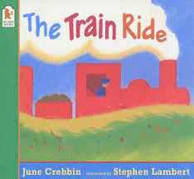  The Great Race – Chinese New Year  RSPB Non – fiction books about birds | 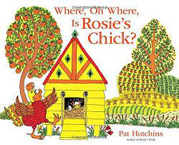  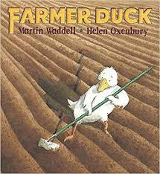  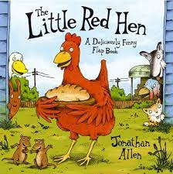 | 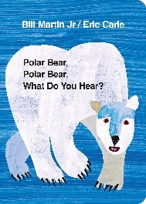  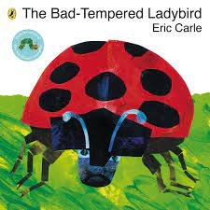  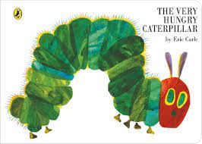  Amelia Earhart | Tim Peake  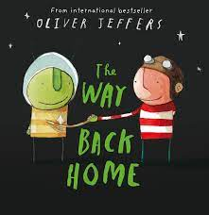  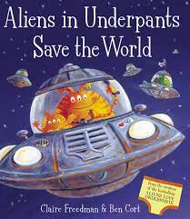  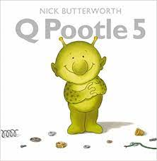  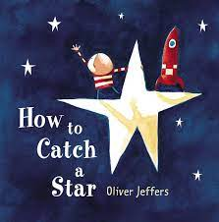
Writing | Mark making  Getting ready to write activities  Re-enacting stories  Letter formation in line with sounds taught | Poppy Poems  Character description | Instructions  Setting and character descriptions  Repeated phrases and patterned language  Recount |  | instructions | Writing in role as an alien/spaceman
VGPS | Aspect 1-7 Phase 1 phonics with Nursery  Phonics- Sounds Write units 1-7 |  | Aspect 1-7 Phase 1 phonics with Nursery  Phonics – Sounds Write units 7-11 |  | Aspect 1-7 Phase 1 phonics with Nursery  Phonics - Sounds Write Units
Spelling

