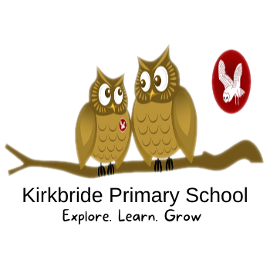
French Long Term Plan

All KS2 pupils will learn French. Teaching is supported by Kapow Primary French scheme.

 |  | Aut 1 | Aut 2 | Spring 1 | Spring 2 | Summer 1 | Summer 2
Cycle A | Y3/4 | French Greetings with puppets | French adjectives of colour, size and shape | French playground games, numbers and ages | In a French Classroom | French Transport | A circle of life in French
 | Y5/6 | French Monster pets | Space exploration in French | Shopping in France | French speaking world | Verbs in a week | Meet my French family
Cycle B | Y3/4 | Portraits- describing in French | Clothes-getting dressed in French | French numbers- calendars and birthdays | French weather and the water cycle | French Food | French and the Eurovision Song Contest
 | Y5/6 | French sport and the Olympics | French football champions | In my French house | Planning a French holiday | Visiting a French town | Revision

