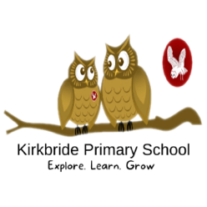

Geography Subject Overview

At Kirkbride Primary School we are currently moving to use Curriculum Unity Schools Partnership (CUSP) Geography scheme of work.
This draws upon several powerful sources of knowledge. It is our intention that pupils become a little more expert as they progress through the curriculum, accumulating and connecting substantive and disciplinary geographical knowledge.
a) Substantive knowledge – this is the subject knowledge and explicit vocabulary used to learn about the content. Common misconceptions are explicitly revealed as non-examples and positioned against known and accurate content as pupils become more expert in their understanding. Misconceptions are challenged carefully and in the context of the substantive and disciplinary knowledge.
In CUSP Geography, it is recommended that misconceptions are not introduced too early, as pupils need to construct a mental model in which to position new knowledge.
b) Disciplinary knowledge – this is the use of knowledge and how children become a little more expert as a geographer by Thinking Geographically.
c) Geographical analysis is developed through selecting, organising and integrating knowledge through reasoning and making sense of the content in response to structured questions and well-designed tasks that cause children to think hard as geographers.
d) Substantive concepts are the big ideas, and the golden threads, that run through a coherent and cohesive geography curriculum. They can include place, space, scale, interdependence, physical and human processes, environmental impact, sustainable development, cultural awareness and cultural diversity. Concepts such as change through erosion are taught through explicit vocabulary instruction as well as through the direct content and context of the study.
