MFL Curriculum Statement
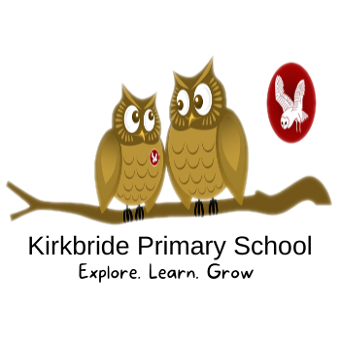

Intent
The intention of the Modern Foreign Languages (MFL) curriculum at Kirkbride Primary School is that children are taught to develop an interest in learning other languages in a way that is enjoyable and stimulating. We aim to encourage children’s confidence and creative skills through the teaching of French. There is a strong link to the teaching of French within the local secondary schools. Whatever the language taught, we strive to stimulate and encourage children’s curiosity about all languages. At Kirkbride, English tends to be the only language that is spoken at home, so it is vital that we help children develop their awareness of cultural differences. We aim to embed the skills of listening, speaking, reading and writing skills necessary to enable children to use and apply their French learning in a variety of contexts and lay the foundations for future language learning.

Implementation
- Our MFL curriculum is designed to progressively develop children’s skills in languages, through weekly taught lessons in KS2.
- Teachers deliver MFL lesson supported by planning by the Kapow Primary Scheme of work
• Children progressively acquire, use and apply a growing bank of vocabulary organised around topics.
• Children are encouraged and supported to develop their speaking and listening skills through conversational work, singing activities and games.
• As confidence and skill grows, children record their work through a range of tailored activities to ensure that all children can access the MFL curriculum that is outlined in the National Curriculum

Impact
Through the use of planning supported by the Kapow Primary Scheme of work, we aim to ensure that eventually children are accessing work at age related expectations. They will be able to recognise and apply key vocabulary within conversations and will be challenged in a range of speaking and listening, reading and writing activities.

