Kirkburton Middle School
Turnshaws Avenue
Kirkburton
Huddersfield
HD8 0TJ

HD8 0TJ

Headteacher: Mr C Taylor

Telephone: 01484 222737
Email: office@kirkburtonmiddleschool.co.uk
Web: www.kirkburtonmiddleschool.co.uk

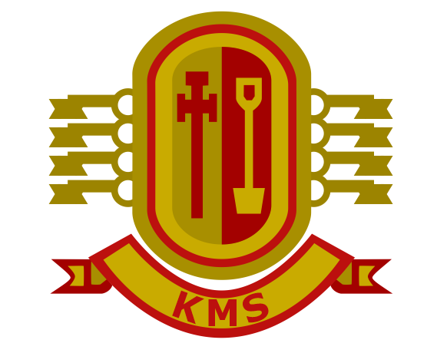

Enjoying, Achieving, Succeeding Together

28th May 2021

Dear Parent/ Carer

We wanted to write and let you know about some of the actions that will be taking place next half-term.
We have recently introduced our pupils to the KMS Way – please see below. All students should have a copy of this stuck in each of their exercise books and we expect pupils to do their absolute best to comply with our high expectations of them. We are very keen for our pupils to take responsibility for their learning and foster good study habits and we believe that taking pride in their work and being equipped for learning will support this. It also helps maintain pace and focus in lessons if teachers do not have to stop to equip pupils. Many of our pupils are making excellent progress with this already.

We would like your support with this therefore, and ask that you ensure that your child has all of the necessary equipment, as detailed in the KMS Way or in the school planner, with them at all times after half-term. Form tutors will be carrying out equipment checks during afternoon registration, pupils will receive a statutory positive if they have all of their equipment but lose that positive if they don’t. If you have any concerns about equipping your child for school, do not hesitate to get in touch with your child’s form tutor.

We would also ask that pupils continue to maintain high standards of uniform until we break up for the year in July. Again, we feel that this helps foster a purposeful working environment, it trains pupils well for their transition to Shelley and ensures equality across the school. Should a pupil arrive at school wearing incorrect uniform, there is the expectation that they will wear loaned clothing/shoes for the day where possible. All loaned uniform is laundered each evening. Again, if you do have any concerns, please contact your child’s form tutor.

During our last half term, we will be having three ‘behaviour’ drives. For the first two weeks, our focus will be on punctuality to school. As you are aware, pupils should be in their seats and ready to learn by 8.55. Unfortunately, some pupils are arriving late to school and we really want to nip this in the bud. If pupils are late, they will receive a late mark: 3 late marks within the half term will result in a 30 minute lunchtime detention and 6 late marks within the term will result in an hour’s detention after school. We will notify you via email of lateness to school.

Between 21st June and 2nd July we will focus on equipment, please see details above. Equipment will be checked each day in afternoon form periods. If pupils forget an exercise book for a lesson, they will also lose their statutory positive in that lesson.

From the 5th July to the 16th July we will focus on manners. We will be talking to pupils about how to speak politely to each other and to adults in school, and will complete some work around kindness and empathy to support our pupils in their personal growth. We would be grateful if you could reinforce and support our messages at home.
We are extremely proud of the vast majority of our pupils and we believe that by having the very highest expectations of them, they will continue to achieve, succeed and enjoy their time with us at KMS.

Kind regards

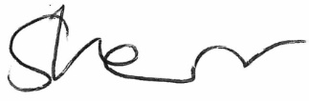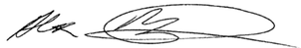
Sam Kerr and Alex MacIntyre - Senior Leadership Team

