Kirkburton Careers Provision plan 2020 – 2021
Gatsby Benchmarks colour code
1 A stable Careers programme | 2 LMI (labour market information) | 3 Addressing the needs of each pupil | 4 Careers in the Curriculum | 5 Encounters with employers and employees | 6 Workplace experience | 7 Encounter with FE and HE | 8 Personal guidance

KMS 2020 - 2021 | Autumn | Winter | Summer
CPD  Meetings | The career development landscape – evidence and impact statement – September 2020  CEIAG Meeting 22/9/20  Careers meeting with head teacher 17/9/20  Careers meeting with SENDCO 23/9/20  SEND advisory group meeting 24/9/20  Virtual Medical festival meeting – 24/9/20  CK Careers TEAMS meeting for virtual wallet 1st October 2020  How to build an Alumni – 25/0.20  Meeting with AM to arrange Careers drop down sessions – 24/9/20  SLT Careers meetings – 14.12.20  SLT Careers meetings – 14.6.21  Staff CPD – October 2020  Staff crib sheet October 2020
Year 5 | Transition to SMS Virtual assembly
Provision in school | LMI display  Diversity and LGBT Careers display  Apprenticeship information  Gatsby Benchmarks and Apprenticeship information in Staff room  Feedback from parents/students on Careers Provision  Feedback for staff/governors on Careers Provision  Letters to enable personal guidance  Careers library  Posters on routes available  Students job vacancy information board  Twitter/Facebook messages on current LMI and local career events  Google review to staff/parents/students for feedback on trips  KMS allowed to join the CEIAG hub group – which enables us to get support from LEC (Careers enterprise and business partners  Careers pages in planner to record activities | LMI display  Diversity and LGBT Careers display  Apprenticeship information  Gatsby Benchmarks and Apprenticeship information in Staff room  Feedback from parents/students on Careers Provision  Feedback for staff/governors on Careers Provision  Letters to enable personal guidance  Careers library  Posters on routes available  Students job vacancy information board  Twitter/Facebook messages on current LMI and local career events  Google review to staff/parents/students for feedback on trips  KMS allowed to join the CEIAG hub group – which enables us to get support from LEC (Careers enterprise and business partners  Careers pages in planner to record activities | LMI display  Diversity and LGBT Careers display  Apprenticeship information  Gatsby Benchmarks and Apprenticeship information in Staff room  Feedback from parents/students on Careers Provision  Feedback for staff/governors on Careers Provision  Letters to enable personal guidance  Careers library  Posters on routes available  Students job vacancy information board  Twitter/Facebook messages on current LMI and local career events  Google review to staff/parents/students for feedback on trips  KMS allowed to join the CEIAG hub group – which enables us to get support from LEC (Careers enterprise and business partners  Careers pages in planner to record activities
Year 6 | Well-being lessons in PHSE  Careers education in PHSE  Weekly current affairs quiz – Culture Capitol  Homework project – My family and the jobs they do.  Careers in the curriculum – Maths – Farm project  Careers in the Curriculum – Science and Design Technology  Assembly – Introduction to Careers  Assembly – Introduction to Apprenticeships  SEND booklet for parents  Life skills booklet SEND  Careers drop down session – class time – booklets  Careers in the curriculum starters in all lessons 30th November  Homework – PPT of subject/career guide  Introduction to Panjango – interactive Careers website  Science Plenary- Black History Month Celebrating the accomplishments of successful BAME in STEM Careers Mark Richard Amazing Untold Story Of NASA's Brilliant African-American Female Scientists Donald Palmer Charlotte Armah Sanjeev Gupta Jassel Black Scientists: Past, Present and Future | Well-being lessons in PHSE  Careers education in PHSE  Weekly current affairs quiz – Culture Capitol  Homework project – My family and the jobs they do.  Careers in the curriculum – Maths – Farm project  Careers in the Curriculum – Science and Design Technology  Form time Booklets – Who am I?  Future Goals Booklets sent to parents  Stereotyping in the workplace PPT  Careers in the curriculum starters in all lessons 1st March  What is an apprenticeship assembly? NAW  Assembly on Careers in the curriculum  Careers drop down session – class time - booklets | Well-being lessons in PHSE  Careers education in PHSE  Weekly current affairs quiz – Culture Capitol  Homework project – My family and the jobs they do.  Careers in the curriculum – Maths – Farm project  Careers in the Curriculum – Science and Design Technology  Careers drop down session – class time - booklets
Year 7 | Well-being lessons in PHSE  Careers education in PHSE  Weekly current affairs quiz – Culture Capitol  Homework project futuristic jobs and a career I would like to have.  Careers in the Curriculum – Science and Design Technology  Assembly – Introduction to Careers  Assembly – What is an Apprenticeship?  ICT Careers day for girls  Form time Booklets – What is an Apprenticeship?  Future Goals Booklets sent to parents last year  SEND booklet for parents  Careers in the curriculum starters in all lessons 30th Nov  Assembly – LMI  Life skills booklet SEND  Careers drop down session – class time - booklets  Homework – PPT of subject/career guide  Introduction to Panjango – interactive Careers website  Science Plenary- Black History Month Celebrating the accomplishments of successful BAME in STEM Careers Mark Richard Amazing Untold Story Of NASA's Brilliant African-American Female Scientists Donald Palmer Charlotte Armah Sanjeev Gupta Jassel Black Scientists: Past, Present and Future | Well-being lessons in PHSE  Careers education in PHSE  Weekly current affairs quiz – Culture Capitol  Homework project futuristic jobs and a career I would like to have.  Careers in the Curriculum – Science and Design Technology  Form time Booklets – What is an Apprenticeship?  Future Goals Booklets sent to parents last year  Stereotyping in the workplace PPT  Careers in the curriculum starters in all lessons 1st March  Careers in the curriculum Assembly  Careers drop down session – class time - booklets | Well-being lessons in PHSE  Careers education in PHSE  Weekly current affairs quiz – Culture Capitol  Homework project futuristic jobs and a career I would like to have.  Careers in the Curriculum – Science and Design Technology  Form time Booklets – Employability skills  Careers drop down session – class time - booklets
Year 8 | Well-being lessons in PHSE  Careers education in PHSE  Weekly current affairs quiz – Culture Capitol  Careers in the Curriculum – Science and Design Technology  Life skills booklet SEND  Office duty – work experience  25 students – Sports young leaders  House captains – In charge of Interform sports challenges  University virtual visit  Huddersfield New College /Greenhead virtual visit.  Leeds UTC Virtual visit  Barnsley College/Kirklees college virtual visit  Assembly – Introduction to Careers  Assembly – What is an Apprenticeship?  SEND booklet for parents  ICT Careers day for girls  Form time Booklets – What is an Apprenticeship?  Future Goals Booklets sent to parents last year  Careers in the curriculum starters in all lessons 30th November  Careers drop down session – class time - booklets  Aspiration work shop – Threedome solutions.  Thursday 3rd December – 30 students for 3 hour workshop.  PP/FSM provision  The students will learn how their actions today will impact their future. They will understand the importance of making the most of their experiences and education today for their future self. The students will explore labelling, ones they like, ones they want to lose and labels they could re-write to be positive.  Self-confidence and self-esteem are both boosted by new experiences. We want to demonstrate to the students how a reluctance to leave their comfort zone is limiting on their development, experiences, opportunities and therefore potential. The students will learn how to take a small step at a time rather than a big leap.  Science Plenary- Black History Month Celebrating the accomplishments of successful BAME in STEM Careers Mark Richard Amazing Untold Story Of NASA's Brilliant African-American Female Scientists Donald Palmer Charlotte Armah Sanjeev Gupta Jassel Black Scientists: Past, Present and Future  Introduction to Panjango – interactive Careers website  Year 8 Maths classes - interviewed an adult (usually mum or dad) about how they use Maths in their chosen career | Well-being lessons in PHSE  Careers education in PHSE  Weekly current affairs quiz – Culture Capitol  Careers in the Curriculum – Science and Design Technology  Life skills booklet SEND  Stereotyping in the workplace PPT  Form time Booklets – What is an Apprenticeship?  Careers in the curriculum starters in all lessons 1st march  Careers in the curriculum Assembly  Assembly – LMI  Careers drop down session – class time - booklets  Virtual Huddersfield University visit  Virtual UTC and Kirklees College Visit  Virtual Careers Fair | Form time Booklets – Employability skills  Interview skills assembly  Well-being lessons in PHSE  Careers education in PHSE  Weekly current affairs quiz – Culture Capitol  Careers in the Curriculum – Science and Design Technology  Life skills booklet SEND  Careers drop down session – class time - booklets

KMS Careers Impact Statement and school vision – 2020

Impact Statement 2020
Black – What we are doing
Purple – When documents are attached
Red – Things that need to be done
Green – Work done through School Closure
1. A stable careers programme
Monitoring activities include | Evaluation activities include
Reviewing the careers programme to determine what activities are happening and when they are happening  Checking the web metrics to see how many times the policy has been downloaded C.Tyson has sent results – see attached.  Monitoring the CPD activities which staff undertake  Introduce a student working party to get student voice.  All activities have been added to Termly Newsletter  Students set Careers work by Head of Careers – Booklet and Buzz Quiz.  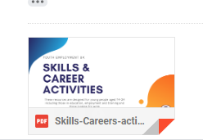  Evidence of work set attached.  Corona work from home.  Study and employability skills booklet  Buzz test.  Skills builder workshops  PE – Careers homework  You tube video of WOW show | Regular meetings with head of PHSE – evidence of work by the students for PHSE Careers and Class time booklets.  Regular monitoring that students are working on Careers in class time.  Feedback sheets after an event and also Google review  Exploring the extent to which career learning has taken place (test, work sampling etc.)  Examine data to check whether there has been a change in progression routes after an activity on apprenticeships (Use feedback sheets to ask students if they might now consider Apprenticeships rather than University)  Observation and interview of programme participants over time perhaps including tracking them into university/post-school life  Reviewing the progression data for students leaving school, or Ofsted reports or quality award assessment reports against the strategic plan / departmental development plan  Google review and feedback from Staff.  Regular completion of Compass  Ofsted report attached.

2. Learning from career and labour market information
Monitoring activities include | Evaluation activities include
Monitoring the use of web pages using web metrics. See data report that is attached.  Counting the number of young people and parents who are using the school website/ Facebook page about careers. See data report that is attached.  Monitor how many parents/students have used their Future Goals Booklet and what the students learned about in their LMI Assembly. Google review (done but in present climate nobody is filling in the review.)  Surveying staff to see who is incorporating information about careers in subject display materials  Up to date displays of LMI on notice board and on display around school. | Exploring which websites learners are using to inform their career decision making  Reviewing formats young people prefer to receive their information  Exploring the specialist information needs of certain groups to determine whether or not gaps in provision exist.  Understanding the way young people use information from information events to explore their decision making  Google review feedback analysis from students/parents/staff  Photographs of displays  Evidence of yearly audits/ Planning and SOW. Evidence of work produced by students.  (Need to do Google review of CIC Starters by Career ready)  Feedback sheets from CIC day to analyse. Students preferred the practical sessions compared to the year before.  Regular completion of Compass

3. Addressing the needs of each pupil
Monitoring activities include | Evaluation activities include
Noting how many learners have an EHC plan  Noting how many young people have received different types of career intervention – visit to Honley Careers Fair, Visit to Kirklees Sports Centre, resilience sessions, transition to Scissett Middle School and up to Shelley College.  Identifying how many STEM careers activities have taken place in school  Monitoring staff who show and discuss the Stereotyping PPT.  Identifying how many girls involved in ICT activities.  PP/FSM students go on all Careers visits free.  PP/FSM students to be selected (30 students in yr 8 – not all PP/FSM) students picked up from well being survey and those who struggle with aspirations and positive growth mindset. 3-hour resilience and aspiration session with VJ, MW and AGR – all in there to train to use sessions again.  SEND students have received an information booklet to give information for the future.  SEND students have a differentiated life skills booklet for careers drop down days. | Reviewing data on pupil premium, FSM, or SEND pupils to target career guidance  Surveying groups of learners to determine how targeted support has impacted on career decisions – Use of Google review and feedback sheets on all visits and careers provision.  Using progression data to determine how many girls have taken up STEM A levels after a careers event aimed at this – To use Shelley College data to see if there is an increase.  Reviewed the widening progression activities to determine the extent to which numbers into HE have increased. To use Shelley College data to see if there is an increase.  Regular completion of Compass  Data stored as Excel Spreadsheets. (please ask for copies if required)  Feedback survey for students.

4. Linking curriculum learning to careers
Monitoring activities include | Evaluation activities include
Surveying teachers to see how many are incorporating information on careers into subject lessons  Career Ready Activity – Posters supplied and delivered – up in classrooms and in hall.  All subjects deliver starters for 2 weeks on CIC using Career ready PPTs. (I attach evidence of PPT)  CIC day (2019)  CIC postponed 2020 due to Corona  CPD training for Maths/English in CIC in their subject  Annual Science week and Bi Annual Science Fayre. CIC included. | Survey learners to see if they like a lesson which has a careers slant  Evidence of Audits/SOW and Planning  Head of Careers attending Maths/English department meetings after CPD to monitor feedback to department.  Evidence of work collected.  Test students’ knowledge of the type of careers specific subjects could lead to (Set as a school closure piece of work week 3) Set as a class charts homework for all year groups in November 2020.  Google review and questionnaire on CIC starters  CIC day through feedback sheets and Google review  Reviewing the extent to which incorporating information and links into curriculum affects the uptake of subjects at GCSE and post-16 through Google review  Contacted Shelley College for Options choice Data for last 2 years.  Review school subject choices against local strategic plans Contacted Shelley College for Options choice Data for last 2 years.  Regular completion of Compass

5. Encounters with employers and employees
Monitoring activities include | Evaluation activities include
Judge and Author came into work with students.  To aim to do something similar each year – even if virtual. Titan Careers fair arranged for Year 8 PHSE lessons.  Hoping to appoint OPUS – SEND encounters with workplaces – Will need to bid for cost. | Used feedback sheets to explore learner’s reaction to activities  Assess the employability skills of those learners who have attended employer events  Explored the positive effects of work-related activities on participating employers  Reviewed the destinations of data of learners who have participated in work-related activities in line with local strategic plans  Regular completion of Compass

6. Experiences of workplaces
Monitoring activities include | Evaluation activities include
Review work set by teachers to allow each school visit to review the establishment as a workplace (As a middle school we are not allowed to let students out for work experience but we use every trip/visit as a workplace visit, e.g. theatre visit, Syngenta Chemistry visit, Sports centre visit)  Count how many experiences of work places each learner has received  To plan online Entrepreneur club  Contacted BEC to see whether possible to club online. | Feedback sheets after every visit. Google reviews on impact of visits.  Testing student learning against pre-determined learning outcomes  Review the choices at GCSE and route taken at 16 compared with workplace visits.  Review the organisations network of employers to identify any gaps in provision  Regular completion of Compass

7. Encounters with further and higher education
Monitoring activities include | Evaluation activities include
Count the number of visits which each learner has taken to FE and HE providers  Kirklees College online open days to use in PHSE in year 8.  Must get CITB, Woodspeen in to do a talk about independent Apprenticeship schemes.  University trip postponed due to Corona  University virtual session bespoke for KMS and SMS to show in PHSE sessions.  UTC at Leeds virtual open day. | Determine how learners feel about their visits to see if they received the information, they needed (use of Goggle review and feedback sheets)  Compare the destinations of learners with the visits to organisations  Survey learners to find out how the visits to providers have influenced their decisions  Compare student progression data to school strategic plans  Regular completion of Compass

8. Personal guidance
Monitoring activities include | Evaluation activities include
Check to ensure external provider has maintained their position on the register of practitioners  Count how many learners have had interviews with a career guidance practitioner – Use of data from Secondary school | Survey students to determine how they rate the careers interview which they have had  Survey the career guidance staff to determine how prepared young people are to receive career guidance  Survey all school staff to determine their career guidance training needs  Review the impact of CPD activities  Regular completion of Compass
Data Metrics on use of website.
The data shows that the Careers policy and Access statement on the website are being looked at much more since the new Careers provision has become more established.
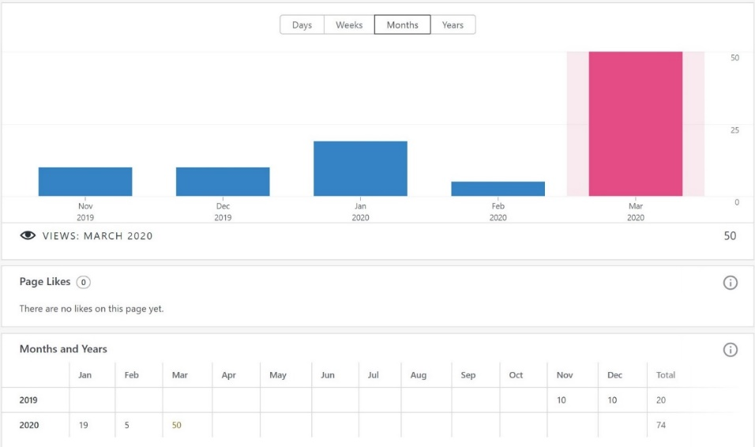
Ofsted Inspection of Kirkburton Middle School
Turnshaws Avenue, Kirkburton, Huddersfield, West Yorkshire HD8 0TJ
Inspection dates: 1–2 October 2019
Overall effectiveness Inadequate
The quality of education Requires improvement
Behaviour and attitudes Inadequate
Personal development Good
Leadership and management Inadequate
Inspection report: Kirkburton Middle School
1–2 October 2019 2
What is it like to attend this school?
There are a wealth of different clubs and activities. The display cabinet is straining with the number of trophies that the school has won. This, alongside the work to develop pupils’ mental and emotional well-being, makes this school distinctive.
There is a good range of different clubs and activities, including football, Nerf Ball, musical activities, chess club and Warhammer. The school was the first in Kirklees awarded the School Games Platinum Award.
Pupils are also encouraged to become young leaders, ‘Befrienders’ to new Year 6 pupils and house captains. This is helping them to develop their character and confidence. Pupils also develop their understanding of the world around them. For example, pupils created ceramic poppies for the centenary of the First World War.
They received a lovely letter of acknowledgement from those attending the ceremony.
There are visits to France, bush craft, camping and a wide range of fundraising events.
Leaders recognise that they need to do more to help pupils to encounter the world of work and careers.
What does the school need to do to improve?
■ During their time in school, pupils should start to learn more about the world of work and be provided with age-appropriate information about careers that will help them when they move on to their next school. This has not been happening and puts pupils at a potential disadvantage when they leave Kirkburton. Leaders need to make sure that pupils better understand their potential next steps and the world of work.
■ Governors are keen to ask questions. However, they are not always the right ones. This means that some of their key responsibilities are not carried out well enough. The trust needs to ensure that all governors are clear on their core responsibilities, including those duties laid down in law.
OFSTED response plan
A brief summary of what we've done to address the key actions points from the inspection.
Since the employment of Head of Careers, the following action points have been put into place.
- A careers website with information for parents – updated on a regular basis.
- A policy has been written and has been approved and added to the school policies on the website. This will be reviewed annually.
- A careers library is set up and is being built up with prospectuses and books throughout the year – the students are encouraged to take them and read them. A bursary for £300 worth of books has just been applied for.
- There is a student jobs vacancy board in the library. This will become more important in September.
- From September there will be a more thorough employment of librarians through an application and interview system.
- A survey has gone out to parents/staff/students on the KMS Careers provision. This has been reviewed and another will be sent out in June – to see if progression has been made.
- A letter to parents has gone out to gain information about each individual child and their families background (put into spreadsheet) This will be used to send students on more specific HE/FE visits in the future.
- All students have received a Future Goals booklet to show their parents.
- SEND students have received an information booklet with lots of advice for the future.
- SEND students and students with learning difficulties have a life skills booklet to work on if they cannot access the Careers booklets.
- Regular Google reviews are sent to parents for feedback from Assemblies and visits – these are analysed to show progression and to improve provision in the future.
- We have a Careers corner in the ICT/Library area – with information on LMI/Diversity/LGBT/routes available and apprenticeships
- There are displays in the staffroom on the Gatsby Benchmarks and Apprenticeships.
- There are regular meetings between Assistant head and Head teacher on careers provision.
- KMS has joined the CEIAG hub – which enables us to get support from LEC (We have now been allocated a Careers Enterprise coordinator and a Business Enterprise coordinator – they will work with Head of Careers and offer support and CPD)
- Regular meetings with Shelley head of careers to do Compass and work on improvement of provision.
- Staff and head governor have had CPD on Gatsby Benchmarks
- All governors have had training on Gatsby Benchamrks and met our CEC (Careers Enterprise coordinator)
- DT staff attended a Textiles Careers CPD training day
- Staff were given a deadline of January 30th to produce displays and put careers into planning. I have received most audits and will be using planning to try to broaden careers in the Curriculum. Displays are going up – Maths, Science, DT, PE are excellent.
- Staff have had CPD on Apprenticeships and Careers in the Curriculum.
- National Careers week – March 2020 – All subjects are using CIC (careers in curriculum) starters in their lessons (CPD on this before)
- School Liason meeting (Shelley, Scissett and Kirkburton) Careers in the Curriculum has been added to the agenda for staff to work collaboratively – postponed due to Corona.)
- Folders have been allocated to form tutors – containing a checklist of career provision and booklets. Meeting with head teacher as Tutors are finding it hard to fit into class time. Head has agreed some extended tutor time to complete booklets. (Yr 6 booklets are about job adverts and skills, Yr 7 and 8 are about Apprenticeships, employability skills, interviews and CV writing – we started these in NAW – National Apprenticeship week)
- Form tutors have shown students a PPT on stereotyping in Careers.
- PHSE staff are meeting to work collaboratively on Careers – planning is in line with Curriculum and follows a similar path to PHSE at SMS. Students rotate and work on Well Being as well as Careers. Year 6 have now moved to a new system with no careers – so work is done in drop down sessions.
- Yr 6,7,8 have had assemblies on Introduction to careers, Apprenticeships and T levels.
- KS 3 have also had assemblies on Careers in the creative industries – Falmouth University and LMI.
- All students have attended an inspirational speech. What is it like to be a judge?
- KMS has a bi annual Science fair – universities attend. Cancelled due to Corona
- All year 8 students will attend SMS annual Careers fair. Cancelled due to Corona. Virtual Careers fair to be shown in PHSE.
- All yr 8 students will attend visits to FE/HE (Huddersfield New College and Huddersfield University) University cancelled due to Corona. A bespoke virtual university tour has been made by Huddersfield University. Students will also attend a UTC virtual session and Kirklees College open day. Use of Kindles to make personal.
- All yr 7 students will visit Magna GUTS – a STEM career day. (lots of employer’s/career exhibitions) Cancelled due to Corona
- Some yr 8 students will attend a STEM trip to Leeds University. Cancelled due to Corona
- Some yr 8 students attended a workplace visit to Syngenta
- Some yr 7,8, girls are attending an ICT cyber girl’s aspirational day. Cancelled due to Corona
- All trips follow a strict use of Evolve for safeguarding.
- Regular Careers work set by head of PHSE (groups on rotation) and Head of Careers for whole school during school closure.
- 30 year 8 students will attend an aspiration session to improve resilience and build their aspirations.
Evidence of work set during school closure
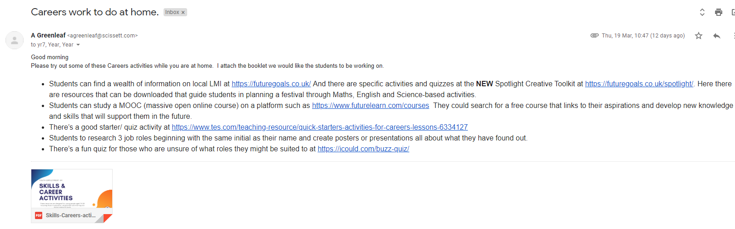
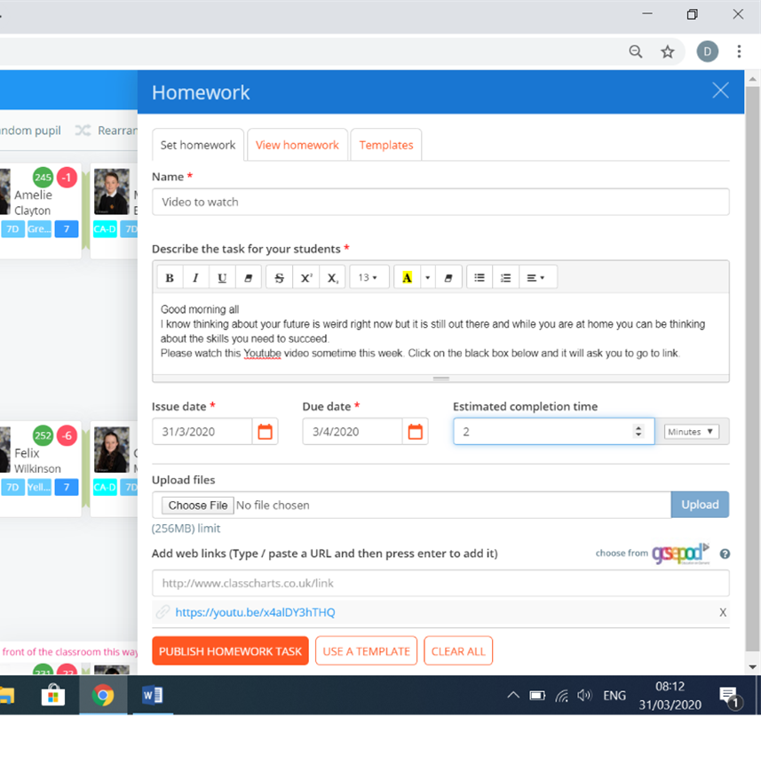
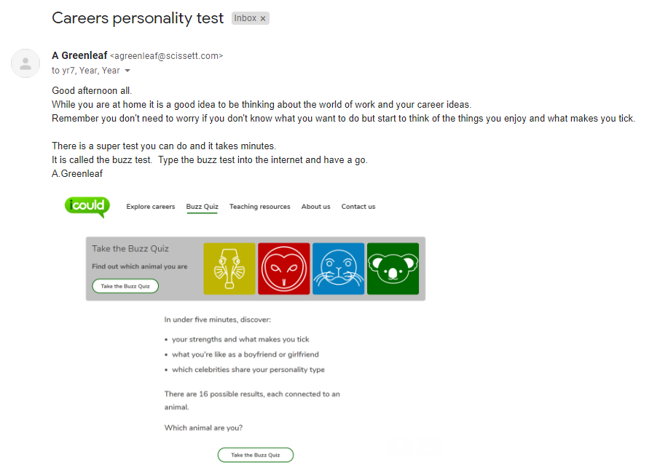
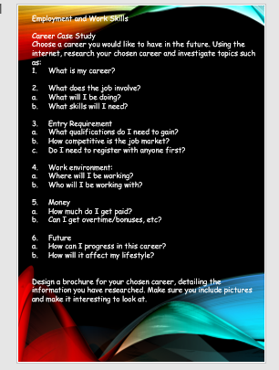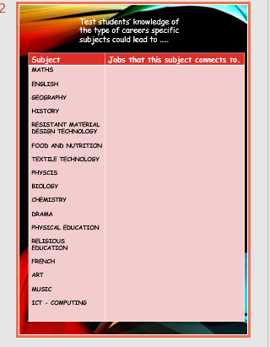
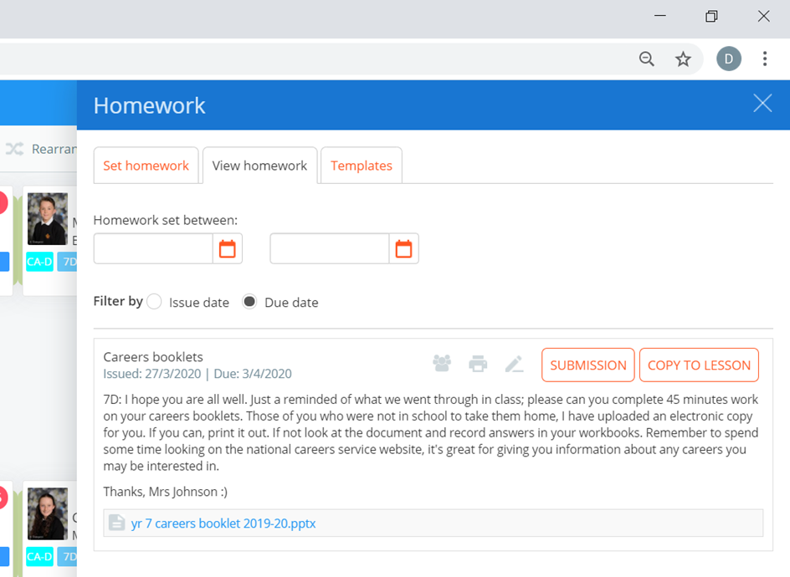
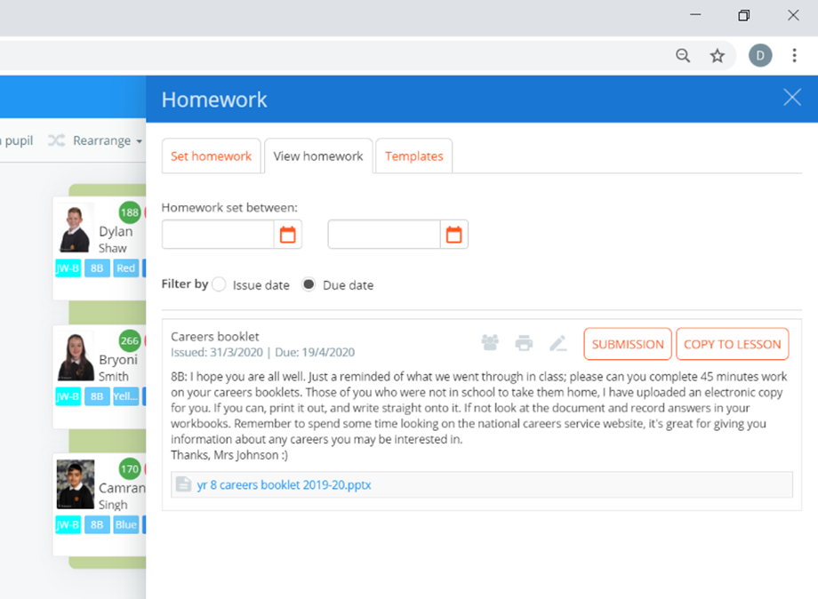
AIMS
By the time they leave our school, we want every young person to be in the position to make informed and ambitious decisions about their future, to have started to think of the route that is right for them and to possess the skills and positive mind-sets that will help them succeed throughout their lives. We believe that disadvantage should not determine destiny. Our aim is to help our students make better choices at the ages of 14, 16 and 18 years old regardless of their socioeconomic background.
By working with excellent teachers, employers, employees and different educational establishments, we’ve seen first-hand how it is possible for young people to scale the hurdles to social mobility and achieve incredible things. Yet it is still the case that children from low-income backgrounds face a litany of barriers to achieving their full potential. Our aim is to narrow the gap of these students.
Our careers provision must be able to help the students understand the range of opportunities available to them in today’s economy and acquire the skills and qualifications they need to succeed in the workplaces of the future.
These aims set out our ambitions to expand the quality and quantity of provision. Our aim is to help build a Britain fit for the future by investing in the development of skills to meet the changing needs of business, increase productivity and drive growth across the whole country. High-quality careers support will allow us to promote new world class technical education and make sure the students know where their qualifications lead. This will increase participation in higher level qualifications, with clear routes so that the students know how to progress to that level. It is vital, in an environment where new industries are emerging and many of the most important jobs of the future don’t yet exist, that individuals have access to high-quality labour market information and earnings data to underpin their choices.
Evaluation
During the three months that the new Careers Provision has been officially in place at Kirkburton Middle School we continually use quantitative and qualitative data to record the impact the Careers provision has had on the student’s future choices. We work closely with the Colleges, Universities and Independent Apprenticeship Companies, our Careers Enterprise Coordinator, CEIAG (Careers Education, Information, Advice and Guidance), Our business Enterprise Coordinator and the Head of Careers at our Secondary College. All our staff, parents, students, stakeholders and governors have a part to play in the implementation and reviewing of the Careers provision. All feedback, reviewing, evaluation and tracking is used to continually improve the provision for all our students.
Areas for Improvement
To enlarge and encourage use of Careers Library. New books coming.
To improve delivery of Careers in the Curriculum through CPD and school liaison support (working with SMS on Careers provision in school)
To use Data Metrics more effectively to see whether the website is being used by parents and students.
To improve the way, we communicate with parents and students through Social Media.
Our students do not get enough meaningful information about vocational colleges. I would like to improve our vocational taster sessions for students who may not be as academic, especially our SEND students. Kirklees College have let us use their virtual open days to look around. UTC have also done us a virtual open day. These are booked for year 8 PHSE sessions.
I would like to establish a student voice careers focus group.
There is currently no extra provision for SEND or FSM/PP students apart from the visits being free and transition. I need to address this from September 2021 with specific visits/workshops. I am working with a company called OPUS (I am trialling at SMS with the hope to bringing to KMS – there may be a cost.)

School Vision 2020

SLT Comments:  I'm sure the pupils will appreciate the opportunity to work on something slightly different as a break from their usual curriculum content. There is some excellent stuff here  I’ve had a good read through the impact summary and it’s very impressive. Let me know if you need any support from me in terms of actioning the identified areas for improvement  1. Do you think the Careers Provision has improved in the last 3 months? If so how? Yes, higher profile, focused assemblies regularly held  2. Do you feel the displays are useful in school? I feel they are there to show we are covering careers and raise the profile as opposed to them being specifically used. I have seen students looking at them though  3. Do you feel the head of careers updates you on new strategies and activities often enough? Yes  4. Is communication sufficient? yes, it's very regular  5. Is there anything you would improve/change- Maybe less is more now the bulk of the hard work and focus has been done. i.e. focused careers days, fewer but more focused assemblies with linked tasks in form time  1. Do you think the Careers Provision has improved in the last 3 months? If so how?  Difficult for me to comment as I don't have a clear idea of what it was like before. Given the work you've presented to me I would say undoubtedly it will have done. Profile of careers raised across the school and across the curriculum. All staff now have a deeper understanding of their role in the delivery of careers education. Pupils have a much greater awareness of careers and the world of work. Our next step is to embed this into the day to day working of the school rather than it being a bolt on - this was necessary currently however given the position the school was in.  2. Do you feel the displays are useful in school?  Yes, without a doubt. They raise the profile of careers, promote discussion and inspire pupils. The more the better. Classrooms, corridors, social spaces.  3. Do you feel the head of careers updates you on new strategies and activities often enough?  Me personally yes - monthly meetings to continue moving forward please. I'm not sure what other staff would say - regular emails keep them updated. A lack of staff meetings since Christmas has meant it's been difficult for you to talk to staff directly. This will change in the future. Teach Meet went very well.  4. Is communication sufficient?  Yes - regular items in the staff and parent bulletin. Email updates to staff,  5. Is there anything you would improve/change  As mentioned previously, we now need to embed out careers provision into the curriculum and spread the activities across the curriculum more - I know this will be the plan moving forward. Anything which brings people from the world of work into school is always very gratefully received. We may want to look at putting on some drop-down days/ enrichment activities into the curriculum. | Link Governor Comments: | Enterprise Adviser Comments  Francis Burkinshaw has just taken the post. She will comment in September when her governor review is written.
Parent Voice Comments:  Yes, it’s made them start to think what they may like to do and the pathway they would need to take to achieve this  Do you think the career provision at Kirkburton is useful to your child? yes  Does your child feel more informed about the choices of university or apprenticeships? yes  Is your child connecting the skills they learn in lessons to skills they need for employment? Yes | Student Voice Comments:  I didn’t realise there were so many Apprenticeships.  The 6th form visit was good – the college looked exciting and had lots of subjects to study.  The visit from the screenwriter for Emmerdale was excellent. I found it much easier to write about his visit because it was interesting to find out about his career. | Staff Voice Comments:  There is a lot to take in.  I need more help to plan CIC into my planning  The assemblies and training have been good to learn about Apprenticeships and LMI.  More CPD and collaboration with SMS on CIC
Vision for Careers Provision Ideas:
Subjects Planning to include Employability skills and careers
Planning for strategy to include equal opportunities for SEND/PP/FSM/Boys underachieving/Girls not doing STEM.
Clubs – Self efficacy, Culture Capitol, Entrepreneurship
Whole school using SIP – Careers education and pupil leadership
To gain Quality in Careers Standard
Workplace visit and vocational taster sessions to be incorporated into 1 visit at Barnsley.
Alumni to establish
CIC to fully implement
Class time Careers more established
Vision for Careers Provision Statement:
The Careers Department at Kirkburton Middle School provides information, advice and guidance to students on a wide range of issues that help them build the skills they will need for working life.
The world of work has undergone significant changes in recent years and continues to do so and it is therefore even more important that we equip our students with the necessary skills for them to make decisions about their future, to know how and where to access information and to link subject areas and qualifications with possible career choices

Kirkburton Middle School is committed to providing a comprehensive and high-quality careers programme, to support all of our students’ knowledge and understanding of how to manage their own lifelong learning and career path. Our programme aims to raise all students’ aspirations, irrespective of age, background, ability or SEND, and to develop our students’ employability skills across the school so that they are best prepared for their lives both during their time at Thamesmead, and in the future

Careers education is an important aspect of students learning experience as it prepares them to make decisions about their education and their future professional life in the world of work. Careers education and guidance at Kirkburton Middle School is delivered through Personal Development lessons, drop down days, tutor time, assembly and additional activities with local colleges, universities and employers. The careers programme in the school supports the curriculum for Key Stages 2 and 3.

The provision of careers guidance and support at Kirkburton Middle School seeks to deliver on the 2018 Department for Education Careers Strategy. We want:
- all pupils to understand the full range of opportunities available to them, to learn from employers about work and the skills that are valued in the workplace and to have first-hand experience of the workplace;
- all pupils to get an excellent programme of advice and guidance that is delivered by individuals with the right skills and experience;
- all pupils to get support tailored to their circumstances. With access to face-to-face advice.
- all pupils to get the information they need to understand the job and career opportunities available, and how their knowledge and skills can help them in considering suitable careers

Kirkburton Middle School Current State

Compass - Current Compass Score: | March 2020  GB1 100%  GB2 100%  GB3 100%  GB4 100%  GB5 100%  GB6 75%  GB7 95%  GB8 100%
Compass - Priority Benchmarks: | GB1 – Further establish CIC and class time Careers  GB6 – Workplaces - Needs to be altered (duel trips – Subject/Careers – have now stopped due to changes in curriculum.)  GB7 – Vocational College and taster sessions  Possible solution – in talks with Barnsley college – Year 7 visit to Barnsley College as a workplace then all choose taster sessions.
Destination Data: | Priority is to analyse with more efficiency using destination data and options data.
LMI – Key Growth Sectors: | Assemblies, CPD for staff and governors, Future goals booklets to go home with letter.
Vulnerable Cohorts/Gaps in outcomes | Year 8 SEND – Needs to be addressed  Year 8 FSM/PP – All visits free (universities, 6th form college) Needs to be addressed

Kirkburton Middle School Strength of Careers Provision SWOT
Components: Careers Education, Careers within subject areas, LMI, Employer Engagement, Experiences of the world of Work, Encounters with FE/HE, 1:1 guidance
Features: Progressive programme, Each & Every & Student Level Tracking, Informed by Stakeholder voice, Known and Understood, Informed by Evaluation, SLT/Gov/HT ‘buy-in'
STRENGTHS  Support of MAST/Governors/SLT  Great help from CEC (Careers enterprise co-ordinator)  Staff willing to get Employers in for specific subjects (Judge for PHSE and Screenwriter for English)  Strong Head of PHSE – Good careers provision in PHSE | WEAKNESSES  CIC – in subjects and planning (particulars Geography)  Personal interviews  Vocational taster sessions  Workplace visits  SEND/PP/FSM – more personalised careers provision.  Class time careers
OPPORTUNITIES  To create Alumni/employer contacts  More connection to world of work  Enterprise competitions with FE/Employers  Continued classroom visits of employers  To merge 2 GB at Barnsley college  To try to get individual interviews at Year 8 parents’ evenings.  Collaboration at School liaison meetings | THREATS  Students not able to do taster sessions  More for SEND/PP/FSM and vulnerable students  Staff not coming on board to add CIC  Time to organise everything when not based at school
Key priority/action areas from SWOT:

- Barnsley College visit to organise
- Establishing an Alumni
- Staff cooperating and including Careers into Curriculum
- Work to include Culture Capital and Self Efficacy in clubs
- To encourage pupil leadership
- To set up visits for SEND/PP/FSM which are more specific to needs
Kirkburton Middle School Key strategic objectives
Key Strategic Objectives
1 | Barnsley College visit to organise and to help develop engage provision through taster sessions for students with low aspirations.  This visit will cover (GB6 & 7.) Analysis from Feedback and Google reviews show that students are starting to understand everywhere they visit is a workplace and the worksheets they are filling in show more recognition of different jobs within a workplace and the need for Employability skills. Google review shows that the majority of students prefer the practical taster sessions even if it means they find out they no longer want to do that job. All year 7 will attend this visit. This connects to whole school SDP on importance of attendance – research shows students are less likely to be NEET if they are inspired by Careers visits. FSM/PP students to go on this visit for free. Research shows that practical taster sessions are extremely meaningful to students who disengage and have low aspirations.
2 | To set up visits/events for SEND/PP/FSM which are more specific to needs  Visits to SEND friendly workplaces (GB6) and careers fairs at high schools (GB5 and GB7) (to aid transition) resilience sessions.
3 | Staff cooperating and including Careers into Curriculum  From October 2019 OFSTED recommendations are that there is a key focus on Careers education. Staff need to write Careers into their planning and incorporate Careers into the curriculum. (GB4)
4 | Clubs to include STEM, Culture Capital and Self Efficacy  To try to encourage staff to run different clubs. Drama clubs where students do presentations and styled talks such as after dinner speaking and having a difficult conversation on a phone (employability skills and self-efficacy) (GB3 and 4.)
5 | To encourage pupil leadership  Connected to the SDP for the relaunch of pupil leadership across the school. School council, Librarians, Prefects. (GB6)
Kirkburton Middle School Action plan
School Name:  Kirkburton Middle School  Career Leader Name:  A.Greenleaf | Date Strategic Careers Plan Created:  April 2020 | Date approved by SLT: | Date approved by Governors: |  | Proposed Review Date:  July 2021
 | Strategic Careers Plan - Academic Year: 2020/2021
Objectives  “What are the problems you are trying to solve?” | Actions, including CPD  “What would solve the problem?” | Responsible  “Who is responsible for each action?” | Time  “When do you aim to have this completed by?” | Outcomes  “What would success look like?” | Progress
1. Gatsby Benchmark 6 – workplace visits  Gatsby Benchmark 7 – Meaningful vocational taster sessions  2. To set up visits/events for SEND/PP/FSM which are more specific to needs.  3. Gatsby Benchmark 4 - Implementing Careers in the Curriculum  4. Clubs to include STEM, Culture Capital and Self Efficacy  5. To encourage pupil leadership | The students visit a 6th form and a university but do not visit a vocational college. This is not suitable for all and an encounter can include our school careers fair. However, to meet the needs of individual students we need to offer practical vocational sessions such as bricklaying/animal care/hairdressing.  We also need to look at these sessions for students who are vulnerable such as FSM/PP/SEND and students with behavioural problems.  An answer objective 1. would be a YR 7 trip to Barnsley college – a bespoke trip – To ask staff who take them on tour to talk about it as a workplace and then to do different taster sessions.  To use contacts to arrange workplace visits for SEND (Scissett Sports centre) and produce a help sheet for parents with children with SEND with useful websites on. To update website with useful websites,  Some departments have started to implement Careers in the curriculum. Displays up and thought of projects that can incorporate Careers. Starting to think about Employability skills within their subject. Collaboration and work with SMS to obtain consistency.  Planning in from each subject – containing Careers and Employability skills.  Some subjects haven’t really engaged with this change and are not willing to add into planning. (Geography) Actions would be – meetings with SMS, staff meetings to allocate adding careers into planning.  To encourage staff to form clubs and to invite the students who have low aspirations and encourage them to join these clubs. To also encourage SEND/FSM/PP to join these clubs. Girls to join the business club.  Introduction of leadership roles (e.g. prefects, numeracy, literacy mentors, sports leaders, school council reps, librarians.) | AGR, admin, SENDCO and Head of FSM/PP.  Barnsley College  AGR and SENDCO  STAFF and AGR  Staff and AGR  Staff and SLT | July 2021  September 2020  July 2021  July 2021  July 2021 | Each visit makes the students more aware of all the different jobs needed to run a company, business etc. The students talk to staff on the visit but also fill in worksheet to do with different careers/employability skills.  Year 7 to visit Barnsley College as workplace and taster sessions.  To have raised the student’s confidence in transition and career choices - using evidence from feedback sheets, option choices and destination data.  Careers is embedded in all subjects planning and displays. Evidence of good quality work and google review  Lunchtime Drama and STEM clubs – photographic evidence.  Groups of students each year that take on responsibilities of whole school issues. | All yr. 7 do taster sessions and visit workplace as Barnsley College  Students to have attended more events and each year 8 ongoing will do same.  All staff feel confident in talking about careers in lessons  High uptake of attendance to clubs which run each year  Established roles and continued each year.

Kirkburton Middle School - Strategic Careers Plan - Vision Statement: A.Greenleaf
The Careers Department at Kirkburton Middle School provides information, advice and guidance to students on a wide range of issues that help them build the skills they will need for working life.
The world of work has undergone significant changes in recent years and continues to do so and it is therefore even more important that we equip our students with the necessary skills for them to make decisions about their future, to know how and where to access information and to link subject areas and qualifications with possible career choices
Kirkburton Middle School is committed to providing a comprehensive and high-quality careers programme, to support all of our students’ knowledge and understanding of how to manage their own lifelong learning and career path. Our programme aims to raise all students’ aspirations, irrespective of age, background, ability or SEND, and to develop our students’ employability skills across the school so that they are best prepared for their lives both during their time at Thamesmead, and in the future
Careers education is an important aspect of students learning experience as it prepares them to make decisions about their education and their future professional life in the world of work. Careers education and guidance at Kirkburton Middle School is delivered through Personal Development lessons, drop down days, tutor time, assembly and additional activities with local colleges, universities and employers. The careers programme in the school supports the curriculum for Key Stages 2 and 3.
The provision of careers guidance and support at Kirkburton Middle School seeks to deliver on the 2018 Department for Education Careers Strategy. We want:
- all pupils to understand the full range of opportunities available to them, to learn from employers about work and the skills that are valued in the workplace and to have first-hand experience of the workplace;
- all pupils to get an excellent programme of advice and guidance that is delivered by individuals with the right skills and experience;
- all pupils to get support tailored to their circumstances. With access to face-to-face advice.
- all pupils to get the information they need to understand the job and career opportunities available, and how their knowledge and skills can help them in considering suitable careers
Statutory Guidance Checklist:
Requirements and Expectations of Schools
Kirkburton Middle School must ensure that pupils are provided with independent careers guidance from Year 8 to 13 | This will be provided in Year 10 At Shelley College
Every school must ensure that there is an opportunity for a range of education and training providers to access all pupils in year 8 to year 13 for the purpose of informing them about approved technical education qualifications or apprenticeships.  Every school must publish a policy statement setting out their arrangements for provider access and ensure that it is followed. Annex A sets out an example policy statement on provider access. | Access Policy statement is on Kirkburton Middle School website  (Example policy accessible here)
Every school should appoint a named person to the role of Careers Leader to lead the careers programme. | Key Contact Details:  School Careers Leader: Adele Greenleaf  School Careers Leader contact details: a.greenleaf@kirkburtonmiddleschool.co.uk  School Careers-Link Governor: Victoria Green  School Enterprise Adviser: Francis Burkinshaw
Every school must publish details of their careers programme for young people and their parents. | Careers Programme is on Scissett Middle school website  Strategic Careers Plan is attached to this document  Careers Policy is on Kirkburton Middles School Website
Every school should begin using the Gatsby Benchmarks to improve careers provision now, and meet them by the end of 2020.  For the employer encounters Benchmark, every school should begin to offer every young person seven encounters with employers – at least one each year from year 7 to year 13 – and meet this in full by the end of 2020. Some of these encounters should be with STEM employers. | Click here to find out more about Gatsby Benchmarks  Career Programme is on Kirkburton Middle School website

