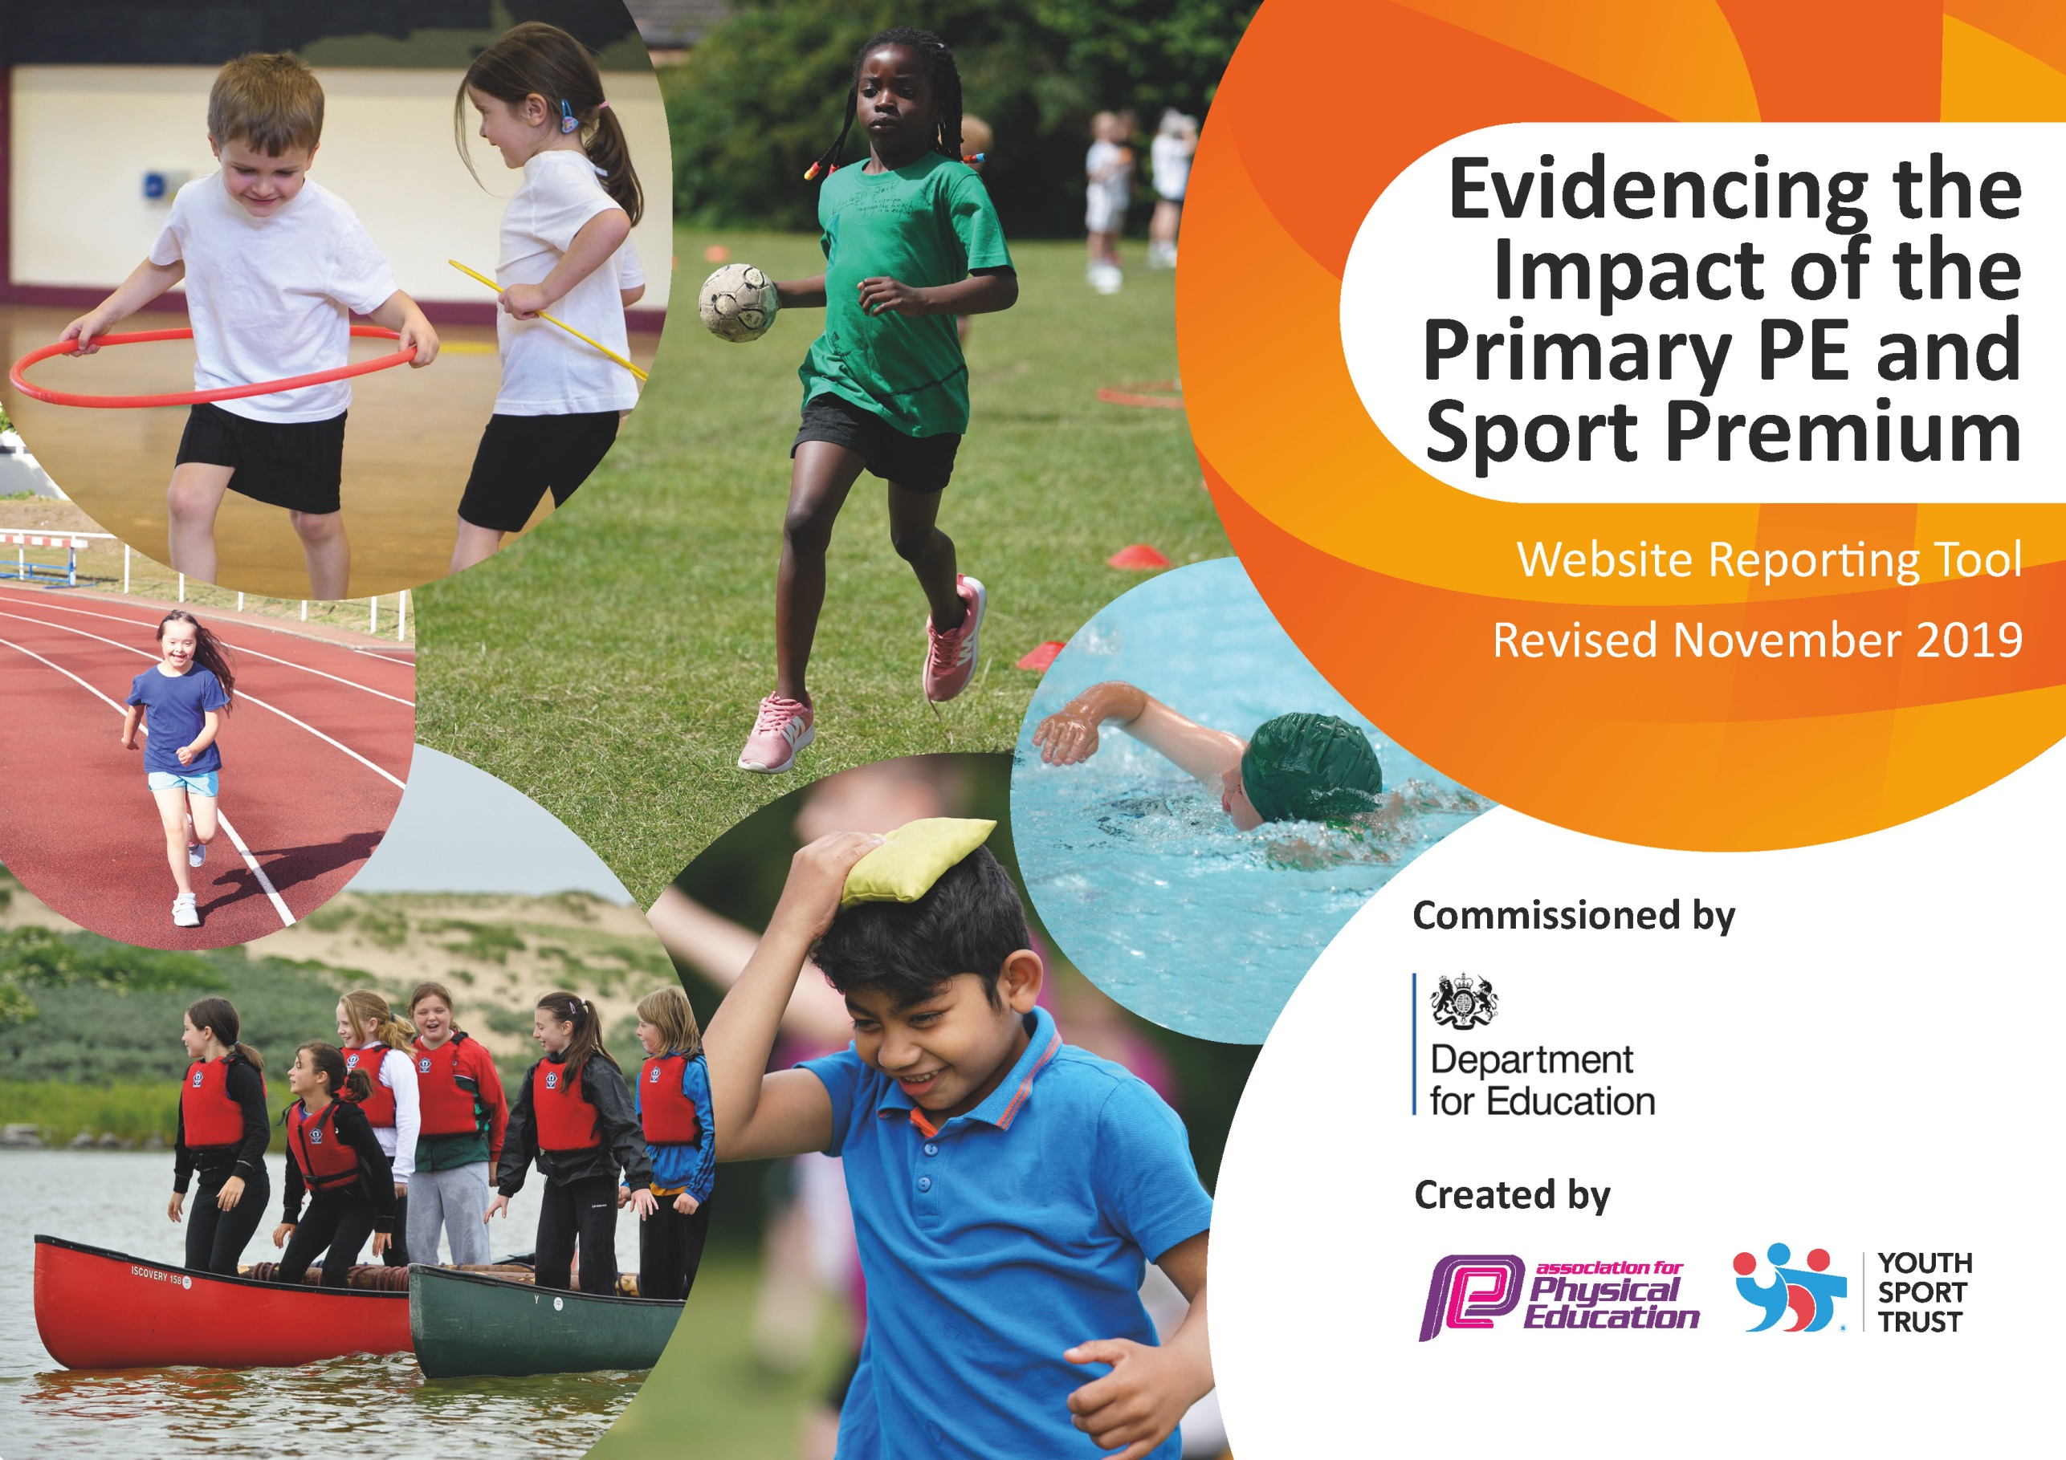
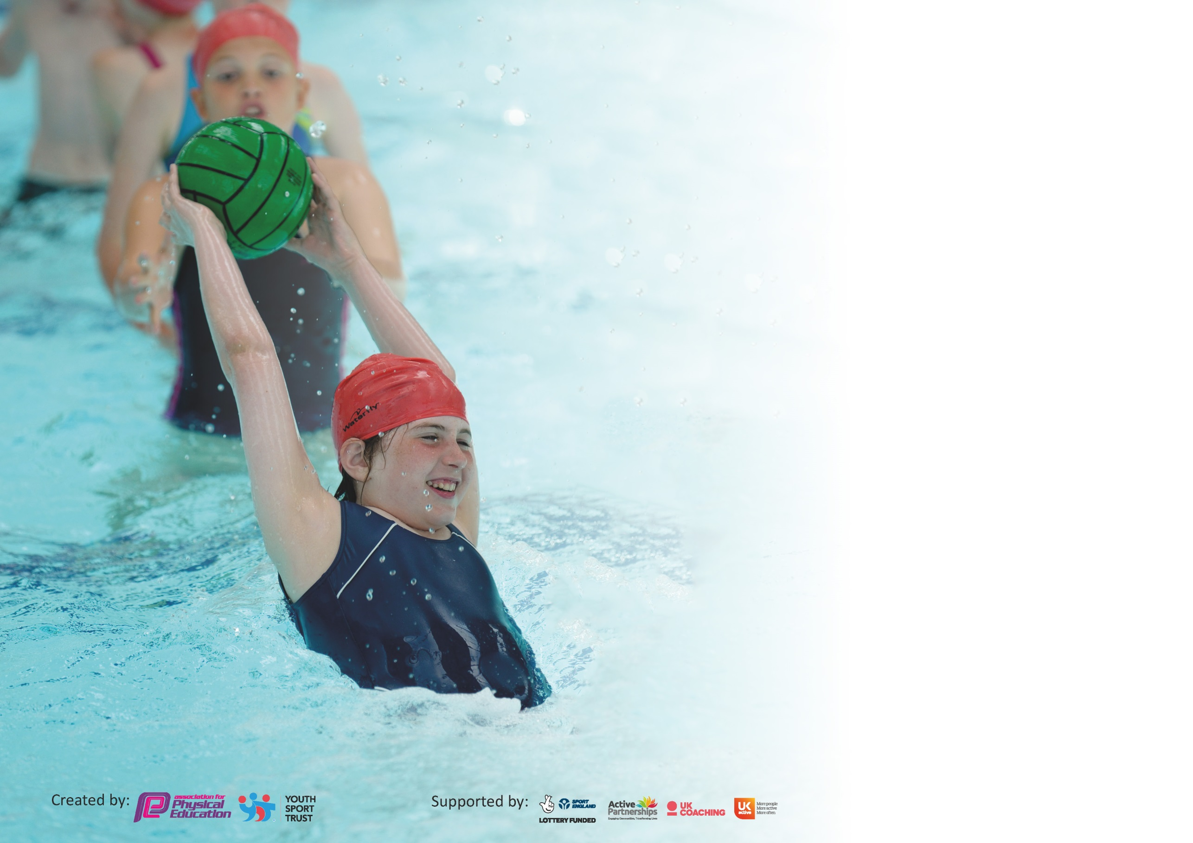

It is important that your grant is used effectively and based on school need. The Education Inspection Framework (Ofsted 2019 p64) makes clear there will be a focus on ‘whether leaders and those responsible for governors all understand their respective roles and perform these in a way that enhances the effectiveness of the school’.

Under the Quality of Education criteria (p41) inspectors consider the extent to which schools can articulate their curriculum (INTENT), construct their curriculum (IMPLEMENTATION) and demonstrate the outcomes which result (IMPACT).

To assist schools with common transferable language this template has been developed to utilise the same three headings which should make your plans easily transferable between working documents.

Schools must use the funding to make additional and sustainable improvements to the quality of Physical Education, School Sport and Physical Activity (PESSPA) they offer. This means that you should
use the Primary PE and Sport Premium to:

- Develop or add to the PESSPA activities that your school already offer
- Build capacity and capability within the school to ensure that improvements made now will benefit pupils joining the school in future years

Please visit gov.uk for the revised DfE guidance including the 5 key indicators across which schools should demonstrate an improvement. This document will help you to review your provision and to report your spend. DfE encourages schools to use this template as an effective way of meeting the reporting requirements of the Primary PE and Sport Premium.

We recommend you start by reflecting on the impact of current provision and reviewing the previous spend.

Schools are required to publish details of how they spend this funding as well as on the impact it has on pupils’ PE and sport participation and attainment by the end of the summer term or by 31st July 2020 at the latest.

We recommend regularly updating the table and publishing it on your website throughout the year. This evidences your ongoing self-evaluation of how you are using the funding to secure maximum, sustainable impact. Final copy must be posted on your website by the end of the academic year and no later than the 31st July 2020. To see an example of how to complete the table please click HERE.

Support for review and reflection - considering the 5 key indicators from DfE, what development needs are a priority for your setting and your pupils now and why? Use the space below to reflect on previous spend and key achievements and areas for development.

Key achievements to date until July 2020: | Areas for further improvement and baseline evidence of need:
Achievement of the School Games Mark Platinum Award  Successful competitive Sports Teams  Excellent participation in Extra Curricular Clubs  Strong Sports Leadership Programme | Develop the curriculum to increase knowledge and skills developed throughout year 6 to 8 in preparation for further studies.  Strengthen the boys curriculum to provide more activities which are not games orientated.

Meeting national curriculum requirements for swimming and water safety. | N/A
What percentage of your current Year 6 cohort swim competently, confidently and proficiently over a distance of at least 25 metres?  N.B. Even though your pupils may swim in another year please report on their attainment on leaving  primary school at the end of the summer term 2020. | %
What percentage of your current Year 6 cohort use a range of strokes effectively [for example, front crawl, backstroke and breaststroke]? | %
What percentage of your current Year 6 cohort perform safe self-rescue in different water-based situations? | %
Schools can choose to use the Primary PE and Sport Premium to provide additional provision for swimming but this must be for activity over and above the national curriculum requirements. Have you used it in this way? | Yes/No

Action Plan and Budget Tracking
Capture your intended annual spend against the 5 key indicators. Clarify the success criteria and evidence of impact that you intend to measure to evaluate for pupils today and for the future.

Academic Year: 2019/20 | Total fund allocated: £ | Date Updated:
Key indicator 1: The engagement of all pupils in regular physical activity – Chief Medical Officer guidelines recommend that primary school pupils undertake at least 30 minutes of physical activity a day in school |  |  |  | Percentage of total allocation:
 |  |  |  | %
Intent | Implementation |  | Impact | 40%
Your school focus should be clear what you want the pupils to know and be able to do and about  what they need to learn and to  consolidate through practice: | Make sure your actions to achieve are linked to your intentions: | Funding allocated: | Evidence of impact: what do pupils now know and what can they now do? What has changed?: | Sustainability and suggested next steps:
To work in collaborative partnerships to promote PE and sport | - Employment of SSCO’s to work within the Shelley Pyramid  - Affiliation to other PE providers e.g. SPIN | £6,613.60  £400 | - Enabling access to organised competition and increased participation in competitive sport for KS1 and 2. Participation has increased a further 19% in the last two years, especially in Tag Rugby, Football KS1 and cycling.  - Supporting Pyramid schools in buying appropriate KS1 and 2 resources to enable multi-skills and specific sports to be developed.  - CPD for school staff teaching / non-teaching to build competence, confidence and knowledge including work with NQTs and new PLTs.  - Promoting a leadership programme, including the introduction of sports crews, enabling pupils to gain new skills and lead activities to ensure there is a physically `active’ school. Assess the impact of this on Year 7 and 8 Leadership Programme.  - Increase levels of participation in physical activity across the curriculum and in extra-curricular activities for all schools.  - Demonstrating expectations of high quality PE and sport at Kirkburton.  - Development of an effective, efficient assessment model for all schools commended by Youth Sport Trust. Core tasks provided in Dance, Gym and Athletics to help promote High quality PE.  - Extension of opportunities for inter-school competitions and tournaments – Netball, Dance, Gymnastics and cycling which broadens the sporting opportunities and experiences available to all pupils. Further increased this year - `B’ team opportunities.  - Use of established links with partner organisations e.g. School Games – to provide enhanced high level opportunities for G&T pupils (West Yorkshire School Games, English Schools Athletics)  - Access to a range of PAN Ability competitions. This provides opportunities for the raising of self-esteem, enthusiasm, skill levels and confidence and helps engender improved attitudes to learning and progress. Continued monitoring of this will enable us to assess the impact upon academic progress in other curriculum areas and the wish to continue to access opportunities out of school.  Access to extended opportunities e.g. Bikeability – 18 year 6 students completed this during the summer term 2020. | Mr Martin will work closely with Mrs Joyce, the new head of PE, to ensure this implementation remains similar.

Key indicator 2: The profile of PESSPA being raised across the school as a tool for whole school improvement |  |  |  | Percentage of total allocation:
 |  |  |  | %
Intent | Implementation |  | Impact | 0%
Your school focus should be clear what you want the pupils to know and be able to do and about  what they need to learn and to  consolidate through practice: | Make sure your actions to achieve are linked to your intentions: | Funding allocated: | Evidence of impact: what do pupils now know and what can they now do? What has changed? | Sustainability and suggested next steps:
To take part in the Sport England Project run by the West Yorkshire Teaching Alliance.  Sports Leadership Programme to develop strong leadership skills and role models.  To increase knowledge of careers in Sport | Attendance at Sport England meetings three time throughout the year.  SSCO to train sports leaders in all year groups.  Devise a notice board for Careers in Sport | None required as Sport England fund it | Staff have increased knowledge and understand of how to develop the PE curriculum. Pupils benefit from a more fun and enjoyable curriculum.  Promoting a leadership programme, including the introduction of sports crews, enabling pupils to gain new skills and lead activities to ensure there is a physically `active’ school. Assess the impact of this on Year 7 and 8 Leadership Programme.  There is now a PE and Sport Careers notice board in the main hall and in the Pavilion which pupils regularly review. | To continue to work with the Sport England Project. New HOD is on the steering group for this.  Maintain the leadership programme.  Develop the Careers notice board regularly to keep it updated.

Key indicator 3: Increased confidence, knowledge and skills of all staff in teaching PE and sport |  |  |  | Percentage of total allocation:
 |  |  |  | %
Intent | Implementation |  | Impact | 35%
Your school focus should be clear | Make sure your actions to | Funding | Evidence of impact: what do | Sustainability and suggested
what you want the pupils to know | achieve are linked to your | allocated: | pupils now know and what | next steps:
and be able to do and about | intentions: |  | can they now do? What has
what they need to learn and to |  |  | changed?
consolidate through practice:
To further develop high quality P.E. | - PE Department to reorganise curriculum planning  - PE Department to amend and streamline assessment framework  - Training Health and Safety new AfPE document/AfPE membership  - Development of the SSCO role and use of the SSCO in delivering some curriculum PE lessons  - Use of specialist coaches within the curriculum especially Dance and Rugby.  - Continued development of leadership programme | £5465.60 | - Development of high quality PE curriculum through coherent long term planning. High quality Schemes of Work to support all PE staff and strengthen curriculum delivery. Planning to be amended to accommodate mixed group teaching in Year 6 to ensure high quality PE Curriculum is maintained. Clear modules of assessment to support analysis of pupil data and promote specific target setting and KPIs.  - Provides evidence of demonstrable high quality PE and enables staff to monitor and assess standards. Gives immediate feedback enabling pupils to evaluate and progress at a faster rate.  - Raises staff knowledge and expertise in PE.  - Good practice is shared and included in curriculum delivery. AfPE membership provides ideas to strengthen planning/delivery and health and safety. Your School Games Platinum Award has been achieved for the very first time and is the only school in Kirklees to do so.  - Continued appointment of Mr Killock in the SSCO role to replace Mrs Hughes. Teaching 0.4 and SSCO 0.6. Over 20% of pupils are actively engaged in the Leadership programme. Support for skills development and intra and inter school competition s, in school and in pyramid schools, is ongoing. This year their skills and knowledge has been used to support West Yorkshire Panability and Sports Hall Athletic events. An excellent development opportunity. Young Ambassadors have improved the level of intra-school participation by starting inter-house hockey and a panability club.  - Pupils are taught a range of skills which they apply in leadership and competitive sport.  - SMSC education is evident in the curriculum e.g. peer support; peer evaluation; tactical and strategy discussions, teamwork, commitment etc.  - Pupils engaged enthusiastically in their Strictly Dance and gym lessons producing high quality dance/gym activities showing very good progress in skills, confidence and attitudes.  - Use of a specialist dance coach in Year 6 energised boys giving them a good foundation for future learning.  - Effective use of coaching for boys and girls rugby (Huddersfield Giants), to further enhance the quality and standards in PE.  - Further use of Dance coach across the curriculum to strengthen Girls PE in the absence of a female PE teacher in Spring 1. | To maintain the Platinum School Games Award.  Employment of a Head of PE strengthen the department from Easter 2020.
Key indicator 4: Broader experience of a range of sports and activities offered to all pupils |  |  |  | Percentage of total allocation:
 |  |  |  | %
Intent | Implementation |  | Impact | 9%
Your school focus should be clear | Make sure your actions to | Funding | Evidence of impact: what do | Sustainability and suggested
what you want the pupils to know | achieve are linked to your | allocated: | pupils now know and what | next steps:
and be able to do and about | intentions: |  | can they now do? What has
what they need to learn and to |  |  | changed?:
consolidate through practice:
Additional achievements:  To develop the breadth of provision and opportunities for all pupils | - Use of quality coaches to extend extra-curricular clubs  - To provide a link to local sports clubs and to sign-post pupils to take part in sport outside the school environment beyond the school day  - Purchase P.E. equipment and resources to support PE in school | £1652.68 | - Table Tennis and Gymnastics – new clubs are well attended Increase in established sports e.g. football and netball maintained.  - Panability Club has been started by Young Ambassadors to support less able pupils.  - Panability teams continue to build upon their West Yorkshire Sports’ success – three teams in in the West Yorkshire Youth Games.  - Dance Club – members have performed regularly at the local theatre.  - Intra school competitions in Netball, hockey and Football encourage further participation.  - New archery equipment has proved popular with Panability groups as well as Sports Hall Athletics equipment  - Good coaches have maintained fun, developed skills and ensured high rates of attendance. Sessions are active and well managed. Regular assessment and pupil voice helps us to look at the impact over time and make changes for improvement.  - Table Tennis and Hockey coaches from the Club coach at school strengthening school / club links. Table tennis players have moved to clubs in Almondbury, hockey players to the Dragons and netball players to the Kirklees Squad.  - Established links with Wakefield Gym Club, Greenhead Gym Club, Scissett Satellite Hockey, Huddersfield Dragons Hockey, Kirkburton Football Club and Emley and Kirkburton Cricket Clubs, Almondbury Table Tennis Club.  - Audit of current sports equipment and purchase of some new equipment appropriate for KS2 lunchtime activities. | Maintain club links and employment of external coaches to provide increased opportunities.

Key indicator 5: Increased participation in competitive sport |  |  |  | Percentage of total allocation:
 |  |  |  | %
Intent | Implementation |  | Impact | 7%
Your school focus should be clear | Make sure your actions to | Funding | Evidence of impact: what do | Sustainability and suggested
what you want the pupils to know | achieve are linked to your | allocated: | pupils now know and what | next steps:
and be able to do and about | intentions: |  | can they now do? What has
what they need to learn and to |  |  | changed?:
consolidate through practice:
To improve competitive opportunities | To enable off site opportunities for competition to be accessible to all pupils | £1,174.15 | - The school mini bus has been maintained and fuel used to travel to extra-curricular fixtures and events have been funded using this money.  - G&T pupils and PAN Ability pupils have all accessed this funding gaining particular success in indoor athletics, football and cricket  - Affiliation fees have been paid for a range of Sports in Kirklees and West Yorkshire Competitions.  - This experience is exciting, exhilarating and inspiring; a valuable opportunity for all pupils. Well supported by parents and families. It also serves as a standards benchmark for staff. | Some of the competitive opportunities have been restricted over the summer 2020 due to Covid 19.  We will enter all competitions when it is safe to do so.

Signed off by
Head Teacher: | Chris Taylor
Date: | 17/07/20
Subject Leader: | Vicki Joyce
Date: | 17/07/20
Governor: | V Green
Date: | 17/07/20

