Kirkburton Middle School
Turnshaws Avenue
Kirkburton
Huddersfield
HD8 0TJ

HD8 0TJ

Headteacher: Mr C Taylor

Telephone: 01484 222737
Email: office@kirkburtonmiddleschool.co.uk
Web: www.kirkburtonmiddleschool.co.uk

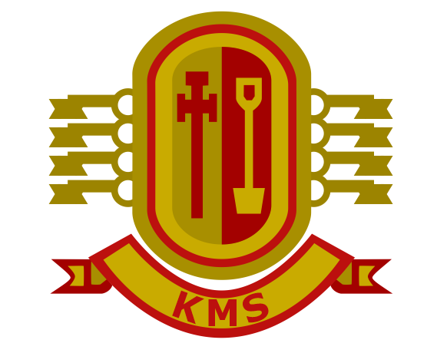

Enjoying, Achieving, Succeeding Together

21st June 2021

Dear Parent/ Carer

I hope you and your family are well. It has been great meeting our Year 6 class of 2021 over recent weeks and we are really looking forward to them joining our school community in September. It is with great regret therefore that I have to inform you that the planned Transition Day for our new pupils on Wednesday 21st July cannot take place as planned.

In light of the recent government announcement that there is a 4 week pause at Step 3 of the Roadmap, we have received further guidance in school, this confirmed that all current measures and risk assessments must remain in place. These measures mean that all pupils must remain in bubbles, test twice weekly etc. Guidance around transition days states: ‘this means that traditional transitional and open days are unlikely to be feasible this academic year’ and this is the position we find ourselves in. Pupils arriving from different schools would not be able to mix and would have to remain in their first school bubbles. Here at Kirkburton we have pupils from 14 different schools in our new intake of 167 pupils; we would not be able to find enough spaces or the numbers of staff needed to keep pupils within their own school bubbles. They would also not be able to mix with any of our current pupils and movement around the school would not be possible safely. We therefore feel that the restrictions would not help pupils to have a meaningful transition day. They would not be able to meet all their teachers, make new friends, find their way around the building and have a taste of the different curriculum areas and the specialist facilities we offer.

Like you and your children, we are bitterly disappointed this cannot go ahead, we are however planning to change our arrangements for September. School will open for Year 6 pupils only on Tuesday 7th September. Year 7 and Year 8 will now start their new academic year on Wednesday 8th September. This will give our new pupils the opportunity to get to know the layout of our building, meet all their teachers and make new friends. They will be able to spend a greater amount of time with their new class teacher on that day and be able to learn their new routines; for example the use of the dining room at lunchtime and catching the bus at the end of the day. For those attending our summer school, they will also get this chance to get to know the school.

Mr Parker, our Head of Year 6, and I have visited all our feeder schools and all pupils have had the opportunity to ask questions; I hope this has been a great help to them. We’ve certainly enjoyed the visits. During the final week of term we hope to hold an in-school transition event for parents, with limited numbers, and following all Covid protocols. We will send out further details as soon as we have our arrangements in place.

Unfortunately, this will be the second year that we have had disruption to our end of year arrangements. Our current Year 6 pupils did not have any transition events due to the national lockdown but we found that they settled into school quickly in September and I am sure your children will too. If you or your child require any further information, please contact the school office. Please also see the transition page of our school website and our social media feeds for up to date information about all that goes on at KMS.

We look forward to seeing you and your child very soon.

Yours sincerely
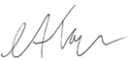

Mr C Taylor, Headteacher

