Kirkburton Middle School
Turnshaws Avenue
Kirkburton
Huddersfield
HD8 0TJ

HD8 0TJ

Headteacher: Mr C Taylor

Telephone: 01484 222737
Email: office@kms.themast.co.uk
Web: www.kirkburtonmiddleschool.co.uk

Enjoying, Achieving, Succeeding Together

11th November 2021

Dear Parent/ Carer

Year 8 Parents’ Evening 2021

This letter outlines the arrangements for the upcoming Year 8 Parents’ Evening which, following the feedback we received from the recent survey (thank you to all those who responded), is being conducted slightly differently this year.

The event will take place over two nights, from 4pm – 7pm, with an option of meeting Face to Face (in school) on Tuesday 23rd November or Remotely via TEAMS on Thursday 2nd December.

Appointments should be booked via ‘Edulink One’ and further details and instructions on how to book appointments can be found at the end of this letter. The booking system will open at 4pm on Monday 15th November and will close at 4pm on Friday 19th November. Please contact the school office if you are having any difficulties in booking appointments.

When the booking system opens, you can book appointments with up to six subject teachers in total. We recognise some parents may want to speak to more than six teachers however, we feel this is the fairest way of ensuring all parents receive feedback from a range of subjects. Please remember, you are welcome to contact teachers at any point during the school year should you wish; there is no need to wait for a parents’ evening to make contact. All appointments will be 5 minutes long and it is essential we stick to these timings. If it becomes clear that further time is needed, we ask you contact the teacher concerned to arrange a mutually convenient time to finish your conversation. Unfortunately, we are unable to assign families to specific dates so we ask you aim to make your six bookings for one of the two evenings. In the unlikely event that you are unable to make appointments for all the six teachers you wish to meet on one evening, you are welcome to split these across the two evening. It is essential you only make six bookings in total however. Where more than six bookings are made we will ask you to cancel additional bookings.

We look forward to seeing you soon either in school or virtually

Yours sincerely
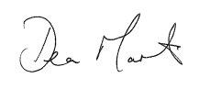

Mr C Taylor Mr D Martin
Headteacher Assistant Headteacher

Booking appointments using Edulink One

The booking system can be accessed by downloading the ‘Edulink One’ app from your usual app store. Alternatively, you can access the booking system via the website - www.edulinkone.com. Please enter the school postcode HD80TJ and log in using your username and password.

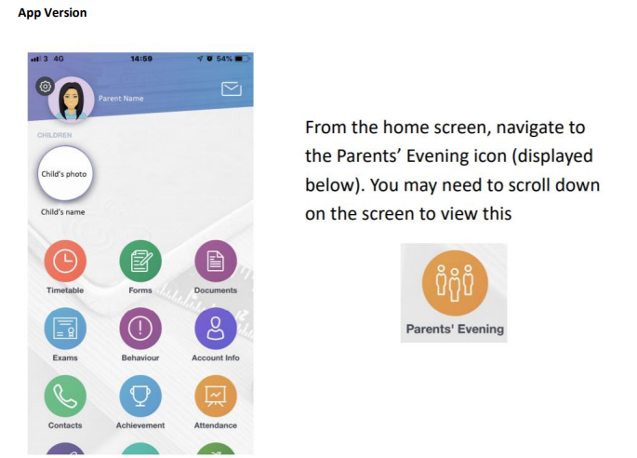

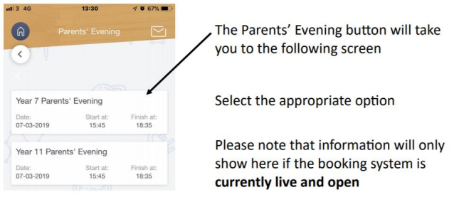

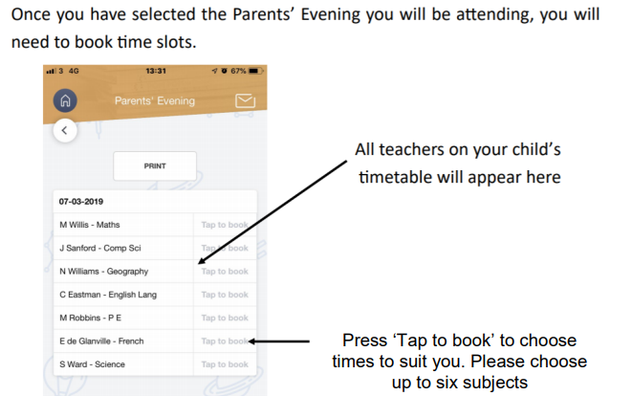

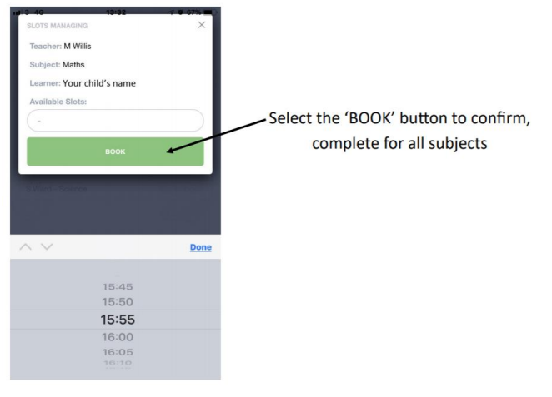

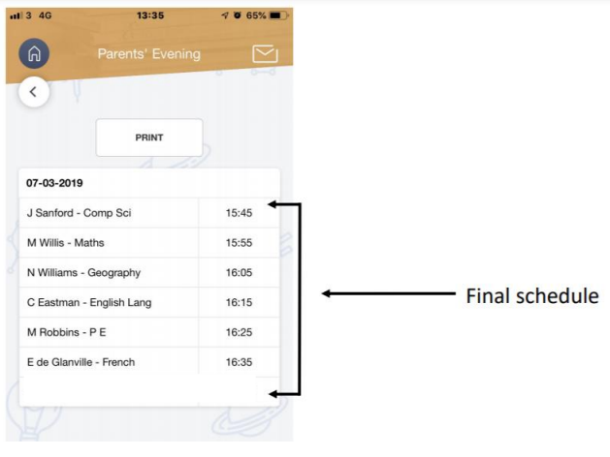

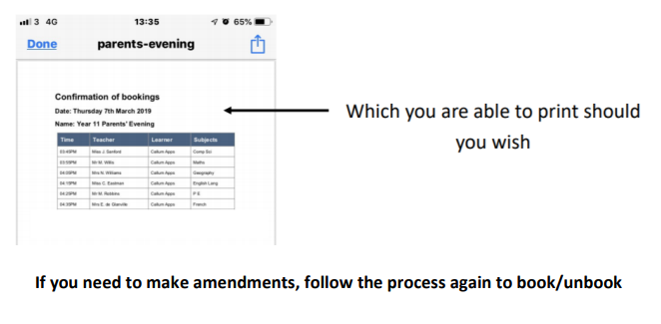

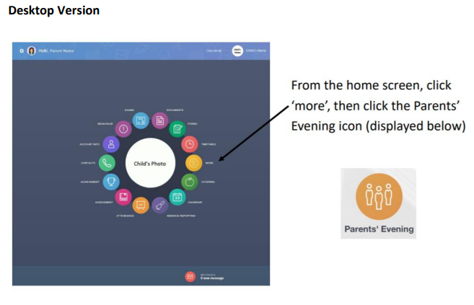

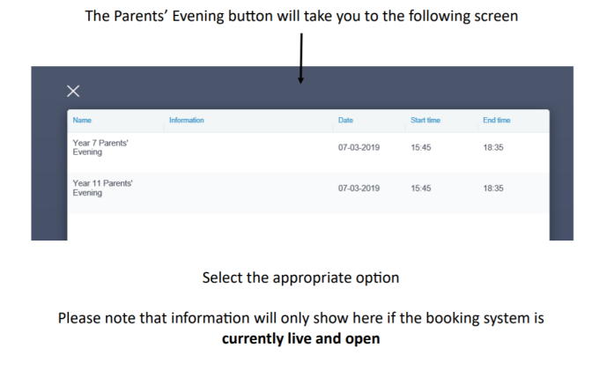

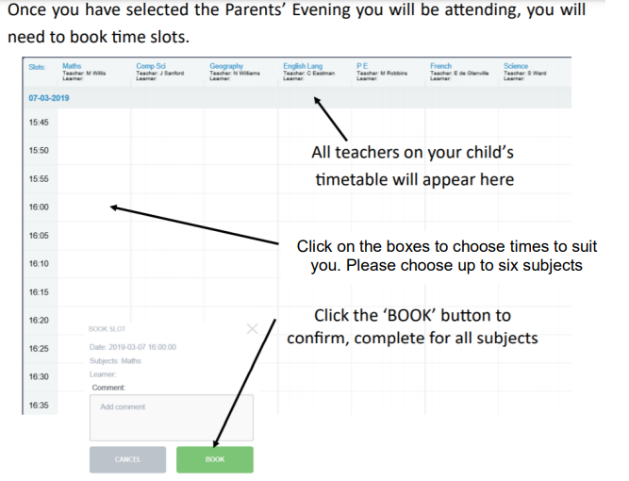

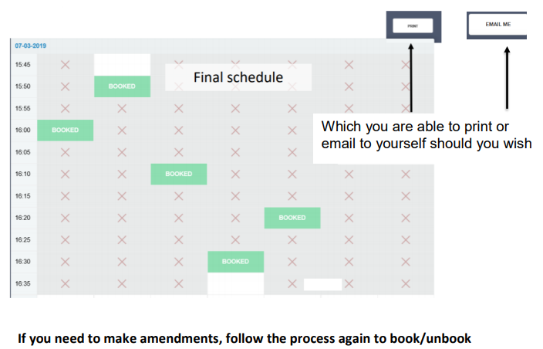
Meeting via Microsoft Teams: Thursday 2nd December

How to access your appointments on the evening

- Prior to the parents evening, you will receive an email providing you with a set of links to access appointments with each teacher.
- If you have not received your links by the day before the parents evening, please contact the school office.
- On the evening, please use the links provided to access your appointments. To do this you can use a laptop or desktop PC, or a mobile device such as a smart phone or a tablet. You do not need to download any software (for example, ‘Microsoft Teams’) in advance of the evening, you simply need to be able to connect to the internet and have access to the links that we will forward to you. In the unlikely event you are asked to log in, please use your child’s account.
- When accessing each link, you will be asked to enter your name. Please enter your child’s full name, rather than yours, so you are clearly identifiable to the member of staff.
- Once you have entered the details you will be put through to a virtual lobby. You will be held in this area until the member of staff has finished the appointment prior to yours, at which point they will ‘admit’ you to the meeting. We would be grateful for your patience as, although we will endeavour to keep appointments to time, they may overrun, resulting in you waiting in the lobby past your appointment start time.
- Throughout the evening there will be staff available in the school office should you have any technical difficulties or require any other support. Please phone 01484 222737 to access this support.

As this is a critical year in your child’s education, we strongly recommend they are available to take part in the meeting with you. Should you have any questions in advance of the evening, or if you require any further support, please do not hesitate to contact us

