Impact Summary For Careers Provision at Kikrburton Middle School 2020
Black – What we are doing
Purple – When documents are attached
Red – Things that need to be done
Green – Work done through School Closure
1. A stable careers programme
Monitoring activities include | Evaluation activities include
Reviewing the careers programme to determine what activities are happening and when they are happening  Checking the web metrics to see how many times the policy has been downloaded C.Tyson has sent results – see attached.  Monitoring the CPD activities which staff undertake  Introduce a student working party to get student voice.  All activities have been added to Termly Newsletter  Students set Careers work by Head of Careers – Booklet and Buzz Quiz.  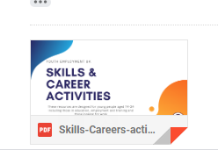  Evidence of work set attached.  Corona work from home.  Study and employability skills booklet  Buzz test.  Skills builder workshops  PE – Careers homework  You tube video of WOW show | Regular meetings with head of PHSE – evidence of work by the students for PHSE Careers and Class time booklets.  Regular monitoring that students are working on Careers in class time.  Feedback sheets after an event and also Google review  Exploring the extent to which career learning has taken place (test, work sampling etc.)  Examine data to check whether there has been a change in progression routes after an activity on apprenticeships (Use feedback sheets to ask students if they might now consider Apprenticeships rather than University)  Observation and interview of programme participants over time perhaps including tracking them into university/post-school life  Reviewing the progression data for students leaving school, or Ofsted reports or quality award assessment reports against the strategic plan / departmental development plan  Google review and feedback from Staff.  Regular completion of Compass  Ofsted report attached.

2. Learning from career and labour market information
Monitoring activities include | Evaluation activities include
Monitoring the use of web pages using web metrics. See data report that is attached.  Counting the number of young people and parents who are using the school website/ Facebook page about careers. See data report that is attached.  Monitor how many parents/students have used their Future Goals Booklet and what the students learned about in their LMI Assembly. Google review (done but in present climate nobody is filling in the review.)  Surveying staff to see who is incorporating information about careers in subject display materials  Up to date displays of LMI on notice board and on display around school. | Exploring which websites learners are using to inform their career decision making  Reviewing formats young people prefer to receive their information  Exploring the specialist information needs of certain groups to determine whether or not gaps in provision exist.  Understanding the way young people use information from information events to explore their decision making  Google review feedback analysis from students/parents/staff  Photographs of displays  Evidence of yearly audits/ Planning and SOW. Evidence of work produced by students.  (Need to do Google review of CIC Starters by Career ready)  Feedback sheets from CIC day to analyse. Students preferred the practical sessions compared to the year before.  Regular completion of Compass

3. Addressing the needs of each pupil
Monitoring activities include | Evaluation activities include
Noting how many learners have an EHC plan  Noting how many young people have received different types of career intervention – visit to Honley Careers Fair, Visit to Kirklees Sports Centre, resilience sessions, transition to Scissett Middle School and up to Shelley College.  Identifying how many STEM careers activities have taken place in school  Monitoring staff who show and discuss the Stereotyping PPT.  Identifying how many girls involved in ICT activities.  PP/FSM students go on all Careers visits free.  PP/FSM students to be selected (30 students in yr 8 – not all PP/FSM) students picked up from well being survey and those who struggle with aspirations and positive growth mindset. 3-hour resilience and aspiration session with VJ, MW and AGR – all in there to train to use sessions again.  SEND students have received an information booklet to give information for the future.  SEND students have a differentiated life skills booklet for careers drop down days. | Reviewing data on pupil premium, FSM, or SEND pupils to target career guidance  Surveying groups of learners to determine how targeted support has impacted on career decisions – Use of Google review and feedback sheets on all visits and careers provision.  Using progression data to determine how many girls have taken up STEM A levels after a careers event aimed at this – To use Shelley College data to see if there is an increase.  Reviewed the widening progression activities to determine the extent to which numbers into HE have increased. To use Shelley College data to see if there is an increase.  Regular completion of Compass  Data stored as Excel Spreadsheets. (please ask for copies if required)  Feedback survey for students.

4. Linking curriculum learning to careers
Monitoring activities include | Evaluation activities include
Surveying teachers to see how many are incorporating information on careers into subject lessons  Career Ready Activity – Posters supplied and delivered – up in classrooms and in hall.  All subjects deliver starters for 2 weeks on CIC using Career ready PPTs. (I attach evidence of PPT)  CIC day (2019)  CIC postponed 2020 due to Corona  CPD training for Maths/English in CIC in their subject  Annual Science week and Bi Annual Science Fayre. CIC included. | Survey learners to see if they like a lesson which has a careers slant  Evidence of Audits/SOW and Planning  Head of Careers attending Maths/English department meetings after CPD to monitor feedback to department.  Evidence of work collected.  Test students’ knowledge of the type of careers specific subjects could lead to (Set as a school closure piece of work week 3) Set as a class charts homework for all year groups in November 2020.  Google review and questionnaire on CIC starters  CIC day through feedback sheets and Google review  Reviewing the extent to which incorporating information and links into curriculum affects the uptake of subjects at GCSE and post-16 through Google review  Contacted Shelley College for Options choice Data for last 2 years.  Review school subject choices against local strategic plans Contacted Shelley College for Options choice Data for last 2 years.  Regular completion of Compass

5. Encounters with employers and employees
Monitoring activities include | Evaluation activities include
Judge and Author came into work with students.  To aim to do something similar each year – even if virtual. Titan Careers fair arranged for Year 8 PHSE lessons.  Hoping to appoint OPUS – SEND encounters with workplaces – Will need to bid for cost. | Used feedback sheets to explore learner’s reaction to activities  Assess the employability skills of those learners who have attended employer events  Explored the positive effects of work-related activities on participating employers  Reviewed the destinations of data of learners who have participated in work-related activities in line with local strategic plans  Regular completion of Compass

6. Experiences of workplaces
Monitoring activities include | Evaluation activities include
Review work set by teachers to allow each school visit to review the establishment as a workplace (As a middle school we are not allowed to let students out for work experience but we use every trip/visit as a workplace visit, e.g. theatre visit, Syngenta Chemistry visit, Sports centre visit)  Count how many experiences of work places each learner has received  To plan online Entrepreneur club  Contacted BEC to see whether possible to club online. | Feedback sheets after every visit. Google reviews on impact of visits.  Testing student learning against pre-determined learning outcomes  Review the choices at GCSE and route taken at 16 compared with workplace visits.  Review the organisations network of employers to identify any gaps in provision  Regular completion of Compass

7. Encounters with further and higher education
Monitoring activities include | Evaluation activities include
Count the number of visits which each learner has taken to FE and HE providers  Kirklees College online open days to use in PHSE in year 8.  Must get CITB, Woodspeen in to do a talk about independent Apprenticeship schemes.  University trip postponed due to Corona  University virtual session bespoke for KMS and SMS to show in PHSE sessions.  UTC at Leeds virtual open day. | Determine how learners feel about their visits to see if they received the information, they needed (use of Goggle review and feedback sheets)  Compare the destinations of learners with the visits to organisations  Survey learners to find out how the visits to providers have influenced their decisions  Compare student progression data to school strategic plans  Regular completion of Compass

8. Personal guidance
Monitoring activities include | Evaluation activities include
Check to ensure external provider has maintained their position on the register of practitioners  Count how many learners have had interviews with a career guidance practitioner – Use of data from Secondary school | Survey students to determine how they rate the careers interview which they have had  Survey the career guidance staff to determine how prepared young people are to receive career guidance  Survey all school staff to determine their career guidance training needs  Review the impact of CPD activities  Regular completion of Compass
Data Metrics on use of website.
The data shows that the Careers policy and Access statement on the website are being looked at much more since the new Careers provision has become more established.
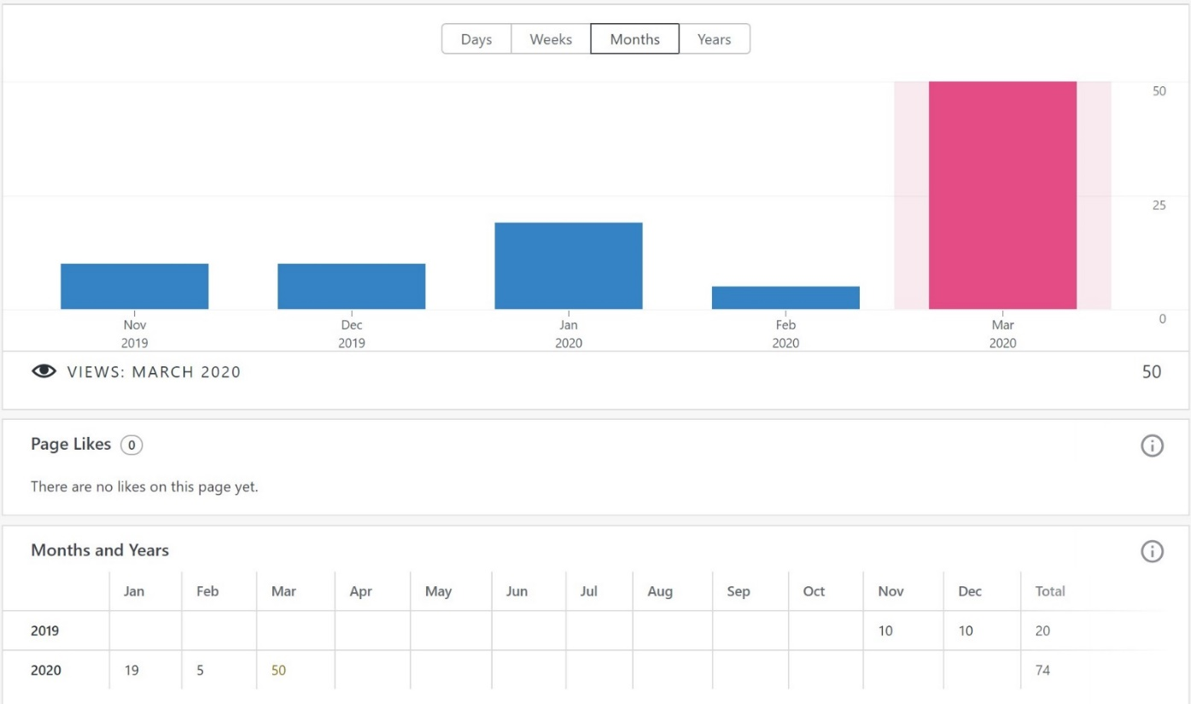
Ofsted Inspection of Kirkburton Middle School
Turnshaws Avenue, Kirkburton, Huddersfield, West Yorkshire HD8 0TJ
Inspection dates: 1–2 October 2019
Overall effectiveness Inadequate
The quality of education Requires improvement
Behaviour and attitudes Inadequate
Personal development Good
Leadership and management Inadequate
Inspection report: Kirkburton Middle School
1–2 October 2019 2
What is it like to attend this school?
There are a wealth of different clubs and activities. The display cabinet is straining with the number of trophies that the school has won. This, alongside the work to develop pupils’ mental and emotional well-being, makes this school distinctive.
There is a good range of different clubs and activities, including football, Nerf Ball, musical activities, chess club and Warhammer. The school was the first in Kirklees awarded the School Games Platinum Award.
Pupils are also encouraged to become young leaders, ‘Befrienders’ to new Year 6 pupils and house captains. This is helping them to develop their character and confidence. Pupils also develop their understanding of the world around them. For example, pupils created ceramic poppies for the centenary of the First World War.
They received a lovely letter of acknowledgement from those attending the ceremony.
There are visits to France, bush craft, camping and a wide range of fundraising events.
Leaders recognise that they need to do more to help pupils to encounter the world of work and careers.
What does the school need to do to improve?
■ During their time in school, pupils should start to learn more about the world of work and be provided with age-appropriate information about careers that will help them when they move on to their next school. This has not been happening and puts pupils at a potential disadvantage when they leave Kirkburton. Leaders need to make sure that pupils better understand their potential next steps and the world of work.
■ Governors are keen to ask questions. However, they are not always the right ones. This means that some of their key responsibilities are not carried out well enough. The trust needs to ensure that all governors are clear on their core responsibilities, including those duties laid down in law.
OFSTED response plan
A brief summary of what we've done to address the key actions points from the inspection.
Since the employment of Head of Careers, the following action points have been put into place.
- A careers website with information for parents – updated on a regular basis.
- A policy has been written and has been approved and added to the school policies on the website. This will be reviewed annually.
- A careers library is set up and is being built up with prospectuses and books throughout the year – the students are encouraged to take them and read them. A bursary for £300 worth of books has just been applied for.
- There is a student jobs vacancy board in the library. This will become more important in September.
- From September there will be a more thorough employment of librarians through an application and interview system.
- A survey has gone out to parents/staff/students on the KMS Careers provision. This has been reviewed and another will be sent out in June – to see if progression has been made.
- A letter to parents has gone out to gain information about each individual child and their families background (put into spreadsheet) This will be used to send students on more specific HE/FE visits in the future.
- All students have received a Future Goals booklet to show their parents.
- SEND students have received an information booklet with lots of advice for the future.
- SEND students and students with learning difficulties have a life skills booklet to work on if they cannot access the Careers booklets.
- Regular Google reviews are sent to parents for feedback from Assemblies and visits – these are analysed to show progression and to improve provision in the future.
- We have a Careers corner in the ICT/Library area – with information on LMI/Diversity/LGBT/routes available and apprenticeships
- There are displays in the staffroom on the Gatsby Benchmarks and Apprenticeships.
- There are regular meetings between Assistant head and Head teacher on careers provision.
- KMS has joined the CEIAG hub – which enables us to get support from LEC (We have now been allocated a Careers Enterprise coordinator and a Business Enterprise coordinator – they will work with Head of Careers and offer support and CPD)
- Regular meetings with Shelley head of careers to do Compass and work on improvement of provision.
- Staff and head governor have had CPD on Gatsby Benchmarks
- All governors have had training on Gatsby Benchamrks and met our CEC (Careers Enterprise coordinator)
- DT staff attended a Textiles Careers CPD training day
- Staff were given a deadline of January 30th to produce displays and put careers into planning. I have received most audits and will be using planning to try to broaden careers in the Curriculum. Displays are going up – Maths, Science, DT, PE are excellent.
- Staff have had CPD on Apprenticeships and Careers in the Curriculum.
- National Careers week – March 2020 – All subjects are using CIC (careers in curriculum) starters in their lessons (CPD on this before)
- School Liason meeting (Shelley, Scissett and Kirkburton) Careers in the Curriculum has been added to the agenda for staff to work collaboratively – postponed due to Corona.)
- Folders have been allocated to form tutors – containing a checklist of career provision and booklets. Meeting with head teacher as Tutors are finding it hard to fit into class time. Head has agreed some extended tutor time to complete booklets. (Yr 6 booklets are about job adverts and skills, Yr 7 and 8 are about Apprenticeships, employability skills, interviews and CV writing – we started these in NAW – National Apprenticeship week)
- Form tutors have shown students a PPT on stereotyping in Careers.
- PHSE staff are meeting to work collaboratively on Careers – planning is in line with Curriculum and follows a similar path to PHSE at SMS. Students rotate and work on Well Being as well as Careers. Year 6 have now moved to a new system with no careers – so work is done in drop down sessions.
- Yr 6,7,8 have had assemblies on Introduction to careers, Apprenticeships and T levels.
- KS 3 have also had assemblies on Careers in the creative industries – Falmouth University and LMI.
- All students have attended an inspirational speech. What is it like to be a judge?
- KMS has a bi annual Science fair – universities attend. Cancelled due to Corona
- All year 8 students will attend SMS annual Careers fair. Cancelled due to Corona. Virtual Careers fair to be shown in PHSE.
- All yr 8 students will attend visits to FE/HE (Huddersfield New College and Huddersfield University) University cancelled due to Corona. A bespoke virtual university tour has been made by Huddersfield University. Students will also attend a UTC virtual session and Kirklees College open day. Use of Kindles to make personal.
- All yr 7 students will visit Magna GUTS – a STEM career day. (lots of employer’s/career exhibitions) Cancelled due to Corona
- Some yr 8 students will attend a STEM trip to Leeds University. Cancelled due to Corona
- Some yr 8 students attended a workplace visit to Syngenta
- Some yr 7,8, girls are attending an ICT cyber girl’s aspirational day. Cancelled due to Corona
- All trips follow a strict use of Evolve for safeguarding.
- Regular Careers work set by head of PHSE (groups on rotation) and Head of Careers for whole school during school closure.
- 30 year 8 students will attend an aspiration session to improve resilience and build their aspirations.
Evidence of work set during school closure
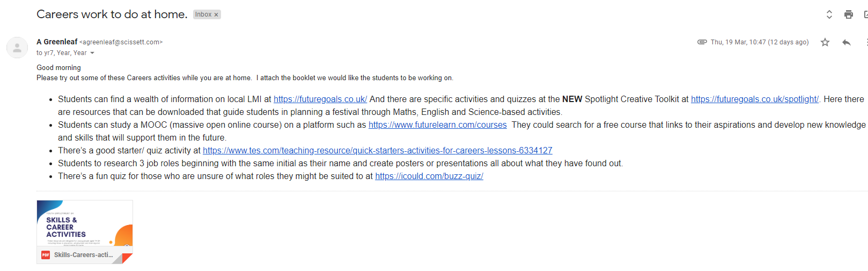
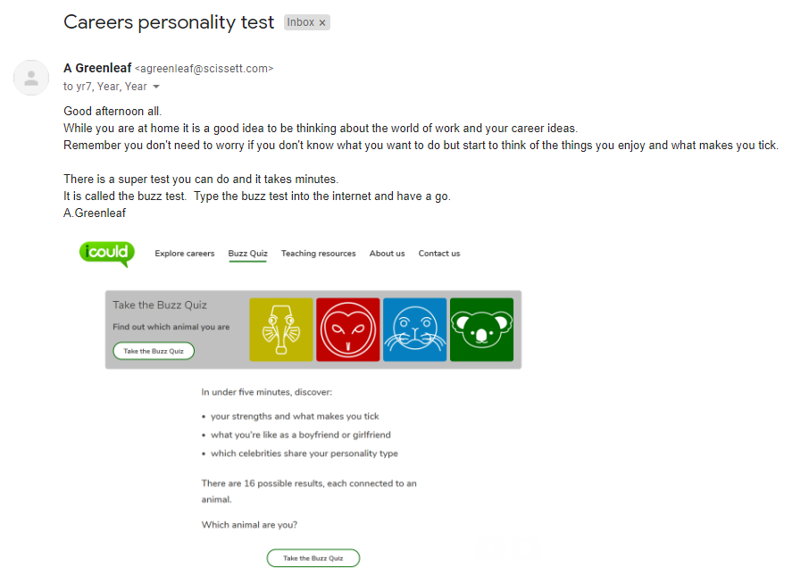
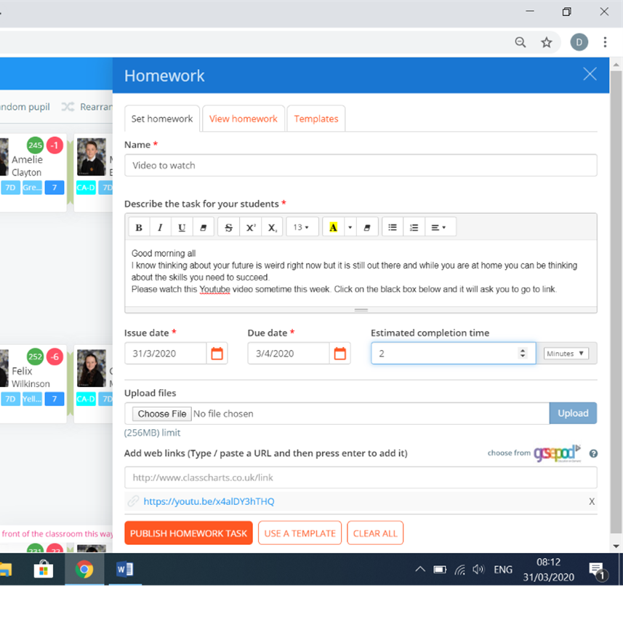
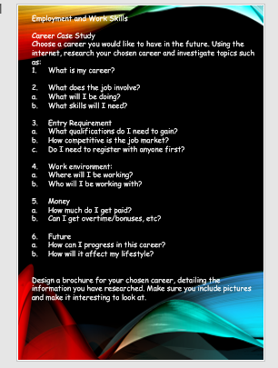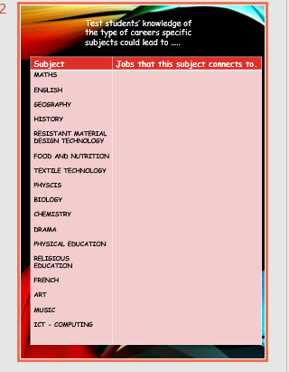
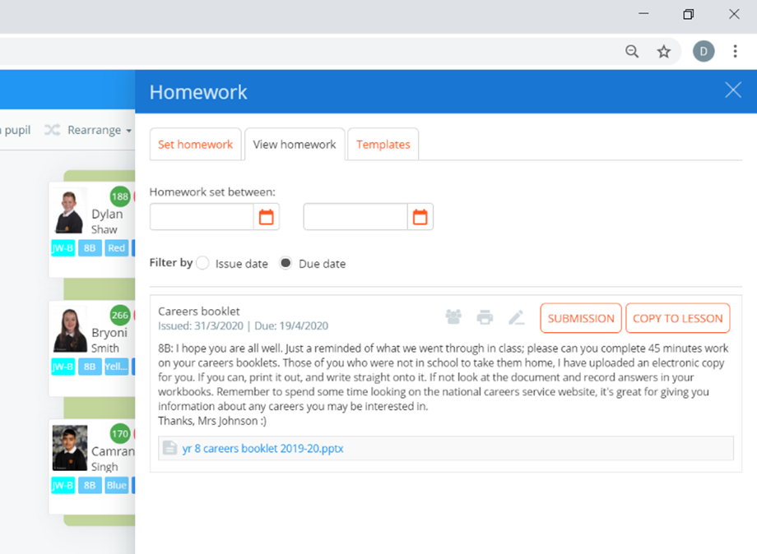
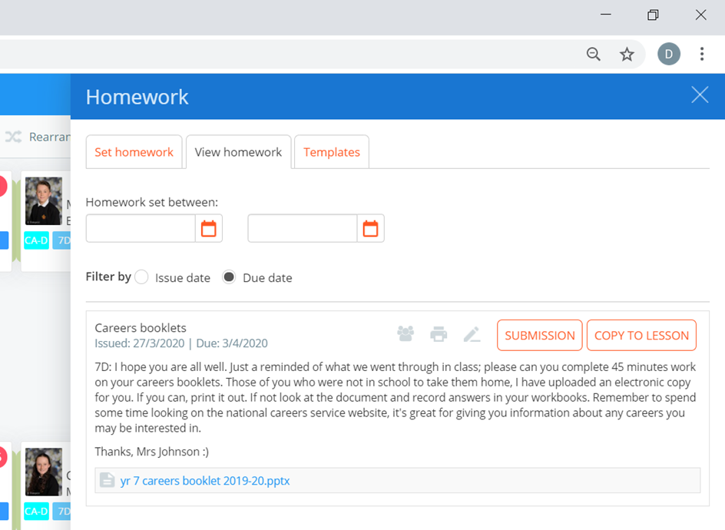

AIMS
By the time they leave our school, we want every young person to be in the position to make informed and ambitious decisions about their future, to have started to think of the route that is right for them and to possess the skills and positive mind-sets that will help them succeed throughout their lives. We believe that disadvantage should not determine destiny. Our aim is to help our students make better choices at the ages of 14, 16 and 18 years old regardless of their socioeconomic background.
By working with excellent teachers, employers, employees and different educational establishments, we’ve seen first-hand how it is possible for young people to scale the hurdles to social mobility and achieve incredible things. Yet it is still the case that children from low-income backgrounds face a litany of barriers to achieving their full potential. Our aim is to narrow the gap of these students.
Our careers provision must be able to help the students understand the range of opportunities available to them in today’s economy and acquire the skills and qualifications they need to succeed in the workplaces of the future.
These aims set out our ambitions to expand the quality and quantity of provision. Our aim is to help build a Britain fit for the future by investing in the development of skills to meet the changing needs of business, increase productivity and drive growth across the whole country. High-quality careers support will allow us to promote new world class technical education and make sure the students know where their qualifications lead. This will increase participation in higher level qualifications, with clear routes so that the students know how to progress to that level. It is vital, in an environment where new industries are emerging and many of the most important jobs of the future don’t yet exist, that individuals have access to high-quality labour market information and earnings data to underpin their choices.
Evaluation
During the three months that the new Careers Provision has been officially in place at Kirkburton Middle School we continually use quantitative and qualitative data to record the impact the Careers provision has had on the student’s future choices. We work closely with the Colleges, Universities and Independent Apprenticeship Companies, our Careers Enterprise Coordinator, CEIAG (Careers Education, Information, Advice and Guidance), Our business Enterprise Coordinator and the Head of Careers at our Secondary College. All our staff, parents, students, stakeholders and governors have a part to play in the implementation and reviewing of the Careers provision. All feedback, reviewing, evaluation and tracking is used to continually improve the provision for all our students.
Areas for Improvement
To enlarge and encourage use of Careers Library. New books coming.
To improve delivery of Careers in the Curriculum through CPD and school liaison support (working with SMS on Careers provision in school)
To use Data Metrics more effectively to see whether the website is being used by parents and students.
To improve the way, we communicate with parents and students through Social Media.
Our students do not get enough meaningful information about vocational colleges. I would like to improve our vocational taster sessions for students who may not be as academic, especially our SEND students. Kirklees College have let us use their virtual open days to look around. UTC have also done us a virtual open day. These are booked for year 8 PHSE sessions.
I would like to establish a student voice careers focus group.
There is currently no extra provision for SEND or FSM/PP students apart from the visits being free and transition. I need to address this from September 2021 with specific visits/workshops. I am working with a company called OPUS (I am trialling at SMS with the hope to bringing to KMS – there may be a cost.)

