The Mast Academy Trust

Our Vision
Enabling everyone within the Trust to harness their own power and potential.

Our Aims
To create amazing learning opportunities for children and for generations to come. To play our part in helping all pupils to contribute to making the world a better place.
The Trust Board of The Mast Academy Trust approved the following

Health and Safety Policy (master copy) on…11th July 2018…
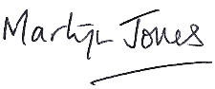

Signed by Chair of Trustees…

Adopted by the Governing Body of Kirkburton Middle School from 17th December 2018

This policy will be reviewed annually by the Trustees, approved by Local Governing Bodies and submitted to the Trust.

HEALTH AND SAFETY POLICY
[This policy must be reviewed and tailored in the areas identified by each individual Local Governing Board, all areas highlighted require individual academy details]

INTRODUCTION Statement of Intent
Health and Safety is an important consideration for The Mast Academy Trust. We will take all reasonable steps to provide a safe and caring environment for pupils, staff and our visitors. All personal data/information maintained in this respect will be held in the strictest confidence in line with relevant legislation.

The Law
Health and Safety in academies is governed by legislation and associated regulations, which are enforced by the Health and Safety Executive (HSE).

Responsibilities
It is recognised that individuals and groups of individuals have responsibilities for the Health, safety and wellbeing in the academy. The individuals and groups identified below are expected to have read and understood the academy’s policies and procedures for ensuring health, safety and wellbeing and to conduct their duties in accordance with them.
The Governing Body (GB) shares with the Academy Trust overall responsibility for Health and
Safety. The GB or LAB and the Headteacher, must comply with any direction given to them by The Mast Academy Trust concerning Health and Safety of persons on the academy’s premises or taking part in any academy activities elsewhere.

The Trust will
- Appoint a Trustee with responsibility for Health and Safety.
- Appoint independent auditors to provide monitoring, annual checking, advice and report of compliance with this policy and any relevant legislation.
- Provide strategic direction in the importance of Health and Safety across the organization • Review all reported events to make sure practice is reviewed and updated if necessary.
- Delegate responsibility for Health and Safety to the Audit Committee.
- Provide Annual training for Headteachers.

For its part the Governing Body will:
- Appoint a Member of the Governing Body with responsibility for Health and Safety.
- Ensure Health and Safety has a high profile.
- Provide as far as reasonably practicable a safe and healthy environment for all persons who work at, attend or visit the academy.
- Ensure, as far as reasonably practicable, the Health and Safety of pupils, staff and volunteers on off-site visits and activities.
- Seek improvement to working conditions according to priorities within existing resources.
- Consult staff and provide training opportunities.
- Monitor and review Health and Safety.
- Report to the Trust on Health and Safety risks or issues that arise.
- Endorse and support the safety policies and procedures of, and to assist The Mast Academy Trust to discharge those responsibilities, which it holds as an employer.
- Ensure that risk assessments are carried out within the academy and to ensure the assessments are reviewed following a significant change or after an incident.
- Encourage informal meetings and ensure time is made available in staff meetings where Health and Safety issues can be raised.
- Review on an annual basis, all accidents and incidents reported to identify trends.

The Headteacher will:
- Develop a Health and Safety culture throughout the academy.
- Following the annual audit, ensure an action plan is written, monitored and progress against items reported to the GB.
- Have a responsibility for day to day management of all Health and Safety matters in the academy in accordance with the Health and Safety policy.
- Ensure staff are aware of their responsibilities.
- Update GB members by submitting inspection reports.
- Ensuring action is taken on health, safety and wellbeing issues.
- Passing on information received on Health and Safety maters to the appropriate people.
- Carrying out accident investigations.
- Draw up Health and Safety procedures within the academy in line with The Mast Academy Trust Policies & Procedures.
- Ensure regular workplace inspections are carried out. Ashley Caver, Senior caretaker.
- Submit inspection reports to the GB.
- Identify and facilitate staff training needs.
- Ensure all new staff receive Health & Safety induction training.
- Ensure all staff receive annual Fire awareness training.
- Ensure all staff receive annual Health & Safety refresher training.
- Maintain a training record.
- Monitor effectiveness of procedures.
- Ensure the academy has relevant and sufficient risk assessments in place.
- Ensure the academy’s fire log is kept up to date and available for inspection.
- Contact the Chief Executive Officer or Director of Finance immediately if an incident occurs that is of a serious nature or fatal.

Staff with special responsibility:

The following staff have special responsibility:
Headteacher: Mr Gary Johnson

H & S Governor: Miss Emma Charlesworth

Senior Caretaker: Mr Ashley Carver

These job holders will be responsible for:
- The local arrangements to ensure the effective control of risks within the specific areas under their control.
- The coordination of the academy's Health and Safety policy in their own academy, directly responsible to the Headteacher for the application of the Health and Safety procedures and arrangements.
- The local arrangements for the purchase, inspection and maintenance of equipment and its specification.
- Establishing and maintaining safe working practices including arrangements for ensuring, as far as is reasonably practicable, the absence of risks to Health and Safety.
- Resolving health, safety and wellbeing problems referred to them by members of their staff or referring to the Headteacher or line manager any problems they are unable to resolve within the resources available to them.
- Ensuring that risk assessments are carried out when necessary and reviewed following a significant change or if an incident has occurred.
- Ensuring, as far as reasonably practicable, that sufficient information, instruction, training and supervision is provided to enable employees and pupils to avoid hazards and to contribute positively to their own Health and Safety.
- Obtaining relevant advice and guidance on Health and Safety matters.

All Staff will:
- Support the implementation of Health and Safety arrangements.
- Take reasonable care for the Health and Safety of themselves and of other people who may be affected by their acts and / or omissions.
- Co-operate fully with their manager or responsible person on all matters relating to their Health and Safety at work.
- Report promptly, injury, significant near miss, incident of violence and aggression or cases of work–related ill health, following the academy’s procedures.
- Report any defects, hazard, damage or unsafe practices or other items that could give rise to an unsafe place of work or cause injury or ill-health to others, following academy procedures. Any defective equipment should be labelled to ensure other employees cannot use the item.
- Wear any protective clothing or equipment and use any safety devices that have been provided for their Health and Safety while at work.
- Observe safety rules, complying with codes of practice and Health and Safety policy and procedures, and adhering to safe working procedures at all times.
- Acquaint themselves with, and comply with, the procedure to follow in case of a fire or other emergency.
- Attend Health and Safety training as directed and undertake their work activities in accordance with any Health and Safety training provided to them.
- Ensure as far as is reasonably practicable that their classroom or work area is safe and tidy.

Volunteers Volunteers have a responsibility to act in accordance with the academy’s policies and procedures for Health and Safety and to report any incident or defective equipment to a member of staff immediately.

Contractors
All contractors under academy control will be appropriately selected and competent in terms of Health and Safety.
- Contractors must be made aware of and abide by the academy's Health and Safety policy and not endanger pupils, staff or other visitors to the site.
- Ashley Carver will be responsible for the co-ordination of the contractors’ activities on site.
- The Headteacher must ensure that any temporary rules, such as exclusion from parts of the premises, are known to all staff, pupils and visitors to the premises. This might be achieved by the posting of suitable notices by the Headteacher, or by the contractor, in consultation with the Headteacher. All contractors must report to the responsible person named above before any work takes place and prior to each working session. The responsible person should then inform the contractor of any conditions which may affect his safety and that of others.

Visitors and other users of the premises
Where the facilities are shared, ensure that there are suitable and sufficient arrangements for communicating and coordinating health, safety and security policies and procedures with other occupiers.
- All visitors to the academy must comply with the academy Health and Safety policy and procedures.
- The Headteacher must ensure that a suitable system is implemented whereby all visitors are required to record their visit to the academy (visitor’s book) and the time they leave.
- Where applicable visitors will be required to wear a ‘visitors’ identification badge which will be supplied by the academy.
- Should a fire / emergency occur or the fire alarm is activated whilst visitors are on the academy's premises, the visitor must evacuate the building in accordance with the academy’s procedure.
- Should an incident / accident occur involving a visitor it must be reported using The Mast
Academy Trust accident reporting procedure and form sent to the Director of and Finance.
An investigation must be undertaken as soon as possible by the relevant responsible person.
- Persons hosting visitors including meeting arrangers must ensure:
  - Visitors are alerted to the establishment fire procedures.
  - Visitors adhere to the ‘no smoking’ policy.
  - Visitors park their vehicles in such a way so as not to obstruct fire escape routes, roads, access or other vehicles.
  - Visitors record time of arrival and departure in the visitor’s book.
  - Where applicable visitors are provided with and wear identification badges.
  - Visitors are accompanied or authorised to enter the premises.
  - Visitors remain within authorised areas and do not enter any restricted area unless permission is granted and the person is accompanied.
  - Visitors do not take anything with them from the premises, or bring anything onto the premises that may create a hazard or risk, unless authorised.
  - Visitors report all accidents, incidents and near misses to the host.
  - Visitors wear protective clothing that is supplied, when necessary.

Pupils
Pupils will be reminded that they are expected to:
- Exercise personal responsibility for the Health and Safety of themselves and others.
- Observe standards of dress consistent with safety and / or hygiene, as detailed within the appropriate curriculum safety guidelines.
- Observe all the Health and Safety rules of the academy and, in particular, the instructions of staff given in an emergency.
- Use and not wilfully misuse, neglect or interfere with things provided for their Health and Safety.
Pupils are taught how to manage risk through a variety of curriculum areas.
All pupils and parents will be made aware of this section of the policy through
Lettings

General Health and Safety Arrangements
The arrangements for Health and Safety have been drawn up following assessment of risk in accordance with the Management of Health and Safety Regulations 1999.
- Smoking is not permitted anywhere on the academy site.
- The academy will provide appropriate training for staff in relation to Health and Safety.
- All new staff and visiting staff, as part of their induction programme, will be advised on safety procedures and associated contingency plans.

Monitoring and Review of Health and Safety Arrangements
- The annual audit and action plan will be used to prioritise need and to inform planning.
- The Site will have a system for reporting and recording immediate need.
- All staff will carry out monitoring on a day to day basis.
- The site manager/caretaker will monitor academy grounds and premises daily.
- Monitoring will be reported to the Trust via the minutes of the GB.

Equipment
All work equipment will be purchased from a reputable supplier. Before purchase the following considerations must be given:
- The installation requirements.
- The suitability for purpose.
- The positioning and/or storage of the equipment.
- Maintenance requirements (contracts and repairs).
- Training and use of the equipment.

Staff must not use new items of work equipment unless appropriate training has been given. A risk assessment must be completed for the work equipment and staff using the equipment must have access to and comply with the risk assessment.
All plant and equipment that require statutory inspection, testing and maintenance for example, steam boilers, pressure cookers, lifting equipment, local exhaust ventilation will be completed by a Trust approved contractor (if the academy does not use an approved contractor they must ensure a competent contractor is used).
Any Personal Protective Equipment (PPE) required for the use of the work equipment will be supplied free of charge by the academy. All employees will be expected to wear the PPE when operating the equipment.

Access equipment (kick-stools, ladders, tower scaffolds and mewps etc)
All access equipment must be purchased form a reputable supplier. Before purchase the following considerations must be given:
- The installation requirements.
- The suitability for purpose.
- The positioning and/or storage of the equipment.
- Training and use of the equipment.
Staff must not use access equipment unless appropriate training has been given. A risk assessment must be completed for the access equipment or task and staff using the equipment must have access to and comply with the risk assessment.
The access equipment should be visually checked before each use. An inventory is required for all access equipment with a formal written 6 monthly check (tower scaffolds and mewps will require specialist and more frequent checks).

Curriculum - Use of Resources
Appropriate professional guidance from a nationally recognised body (e.g. CLEAPPS) must be followed with to regard to Science, ICT, Technology, Art and PE. A copy of relevant guidance and risk management must be kept locally at the academy, and should be available for inspection on request, and also with the subject leader who is responsible for disseminating the information to the staff and pupils.
The following subjects are considered to have higher risk aspects:
- Science
- Art
- Design and Technology
- PE
Specific care should be taken to seek advice if any member is unsure as to the safe nature of activities in these subjects. Where no formal advice or guidance can be found a risk assessment needs to be undertaken prior to the lesson.

PE
Clothing
All pupils will change into suitable clothing for the activity in which they will participate, details of clothing are listed in the school’s Uniform Policy.

Teachers should, where possible, change into appropriate clothing for outdoor games. This sets a good example to pupils and allows a greater degree of manoeuvrability for demonstrating skills, or accessibility to a student should an accident occur.

Jewellery
The wearing of jewellery is not permitted. If ears are pierced, studs only may be worn but must be removed for PE.
It is advisable to collect all such items prior to the lesson and store safely.

Manual Handling
The academy completes risk assessments on any significant manual handling tasks. Employees who complete manual handling tasks will have suitable and sufficient training.

Academy Building Access
In order to improve safety for everyone in the academy, measure have been taken to restrict access into the academy building. Pupils may use Y6 entrance door to gain access to the breakfast area between 8am and 8:45am after which Y6, Y7 and Y8 doors are open at 8:50am to gain access.
The gates are opened and locked as follows.
Main gates: Opened 05:30am Closed 18:00pm
Student access: Opened 05:30am Closed 09:30am
Opened 15:00pm Closed 17:30pm

After 09:00am late arrivals should enter via the main entrance. All visitors must report to the academy office and sign the visitor’s book where they will be issued with a visitor’s badge.
All visitors must sign out when leaving the academy site/building. Any adults on site who do not work in the academy and who are not wearing a visitors badge must be reported to the academy office. The main entrance is locked, allowing access on request from the academy office, via an intercom.

Vehicles
Parents are requested not to bring their cars onto the academy site. Parents collecting pupils who are injured or unwell should use the designated car park. Staff cars should be parked in the marked bays. Other areas should remain clear. Delivery vehicles are expected to use the delivery area. There are 2 marked disabled bays.

Wherever possible deliveries should be made once the pupils are safely in the building. Other trade vehicles should park safely and not block doorways, disabled parking or delivery areas.

Lone Working
The academy completes risk assessments for any lone working scenario in line with the school Lone Working Policy.

Key Holder Safety during Call Outs
Key holders on call out should be mindful of their own safety. If the police have left the premises, a key holder can contact the police and request that they return before entering the building. Key holders should lock themselves in. Before leaving the key holder should ensure that the academy is secure and the alarm re-set. If any member of staff is on site and is concerned about people on or about the site they should telephone the police on 101 or on 999 if concerned about their own or the academy's wellbeing.

Fire Safety
The academy will ensure that a fire evacuation drill is completed at least once per term and record the date in the fire log.
The fire log will be kept up to date with entries for weekly fire alarm checks and fire door checks, monthly emergency lighting checks and fire extinguisher checks and any contractor visits or false alarms.
Arrangements are in place for evacuating disabled people (a Personal Emergency Evacuation Plan PEEP).
The Headteacher will ensure a fire risk assessment is completed and updated at least annually or more frequently if there is a significant change to the building.
All staff are responsible for ensuring that pupils and visitors evacuate in an orderly and timely fashion in the event of the alarm sounding. All staff are responsible for ensuring evacuation routes and doors are kept clear at all times. For further details please see the academy's policy for fire. The Fire Certificate is displayed in the Fire Safety log book.

Evacuation Procedures
Evacuation procedures, detailed in each room and classroom are practised termly and reviewed annually or more regularly if appropriate. Evacuation routes and meeting points are detailed on the academy site plan, which is shown at on a map in every room.

Supervision of Pupils
Academy Hours: 08:50am to 15:45pm

Office Hours: 08:00am to 16:30pm

Duties
A member of staff needs to be around the playground area to supervise pupils arriving at the academy. The bell is rung at 08:50am
At 15:35pm to 15:40pm the class teachers supervise the pupils leaving the academy.
At break times 8 of staff are on duty. Staff should return to their classrooms in time for lessons to resume.
Outdoor Duty: the staff on duty cover the play areas at the side of the academy. The bell should be rung promptly at the end of break.
Indoor Duty: If it is a wet morning playtime staff stay with their classes until they have made contact with another member of staff and arranged to cover one another for a short release time.
All members of staff are responsible for making sure that their classroom is clear of pupils. All staff (teaching and non-teaching) should be in their classrooms to receive the pupils as they come in first thing in the morning, from morning break and after lunch. The rota for duties is on the staff room notice board.

Lunchtime Supervision
The Senior Supervisory Assistant is responsible for the organisation and management of lunch times, and works with a team of Supervisory Assistants. The Headteacher, Pastoral Leader and Heads of Year also provide support at lunchtime.

First Aid
The academy has assessed the need for First Aid provision and ensures that the guidelines given within the latest First Aid Code of Practice are complied with.
An up to date list of all First Aiders is displayed in the school office.
First Aid kits are located at strategic points in the academy. Main office, PE changing rooms, science, FFT and RMT rooms. Portable kits are available for lunchtimes, PE lessons and academy trips and visits.
The contents of the kits will be checked on a termly basis and the kit will be labelled with the date of checking and signature of the person who has checked the kit.
For further information please see the academy's First Aid Policy.

Health and Accidents to Pupils or Staff
Academy staff are expected to take reasonable action as responsible adults, to deal with injuries, etc. that pupils sustain until they can, if necessary, receive professional medical treatment.

The academy has trained first aiders – currently
Mrs Rachel Barrett - Clerical
Mrs Catherine Smith - ETA
Mr Craig Tyson - Teacher
First Aid and medical treatment is available in the medical room
Disposable gloves should always be used when dealing with blood and then be placed in the medical bin
First Aid boxes for academy journeys are stored in the medical room as well as other items required to be on hand during a journey.
If a student receives a bump to the head that causes concern, parents will be contacted and given the option of coming to the academy to check the student themselves or leaving the student to recover and return to class.
A note should be made in the Accident Book, Which is Kept in the ,of all actions taken. Serious accidents will also require and accident form to be completed and may require statements from all staff involved. Any student who goes home should be recorded as having done so and the class/form teacher informed.
Accidents to staff must also be reported and a record kept in the Accident Book, which is kept in the academy office. Details of reporting procedures are on page 257 and 258 of volume one of the Manual of Personnel Practice held in the academy office.

Medication Policy
The academy follows DfE guidance on the dispensing of medicines within academy.

Off site visits
Off site visits are logged on the Local Authorities Evolve System.

Allergies
Information about pupils who suffer from an allergy will be published in the staff room and the main kitchen. All staff will be informed of the individuals involved. Class teachers are issued with lists informing of any medical issues concerning pupils. The academy has identified those able to administer adrenaline via an Epi Pen when necessary.

Contagious Diseases
Outbreaks of notifiable diseases will be published to parents and staff immediately to ensure pregnant women are informed.
We follow HSE guidance on advice/reporting of diseases available at http://www.hse.gov.uk/pubns/edis1.htm. If in doubt, staff or parents are recommended to seek advice from their GP.

Staff Health and Welfare Stress
Any member of staff who feels they may be suffering from stress should discuss their concerns with the Headteacher, senior staff or the academies Health and Safety representative as soon as possible. The Headteacher will discuss the matter with the person concerned within 24 hours of the issue being raised, where physically possible.
A free and confidential counselling service is available to all employees on
A list of emergency contact names and phone numbers for all staff is held in the academy office.

Safety
Each academy to insert its own details – consider:-
- Working at heights
- Carrying hot drinks
- One way systems
- Manual Handling etc

Violence

Staff should always take steps to minimise the possibility of violence in the academy. Parents who are known to be violent or aggressive should never been seen by staff unless another adult is present.

VDU Operators
Staff regularly using VDUs should vary their work routines and follow guidance on regular eye tests. They should complete a DSE assessment during their probationary period and discuss any concerns with the Health & Safety representative or their line manager.

Reporting
Any accidents reportable to the HSE under the Reporting of Injuries, Diseases and Dangerous Occurrences Regulations 1995 (RIDDOR) will be completed by the Trust on the academy’s behalf.
All accidents, illness or near misses must be recorded in the Accident and Illness Book held at the Academy.
Where these are reportable under RIDDOR (see http://www.hse.gov.uk/pubns/edis1.htm) the Academy should complete the Accident Report Form, copying in the relevant GB/LAB Member, and the Director of Operations and Finance.
The Accident book should be regularly reviewed and reported on the GB/LAB to:
- Identify where accidents seem to be part of a trend that needs to be addressed
- Whether appropriate measures could be taken to reduce either frequency or impact of such accidents
All reportable incidents will be investigated by the Trust.
Critical Incidents
The academy has in place an Emergency scheme for dealing with critical incidents.

Control of hazardous substances
All substances that may be considered hazardous to health have been assessed (except in Science – these are covered by CLEAPSS hazcards). A copy of the Health and Safety data sheet and COSHH assessment will be available in the location of where the chemicals are used / stored. Any person using these chemicals must ensure they have seen and follow the information given on the COSHH assessment (including the wearing of any identified PPE). Staff must not bring any hazardous chemical onto the school site unless prior permission has been sought and a COSHH assessment has been completed.

Asbestos
The academy has an asbestos register (even if there is no asbestos on site there is still a register to state this) which is located in the main office
All contractors must be shown the register before work commences.
Any damaged or suspected damage to asbestos should be reported to the Headteacher who will contact the relevant surveyor immediately, copying in the Director of Operations and Finance.

Legionella
The school has a legionella survey which is located in the main office. Ashley Carver is responsible for ensuring that any monthly temperature checks are completed and the weekly flushing records are completed. Further information of legionella can be obtained from the IWS log book in the main office

Risk Assessments
Risk assessments are completed for any significant risks identified. These risk assessments are working documents and must be viewed by staff carrying out the activity and updated / reviewed whenever there is a significant change to the activity / task / personnel / or following an accident.

Training and records
The school will ensure that all staff has suitable and sufficient training to complete the tasks required of them. The school will ensure all training is recorded and up-date training is completed where required.

Appendix 1: Accident Reporting Slip
Appendix 2: HSE – Incident reporting in schools (accidents, diseases and dangerous occurrences) – Education information sheet no 1 (Revision 3)

Appendix 3: Near Miss / Health and Safety Concern Form

Appendix 4: Procedures to be followed in the event of a fire
Appendix 5: Evacuation Plan

Appendix 6: Emergency closure policy

Appendix 7: Link to education visits and off site activities procedures ( Kirklees document adopted by Kirkburton Middle School)

Appendix 1 - Accident reporting Slip
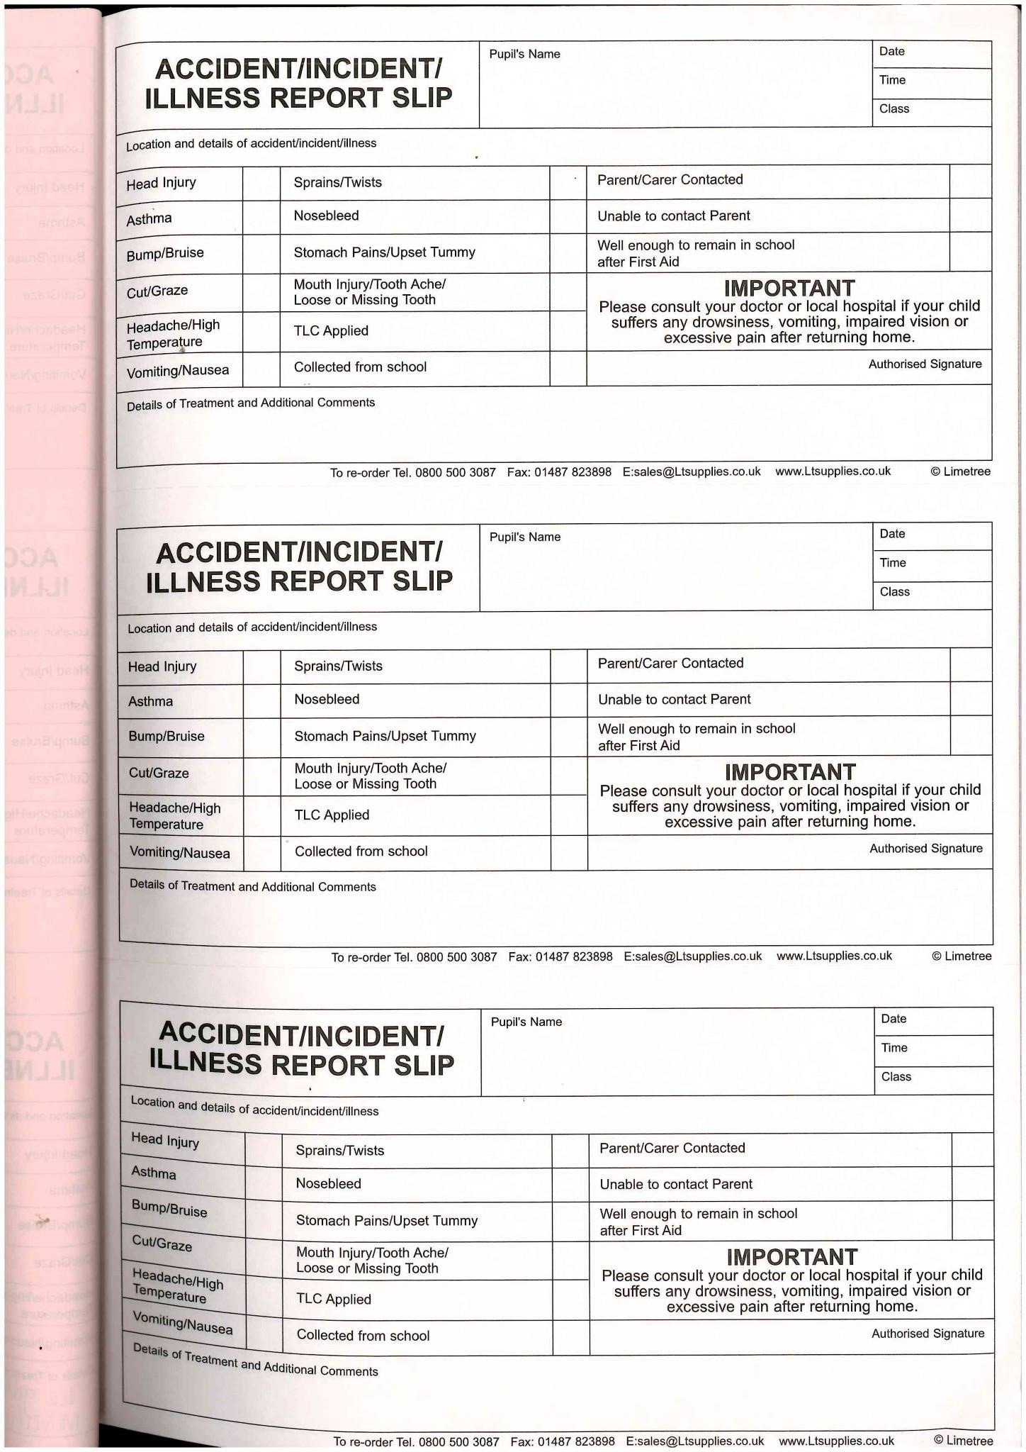

Appendix 2 - HSE – Incident reporting in schools (accidents, diseases and dangerous occurrences) – Education information sheet no 1

Incident reporting in schools (accidents, diseases and dangerous occurrences)

Guidance for employers
HSE information sheet

Introduction

This information sheet gives guidance on how the
Reporting of Injuries, Diseases and Dangerous Occurrences Regulations 2013 (RIDDOR) apply to schools. Most incidents that happen in schools or on school trips do not need to be reported. Only in limited circumstances will an incident need notifying to the Health and Safety Executive (HSE) under RIDDOR. The information sheet gives practical guidance to schools about what they need to report and how to do it.
What needs to be reported?
RIDDOR requires employers and others in control of premises to report certain accidents, diseases and dangerous occurrences arising out of or in connection with work.
The information sheet includes examples of the incidents that sometimes result from schools’ activities and are reportable under RIDDOR. The sheet contains three sections, which cover:
■■ injuries and ill health involving employees
(Section 1);
■■ injuries involving pupils and other people not at work (Section 2); ■■ dangerous occurrences (Section 3).
Who should report?
The duty to notify and report rests with the ‘responsible person’. For incidents involving pupils and school staff, this is normally the main employer at the school. The education pages on HSE’s website at www.hse.gov.uk/services/education provide information about who the employer is in different types of schools.
Some school employers may have centrally co-ordinated reporting procedures. In others, reporting may be delegated to the school management team. The health and safety policy should set out the responsibilities and arrangements for reporting in each school.
Incidents involving contractors working on school premises are normally reportable by their employers. Contractors could be, eg builders, maintenance staff, cleaners or catering staff.
If a self-employed contractor is working in school premises and they suffer a specified injury or an overseven-day injury, the person in control of the premises will be the responsible person. (See HSE’s RIDDOR web pages at www.hse.gov.uk/riddor for more detail on the reporting arrangements for selfemployed people.)
Who do I report to?
For general advice about how to report, see HSE’s RIDDOR web pages. You can report all incidents online and there is a telephone service for reporting fatal and specified injuries only. Reporting details for out of hours incidents are available from HSE’s out of hours web page at www.hse.gov.uk/contact/ contact.htm.
For incidents on school premises involving members of staff, pupils or visitors, HSE is the enforcing authority and you should submit your reports to them. HSE is also the enforcing authority for nursery provision provided and operated by local authorities. For privately run nursery schools, the local authority is the enforcing authority.
What records must I keep?
You must keep records of:
■■ any reportable death, specified injury, disease or dangerous occurrence that requires reporting under RIDDOR;
■■ all occupational injuries where a worker is away from work or incapacitated for more than three consecutive days. From 6 April 2012 you don’t have to report over-three-day injuries, but you must keep a record of them. Employers can record these injuries in their accident book.
You must keep records for at least three years after the incident.

Section 1: Injuries and ill health to people at work
Under RIDDOR, the responsible person must report the following work-related accidents, including those caused by physical violence, if an employee is injured, wherever they are working:
■■ accidents which result in death or a specified injury must be reported without delay (see
‘Reportable specified injuries’);
■■ accidents which prevent the injured person from continuing their normal work for more than seven days (not counting the day of the accident, but including weekends and other rest days) must be reported within 15 days of the accident.
The responsible person must also report any case of a work-related disease, specified under RIDDOR, that affects an employee and that a doctor confirms in writing (see ‘Reportable diseases’). You can find detailed guidance about RIDDOR reporting and online reporting procedures at www.hse.gov.uk/riddor/ report.htm.
If you are in control of premises, you are also required to report any work-related deaths and certain injuries to self-employed people that take place while they are working at the premises. Reportable specified injuries These include:
■■ fractures, other than to fingers, thumbs and toes;
■■ amputations;
■■ any injury likely to lead to permanent loss of sight or reduction in sight;
■■ any crush injury to the head or torso causing damage to the brain or internal organs;
■■ serious burns (including scalding), which:
- cover more than 10% of the body; or
- cause significant damage to the eyes, respiratory system or other vital organs;
■■ any scalping requiring hospital treatment;
■■ any loss of consciousness caused by head injury or asphyxia;
Incident reporting in schools (accidents, diseases and dangerous occurrences)
■■ any other injury arising from working in an enclosed space which:
- leads to hypothermia or heat-induced illness; or
- requires resuscitation or admittance to hospital for more than 24 hours.

Physical violence
Some acts of non-consensual physical violence to a person at work, which result in death, a specified injury or a person being incapacitated for over seven days, are reportable. In the case of an over-seven-day injury, the incapacity must arise from a physical injury, not a psychological reaction to the act of violence.
Examples of reportable injuries from violence include an incident where a teacher sustains a specified injury because a pupil, colleague or member of the public assaults them while on school premises. This is reportable, because it arises out of or in connection with work.

Reportable occupational diseases
Employers must report occupational diseases when they receive a written diagnosis from a doctor that their employee has a reportable disease linked to occupational exposure. (See www.hse.gov.uk/riddor for details of the reporting arrangements for selfemployed people.) These include:
■■ carpal tunnel syndrome;
■■ severe cramp of the hand or forearm;
■■ occupational dermatitis, eg from work involving strong acids or alkalis, including domestic bleach;
■■ hand-arm vibration syndrome;
■■ occupational asthma, eg from wood dust and soldering using rosin flux;
■■ tendonitis or tenosynovitis of the hand or forearm;
■■ any occupational cancer;
■■ any disease attributed to an occupational exposure to a biological agent.

Stress
Work-related stress and stress-related illnesses (including post-traumatic stress disorder) are not reportable under RIDDOR. To be reportable, an injury must have resulted from an ‘accident’ arising out of or in connection with work.
In relation to RIDDOR, an accident is a discrete, identifiable, unintended incident which causes physical injury. Stress-related conditions usually result from a prolonged period of pressure, often from many factors, not just one distinct event.

Section 2: Incidents to pupils and other people who are not at work
Injuries to pupils and visitors who are involved in an accident at school or on an activity organised by the school are only reportable under RIDDOR if the accident results in:
■■ the death of the person, and arose out of or in connection with a work activity; or
■■ an injury that arose out of or in connection with a work activity and the person is taken directly from the scene of the accident to hospital for treatment (examinations and diagnostic tests do not constitute treatment).
The lists of specified injuries and diseases described in Section 1 only apply to employees. If a pupil injured in an incident remains at school, is taken home or is simply absent from school for a number of days, the incident is not reportable.
How do I decide whether an accident to a pupil ‘arises out of or is in connection with work’?
The responsible person at the school should consider whether the incident was caused by:
■■ a failure in the way a work activity was organised (eg inadequate supervision of a field trip); ■■ the way equipment or substances were used (eg lifts, machinery, experiments etc); and/or ■■ the condition of the premises (eg poorly maintained or slippery floors).
So, if a pupil is taken to hospital after breaking an arm during an ICT class, following a fall over a trailing cable, the incident would be reportable. If a pupil is taken to hospital because of a medical condition (eg an asthma attack or epileptic seizure) this would not be reportable, as it did not result from the work activity.
This means that many of the common incidents that cause injuries to pupils at school tend not to be reportable under RIDDOR, as they do not arise directly from the way the school undertakes a work activity. Remember, in all these cases, you only need to consider reporting where an accident results in a pupil’s death or they are taken directly from the scene of the accident to hospital for treatment. There is no need to report incidents where people are taken to hospital purely as a precaution, when no injury is apparent.
Incident reporting in schools (accidents, diseases and dangerous occurrences)
What about accidents to pupils during sports activities?
Not all sports injuries to pupils are reportable under RIDDOR, as organised sports activities can lead to sports injuries that are not connected with how schools manage the risks from the activity.
The essential test is whether the accident was caused by the condition, design or maintenance of the premises or equipment, or because of inadequate arrangements for supervision of an activity. If an accident that results in an injury arises because of the normal rough and tumble of a game, the accident and resulting injury would not be reportable. Examples of reportable incidents include where:
■■ the condition of the premises or sports equipment was a factor in the incident, eg where a pupil slips and fractures an arm because a member of staff had polished the sports hall floor
and left it too slippery for sports; or
■■ there was inadequate supervision to prevent an incident, or failings in the organisation and management of an event.
What about accidents to pupils in a playground?
Most playground accidents due to collisions, slips, trips and falls are not normally reportable. Incidents are only reportable where the injury results in a pupil either being killed or taken directly to a hospital for treatment. Either is only reportable if they were caused by an accident that happened from or in connection with a work activity.
This includes incidents arising because:
■■ the condition of the premises or equipment was poor, eg badly maintained play equipment; or
■■ the school had not provided adequate supervision, eg where particular risks were identified, but no action was taken to provide suitable supervision.

Physical violence
Violence between pupils is a school discipline matter and not reportable under RIDDOR, as it does not arise out of or in connection with a work activity.

Other scenarios
Injuries to pupils while travelling on a school bus If another vehicle strikes the school bus while pupils are getting on or off and pupils are injured and taken to hospital, this is normally reportable under RIDDOR.
However, you do not have to report deaths and injuries resulting from a road traffic accident involving a school vehicle travelling on the public highway under RIDDOR. These are classed as road traffic incidents and are investigated by the police.
Incidents involving pupils on overseas trips RIDDOR only applies to activities which take place in Great Britain. So, any incident overseas is not reportable to HSE.
Incidents to pupils on work experience placements If pupils are on a training scheme or work placement, they are deemed to be employees for the period of the placement. In these circumstances, the employer, as the responsible person, should report a death, injury or disease to a pupil, which arises out of or in connection with work. This means the wider range of reporting categories for employees is applicable.

Section 3: Dangerous occurrences
These are specified near-miss events, which are only reportable if listed under RIDDOR.
Reportable dangerous occurrences in schools typically include:
■■ the collapse or failure of load-bearing parts of lifts and lifting equipment;
■■ the accidental release of a biological agent likely to cause severe human illness;
■■ the accidental release or escape of any substance that may cause a serious injury or damage to health;
■■ an electrical short circuit or overload causing a fire or explosion.

Supplementary information

Consultation
Under the Safety Representatives and Safety
Committees Regulations 1977 and the Health and
Safety (Consultation with Employees) Regulations 1996, employers must make relevant health and safety documents available to safety representatives.
This includes records kept under RIDDOR, except where they reveal personal health information about individuals. Further information is available in Consulting employees on health and safety: A brief guide to the law Leaflet INDG232(rev2) HSE Books 2013 www.hse.gov.uk/pubns/indg232.htm.

Reporting requirements of other regulators
There may be other reporting requirements placed on schools by other regulators in the education sector. The requirements of these other regulators are separate to, and distinct from, the legal duty to report incidents under RIDDOR.

Further information
For information about health and safety, or to report inconsistencies or inaccuracies in this guidance, visit www.hse.gov.uk/. You can view HSE guidance online and order priced publications from the website. HSE priced publications are also available from bookshops.
This guidance is issued by the Health and Safety Executive. Following the guidance is not compulsory, unless specifically stated, and you are free to take other action. But if you do follow the guidance you will normally be doing enough to comply with the law. Health and safety inspectors seek to secure compliance with the law and may refer to this guidance.
This information sheet is available at: www.hse.gov.uk/pubns/edis1.htm.
© Crown copyright If you wish to reuse this information visit www.hse.gov.uk/copyright.htm for details. First published 10/13.
APPENDIX 3
NEAR MISS /

HEALTH AND SAFETY CONCERN

REPORT FORM

NAME:
SCHOOL:
DATE:

DESCRIPTION OF NEAR MISS / HEALTH AND SAFETY CONCERN

LOCATION:

ONCE COMPLETED PLEASE DEPOSIT IN THE HEALTH AND SAFETY CONCERN BOX IN THE STAFF ROOM OR RETURN TO THE SCHOOL OFFICE
STOP THINK ACT

Appendix 4
KIRKBURTON MIDDLE SCHOOL

EMERGENCY EVACUATION POLICY
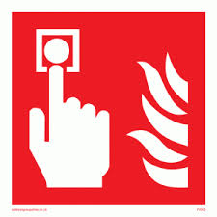
WHENEVER THE ALARM SOUNDS, EVERYONE MUST EVACUATE
THE BUILDING IMMEDIATELY

ALL STAFF:

- Make sure that you know where the nearest alarm point and fire extinguishers are located in the areas you work in;
- Familiarise yourself with the shortest way out of the building as indicated on the plan in each teaching area;
- At the start of each lesson, make sure that exit routes are not obstructed by bags or furniture;
- If you discover a fire break the nearest glass. Unless it is a very minor fire do not stay to fight it
- If you hear the alarm direct your class out in an orderly manner and in silence through the nearest exit
- Be aware of pupils who may be working elsewhere or visiting the toilet
- Accompany pupils to assembly point on the large playground where pupils line up in silence in register order in class lines.

SPECIFIC RESPONSIBILITIES:

OFFICE STAFF: Take out Registers and Signing in / out books
ASSISTANT HEAD (1): Notify Music Room
ASSISTANT HEAD (2): Check supply staff and other adults and report to Headteacher. Notify Bungalow and All weather pitch users
CLASS TEACHERS Check Registers, initially by counting and report to Heads of Year
PUPIL ACHIEVEMENT LEADERS: Report Pupil count and Year Staff to Headteacher
HEADTEACHER: Notify Pavilion. Gives all clear to return to building

SPECIAL ARRANGEMENTS:

At morning and afternoon breaks:
All staff in the building should evacuate the building by the nearest available exit, checking en route that pupils leave general areas including toilets and medical and informing the teacher on duty in each play area who will direct pupils to walk towards the large playground in a quiet and orderly manner.

If it is an indoor break, the member of staff on duty, assisted by any other staff in the area, should ensure that the area is vacated in a quiet and orderly manner.

AT LUNCHTIME:

All staff should evacuate the building by the nearest available exit, checking that pupils leave general areas including toilets and medical room en route.

Pupils eating in the dining hall leave meals and walk out to the large playground, directed by the supervisor on duty and the Head and/or Deputy. Both doors to the Dining Hall should be opened wide and pupils should leave the building through the main entrance.

Teaching staff and/or lunchtime supervisory staff will inform en route the supervisor on duty in each play area and assist with the direction of pupils to walk towards the Year 7 playground in a quiet and orderly manner.

All staff to assemble on the large playground and assist with general supervision.

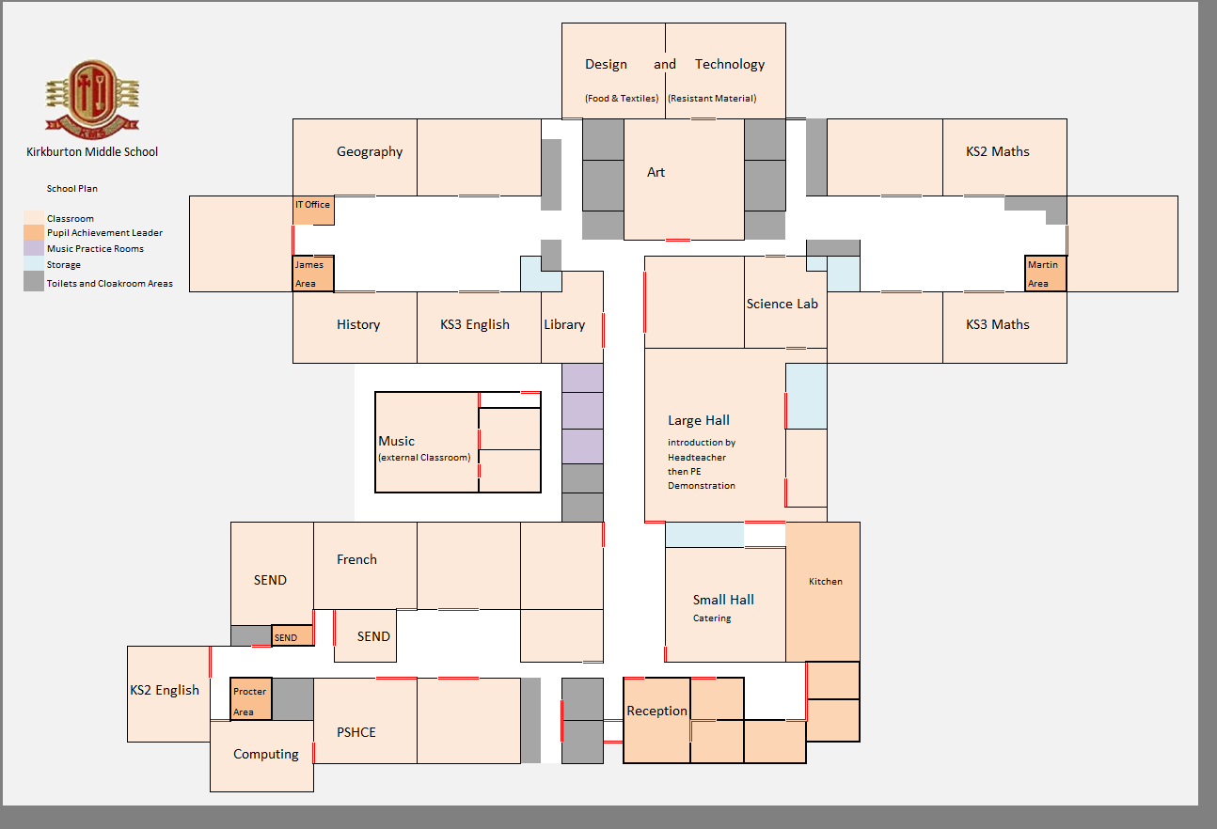
Appendix 5
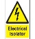
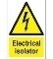

CALL POINTS
EXTINGUISHERS
FIRE EXITS
ELECTRICAL ISOLATOR

Boiler
ASSEMBLY POINT

MUSIC
Miss Kaye
Mrs Cozens
C1
Miss Charlesworth
C2
Mr Covell
Mr Killock
C3
Mr Smith
C4
Mr Tyson
C5
ART
Mrs Aaron
Mrs Hudson
Mrs Sharples
B5
Mr Bennett
Mr Parker
B4
Miss Seedat
B3
Mrs Crowther
Mr Townend
B1
Mr O’Brien
Mrs McKeown
A1

Mrs Hallas
A7

Mrs Sheridan
A6

Mrs Tedder
A5
Mrs Price
A4
Computing
Mr Sarrafi
A3

Ms Abbas
A2

Appendix 6

KIRKBURTON MIDDLE SCHOOL

EMERGENCY
CLOSURE
POLICY

KIRKBURTON MIDDLE SCHOOL

EMERGENCY CLOSURE POLICY

C O N T E N T S

Page

Introduction 3

Loss of Essential Services 3

Severe Weather 3

Preparation 4

Procedure for Early Closure 4

Contingency Plan 5

KIRKBURTON MIDDLE SCHOOL

EMERGENCY CLOSURE POLICY

Introduction

Emergency closure occurs in exceptional circumstances:

1. Where there is a loss of an essential service which cannot be compensated for (e.g. boiler failure or prolonged electricity or water cut);

2. When severe weather conditions adversely affect access and threaten safety of pupils and staff.

Emergency closure days are for pupils; these are working days for staff though this may mean undertaking school-related tasks at home.

1. Closure due to a Loss of Essential Services or Severe Weather

A decision to close will be made by the Headteacher, in consultation with the school Senior Leadership Team and the Executive Leadership Team of Mast Academy Trust (if appropriate).

In the event of either situation above, pupils may be sent home early and/or a decision may be made to close on the following day. Following Kirklees’ ‘Guidelines for Handling School Closures Due to Bad Weather’ the L.A. will be informed of any decision to close in order that information can be broadcast to members of the public. This will be via email: schoolclosures@kirklees.gov.uk, or on 01484 414722.

This decision will be communicated to all pupils and staff before departure from home via Groupcall text and via the school web-site.
A decision to close after the pupils have left school and before school starts on the following day would only be made in the most exceptional circumstances e.g. major fire, flood or unforeseeable severe weather. In such circumstances the Contingency Plan will operate (see below).

PREPARATION:

In the Autumn Term a letter will be sent home explaining arrangements for emergency closure of the school. It will explain that if bus routes are in danger of being closed by snow, buses to outlying villages may collect children earlier than usual and all pupils will be sent home early.

(Because some staff may also need to leave early and because it will be impossible to continue with normal lessons under such circumstances, pupils who walk home will also be released early.)

The School Admission Form contains contact details for each pupil in the event of an unforeseen closure.

PROCEDURE FOR EARLY CLOSURE:

If the decision is made to close early the bus companies and taxis will be contacted. Pupils and staff will be informed via a Groupcall text and via the school web-site.

Internal cover arrangements will operate for staff who have difficult journeys to make who will be released early. Otherwise normal lessons will operate for as long as possible.

As buses arrive, a message will be sent to all groups to assemble in the halls, Years 6 and 7 in the Large Hall and Year 8 in the Small Hall, to be supervised by remaining class teachers.

Pupils who walk home will be released at this point.

Pupils who travel on buses / in taxis will leave as transport arrives.

Note: Parents who are particularly concerned may call for pupils at any time even if a whole school decision has not been taken.

It will be the responsibility of the Headteacher to remain in school until all children have been safely collected.

Pupils will be allowed to use mobile phones to contact parents if necessary. Pupils will only be allowed to leave with adults named by the pupil’s parent/carer (either in writing or verbally on the day).

CONTINGENCY PLAN:

If school is closed after pupils have left for home, the Headteacher will contact all staff via Groupcall. The Assistant Head with responsibility for supply staff will inform anyone who is booked for the days closed. The headteacher will inform the LA school Closure Team who will contact all relevant media stations and display th closure on the Kirklees Schools web-site. The school will inform parents via Groupcall texts and via the school web-site. However, as there is every likelihood that some parents may not receive this message the building will always be open in the morning and all staff who can safely make the journey will do so. (Other staff should undertake school-related tasks at home and should advise school by telephone as soon as possible if they are unable to get in). In the absence of the Headteacher, Contingency arrangements will then be made by the most Senior Teacher present, after consultation with colleagues, in order to:

1. Properly supervise pupils who have arrived at school, paying particular attention to their physical well-being, including provision of meals and organising as meaningful
activities as possible under the circumstances.

2. Answer the telephone.

3. Try to contact parents to see if pupils can be collected / sent home if necessary.

The nature of such arrangements will depend upon the number of staff / pupils present.

This policy was reviewed and agreed by Governors on: 3rd April 2017

