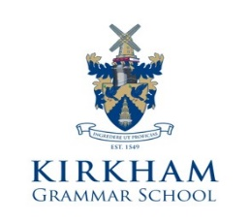

HMC Independent Co-Educational Day and Boarding School (3 – 18 Years)

House Parent (Pastoral)
For Girls’ Boarding House
Permanent, Part-time

The successful applicant will:
- Join our Girls’ Boarding House Team to assist the House Parent (Academic) in the provision of pastoral and health care of the pupils;
- Plan weekend activities for boarders;
- Support and implement the School’s family ethos.
Further details and application form can be downloaded from our website at www.kirkhamgrammar.co.uk or by contacting Miss S L Felton, HR Manager, Kirkham Grammar School, Ribby Road, Kirkham, Preston. PR4 2BH
Tel: 01772 684462
e-mail: sl.felton@kirkhamgrammar.co.uk

Closing Date for Applications: Friday 29 October 2021

Kirkham Grammar School is committed to safeguarding and promoting the welfare of children and young people. An enhanced DBS clearance will be undertaken by the school

