 CEDAR CLASS - Long term curriculum overview
 |  | Autumn 1 | Autumn 2 | Spring 1 | Spring 2 | Summer 1 | Summer 2
English |  | 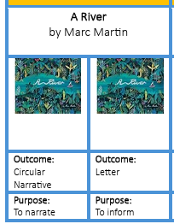 | 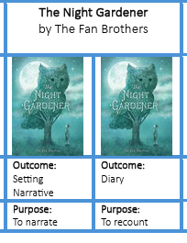 | 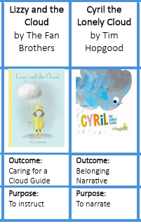 | 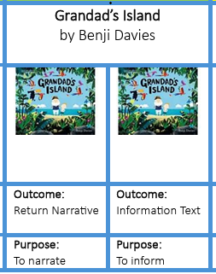 | 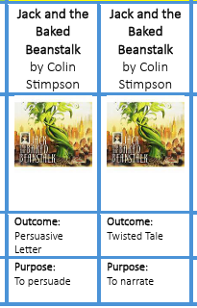 | 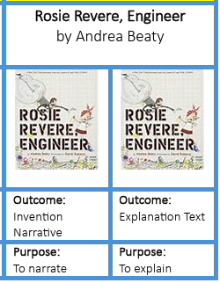
Key Texts |  | Focus Text:  A River by Marc Martin  Linked Texts:  The Wind in The Willows (Abridged Version) by Gemma Barder & Kenneth Graham  Mr Gumpy’s Outing by John Burmingham  Lost and Found by Oliver Jeffers  Mouse on the River by Will Snow  Great Rivers: Rivers of the United Kingdom by Catherine Brereton | Focus Text:  The Night Gardener by The Fan Brothers  Linked Texts:  Marve and the Killer Plants by Alex Falase-Koya  Voices in the Park by Anthony Brown  Leaf Man by Lois Ehert  It fell from the Sky by Terry Fan and Eric Fan  Sunflower Shoots and Muddy Boots: A Child’s Guide to Gardening by Katherine Halligan | Focus Text:  Lizzy and the Cloud by the Fan Brothers  Cyril the Lonely Cloud by Tim Hopgood  Linked Texts:  Hello Lighthouse by Sophie Blackall  Ocean Meets the Sky by Terry Fan  The Rabbit Listened by Cori Doerrfeld  The Invisible Boy by Trudy Ludwig  Rain before Rainbows by Smriti Halls & David Litchfield  The Night Gardener by The Fan Brothers | Focus Text:  Grandad’s Island by Benji Davies  Linked Texts:  The Storm Whale by Benji Davies  Grandma Bird by Benji Davies  Jack and the Flumflum Tree by Julia Donaldson  The Invisible String by Patrice Karst  Badger’s Parting Gift by Susan Varley  The Heart and the Bottle by Oliver Jeffers | Focus Text:  Jack and the Baked Beanstalk by Colin Stimpson  Linked Texts:  Various versions of Traditional Tales  Prince Cinders by Babette Cole  Goldilocks and the Three Crocodiles by Michael Rosen  The Princess and the Peas by Carly Kart  Porridge Please! By Laura Muchabooks linted to Lizzy and the Cloud | Focus Text:  Rosie Revere, Engineer by Andrea Beaty  Linked Texts:  Ada Twist the Scientist by Andrea Beaty  Violet the Pilot by Steve Breen  The Girl who Never Made Mistakes by Matt Prett  An Engineer Like Me by Dr Shini Somara  Wallace & Gromit: Cracking Contractions Manual by Derek Smith and Graham Bleatham  Leonora Bolt: Eco Engineer by Lucy Brandt
Guided Reading Texts |  | Fiction  - Grimwood  - Illustrated stories from Aesop  Non-Fiction  - The Wild Life of Animals  - Never get Bored Draw or Paint  Poetry  - The Puffin Book of Fantastic First Poems  - Words can Fly | Fiction  - A Year Full of Stories  - Secrets of the Forest  Non-Fiction  - National Trust: Out and About Bird Spotter  - Complete Children’s Cookbook  Poetry  - Midnight Feasts  - Jelly Boots, Smelly Boots | Fiction  - A World full of Animal Stories – North America  - Wild Magic  Non-Fiction  - Everything Under the Sun  - A Year Full of Celebrations and Festivals  Poetry  - Poems for Every Season  - The Best Ever Book of Funny Poems | Fiction  - A World full of Animal Stories – Africa  - A Bear called Paddington  Non-Fiction  - First Big Book of How  - 101 Great Science Experiments  Poetry  - A First Book of Animals  - The Shirley Hughes Treasury | Fiction  - Pinocchio  - The Boy who Grew Dragons  Non-Fiction  - My Encyclopaedia of Very Important Dinosaurs  - First Big Book of Why  Poetry  - The Works  - 50 Ways to Score a Goal | Fiction  - Leonora Bolt, Secret Inventor  - Einstein the Penguin  Non-Fiction  - Little People, Big Dreams  - My Encyclopaedia of Very Important Things  Poetry  - A Poem for Every Question  - A First Book of Nature
Maths |  | Place Value  Addition and Subtraction  Shape |  | Money  Multiplication and Division  Length and Height  Mass, Capacity and Temperature |  | Fractions  Time  Statistics  Position and Direction
 | Science | Animals  (inc humans)  - To notice that animals, inc humans have offspring which grow into adults  - To find out about and describe the basic needs of animals, inc humans, for survival  - To describe the importance for humans to exercise, eat the right types of food and food hygiene | Seasons  (migration & hibernation)  - To understand how different animals prepare for the winter months in the UK (EG squirrels, tortoises) and in other climates (e.g., beards hibernating in Arctic climates)  - To understand how native birds and mammals etc. will find food during the winter months | Seasons  (nesting and emerging from hibernation)  - To understand how biological clocks work and what signals a hibernating animal to waken  - To track animals when they emerge from hibernation in the UK and abroad | Plants  - To observe how bulbs grow and mature into plants  - To find out and describe how plants need water, light and a suitable temperature to grow and stay healthy | Living things and their habitats  - To explore and investigate the difference between things that are living, dead and have never been alive  - To identify that most things live in a habitat to which they are suited and describe how different kinds of animals and plants and how they depend on each other  - To identify and name a variety of plants and animals in their habitats inc microhabitats  - To describe how animals obtain their food using the idea of a simple food chain, and identify and name different sources of food. | Use of everyday materials  - To identify and compare the suitability of a variety of everyday materials, inc wood, plastic, brick, paper and cardboard  - To find out how the shape of solid objects made from some materials can be changed by squashing, bending, twisting and stretching
 | topic | KIRKHAM EXPEDITION |  | THE MONARCHY |  | SAVE OUR OCEANS
 | History |  | Our Local Area  Significant historical events, people and places in their own locality focusing on our local area. |  | Monarchs  The lives of significant individuals in the past who have contributed to national & international achievements. (King Charles III, Queen Elizabeth II & Henry VIII) |  | Titanic  To explore the significant global and national event of the sinking of the Titanic.
 | Geography | Our Local Area  What is my local area like? |  | UK Weather  Weather in the UK  Where in the World is the UK? |  | Save our Oceans  Why do oceans matter?  Should we look after our world?
 | Art | Key artist & artwork  Weeping Woman – Pablo Picasso (1937)  Sculpture  Our Local Area  Anthony Gormley Angel of the North (1998) | Key artist & artwork  Pumpkin -  Yayoi Kusama (1998) | Key artist & artwork  The Starry Night – Vincent Van Gogh (1889)  Drawing  The Monarchy  David Hockney  Mum portrait (1988) | Key artist & artwork  Girl with a Pearl Earring –  Johannes Vermeer (1665) | Key artist & artwork  Going to Work – L.S. Lowry (1943)  Collage  Save our Oceans  Henri Matisse  The Snail (1952) | Key artist & artwork  The Scream – Edvard Munch (1893)
 | D & T |  | Food  Making picnic sandwiches |  | Construction  Photo Frames |  | Materials  Waterproof Jacket
 | Computing | Coding (6)  Questioning (2) | Questioning (2)  Creating Pictures (5) | Presenting Ideas (4)  The Internet (2) | The internet (2)  Making Music (3) | Spreadsheets (6) | Route Explorers (4)
 | French | Fancy-dress party & Let's go to the park |  | Minibeasts & Animals |  | Little Red Riding Hood and Recap
 | Music | Questions and Answers | Let’s Keep Singing | Sound and Symbol 1 | Sound and Symbol 2 | Around the World | The Power of Communication
 | PE | KS1 – Y2 FMS  Bounce Ball  KS1 – Y2 Dance  Wind in the Willows | KS1 – Y2 FMS  Playground Games in the 20th Century  Y2 Gymnastics Activities 1 | Y2 Games  Piggy in the Middle  Y2 Games  Net and Wall | KS1 – Y2 Dance Explorers  Y2 Games Striking and Fielding | KS1 – Y2 Athletics  Y2 Dance  Moving Along | Y2 FMS - End of KS1 Assessment  Y2 OAA - The Great Outdoors
 | RE | Christianity (God)  Does how we treat the world matter?  - Creation  - Care for the planet  - Harvest | Christianity (Jesus)Why do Christians say that Jesus is the ‘light of the world’?  - Jesus as the light of the world  - Symbolism of light  - Advent & Christmas | Hindu Dharma  How might people show their devotion?  - Devotion  - Worship at home and temple | Islam  Why do Muslims believe it is important to obey God?  - Submission and gratitude  - Prayer | Christianity (Church)  What unites Christian Communities?  - Worship  - The church  - Use of symbols | Judaism  What aspects of life really matter?  - Moses  - Ten Commandments  - The Sabbath
 | PSHE | Relationships  - Making friends; feeling lonely and getting help  - Managing secrets; resisting pressure and getting help; recognising hurtful behaviour  - Recognising things in common and differences; playing and working cooperatively; sharing opinions |  | Living in the Wider World  - Belonging to a group; roles and responsibilities; being the same and different in the community  - The internet in everyday life; online content and information  - What money is; needs and wants; looking after money |  | Health and Wellbeing  - Why sleep is important; medicines and keeping healthy; keeping teeth healthy; managing feelings and asking for help  - Growing older; naming body parts; moving class or year  - Safety in different environments; risk and safety at home; emergencies
 | Visits/  Visitors  (subject to change) | Visit Milbanke Care Home, Kirkham |  | Visitor from or visit to Hindu Temple, Preston |  | Visit Sea Life Centre, Blackpool | Forest School – Creating plant and animal habitats.

